Supplementary material
2. Case A – Example of a tailored recovery training plan after an injury
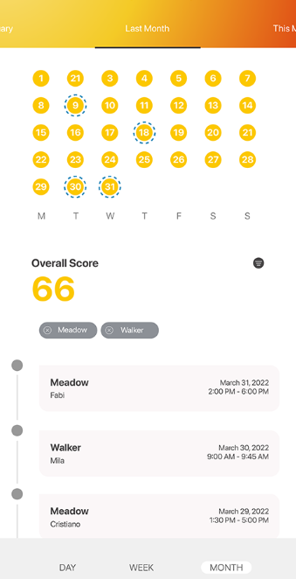
Source: Cabasus, 2025

3. Case A – Example of the biomechanics analysis score for a horse (Cabasus, 2025)
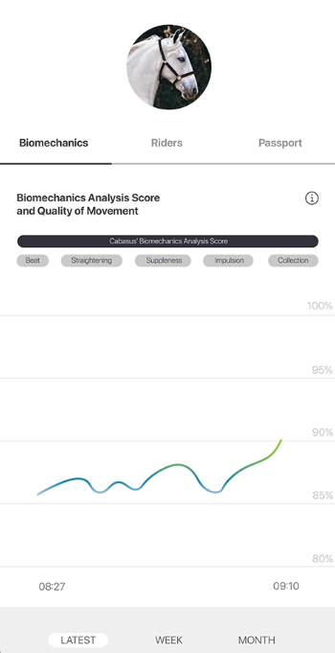
Source: Cabasus, 2025

4. Case B - Example of laming score (top left corner) for cows
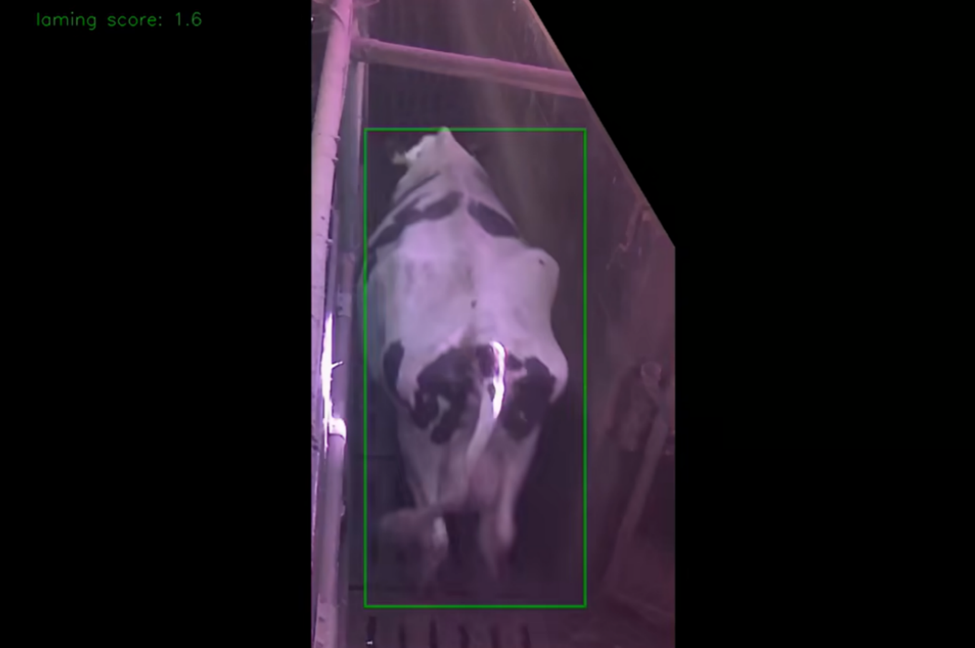
Source: ACARiS, 2025

5. Case B - Example of body condition score and cow ID recognition
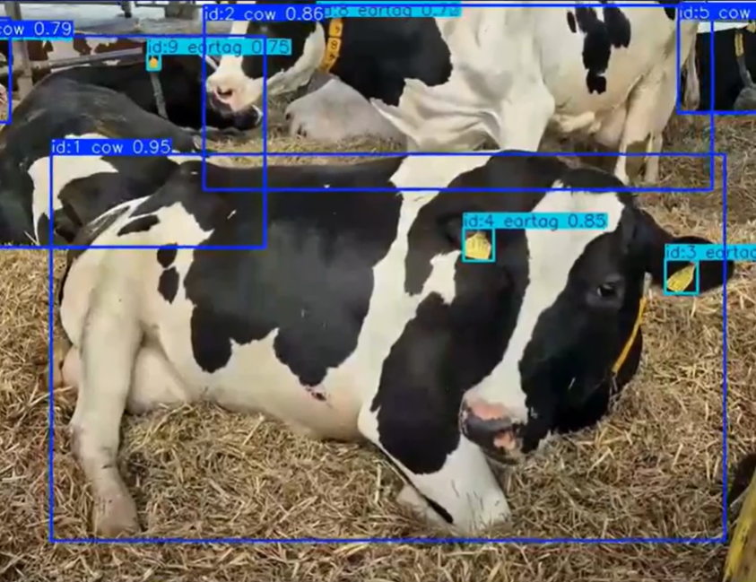
Source: ACARiS, 2025

6. Case D - Example of the monitoring and GenAI agronomist advice for barley
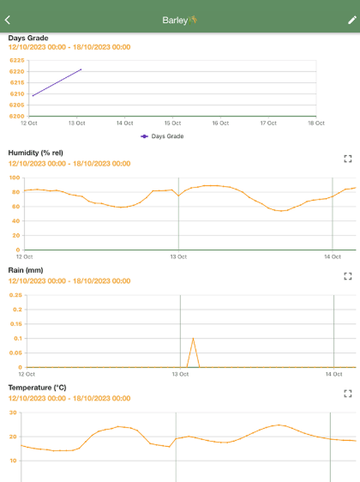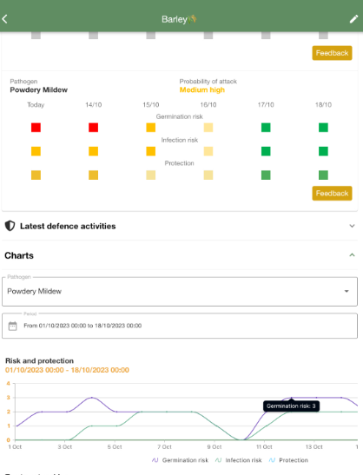
Source: xFarm Technologies SA, 2025

7. Coding and research findings
Case & representative evidence | IIL depth / process trajectory | Recursive IIL mechanism | DC activated | Organizational embedding / outcome
Case A: “we check the dashboard every morning.” | Moderate recursive recalibration | Repeated interaction normalized GenAI-supported monitoring practices | Sensing | AI-generated insights became integrated into daily operational awareness
Case A: groom checks AI explanation after biomechanics score drops | Moderate recursive recalibration | Employees increasingly interpreted GenAI alerts alongside tacit expertise | Sensing | GenAI outputs supported earlier recognition of potential health risks
Case A: “the AI doesn’t replace experience but sometimes it notices patterns we don’t see yet.” | Moderate recursive recalibration | Human-GenAI interpretive alignment strengthened trust in system outputs | Seizing | GenAI-supported insights increasingly informed operational decisions
Case A: trainer shortens training session based on AI recommendation | Moderate recursive recalibration | AI-generated recommendations influenced intervention timing and workload decisions | Seizing | Operational coordination increasingly incorporated AI-generated guidance
Case A: “when farmers tell us a warning was wrong we recalibrate the algorithm.” | Moderate recursive co-learning | Sustained provider-user feedback recursively refined interpretive parameters | Seizing | GenAI outputs became progressively more contextually reliable
Case A: “we now intervene earlier.” | Moderate recursive co-learning | Recursive recalibration improved interpretive precision of warnings | Seizing → reconfiguring | Preventive intervention routines became embedded into animal management
Case A: “in two cases we prevented injuries.” | Moderate recursive co-learning | GenAI-supported monitoring became institutionalized within training routines | Seizing | Sustained welfare-oriented management practices emerged
Case B: “employees were not sure which reports were really important.” | Moderate recursive recalibration | Initial interpretive uncertainty limited operational use of outputs | Weak sensing | Ai-generated insights remained only partially actionable
Case B: “we contacted the provider to understand how the scores were calculated.” | Moderate recursive recalibration | Collaborative interpretation improved understanding of AI-generated outputs | Sensing → seizing | Employees increasingly coordinated monitoring activities around GenAI insights
Case B: “the provider adjusted thresholds.” | Moderate recursive co-learning | Recursive provider-user feedback refined alert relevance and contextual accuracy | Seizing | GenAI outputs became operationally actionable within monitoring workflows
Case B: employees manually inspect cows after lameness alerts | Moderate recursive recalibration | AI-generated alerts guided targeted inspection and intervention practices | Seizing | Monitoring routines became increasingly coordinated around shared GenAI interpretations
Case B: “we now detect health issues earlier.” | Moderate recursive co-learning | Sustained recalibration strengthened confidence in GenAI-supported monitoring | Seizing → reconfiguring | Preventive welfare management became embedded into operational routines
Case B: “healthy cows require fewer treatments.” | Moderate recursive co-learning | GenAI-supported intervention practices progressively reshaped herd management | Seizing → reconfiguring | Welfare improvements and operational efficiencies became institutionalized
Case C: “the advice was often too generic.” | Shallow experimentation | Limited provider-user recalibration prevented contextual refinement of GenAI outputs | Weak sensing | AI-generated recommendations remained insufficiently trusted for operational decision-making
Case C: “the system did not always take into account the specific conditions of our fields.” | Shallow experimentation | Localized operational knowledge was not integrated into system outputs | Weak sensing | GenAI insights failed to align with field-specific conditions
Case C: “two fields with different soil properties might receive very similar recommendations.” | Shallow experimentation | Feedback exchanges remained fragmented and did not produce recursive learning | Weak sensing | Employees continued relying primarily on experiential judgment
Case C: “we decided to stop using the system.” | Breakdown of iterative improvement | Absence of sustained recalibration weakened confidence in GenAI outputs | Weak seizing | GenAI-supported routines were discontinued
Case C: farmer manually verifies chatbot recommendations in the field | Breakdown of iterative improvement | AI outputs were repeatedly overridden rather than operationally integrated | No reconfiguring | Existing organizational routines remained unchanged
Case D: “the system predicts disease risks such as powdery mildew.” | Moderate recursive co-learning | Continuous data integration strengthened predictive interpretive capabilities | Sensing | GenAI-supported monitoring enabled proactive risk identification
Case D: farmer reviews disease risk timeline chart | Deep recursive co-learning | AI-generated forecasts became integrated into everyday monitoring routines | Sensing | Continuous data-driven situational awareness developed
Case D: farmer adjusts protection measures based on AI risk forecasts | Deep recursive co-learning | GenAI-supported interpretation increasingly guided operational resource allocation | Seizing | Decision-making became coordinated around AI-generated insights
Case D: “employees consult the dashboard before planning activities.” | Deep recursive co-learning | AI-generated recommendations became embedded into planning processes | Reconfiguring | Organizational coordination increasingly depended on GenAI-supported decision-making
Case D: “less fertilizer and pesticides could be used.” | Deep recursive co-learning | Recursive optimization aligned GenAI outputs with sustainability objectives | Reconfiguring | Resource management routines became environmentally optimized
Case D: sustainability reports generated automatically | Deep recursive co-learning | GenAI-supported reporting became institutionalized within management systems | Reconfiguring | Sustainability governance and certification routines were restructured around GenAI-supported processes
Source(s): Authors' own work.

8. Interview transcript

Case A – Horse training and breeding stable (Germany)
Initial interview – Farm owner (March 2025)
Interview duration: ~60 minutes
Interview type: semi-structured
Respondent: Owner-manager
Focus: GenAI-generated horse health narratives and recovery training plans

Researcher: Could you briefly describe your operation and how you manage horse health today?
Owner: We run a small training and breeding stable with around 25 horses. Most of them are sport horses in training. Health monitoring has always been based on observation — the grooms look for subtle changes in movement, appetite, or behavior. But honestly, injuries are often detected too late.

Researcher: What motivated you to adopt the GenAI monitoring system?
Owner: The provider demonstrated that their system generates biomechanical analysis scores and training recommendations based on movement data. That caught my attention because it goes beyond just measuring data — it actually generates an interpretation of the horse's condition and suggests a recovery plan. For example, instead of just saying “movement irregularity detected”, it generates a training adjustment plan.

Researcher: How do you use the GenAI-generated insights?
Owner: Every morning we check the dashboard. The system produces a biomechanics score for each horse and occasionally generates a health narrative explaining abnormal patterns. For instance last month one horse received a lower score and the system generated a message suggesting early tendon stress. It also produced a recommended training schedule for recovery. At first we were skeptical because nothing was visible yet, but two days later the horse showed mild stiffness.

Researcher: How reliable do you perceive the AI outputs to be?
Owner: At the beginning we had many alerts that turned out to be irrelevant. The provider explained that the algorithm still needed to adapt to our horses. Now the generated narratives are becoming more specific. Earlier it would say something generic like: “movement anomaly detected”. Now it generates explanations like: “increased asymmetry during canter phase suggesting early fatigue or overload in the left hind limb.” That level of detail helps us decide whether to reduce training.

Researcher: Have you provided feedback to the provider?
Owner: Yes, several times. We reported when alerts didn’t match what we observed. They adjusted the thresholds and explained that the system learns from repeated corrections.

Researcher: What would success with the system look like?
Owner: If the system can consistently generate early warnings and useful training recommendations, we could prevent injuries. That would be huge — both for animal welfare and financially.

Field observation notes – Case A
Observation period: One on-site visit (April 2025)
Additional material: dashboard screenshots and reports from several weeks

Employees began the day by opening the GenAI dashboard on a tablet in the stable office.
Each horse was displayed with: Biomechanics score, activity metrics, a short AI-generated interpretation
One groom commented:
“When the score drops we check the explanation the AI generates.”

Example Interaction With GenAI Output
Horse “Apollo” had a slightly reduced score.
The system generated a movement analysis narrative indicating: “reduced stride symmetry in the hind limbs during trot”.
The groom explained:
“If we see something like this we watch the horse more closely during training.”
Later during training, the trainer shortened Apollo’s session.
He explained: “The AI suggested reducing workload for two days.”
Employees appeared to use the AI output as a second opinion, not as the sole decision maker.
One groom stated:
“The AI doesn’t replace experience but sometimes it notices patterns we don’t see yet.”

Provider interview – Livestock analytics startup (March 2025)
Respondent: CEO
Duration: ~15 minutes

The CEO explained that the system processes continuous sensor data but the core value lies in GenAI-generated interpretation. “Farmers don’t need raw movement data. The system generates biomechanical assessments and training recommendations.”
He explained that farmer feedback improves the model: “When farmers tell us that a generated warning was wrong, we recalibrate the algorithm.”
“Our goal is to generate actionable health narratives, not just alerts.”

Follow-up interview – Farm owner (October 2025)

The owner reported that the system had improved.
“At the beginning we ignored many alerts. Now the generated explanations are more accurate.”
Training schedules are occasionally adjusted based on AI-generated recovery plans.
The owner described earlier detection of health issues.
“We now intervene earlier. In two cases we prevented injuries because the system generated warnings before symptoms appeared.”

Case B – Mixed livestock farm (Cows, horses & chickens, Switzerland)
Initial interview – Farm owner (March 2025)
Interview duration: ~60 minutes
Respondent: Owner-manager
Method: Semi-structured interview with paraphrased notes
Focus: GenAI camera system generating lameness scores, body condition scores, and AI-generated health explanations

Researcher: Can you describe your farm operation and the role dairy cows play in your business?
Owner: We are a family farm with around four employees. Our main income comes from dairy production, but we also have horses and chickens. The cows are the most important part of the business because milk production is our primary revenue source. Keeping cows healthy is essential because healthy cows produce more milk and require fewer treatments.

Researcher: What motivated you to adopt the GenAI monitoring system?
Owner: The provider presented a system that does more than just camera monitoring. The cameras analyze the animals and generate health scores and explanations, especially the lameness score and the body condition score. These are two things that are very important for dairy farming. If a cow becomes lame or loses too much body condition, milk production drops very quickly. The interesting part was that the system generates reports explaining the likely cause of abnormal behavior, not just a simple alert.

Researcher: Why is the lameness score particularly relevant for your farm?
Owner: Lameness is one of the biggest problems in dairy farming. If a cow is lame she moves less, eats less, and that immediately affects milk production. Normally you only see lameness when it becomes quite obvious, but by then the cow might already have been in pain for several days. The system generates a lameness score based on how the cow walks and distributes weight. If the score indicates a potential issue, we can check the animal earlier. Sometimes the system also generates a short explanation like: “Reduced weight distribution on the rear leg detected – possible early stage lameness.” That helps us understand what the AI thinks might be happening.

Researcher: How do you use the body condition score generated by the system?
Owner: The body condition score is very important for milk production and cow health. If a cow becomes too thin she does not produce milk efficiently and can become sick. If she becomes too fat that can also cause problems, especially during calving. Before the AI system we estimated body condition mostly visually. Now the cameras analyze the cows and generate a body condition score automatically. The system sometimes produces a report indicating that a cow is below the optimal range and might need nutritional adjustment. For example, the system generated a report saying a cow was losing condition during early lactation. That helped us react faster by adjusting feed.

Researcher: How easy was it initially for employees to interpret these AI reports?
Owner: At the beginning it took us a bit to adapt to the system. The system generated many reports and the employees were not sure which ones were really important. Sometimes the explanations were too generic, so we contacted the provider to understand how the scores were calculated. After a few weeks the reports became clearer and we started to see patterns.

Researcher: Did you provide feedback to the technology provider?
Owner: Yes, especially regarding cow specific diseases such as feet problems and calving. The provider adjusted some thresholds and added more specific categories for behaviors like calving.

Researcher: What benefits do you expect from the system in the long run?
Owner: The main benefit is detecting health problems earlier so we don't loose out on milk production or in very serious cases loose an animal. With a bigger herd it is difficult to always monitor everything yourself. I had to hire additional employees but they are not always as highly skilled yet so I hope the GenAI can help them. If cows stay healthy, they produce more milk and require fewer treatments. That improves animal welfare, farm profitability and we can produce more milk for the local community.

Field observation notes – Case B
Observation: On-site visit with employees interacting with the GenAI dashboard
Additional material: dashboard reports from several weeks

Employees accessed a web dashboard displaying all cows with their AI-generated health indicators.
Each cow profile included:
Lameness score
Body condition score
AI-generated behavioral explanation
time-stamped activity data
Moreover the cameras monitored various areas of the stable and could be accessed in a live stream and could replay captured events. Recording started either with movement or with the detection of alerts depending on the settings chosen. For more frequently populated areas of the stable the employees set the recording to alerts based because it became difficult to keep track of the recording otherwise.
The system generated an alert for a cow indicating: “Elevated lameness score detected. Reduced stability in rear limb movement.” Employees noticed this alert. “If the lameness score increases 0.2 more we will check the cow manually. The AI sometimes notices small movement changes that we would normally not detect so early.” The employee then physically inspected the cow in the barn
The dashboard displayed two cows with lower body condition scores. One employee explained: “When the score drops we check whether the cow is eating enough or if something else is wrong.” The farm owner later explained that maintaining proper body condition is essential because: “Cows that lose too much body condition produce less milk.”
Employees used the AI output as an early warning system, combining it with their own experience. They did not automatically act on every alert but used the scores as an indication of which animals should be inspected more closely.

Provider interview – Monitoring system company (March 2025)
Respondent: CEO
Duration: ~20 minutes

The CEO explained that the system analyzes camera data and generates health metrics and explanations.

“Farmers have a lot on their plate these days. They need help and they need systems that generate readily available reports. This is why we have easily interpretable outputs like lameness scores and body condition scores.” The provider emphasized that these metrics are closely linked to productivity. “For dairy farmers, cow health and milk production are directly connected. Our AI helps identify health risks before they affect productivity.”
The CEO explained that the system improves through farmer feedback. “When farmers report that an alert was inaccurate, we refine the algorithm.”

Follow-up interview – Farm owner (October 2025)
Interview duration: ~30 minutes
The owner explained that employees had become more comfortable interpreting the AI reports. “At the beginning the reports were difficult to interpret. Now we understand how the lameness and body condition scores relate to the cows’ health.”
Employees now also use the system during busy periods such as calving season. The system helped reduce manual night monitoring.
The owner reported that the AI-generated health reports improved early detection of problems.
“We now detect health issues earlier. Healthy cows produce more milk, so this is good for both the animals and the business.”

Case C – Crop farm using generative agronomy chatbot (Switzerland)

Initial interview – Farm Owner (March 2025)
Interview duration: ~60 minutes
Respondent: Owner-manager
Method: Semi-structured interview with paraphrased notes
Focus: Conversational GenAI system generating agronomic advice through chatbot interaction

Researcher: Can you describe your farm and the crops you cultivate?
Owner: We mainly grow grains and hay/silage. The farm consists of several fields with different characteristics. Some fields are flatter while others are slightly sloped, and soil quality varies. In crop farming, every year is different because weather conditions change constantly. Rainfall patterns, temperature, and soil moisture all influence how crops develop. Because of that, decisions about fertilization, irrigation, or pest control often depend on very specific field conditions.

Researcher: What motivated you to try the GenAI system?
Owner: The provider presented it as a chatbot for farmers, similar to a system like ChatGPT but trained with agricultural data. Instead of just showing data, the system allowed us to ask questions about crop management and it generated written recommendations. For example, we could ask questions such as: “Should I fertilize my wheat field this week?” “What could be the cause of the yellow leaves in my maize?” The system would then generate an explanation and suggest possible actions.

Researcher: How did you typically use the chatbot?
Owner: We used it mostly through a web interface. You would type a question and the AI would generate an answer. Sometimes the answers were quite detailed. For example, when we asked about crop stress, the AI generated explanations about possible causes and suggested possible treatments. An example response looked like this: “Yellowing leaves in maize may indicate nitrogen deficiency or water stress. Consider assessing soil nitrogen levels and recent rainfall conditions.” The system also sometimes suggested actions like fertilizer application.

Researcher: What did you initially find useful about the system?
Owner: At the beginning it was interesting because it provided quick explanations and agronomic knowledge. It felt similar to asking an agronomist questions. For someone with less experience, the system could probably be quite helpful as a learning tool.

Researcher: What limitations did you notice when using the chatbot?
Owner: The biggest issue was that the advice was often too generic. The system did not always take into account the specific conditions of our fields. For example, two fields with different soil properties might receive very similar recommendations. But in practice those differences matter a lot. Farmers often make decisions based on very small local variations.

Researcher: Were there any other challenges?
Owner: Yes, sometimes the information seemed outdated or not specific enough to current conditions. In crop farming the situation can change quickly. If there is rain or a sudden temperature change, the crop situation can look very different within a few days. The AI responses did not always reflect those rapid changes.

Researcher: How important is weather variability for your decisions?
Owner: Weather is extremely important. No year is ever the same. Farmers often adjust decisions based on very recent weather developments. Because the chatbot relied mostly on general knowledge and broader data sources, it sometimes missed local weather effects or microclimates.

Researcher: What ultimately led you to stop using the system?
Owner: After some time we realized that the chatbot was not specialized enough for our situation. It provided general agricultural advice, but it did not incorporate enough farm-specific knowledge. Because of that we decided to stop using it.

Field observation notes – Case C

Observation: On-site visit during crop inspection
Observed Interaction with the Chatbot
During the observation, the farm owner demonstrated how he interacted with the GenAI system. He typed a question into the chatbot: “What could cause uneven growth in my wheat field?” The system generated a written response suggesting several possible explanations, including nutrient deficiency, soil compaction, and uneven moisture levels. The owner explained that the answers were technically correct but often too general. “The AI gives possible explanations, but these are things we already consider when inspecting the field.” During the observation, the owner walked into the field to examine the crop directly. He explained that farmers usually combine: visual inspection, soil knowledge, weather observations, past experience with the field and measurements of nutrients and moisture to make decisions. He noted that the chatbot did not always incorporate this type of localized knowledge.

Provider interview – Agronomy GenAI Chatbot (March 2025)
Respondent: Company representative
Duration: ~10 minutes
The provider described the system as a generative agronomy assistant designed to provide farmers with conversational advice. “Farmers can interact with the system in natural language and receive agronomic recommendations.” The provider emphasized that the system uses large language models trained on agricultural knowledge to generate responses to farmer questions. “The goal is to make agronomic expertise more accessible to farmers through conversational AI.” The provider acknowledged that agricultural decision-making can be complex. “Local field conditions and weather variability can strongly influence crop management decisions.” They explained that the system aims to improve as more farm-specific data becomes available.

Follow-up interview

No follow-up interview was conducted for this case because the farm discontinued the use of the GenAI chatbot. The owner concluded that the system produced useful general agronomic knowledge but lacked the contextual specificity required for practical crop management decisions.

Case D – Crop farm using a “virtual agronomist” system (Switzerland)

Initial interview – Farm owner (March 2025)
Interview duration: ~50 minutes
Respondent: Owner-manager
Method: Semi-structured interview with paraphrased notes
Focus: GenAI system acting as a virtual agronomist, generating field-specific agronomic advice based on machinery sensor data

Researcher: Can you describe your farm operation and the role crop production plays in your business?
Owner: We are primarily a crop farm growing grains and some other rotational crops. The fields differ quite a bit in terms of soil composition and terrain. Efficient use of inputs like seeds, fertilizer, and pesticides is very important because these inputs are expensive and have environmental impacts. Our goal is always to optimize field operations while keeping input use as efficient as possible.

Researcher: What motivated you to adopt the virtual agronomist system?
Owner: The system was introduced to us as a digital agronomist that analyzes field data and generates recommendations for crop management. What made it interesting is that it is connected directly to agricultural machinery and sensors. The system collects information from: LiDAR sensors, radar sensors, soil sensors and machine operation data. The AI then generates agronomic reports explaining how field operations could be optimized.

Researcher: How does the system interact with your machinery?
Owner: The system is connected to the tractors and implements. When we perform operations like seeding or tillage, the sensors collect data about soil conditions and terrain. The AI then generates recommendations for things like: optimal seeding density, tillage depth and pesticide application. The system explains these recommendations in reports similar to advice you would receive from an agronomist.

Researcher: How do you access the information generated by the system?
Owner: The dashboard shows a map of each field. Each field is divided into smaller zones, and the system visualizes conditions and recommendations for each area. The map helps us see where conditions differ across the field. Moreover, we can also go by a dashboard view that provides us with overviews such as risk of pest attack and suggested actions.

Researcher: What types of reports does the system generate?
Owner: The AI generates several types of reports. For example: field efficiency reports, input optimization recommendations as well as pest and disease risk assessments. One useful feature is the disease risk prediction. The system analyzes environmental conditions and then generates a risk assessment for diseases such as powdery mildew.
Researcher: How does the system communicate these disease risks?
Owner: The dashboard displays a chart showing protection level and risk of infection over time. The system shows daily indicators from red to green, which indicate whether the risk of disease is low or high. This helps us see when crops may require protection measures. For example, if the system predicts a higher risk of powdery mildew in the coming days, we can consider protective measures earlier.

Researcher: How easy was it for employees to interpret the AI-generated advice?
Owner: The visualizations helped a lot. The field maps and color indicators made it easier to understand what the system was recommending. Employees could quickly see which areas of the field might require attention.

Researcher: What benefits do you see from using the system?
Owner: The biggest benefit is optimizing input use. Seeds, pesticides, and fertilizers are expensive, so using them more precisely helps both economically and environmentally. The system also helps identify potential risks earlier, which makes it easier to plan field operations.

Field observation notes – Case D
Observation: On-site visit during crop monitoring and machinery preparation
Additional material: dashboard access and AI-generated agronomy reports

The dashboard presented a digital map of the farm’s fields.
Each field was divided into zones with color-coded indicators showing conditions such as: soil moisture, crop health, pest or disease risk.
The visualization allowed the farmer to zoom into specific areas of the field.
During the observation, the farmer opened a disease risk report for one field. The report included a timeline chart showing risk levels for powdery mildew. The chart displayed daily indicators: green/ low risk, yellow/ moderate risk, red/ high risk. The farmer explained that these predictions help determine when crop protection might be necessary. The system generated a recommendation indicating a possible increase in disease risk within the next days. The farmer commented: “The system helps us see when the conditions might favor diseases before they actually appear.”
Employees used the dashboard to plan field operations. They discussed which fields might require attention and compared the AI recommendations with their own field observations.

Provider interview – Virtual agronomist platform (March 2025)

Respondent: PR Manager
Duration: ~10 minutes

The provider described the platform as a virtual agronomist powered by GenAI. The system integrates sensor data from agricultural machinery and environmental sources to generate agronomic recommendations. The provider explained that the system uses generative AI to produce interpretable agronomic reports rather than just raw data. “Farmers receive explanations and recommendations similar to advice from a professional agronomist.” The system integrates multiple data sources including: machinery sensors, LiDAR and radar data, soil sensors and weather information. This data allows the AI to generate field-specific recommendations.
According to the provider, the system aims to help farmers improve: field efficiency, input optimization and early detection of crop risks.

Follow-up interview – Farm owner (October 2025)
Interview duration: ~30 minutes
The owner explained that employees became more comfortable using the dashboard over time. The visual field maps helped them integrate the AI insights into their daily work routines. The system influenced planning of field operations, particularly regarding pesticide application and soil management. Employees began consulting the dashboard before planning certain activities.
The owner reported that the system improved awareness of field variability and disease risks. The AI-generated reports helped support decisions about input use and field management strategies. Less fertilizer and pesticides could be used. Moreover, the owner said he asked the provider for help to use the collected data to automatically create sustainability reports which have to be created for subsidies. Before this was a manual labor that meant that many recordings had to be made and individually plotted into reports, now this could be created by the tool.

