Figure 1a. The PRISMA flowchart of the study
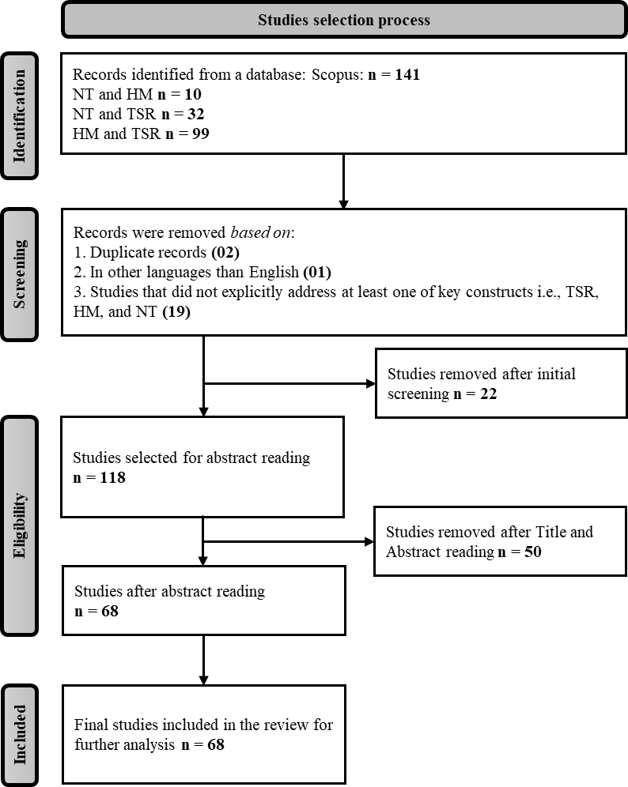
Source: Authors’ work

Table Ia. Research streams and search strings
Research streams | Search strings | Articles
NT and HM¹ | (TITLE-ABS-KEY (“humanistic management*”) OR TITLE-ABS-KEY(“humanistic*”) AND TITLE-ABS-KEY(“need theor*”)) AND (LIMIT-TO (LANGUAGE, “English”)) | 03
NT and TSR² | (TITLE-ABS-KEY (“transformative service*”) OR TITLE-ABS-KEY (“service*”) AND TITLE-ABS-KEY (“need theor*”)) ND (LIMIT-TO (LANGUAGE, “English”)) AND (LIMIT-TO (SUBJAREA, “BUSI”)) | 17
HM and TSR³ | (TITLE-ABS-KEY (“transformative service*”) OR TITLE-ABS-KEY (“service*”) AND TITLE-ABS-KEY (“humanistic management*”) OR TITLE-ABS-KEY (“humanistic*”)) AND (LIMIT-TO (LANGUAGE, “English”)) AND (LIMIT-TO (SUBJAREA “BUSI”)) | 48

¹ NT and HM: Needs Theory and Humanistic Management
² NT and TSR: Needs Theory and Transformative Service Research
³ HM and TSR: Humanistic Management and Transformative Service Research

Source: Authors’ work

Table IIa. Samples of eligible articles in the established body of studies

Articles | Research Stream
Xiaofan et al., 2024  Sacchetti & Tortia, 2022 | NT-HM¹  NT-HM
Acevedo, 2018 | NT-HM
Guo & Ayoun, 2023 | NT-TSR²
Chan et al., 2025 | NT-TSR
Jurie, 2000 | NT-TSR
Huang & Hsu, 2009 | NT-TSR
Kumar et al., 2022 | NT-TSR
Pantouvakis et al., 2023 | NT-TSR
Schepers & Streukens, 2022 | NT-TSR
Mishra & Farooqi, 2021 | NT-TSR
Taujanskaite et al., 2015 | NT-TSR
Hoang et al., 2022 | NT-TSR
Xiulian & Shanhong, 2010 | NT-TSR
Li & Yang, 2012 | NT-TSR
Frattini et al., 2013 | NT-TSR
Nakamura et al., 2006 | NT-TSR
Nakamura et al., 2007 | NT-TSR
Nakamura & Kameoka, 2007 | NT-TSR
Smith, 2010 | NT-TSR
Haldorai et al., 2020 | HM-TSR³
Balakrishnan, 1999 | HM-TSR
Rosenbaum & Massiah, 2011 | HM-TSR
Applbaum, 2011 | HM-TSR
Mattsson, 1997 | HM-TSR
Mumford et al., 2021 | HM-TSR
Kelley, 1989 | HM-TSR
Kabadayi et al., 2023 | HM-TSR
Kelley, 2016 | HM-TSR
Nicolescu et al., 2025 | HM-TSR
Hamid, 2016 | HM-TSR
Harmon et al., 2003 | HM-TSR
Sherry & Fischer, 2008 | HM-TSR
Capulis, 2010 | HM-TSR
Malloch, 2000 | HM-TSR
Collins, 1996 | HM-TSR
Kleiner, 1983 | HM-TSR
Velamoor, 2000 | HM-TSR
Hultsman, 1995 | HM-TSR
Douglas, 2004 | HM-TSR
Koponen & Álamo, 2021 | HM-TSR
Compagni et al., 2023 | HM-TSR
Dierksmeier, 2009 | HM-TSR
Nicolaides, 2018 | HM-TSR
Zhu et al., 2021 | HM-TSR
Kleinman, 1981 | HM-TSR
Grandey et al., 2015 | HM-TSR
Vui-Yee, 2016 | HM-TSR
Simmers et al., 2021 | HM-TSR
Hale et al., 2018 | HM-TSR
Lovins, 2016 | HM-TSR
Chinchilla et al., 2019 | HM-TSR
Coura et al., 2015 | HM-TSR
Kabadayi et al., 2019 | HM-TSR
Amillano et al., 2020 | HM-TSR
Reed, 1997 | HM-TSR
Basheer et al., 2024 | HM-TSR
Mele, 2011 | HM-TSR
Rivera, 2023 | HM-TSR
Waddock, 2016 | HM-TSR
Pirson et al., 2019 | HM-TSR
Fisk, 2019 | HM-TSR
Solnet et al., 2020 | HM-TSR
Deets et al., 2020 | HM-TSR
Simosi, 2012 | HM-TSR
Byrd, 2018 | HM-TSR
Papadopoulos, 2018 | HM-TSR
Macfarlane et al., 2012 | HM-TSR
¹ NT and HM: Needs Theory and Humanistic Management
² NT2 and TSR: Needs Theory and Transformative Service Research
³ HM and TSR: Humanistic Management and Transformative Service Research

Source: Authors’ work

