APPENDIX A.
Detailed initial keyword search strategy with 21 search combinations
BATCH 1:
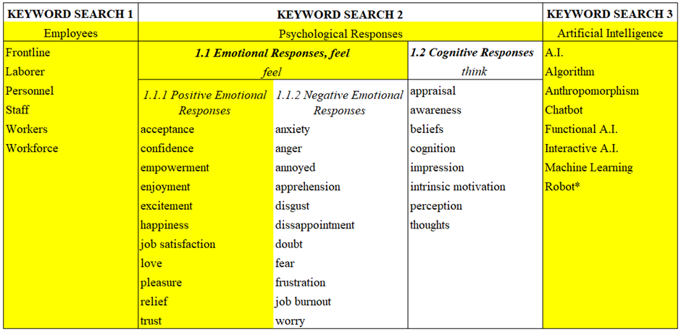
Search 1: Employees & (“psychological response*” OR emotion* OR feel OR accept* OR confiden* OR empower* OR enjoy* OR excite* OR happiness OR “job satisfaction” OR love OR pleasure OR relief OR trust) & (“Artificial Intelligence*” OR AI OR Algorithm OR Anthropomorph* OR Chatbot OR "Machine Learn*" OR Robot*)
Search 2: Frontline & (“psychological response*” OR emotion* OR feel OR accept* OR confiden* OR empower* OR enjoy* OR excite* OR happiness OR “job satisfaction” OR love OR pleasure OR relief OR trust) & (“Artificial Intelligence*” OR AI OR Algorithm OR Anthropomorph* OR Chatbot OR "Machine Learn*" OR Robot*)
Search 3: Labo?rer & (“psychological response*” OR emotion* OR feel OR accept* OR confiden* OR empower* OR enjoy* OR excite* OR happiness OR “job satisfaction” OR love OR pleasure OR relief OR trust) & (“Artificial Intelligence*” OR AI OR Algorithm OR Anthropomorph* OR Chatbot OR "Machine Learn*" OR Robot*)
Search 4: Personnel & (“psychological response*” OR emotion* OR feel OR accept* OR confiden* OR empower* OR enjoy* OR excite* OR happiness OR “job satisfaction” OR love OR pleasure OR relief OR trust) & (“Artificial Intelligence*” OR AI OR Algorithm OR Anthropomorph* OR Chatbot OR "Machine Learn*" OR Robot*)
Search 5: Staff & (“psychological response*” OR emotion* OR feel OR accept* OR confiden* OR empower* OR enjoy* OR excite* OR happiness OR “job satisfaction” OR love OR pleasure OR relief OR trust) & (“Artificial Intelligence*” OR AI OR Algorithm OR Anthropomorph* OR Chatbot OR "Machine Learn*" OR Robot*)
Search 6: Workers & (“psychological response*” OR emotion* OR feel OR accept* OR confiden* OR empower* OR enjoy* OR excite* OR happiness OR “job satisfaction” OR love OR pleasure OR relief OR trust) & (“Artificial Intelligence*” OR AI OR Algorithm OR Anthropomorph* OR Chatbot OR "Machine Learn*" OR Robot*)
Search 7: Workforce & (“psychological response*” OR emotion* OR feel OR accept* OR confiden* OR empower* OR enjoy* OR excite* OR happiness OR “job satisfaction” OR love OR pleasure OR relief OR trust) & (“Artificial Intelligence*” OR AI OR Algorithm OR Anthropomorph* OR Chatbot OR "Machine Learn*" OR Robot*)
BATCH 2:
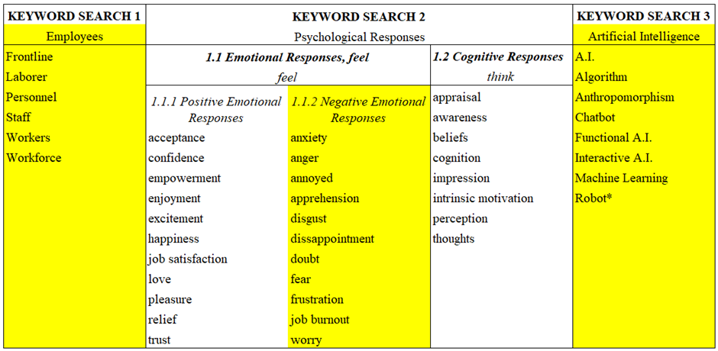
Searches 8- 14: (“psychological response*” OR emotion* OR feel OR accept* OR confiden* OR empower* OR enjoy* OR excite* OR happiness OR “job satisfaction” OR love OR pleasure OR relief OR trust) from Searches 1-7 was replaced with (anxiety OR anger OR annoy* OR apprehens* OR disgust OR disappoint* OR doubt OR fear OR frustrat* OR “job burnout” OR worry)
BATCH 3:
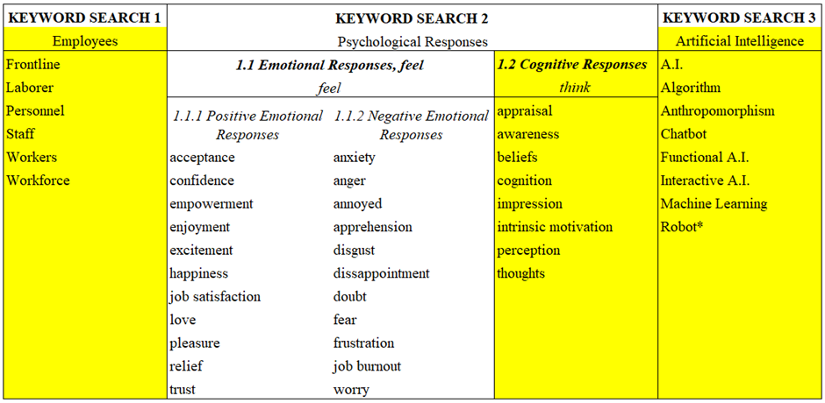
Searches 15-21: (anxiety OR anger OR annoy* OR apprehens* OR disgust OR disappoint* OR doubt OR fear OR frustrat* OR “job burnout” OR worry) from Searches 8-14 was replaced with (“cognitive response*” OR appraisal OR awareness OR beliefs OR cognition OR impression OR “intrinsic motivation” OR perception OR thoughts)

Source: Authors' own work

APPENDIX B.
Articles included in the systematic literature review
 | Citation | Title | Journal | Industry Type | Research method | # of respondents | Key Findings
1 | Abdelhakim et al., 2023 | The fast-food employees' usage intention of robots: A cross-cultural study | Tourism Management Perspectives | tourism & hospitality | survey | 428 | Ease of use, trusted recommendations, and necessary skills influence fast-food employees' intention to use robots, extending research on robotics adoption in hospitality and aiding post-COVID-19 planning.
2 | Abubakar et al., 2019 | Applying artificial intelligence technique to predict knowledge hiding behaviour | International Journal of Information Management | banking sector | survey | 152 | psychological ownership and social interaction, alongside organizational justice, impact knowledge hiding behaviour.
3 | Arias-Pérez & Vélez-Jaramillo, 2022a | Ignoring the three-way interaction of digital orientation, Not-invented-here syndrome, and employee's artificial intelligence awareness in digital innovation performance: A recipe for failure | Technological Forecasting and Social Change | manufacturing and service firms | survey | 79 | High artificial intelligence awareness among employees amplifies the negative effects of the Not-Invented-Here Syndrome, showing its persistence in the digital era with biases in technology assessment and suboptimal usage.
4 | Arias-Pérez & Vélez-Jaramillo, 2022b | Understanding knowledge hiding under technological turbulence caused by artificial intelligence and robotics | Journal of Knowledge Management | variety | survey | 136 | Employee's AI and robotics awareness largely mediates technological turbulence's impact on various forms of knowledge hiding.
5 | Behn et al, 2024 | Employees’ acceptance of AI-based emotion analytics from speech on a group level in virtual meetings | Technology in Society | not stated | survey | 470 | Employees' intention to use Emotion Analytics Software in virtual meetings is primarily influenced by their attitude towards the software and perceived efficacy, with non-adaptive rewards and privacy concerns also playing significant roles.
6 | Bhattacharyya, 2023 | Co-working with robotic and automation technologies: technology anxiety of frontline workers in organisations | Journal of Science and Technology Policy Management | variety | interview | 62 | Frontline employees are generally receptive to working with automation and robotics despite experiencing anxiety primarily due to potential job loss.
7 | Boustani, 2022 | Artificial intelligence impact on banks clients and employees in an Asian developing country | Journal of Asia Business Studies | banking sector | survey | 50 | AI improves banking transactions but may replace technical jobs, yet it cannot surpass human emotional intelligence in client and employee relationships.
8 | Brougham & Haar, 2018 | Smart technology, artificial intelligence, robotics, and algorithms (STARA): Employees’ perceptions of our future workplace | Journal of Management & Organization | several services sector | survey | 120 | Significant STARA awareness relates negatively to organizational commitment and career satisfaction, and relates positively to turnover intentions, cynicism, and depression.
9 | Cao et al., 2021 | Understanding managers’ attitudes and behavioural intentions towards using artificial intelligence for organizational decision-making | Technovation | variety | survey | 269 | An integrated AI acceptance-avoidance model offers a holistic approach to understanding and forecasting managers' attitudes and intentions regarding AI usage.
10 | Cheng et al., 2023 | Challenge or hindrance? How and when organizational artificial intelligence adoption influences employee job crafting | Journal of Business Research | manufacturing | survey | 332 | Organizational AI adoption influences job crafting via locus of control: Internals focus on promotion, externals on prevention.
11 | Chiu et al., 2021 | In the hearts and minds of employees: A model of pre-adoptive appraisal toward artificial intelligence in organizations | International Journal of Information Management | variety | Survey | 363 | Perceptions of AI's capabilities influence attitudes positively, while concerns have a negative impact on affective attitudes alone.
12 | Chowdhury et al., 2022 | AI-employee collaboration and business performance: Integrating knowledge-based view, socio-technical systems, and organizational socialization framework | Journal of business research | creative industry | survey | 164 | Collaborative intelligence will significantly impact business performance through AI skills, job clarity, trust, and dynamic capability.
13 | Dang & Liu, 2022 | Implicit theories of the human mind predict competitive and cooperative responses to AI robots | Computers in Human Behaviour | variety | survey | 303;300 | The malleable theory of the human mind correlated negatively with performance-avoidance goals and positively with mastery goals, predicting corresponding responses to robots.
14 | Ding, L., 2021 | Employees’ challenge-hindrance appraisals toward STARA awareness and competitive productivity: a micro-level case | International Journal of Contemporary Hospitality Management | quick service restaurants | survey | 190 | Restaurant employees' positive views of challenges related to STARA awareness led to increased ICP, with work engagement mediating this relationship.
15 | Do et al., 2023 | Empathetic creativity for frontline employees in the age of service robots: conceptualization and scale development | Journal of Service Management | service industry | literature review; survey | 131 | Advances in AI are pushing frontline workers to enhance empathetic creativity, a critical skill robots can't yet replicate, defined as creatively applying empathetic intelligence in service encounters.
16 | Dutta et al., 2023 | Augmented employee voice and employee engagement using artificial intelligence-enabled chatbots: a field study | International Journal of Human Resource Management | HRM | survey | 431 | AI-enabled chatbots significantly enhance employee engagement by fostering a climate of trust, bridging gaps in engagement across performance and age groups
17 | Garrelfs et al., 2023 | Employee acceptance of disruptive service innovations at the frontline: The role of collective sensemaking processes | Creativity and Innovation Management | service industry | survey | 582 | Frontline employees accept incremental innovations more readily than radical ones, with information exchange within workgroups and organizational entrepreneurial orientation moderating the acceptance of these innovations and the competitive threats posed by new market entrants.
18 | Gkinko & Elbanna, 2022 | Hope, tolerance, and empathy: employees' emotions when using an AI-enabled chatbot in a digitalised workplace | Information Technology & People | financial sector | case study analysis | 41 | Employee perceptions of chatbots were influenced by design, context, and social factors, evoking diverse emotions like connection, thereby promoting sustained usage.
19 | Gkinko & Elbanna, 2023 | Designing trust: The formation of employees’ trust in conversational AI in the digital workplace | Journal of Business Research | variety | interview | 46 | Users' sustained trust in the AI chatbot, fostered by emotional engagement and social cues, enabled continuous usage, facilitating both its development and cognitive trust enhancement.
20 | He et al, 2023a | Linking employees’ challenge-hindrance appraisals toward AI to service performance: the influences of job crafting, job insecurity and AI knowledge. | International Journal of Contemporary Hospitality Management. | hospitality industry | survey | 297 | AI challenge appraisal positively affects service performance through job crafting, while hindrance appraisal negatively affects it via job insecurity, with AI knowledge enhancing these effects.
21 | He et al., 2023b | The Dark Side of Employee Collaboration with Robots: Exploring Its Impact on Self-Esteem Threat and Burnout | International Journal of Human-Computer Interaction | not stated | survey | 271; 335 | Employee collaboration with robots can lead to increased burnout through self-esteem threats, especially when robots are perceived as highly intelligent.
22 | Hornung & Smolnik, 2022 | AI invading the workplace: negative emotions towards the organizational use of personal virtual assistants | Electronic Markets | variety | interview | 45 | Loss and deterrence emotions shape the boundaries of organizational AI use.
23 | Im & Kim, 2022 | A study on hotel employees’ perceptions of the fourth industrial technology | Journal of Hospitality and Tourism Management | hotel industry | interview | 29 | The study found three perceptions on AI among hotel employees: readiness for change, scepticism about replacement, and openness to its benefits.
24 | Kang et al, 2024 | Hospitality labor leakage and dynamic turnover behaviors in the age of artificial intelligence and robotics | Journal of Hospitality and Tourism Technology | hospitality | survey | 259 | AI awareness increases job stress and insecurity, which boosts turnover intentions, especially towards non-hotel companies, while social capital's moderating effect on job insecurity varies across turnover intention dimensions.
25 | Kang et al., 2023 | Smart technology and service employees’ job crafting: Relationship between STARA awareness, performance pressure, receiving and giving help, and job crafting | Journal of Retailing and Consumer Services | several services sector | survey | 301 | High STARA awareness among service employees positively influenced job crafting via performance pressure, particularly accentuated with increased help-receiving levels, while help-giving did not show a mitigating effect.
26 | Kar & Kushwaha, 2021 | Facilitators and Barriers of Artifcial Intelligence Adoption in Business– Insights from Opinions Using Big Data Analytics | Information Systems Frontiers | variety | content analysis | 10,000 tweets | Efficiency, innovation, and novelty drive business owners to invest in AI, yet skepticism about manual involvement and fear of failure may hinder adoption among employees.
27 | Khaliq et al., 2022 | Application of AI and robotics in hospitality sector: A resource gain and resource loss perspective | Technology in Society | hospitality and tourism | questionnaires | 330 | Awareness of AI and robotics positively influences turnover intention, moderated by mutual trust but not competitive psychological climate.
28 | Khoa et al., 2023 | Competition or collaboration for human–robot relationship: a critical reflection on future cobotics in hospitality | International Journal of Contemporary Hospitality Management | hospitality | review paper |  | Enhancing trust in human-robot interaction requires fostering both cognitive and affective trust, achieved through improving robot reliability and functionality, and carefully balancing anthropomorphism to avoid the "uncanny valley" effect.
29 | Kong et al., 2021 | Influences of artificial intelligence (AI) awareness on career competency and job burnout | International Journal of Contemporary Hospitality Management | hospitality industry | survey | 432 | AI awareness positively correlates with job burnout, with organizational commitment mediating its impact on career competencies and burnout.
30 | Koo et al., 2021 | Examining the impact of artificial intelligence on hotel employees through job insecurity perspectives | International Journal of Hospitality Management | hospitality and tourism | surveys; interviews; case study analysis | 11;425 | Perceived job insecurity impacts job engagement and indirectly influences turnover intention via job engagement.
31 | Leung et al., 2023 | Why do hotel frontline employees use service robots in the workplace? A technology affordance theory perspective | International Journal of Hospitality Management | hospitality | surveys | 86; 129; 212; 177 | Hotel frontline employees prefer room service robots (physical affordance) over concierge robots (cognitive affordance) due to higher perceived usefulness and trust, influenced by COVID-19 compliance and cultural values.
32 | Li et al, 2024 | When do employees learn from artificial intelligence? The moderating effects of perceived enjoyment and task-related complexity | Technology in Society | general | survey | 167 | Employees learn more effectively from AI when they frequently use it, enjoy the process, and face complex tasks.
33 | Li et al., 2019 | Hotel employee's artificial intelligence and robotics awareness and its impact on turnover intention: The moderating roles of perceived organizational support and competitive psychological climate | Tourism Management | hospitality industry | survey | 468 | AI and robotics awareness was significantly linked to employee turnover intention, moderated by perceived organizational support and competitive psychological climate.
34 | Li, et al., 2023 | Embracing artificial intelligence (AI) with job crafting: Exploring trickle-down effect and employees’ outcomes | Tourism Management | service industry | survey | 148 | Leader AI crafting boosts employee AI crafting, enhancing engagement and helping, moderated by employee motives.
35 | Liang et al., 2022 | Investigating the double-edged sword effect of AI awareness on employee's service innovative behaviour | Tourism Management | hotel industry | survey | 317 | AI awareness impacts employees by increasing emotional exhaustion, hindering service innovation while also boosting intrinsic motivation, fostering innovative behavior, with future orientation mitigating strain and reinforcing motivation pathways.
36 | Lin et al., 2022 | Employees' perceptions of chatbots in B2B marketing: Affordances vs. disaffordances | Industrial marketing management | B2B marketing; customer service | survey | 228 | Chatbot effectiveness and discomfort impact employee attitudes, with automatability and personalization enhancing effectiveness, especially for different-sized firms, while null decision-making contributes to discomfort, but availability's effect is inconclusive, highlighting implications for theory and practice.
37 | Lingmont & Alexiou, 2020 | The contingent effect of job automating technology awareness on perceived job insecurity: Exploring the moderating role of organizational culture | Technological Forecasting and Social Change | variety | survey | 491 | STARA awareness correlates positively with perceived job insecurity, particularly amplified by an authoritarian organizational culture, while the anticipated moderating influence of retraining expectations was not evidenced.
38 | Loureiro et al., 2023 | Working with AI: can stress bring happiness? | Service Business | tourism and hospitality industry | interview; survey | 9;200 | Incorporating AI in the workplace can generate both stress and positive effects, impacting employee well-being and engagement, with factors such as fear of change, uncertainty, and self-esteem playing significant roles.
39 | Madan and Ashok, 2024 | Making sense of AI benefits: a mixed-method study in Canadian public administration | Information Systems Frontiers | public administration | survey; interview | 272; 38 | Service coercive pressures significantly impact the perceived benefits of AI use in public administration, while consultant pressures indirectly influence these benefits through service coercive pressures, and cognitive constraints and public sector reforms shape the overall context.
40 | Makridis & Han, 2021 | Future of work and employee empowerment and satisfaction: Evidence from a decade of technological change | Technological Forecasting and Social Change | variety | survey | 9671;200 | Technological changes benefit workers under manager moderation, but workers also drive innovation, supported by evidence linking wage increases to technology adoption.
41 | Malik et al., 2021 | Impact of artificial intelligence on employees working in industry 4.0 led organizations | International Journal of Manpower | variety | interviews | 32 | Highlights both the adverse effects, such as information security risks and job insecurity, and the positive impacts, including work flexibility and innovation, of AI adoption, while also identifying contributing factors to technostress among employees.
42 | Mirbabaie et al., 2022 | The rise of artificial intelligence–understanding the AI identity threat at the workplace | Electronic Markets | variety | literature review; survey | 303 | Changes to work, loss of status position, and AI identity significantly predict perceptions of AI identity threat, with experience with AI having no effect on altering this perception.
43 | Motamarri et al., 2020 | Frontline employee empowerment: Scale development and validation using Confirmatory Composite Analysis | International Journal of Information Management | service industry | literature review; interview | 30 | Organizations are grappling with the challenge of technology investments not yielding expected returns, emphasizing the need for senior management to simplify information delivery and cultivate a service analytics culture among frontline employees.
44 | Nam, 2019 | Technology usage, expected job sustainability, and perceived job insecurity | Technological Forecasting and Social Change | variety | survey | 2001 | Employees' current sense of job insecurity correlates strongly with their use of technology and their long-term perspectives on their job and work.
45 | Nguyen et al., 2023 | Chatbots in frontline services and customer experience: An anthropomorphism perspective | Psychology & Marketing | fashion industry | survey | 318 | Combining anthropomorphic language and appearance enhances customer engagement, but lower credibility brands may face skepticism, triggering perceptions of inauthenticity.
46 | Paluch et al, 2022 | “My colleague is a robot”–exploring frontline employees' willingness to work with collaborative service robots | Journal of Service Management | variety | interview | 36 | It reveals the multistage appraisal process of frontline employees interacting with service robots, highlighting key attributes and employee personas shaping their collaboration.
47 | Park et al, 2024 | Attitudes towards artificial intelligence at work: Scale development and validation | Journal of Occupational and Organizational Psychology | not stated | survey | 830 | Workers' attitudes towards AI significantly influence recruiting outcomes, with personal utility showing the strongest moderating effect, whereas job insecurity did not demonstrate meaningful moderation despite prior concerns, suggesting a focus on mitigating negative AI attitudes for improved recruitment results.
48 | Parvez et al., 2022 | Employees’ perception of robots and robot-induced unemployment in hospitality industry under COVID-19 pandemic. | International Journal of Hospitality Management | tourism and hospitality industry | survey | 405 | Perception of robots' social skills impacts service employees' view on robot-induced unemployment.
49 | Pillai et al., 2023 | Adoption of artificial intelligence (AI) based employee experience (EEX) chatbots | Information Technology & People | IT and e-commerce | survey | 1,130 | Employee attitudes and intentions to adopt EEX chatbots are strongly influenced by personalized, interactive, and intelligent features, confirming several hypotheses on the positive impact of these attributes.
50 | Prentice et al., 2020 | Emotional intelligence or artificial intelligence–an employee perspective | Journal of Hospitality Marketing & Management | hospitality and tourism | surveys | not stated | Emotional intelligence has a significant effect to employee retention and performance, while AI moderates employee performance.
51 | Prentice et al., 2023 | Artificial intelligence as a boundary-crossing object for employee engagement and performance | Journal of Retailing and Consumer Services | variety | survey | 219 | AI performance significantly impacted job engagement, employee service performance, and job performance appraisal, with job engagement and service performance acting as significant mediators, while job security moderated their effects.
52 | Presbitero & Teng-Calleja, 2023 | Job attitudes and career behaviours relating to employees' perceived incorporation of artificial intelligence in the workplace: a career self-management perspective | Personnel Review | call center industry | survey | 345 | Perceptions of AI job takeover correlate with increased career exploration, with job insecurity and psychological distress serving as explanatory pathways.
53 | Qiu et al., 2022 | The impact of AI-enabled service attributes on service hospitableness: the role of employee physical and psychological workload | International Journal of Contemporary Hospitality Management | hospitality and tourism | interviews; surveys | 11 interviewee and 7 academic experts;342 FLE and 69 supervisors | Anthropomorphic, entertainment, functional, and information attributes explain AI-enabled service well, enhancing FLEs and service hospitableness, while psychological job demand moderates physical fatigue effects.
54 | Sattu et al, 2024 | Should I adopt AI during talent acquisition? Evidence from HR professionals of Indian IT organisations | Journal of Organizational Effectiveness: People and Performance | Human resource management | survey | 198 | AI adoption in talent acquisition is driven by its cost-effectiveness, ability to enhance recruitment efficiency, perceived benefits outweighing sacrifices, and the critical role of HR readiness, while addressing concerns about trust, security, and innovation resistance.
55 | Saxena & Mishra, 2023 | Artificial intelligence: the way ahead for employee engagement in corporate India | Global Knowledge, Memory and Communication | human resource management | interviews | 20 | Participants identified various challenges in implementing AI for employee engagement, including cost, mindset, demographics, technology comfort, organizational size, change management, and software vendor support.
56 | Shamim et al., 2023 | Mechanisms of cognitive trust development in artificial intelligence among front line employees: An empirical examination from a developing economy | Journal of Business Research | variety | survey | 314 | Positive AI features enhance employee cognitive trust, while disruptions in work routines diminish it; effective data governance fosters trust in both data governance and AI.
57 | Song et al, 2024 | Driverless metros are coming, but what about the drivers? A study on AI-related anxiety and safety performance | Safety science | transportation | survey | 364 | AI-related anxiety among metro drivers negatively impacts safety performance through job insecurity, thriving at work, and perceptions of HR system strength.
58 | Song et al., 2022 | Dancing with service robots: The impacts of employee-robot collaboration on hotel employees’ job crafting | International Journal of Hospitality Management | hospitality | survey | 407 | Perceived risk and playfulness drive employees' effort and performance, with risk having the strongest influence on effort, while both expectancy factors impact job crafting.
59 | Suseno et al., 2022 | Beliefs, anxiety and change readiness for artificial intelligence adoption among human resource managers: the moderating role of high-performance work systems | The International Journal of Human Resource Management | human resource management | survey | 417 | HR managers' AI attitudes and anxiety significantly shape their readiness for AI adoption, with positive beliefs facilitating readiness and anxiety impeding it.
60 | Tojib et al., 2023 | How does service robot anthropomorphism affect human co-workers? | Journal of Service Management | service industry | survey | 274 | Service robot anthropomorphism significantly affects human employees' perceptions and adaptation in the digitized workplace, with perceived job-security threat as a key mediating factor influenced by robot AI type and competence, highlighting nuanced responses beyond mere anthropomorphic attributes.
61 | Tong et al., 2021 | The Janus face of artificial intelligence feedback: Deployment versus disclosure effects on employee performance | Strategic Management Journal | call centre industry | experiment | 265 | AI feedback boosts job performance by 12.9% compared to human feedback, offering deeper insights, yet disclosure of AI feedback leads to a 5.4% performance decrease due to trust issues and job displacement concerns, particularly mitigated by longer tenure.
62 | Vasiljeva et al., 2021 | Artificial Intelligence: The Attitude of the Public and Representatives of Various Industries | Journal of Risk and Financial Management | variety | interview; survey | 13; 409 | Attitudes toward AI vary by industry, influenced by management, competition, and regulations.
63 | Vatan & Dogan, 2021 | What do hotel employees think about service robots? A qualitative study in Turkey | Tourism Management Perspectives | hospitality | interviews | 40 | Hotel employees have mixed feelings about service robots, recognizing potential benefits but also fearing negative impacts like communication problems and increased unemployment.
64 | Verma & Singh, 2022a | Impact of artificial intelligence-enabled job characteristics and perceived substitution crisis on innovative work behaviour of employees from high-tech firms | Computers in Human Behaviour | high-tech sector | survey | 486 | AI-enabled task and knowledge characteristics significantly influence innovative work behaviour, particularly under varying perceptions of substitution crisis.
65 | Verma & Singh, 2022b | The Employees Intention to Work in Artificial Intelligence-Based Hybrid Environments | IEEE Transactions on Engineering Management | variety | survey | 596 | Future human-cobot collaboration must balance cobot benefits with human skills and expertise.
66 | Vorobeva et al., 2022 | Thinking skills don’t protect service workers from replacement by Artificial Intelligence | Journal of Service Research | service industry | content analysis; surveys (3) | 18,869 tweets;680;242;331 | Five studies suggest that AI presence negatively impacts employees' performance in cognitive tasks, affecting their perceived performance, particularly when compared to AI.
67 | Wang et al., 2021 | Accelerating AI adoption with responsible AI signals and employee engagement mechanisms in health care | Information Systems Frontiers | healthcare sector | surveys | 404 | The adherence to autonomy, beneficence, explainability, justice, and non-maleficence in AI for employees boosts engagement and fosters positive attitudes, satisfaction, and intentions for technology use.
68 | Wang et al., 2023 | Robot anthropomorphism and job insecurity: The role of social comparison | Journal of Business Research | variety | survey | 141; 76; 187; 100 | Anthropomorphized robots increase job insecurity among employees by triggering social comparison, a finding consistent across multiple studies involving diverse work environments.
69 | Wijayati et al., 2022 | A study of artificial intelligence on employee performance and work engagement: the moderating role of change leadership | International Journal of Manpower | services and banking industry | surveys | 254 | AI significantly boosts employee performance and work engagement, with positive leadership amplifying its impact.
70 | Willems et al., 2023 | Frontline employee expectations on working with physical robots in retailing | Journal of Service Management | retail | interview; survey | 32; 165 | Mixed expectations among retail frontline employees (FLEs) on robots' impact, with many foreseeing no net change in job engagement and well-being, yet those anticipating effects lean towards negative impacts.
71 | You et al., 2018 | Enhancing perceived safety in human–robot collaborative construction using immersive virtual environments | Automation in Construction | construction | experiment | 30 | Separation of work areas between robots and humans enhances perceived safety, fostering team identification and trust in the robot, consequently increasing willingness for future collaboration.
72 | Zhang and Jin, 2023 | How does smart technology, artificial intelligence, automation, robotics, and algorithms (STAARA) awareness affect hotel employees’ career perceptions? A disruptive innovation theory perspective | Journal of Hospitality Marketing & Management | hotel industry | survey | 100;181 | Negative awareness of STAARA among hotel employees increases job insecurity and mobility, particularly for those with low-level career progression, but not for those with high-level career progression.
73 | Zhao et al., 2023 | That honey, my arsenic: The influence of advanced technologies on service employees’ organizational deviance. | Journal of Retailing and Consumer Services | variety | survey | 447 | STARA awareness influenced breach of psychological contracts, leading to deviant behaviour, mitigated by the industrial relations climate.
74 | Zhu and Kanjanamekanant, 2023 | Human–bot co-working: job outcomes and employee responses | Industrial Management & Data Systems | various | survey | 128 | RPA deployment breadth and depth differently impact work intensification, with job autonomy mitigating burnout and both job autonomy and perceived RPA performance boosting continued RPA usage intentions.
75 | Zhu et al., 2020 | Understanding employees’ responses to artificial intelligence | Organizational Dynamics | variety | survey | 363 | AI's business potential hinges on addressing employee perceptions and concerns to ensure successful integration.
76 | Zirar et al., 2023 | Worker and workplace Artificial Intelligence (AI) coexistence: Emerging themes and research agenda | Technovation | not stated | literature review |  | workers' trust in workplace AI depends on addressing existential fears of job displacement through continuous reskilling and upskilling, transparent AI adoption strategies, and policy interventions promoting a symbiotic relationship between AI and human skills.
As of 16 Dec 2024
Source: Authors' own work

APPENDIX C.
Year-wise growth of FLE psychological responses to AI integration in service delivery research
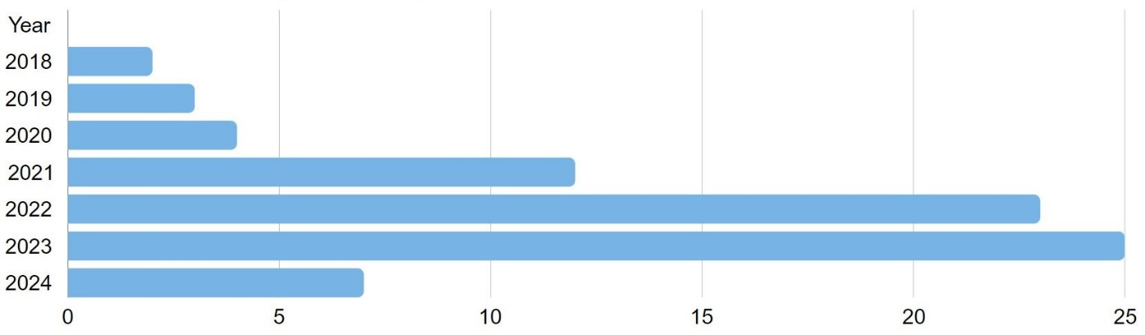

APPENDIX D.
Journals and number of publications
 | Journal | Categories | # | Articles | Journal Citation Indicator (JCI) | ABDC ranking
1 | International Journal of Contemporary Hospitality Management | Hospitality, Leisure, Sport & Tourism | Management | 5 | Ding, L., 2021; Kong et al., 2021; Qiu et al., 2022; He et al, 2023b; Khoa et al., 2023 | 2.11 | A
2 | Journal of Business Research | Business | 5 | Chowdhury et al., 2022; Gkinko & Elbanna, 2023; Shamim et al., 2023; Cheng et al., 2023; Wang et al., 2023 | 2.32 | A
3 | Tourism Management | Environmental Studies | Hospitality, Leisure, Sport & Tourism | Management | 5 | Li et al., 2019; Vatan & Dogan, 2021; Liang et al., 2022; Abdelhakim et al., 2023; Li, et al., 2023 | 3.05 | A
4 | International Journal of Hospitality Management | Hospitality, Leisure, Sport & Tourism | 4 | Koo et al., 2021; Parvez et al., 2022; Song et al., 2022; Leung et al., 2023 | 2.97 | A*
5 | Journal of Service Management | Management | 4 | Paluch et al, 2022; Do et al., 2023; Tojib et al., 2023; Willems et al., 2023 | 2.12 | A
6 | Technological Forecasting and Social Change | Business | Regional & Urban Planning | 4 | Nam, 2019; Lingmont & Alexiou, 2020; Makridis & Han, 2021; Arias-Pérez & Vélez-Jaramillo, 2022b | 2.47 | A
7 | Information Systems Frontiers | Categories:  Computer Science, Information Systems | Computer Science, Theory & Methods | 3 | Kar & Kushwaha, 2021; Wang et al., 2021; Madan & Ashok, 2024 | 1.47 | A
8 | International Journal of Information Management | Information Science & Library Science | 3 | Abubakar et al., 2019; Motamarri et al., 2020; Chiu et al., 2021 | 5.72 | A*
9 | Journal of Retailing and Consumer Services | Business | 3 | Kang et al., 2023; Prentice et al., 2023; Zhao et al., 2023 | 2.19 | A
10 | Technology in Society | Social Issues | Social Sciences, Interdisciplinary | 3 | Khaliq et al., 2022; Behn et al, 2024; Li et al, 2024 | 3.84 | C
11 | Computers in Human Behaviour | Psychology, Multidisciplinary | Psychology, Experimental | 2 | Verma & Singh, 2022a; Dang & Liu, 2022 | 2.81 | B
12 | Electronic Markets | Business | Management | 2 | Hornung & Smolnik, 2022; Mirbabaie et al., 2022 | 1.52 | A
13 | Information Technology & People | Information Science & Library Science | 2 | Gkinko & Elbanna, 2022; Pillai et al., 2023 | 1.28 | A
14 | International Journal of Human Resource Management | Management | 2 | Suseno et al., 2022; Dutta et al., 2023 | 1.30 | A
15 | International Journal of Manpower | Management | Industrial Relations & Labor | 2 | Malik et al., 2021; Wijayati et al., 2022 | 1.17 | A
16 | Journal of Hospitality Marketing & Management | Business | Hospitality, Leisure, Sport & Tourism | Management | 2 | Prentice et al., 2020; Zhang & Jin, 2023 | 1.95 | A
17 | Technovation | Engineering, Industrial | Operations Research & Management Science | Management | 2 | Cao et al., 2021; Zirar et al., 2023 | 2.13 | A
18 | Automation in Construction | Construction & Building Technology | Engineering, Civil | 1 | You et al., 2018 | 1.99 | A*
19 | Creativity and Innovation Management | Management | 1 | Garrelfs et al., 2023 | 0.78 | C
20 | Global Knowledge, Memory and Communication | Information Science & Library Science | 1 | Saxena & Mishra, 2023 | 0.44 | B
21 | IEEE Transactions on Engineering Management | Engineering, Industrial | Business | Management | 1 | Verma & Singh, 2022b | 1.17 | A
22 | Industrial Management & Data Systems | Computer Science, Interdisciplinary Applications | Engineering, Industrial | 1 | Zhu & Kanjanamekanant, 2023 | 0.84 | A
23 | Industrial Marketing Management | Business | Management | 1 | Lin et al., 2022 | 1.92 | A*
24 | International Journal of Human-Computer Interaction | Computer Science, Cybernetics | Ergonomics | 1 | He et al., 2023a | 0.82 | B
25 | Journal of Asia Business Studies | Business | 1 | Boustani, 2022 | 0.60 | C
26 | Journal of Hospitality and Tourism Management | Hospitality, Leisure, Sport & Tourism | Management | 1 | Im & Kim, 2022 | 1.89 | A
27 | Journal of Hospitality and Tourism Technology | Hospitality, Leisure, Sport & Tourism | 1 | Kang et al, 2024 | 1.01 | B
28 | Journal of Knowledge Management | Information Science & Library Science | Management | 1 | Arias-Pérez & Vélez-Jaramillo, 2022a | 1.97 | C
29 | Journal of Management & Organization | Management | 1 | Brougham & Haar, 2018 | 0.94 | B
30 | Journal of Occupational and Organizational Psychology | Psychology, Applied | Management | 1 | Park et al, 2024 | 1.35 | A
31 | Journal of Organizational Effectiveness: People and Performance | Management | 1 | Sattu et al, 2024 | 0.83 | B
32 | Journal of Risk and Financial Management | Risk and Financial Management | 1 | Vasiljeva et al., 2021 | N/A | B
33 | Journal of Science and Technology Policy Management | Management | 1 | Bhattacharyya, 2023 | 0.57 | C
34 | Journal of Service Research | Business | 1 | Vorobeva et al., 2022 | 1.87 | A*
35 | Organizational Dynamics | Business | Psychology, Applied | Management | 1 | Zhu et al., 2020 | 0.47 | A
36 | Personnel Review | Industrial Relations & Labor | Psychology, Applied | Management | 1 | Presbitero & Teng-Calleja, 2023 | 1.07 | A
37 | Psychology & Marketing | Business | Psychology, Applied | 1 | Nguyen et al., 2023 | 1.45 | A
38 | Safety science | Engineering, Industrial | Operations Research & Management Science | 1 | Song et al, 2024 | 1.10 | A
39 | Service Business | Business | Management | 1 | Loureiro et al., 2023 | 1.08 | B
40 | Strategic Management Journal | Business | Management | 1 | Tong et al., 2021 | 1.66 | A*
As of 16 Jun 2024

APPENDIX E.
Ten most cited studies
 | Study | Journal | Citations* | Average citations per year **
1 | Brougham & Haar, 2018 | Journal of Management & Organization | 665 | 110.83
2 | Li et al., 2019 | Tourism Management | 532 | 106.4
3 | Prentice et al., 2020 | Journal of Hospitality Marketing & Management | 289 | 72.25
4 | Cao et al., 2021 | Technovation | 277 | 92.33
5 | Nam, 2019 | Technological Forecasting and Social Change | 224 | 44.8
6 | Abubakar et al., 2019 | International Journal of Information Management | 222 | 44.4
7 | Malik et al., 2022 | International Journal of Manpower | 203 | 67.67
8 | Tong et al., 2021 | Strategic Management Journal | 192 | 64
9 | You et al., 2018 | Automation in Construction | 163 | 27.17
10 | Kong et al., 2021 | International Journal of Contemporary Hospitality Management | 136 | 45.33
*Based on Google Scholar (as of 16 Jun 2024).
**Total number of citations divided by number of years after article publication

APPENDIX F.
Countries and number of publications
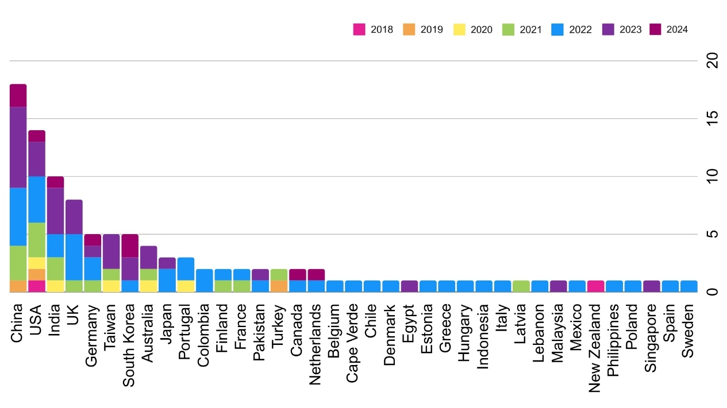

APPENDIX G.
Research methods and sample type
Research methods | # | SAMPLE TYPES
Research methods | # | Presently using AI | Foreseeing AI | Both
case study analysis | 2 | Gkinko and Elbanna, 2023 | Koo et al., 2023
content analysis | 3 | Kar and Kushwaha, 2023; Khoa et al., 2023 |  | Vorobeva et al., 2022
experiment | 2 | You et al., 2018; Tong et al., 2021
interview | 15 | Motamarri et al., 2021; Vasiljeva et al., 2021; Qiu et al., 2022; Gkinko and Elbanna, 2023; Saxena and Mishra, 2025; Bhattacharyya, 2023; Willems et al., 2023; Madan & Ashok, 2024 | Malik et al., 2022; Hornung and Smolnik, 2022; Im and Kim, 2022; Koo et al., 2022; | Vatan and Dogan, 2021; Paluch et al., 2022; Loureiro et al., 2023
literature review | 4 | Motamarri et al., 2020; Do et al., 2023; Zirar et al., 2023 | Mirbabaie et al., 2022
survey | 61 | Abubakar et al., 2019; Li et al., 2019; Lingmont and Alexiou, 2020; Prentice et al., 2020; Cao et al., 2021; Ding, L., 2021; Makridis and Han, 2021; Wang et al., 2021; Arias-Pérez and Vélez-Jaramillo, 2022a; Arias-Pérez and Vélez-Jaramillo, 2022b; Boustani, 2022; Chowdhury et al., 2022; Khaliq et al., 2022; Lin et al., 2022; Vasiljeva et al., 2022; Verma and Singh, 2022a; Verma and Singh, 2022b; Wijayati et al., 2022; He et al., 2024; Kang et al., 2023; Prentice et al., 2023; Qiu et al., 2023; Shamim et al., 2023; Zhao et al., 2023; Willems et al., 2023; Do et al., 2023; Garrelfs and Luengen, 2023; Zhu and Kanjanamekanant, 2023; Pillai et al., 2024; Leung et al., 2023; Dutta et al., 2023; He et al., 2025; Cheng et al., 2023; Wang et al., 2023; Park et al, 2024; Sattu et al, 2024; Tojib et al., 2023; Nguyen et al., 2023; Li, et al., 2023; Behn et al, 2024; Kang et al, 2024; Li et al, 2024; Madan & Ashok, 2024; Song et al, 2024 | Zhu et al., 2021; Chiu et al., 2021; Kong et al., 2021; Koo et al., 2021; Dang and Liu, 2022; Liang et al., 2022; Mirbabaie et al., 2022; Song et al., 2022; Suseno et al., 2022; Abdelhakim et al., 2023; Presbitero and Teng-Calleja, 2023; Zhang and Jin, 2023; | Brougham and Haar, 2018; Nam, 2019; Parvez et al., 2022; Loureiro et al., 2023; Vorobeva et al., 2023
# represents number of publications.

APPENDIX H.
Organization-related attributes as moderator

1. Leadership. Effective leadership is the cornerstone for fostering commitment and mitigating resistance during AI integration (Wijayati et al., 2022). When leaders emphasize how AI can enhance job performance and career growth opportunities, FLE are more likely to experience achievement and challenge emotions (Hornung and Smolnik, 2022). By articulating AI's benefits for career growth, leaders can shape FLE perceptions and enhance their engagement and adaptability.
2. Transparency. A lack of AI transparency can diminish cognitive trust, making it challenging for FLE to feel in control when following AI-generated recommendations (Shamim et al., 2023). Organizations that prioritize transparent communication about AI capabilities, limitations, and decision-making processes foster cognitive trust and reduce fear of misuse or job displacement. (Presbitero and Teng-Calleja, 2023). For example, clearly explaining the rationale behind AI integration helps FLE perceive AI as a tool to complement their roles rather than as a threat, creating a more confident and cooperative workforce.
3. Organizational culture. Organizational culture is a lens through which FLE interprets AI integration (Lingmont and Alexiou, 2020). Innovative cultures, which emphasize adaptability and technological progress, encourage FLE to view AI as an asset, reducing negative emotions (Abubakar et al., 2019). Conversely, risk-averse or rigid cultures often exacerbate resistance to AI (Vasiljeva et al., 2021). Establishing a supportive, collaborative culture that aligns organizational goals with FLE characteristics and roles is essential to mitigate resistance and enhance engagement during technological transitions (Abdelhakim et al., 2023).
4. Industrial relations climate. A positive industrial relations climate can buffer against potential disruptions caused by AI integration. When trade unions and organizations maintain harmonious relations, FLE are more likely to feel secure and supported, mitigating resistance to change (Zhao et al., 2023). Conversely, adversarial relationships can heighten fears regarding job security and undermine trust, thereby exacerbating negative psychological responses to AI deployment (Khoa et al., 2023).
5. Competitive psychological climate. The perception of internal competition within organizations can shape FLE attitudes toward AI. A healthy, competitive psychological climate motivates FLE to embrace AI as a tool to enhance their performance relative to their peers (Li et al., 2019). Organizations prioritize competitiveness in their markets because internal competition enhances efficiency, product quality, and service excellence while also reducing operational costs (Khaliq et al., 2022). However, excessive competitiveness may lead to stress and reduce collaboration (Dang and Liu, 2022).
6. Perceived organizational support. It emphasizes organizational incentives and robust support to motivate FLE across all levels, fostering a more productive mindset, and cultivating a successful work environment (Garrelfs and Luengen, 2023). Organizations that invest in FLE well-being, provide training, and offer incentives foster a sense of mutual commitment, reducing stress and resistance (Bhattacharyya, 2023). This enhances FLE engagement and strengthens their confidence in leveraging AI for improved service delivery.
7. FLE engagement. Engaged FLE exhibit higher levels of enthusiasm, dedication, and productivity, which are essential for maximizing the AI potential in service delivery contexts (Prentice et al., 2023). Research indicates that under similar trust levels, high and moderate performers exhibit comparable engagement levels (Dutta et al., 2023). Organizational efforts aimed at enhancing engagement, such as recognition, career development opportunities, and well-structured support systems, can significantly reduce turnover intention and improve AI adoption (Wang et al., 2023).

