SUPPLEMENTARY FILES
Appendix A. Measurement items of the constructs
Item | M | SD | V | S | K | L
ABS Usage Frequency
How often do you rent e-scooters? (Daily; Few times a week; Few times a month; Few times a year)
ABS Compatibility (adapted from Hazée et al., 2017) *
Renting e-scooters fits my lifestyle. | 3.62 | 1.868 | 3.491 | 0.314 | $\text{-}$0.943 | 0.912
Renting e-scooters fits my social activities. | 3.96 | 1.886 | 3.558 | 0.080 | $\text{-}$1.067 | 0.920
Renting e-scooters fits my travel patterns. | 3.73 | 1.846 | 3.406 | 0.277 | $\text{-}$0.956 | 0.876
ABS Loyalty (adapted from Bloemer et al., 1999) *
I would recommend renting e-scooters to other people. | 4.61 | 1.669 | 2.785 | $\text{-}$0.390 | $\text{-}$0.510 | 0.926
I will continue renting e-scooters in the future even if the price is raised a little. | 3.02 | 1.581 | 2.501 | 0.562 | $\text{-}$0.252 | 0.853
Attitude toward Ownership (based on Hawlitschek et al., 2016; Schaefers et al., 2016b) *
Owning an e-scooter rather than renting one would make me more independent. | 3.86 | 2.049 | 4.197 | 0.021 | $\text{-}$1.225 | 0.756
Owning an e-scooter would be hassle free in comparison to renting one. | 3.70 | 2.076 | 4.309 | 0.207 | $\text{-}$1.237 | 0.822
Owning an e-scooter would be a better economic option than renting one. | 4.26 | 2.043 | 4.174 | $\text{-}$0.186 | $\text{-}$1.142 | 0.736
Owning an e-scooter would be more reliable than renting one. | 4.57 | 1.825 | 3.332 | $\text{-}$0.279 | $\text{-}$0.856 | 0.755
Product Purchase Intention (adapted from Chen et al., 2021) *
I can consider buying an e-scooter in the future. | 2.97 | 1.820 | 3.314 | 0.542 | $\text{-}$0.815 | 0.912
I will try to buy an e-scooter in the future. | 2.34 | 1.488 | 2.215 | 1.032 | 0.363 | 0.950
I plan to buy an e-scooter in the future. | 1.97 | 1.366 | 1.866 | 1.485 | 1.696 | 0.882
Satisfaction (adapted from Gustafsson et al., 2005; Fornell et al., 1996) *
I am satisfied with renting e-scooters. | 4.93 | 1.413 | 1.997 | −0.370 | −0.300 | 0.867
I am satisfied with using e-scooters. | 5.03 | 1.419 | 2.013 | −0.525 | 0.042 | 0.846
I am satisfied with the e-scooter companies I have used. | 5.02 | 1.352 | 1.827 | −0.421 | −0.048 | 0.854
My experience with renting e-scooters has fulfilled my expectations. | 5.13 | 1.337 | 1.787 | −0.428 | −0.082 | 0.873
Note: N=430 (no missing values). M=Mean; SD=standard deviation; V=variance; S=skewness; K=kurtosis; L=outer loading. *Items measured on a seven-point Likert scale ranging from 1 (strongly disagree) to 7 (strongly agree).
Source: The above table was created by the authors

Appendix B. Heterotrait–monotrait (HTMT) ratio
 | ABS_LOY | ABS_COMP | USG_FRQ | ATT_OWN | PURC_INT | SAT
ABS_LOY |  | .584–.742 | .336–.516 | .062–.202 | .147–.365 | .596–.834
ABS_COMP | .669 |  | .438–.594 | .063–.160 | .132–.325 | .412–.587
USG_FRQ | .428 | .521 |  | .050–.159 | .124–.320 | .162–.320
ATT_OWN | .134 | .117 | .102 |  | .412–.591 | .049–.136
PURC_INT | .260 | .229 | .223 | .504 |  | .042–.174
SAT | .669 | .504 | .243 | .103 | .097
Note: The HTMT values are given below the diagonal. The bias-corrected confidence intervals [2.5%–97.5%] are provided above the diagonal and were estimated using the bootstrapping procedure (10,000 samples).
Source: The above table was created by the authors

Appendix C. Inner variance inflation factor (VIF) values
 | Inner VIF
ATT_OWN → PURC_INT | 1.022
ATT_OWN x USG_FRQ → PURC_INT | 1.010
ABS_LOY → PURC_INT | 1.198
ABS _LOY → USG_FRQ | 1.510
ABS_COMP → USG_FRQ | 1.511
ABS_COMP x ABS_LOY → USG_FRQ | 1.043
USG_FRQ → PURC_INT | 1.218
sat (control) → ABS_LOY | 1.000
age (control) → PURC_INT | 1.072
gender (control) → PURC_INT | 1.044
income (control) → PURC_INT | 1.083
Note: The VIF values, obtained from the PLS algorithm, are all well below 3. Therefore, there are no multicollinearity issues to consider, and the model is not contaminated by common method variance.
Source: The above table was created by the authors

Appendix D. Assessment of endogeneity using the Gaussian Copula (GC) approach
 | 𝛽 | p
Regression model:
ABS Loyalty → Usage Frequency | .335 | .018
ABS Compatibility → Usage Frequency | .039 | .848
ABS Compatibility × ABS Loyalty → Purchase Intention | .116 | .009
ABS Loyalty → Purchase Intention | .098 | .296
Usage Frequency → Purchase Intention | .260 | .050
Attitude to. Ownership → Purchase Intention | .365 | .069
Attitude to. Ownership × Usage Frequency → Purchase Intention | .084 | .042
Satisfaction → ABS Loyalty | .831 | <.001
Age → Purchase Intention | –.028 | .552
Gender → Purchase Intention | –.126 | .008
Income → Purchase Intention | .002 | .974
Gaussian copula terms:
GC (ATT_OWN → PURC_INT) → PURC_INT | .080 | .692
GC (SAT → ABS_LOY) → SERV_LOY | –.175 | .129
GC (ABS_LOY → PURC_INT) → PURC_INT | .050 | .310
GC (ABS_LOY → USG_FRQ) → USG_FRQ | .023 | .707
GC (ABS_COMP → USG_FRQ) → USG_FRQ | .297 | .056
GC (USG_FRQ → PURC_INT) → PURC_INT | –.074 | .256
Source: The above table was created by the authors

Appendix E. Assessment of unobserved heterogeneity using the FIMIX-PLS approach
Fit indices for the one- to six-segment solutions
 | No. of segments
Criteria | 1 | 2 | 3 | 4 | 5 | 6
AIC | 3174.233 | 2901.846 | 1837.283 | 1790.038 | 1738.936 | 1729.898
AIC3 | 3188.233 | 2930.846 | 1875.283 | 1841.038 | 1802.936 | 1806.898
AIC4 | 3202.233 | 2959.846 | 1913.283 | 1892.038 | 1866.936 | 1883.898
BIC | 3231.126 | 3019.696 | 1991.707 | 1997.291 | 1999.018 | 2042.809
CAIC | 3245.126 | 3048.696 | 2029.707 | 2048.291 | 2063.018 | 2119.809
HQ | 3196.698 | 2948.381 | 1898.261 | 1871.876 | 1841.634 | 1853.457
MDL5 | 3570.698 | 3723.095 | 2913.403 | 3234.303 | 3551.347 | 3910.455
LnL | -1573.117 | -1421.923 | -880.642 | -844.019 | -805.468 | -787.949
EN | n/a | 0.936 | 0.763 | 0.801 | 0.847 | 0.858
NFI | n/a | 0.953 | 0.775 | 0.786 | 0.82 | 0.819
NEC | n/a | 27.517 | 102.095 | 85.585 | 65.802 | 60.954
Note: AIC=Akaike’s information criterion; AIC3=modified AIC with factor 3; AIC4=modified AIC with factor 4; BIC=Bayesian information criteria; CAIC=consistent AIC; HQ=Hannan-Quinn criterion; MDL5=minimum description length with factor 5; LnL=log likelihood; EN=entropy statistic; NFI=non-fuzzy index; NEC=normalized entropy criterion; n/a=not available; numbers in bold indicate the best outcome per segment retention criterion.
Source: The above table was created by the authors

Relative segment sizes
No. of segments | Segment 1 | Segment 2 | Segment 3 | Segment 4 | Segment 5 | Segment 6
2 | 82.82% | 17.18%
3 | 65.31% | 22.29% | 12.40%
4 | 60.73% | 22.01% | 10.75% | 6.51%
5 | 57.80% | 22.18% | 7.89% | 7.47% | 4.66%
6 | 55.73% | 21.58% | 7.27% | 6.21% | 5.30% | 3.90%
Source: The above table was created by the authors
Appendix F. Predictive relevance analysis of Product Purchase Intention
Distribution of prediction errors
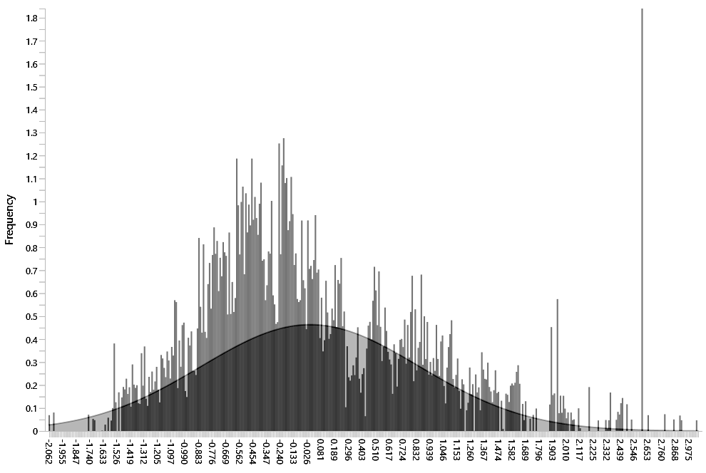
Prediction errors
 | Q²_{predict} | PLS RMSE | LM RMSE | PLS  MAE | LM  MAE
I can consider buying an e-scooter in the future. | 0.278 | 1.538 | 1.542 | 1.283 | 1.250
I will try to buy an e-scooter in the future. | 0.163 | 1.357 | 1.362 | 1.064 | 1.070
I plan to buy an e-scooter in the future. | 0.086 | 1.293 | 1.301 | 0.976 | 0.985
Note: Compared to the linear regression model (LM) scores, the PLS-SEM scores yielded lower prediction errors in terms of the root mean squared error (RMSE)—as well as the mean absolute error (MAE), which is considered a more relaxed measure for two of the three indicators. Therefore, the model can be said to have high predictive power.
Source: The above figure was created by the authors

Appendix G. Moderating effect of ABS Compatibility

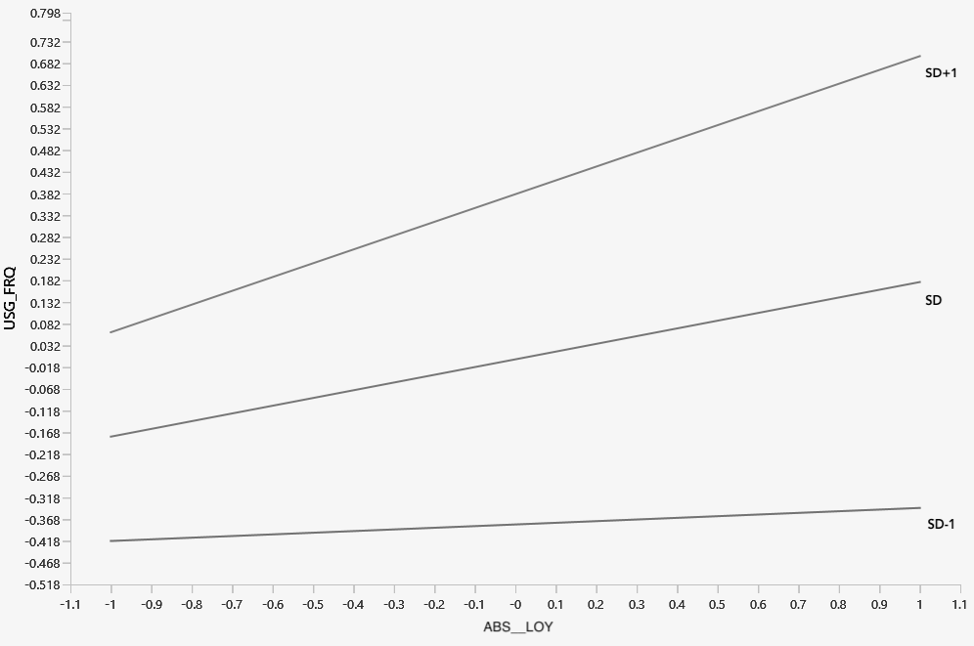
Source: The above figure was created by the authors

Appendix H. Moderating effect of Attitude toward Ownership

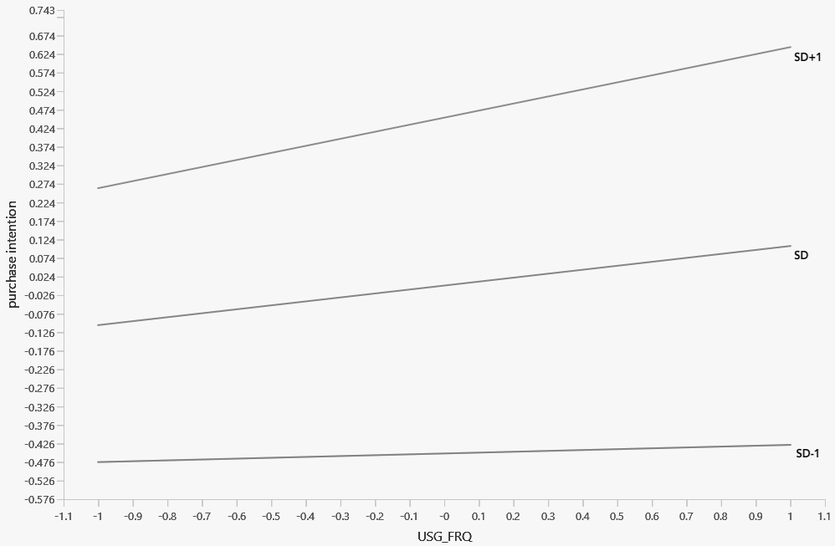Source: The above figure was created by the authors

Appendix I. Total effects
 | ABS_LOY | ABS_COMP | USG_FRQ | ATT_OWN | PUR_INT | SAT
ABS_LOY |  |  | .073–.275 |  | .133–.312 | .573–.690
ABS_COMP |  |  | .282–.476 |  | .004–.087
USG_FRQ | .178 | .380 |  |  | .009–.203 | .045–.178
ATT_OWN |  |  |  |  | .377–.519
PURC_INT | .225 | .041 | .107 | .453 |  | .084–.203
SAT | .636 |  | .113 |  | .143
Note: The total effects provided below the diagonal were obtained from the PLS algorithm. The bias-corrected confidence intervals [2.5%–97.5%] provided above the diagonal were obtained using the bootstrapping procedure (10,000 samples).
Source: The above table was created by the authors

Appendix J. Importance–performance map analysis (IPMA) of Product Purchase Intention

Source: The above figure was created by the authors

