Supplementary Materials 1: Study Area
Karaj, the capital of Alborz Province, is a city nestled in the northwestern region of Iran (35.8272° N, 50.9980° E). It is situated approximately 42 kilometers west of Tehran, the capital of the country, and is considered an integral part of the Tehran metropolitan area. The area of this city is 134 Km2 and is composed of 11 districts characterized by diverse socio-economic and demographic compositions. These areas range from densely populated urban cores to suburban and peri-urban regions, presenting a mosaic of residential, commercial, and industrial zones. Based on the latest censuses, Karaj's population in 2007 and 2017 was 1.3 and 1.6 million, respectively, which makes it the fourth most populated city in Iran and the twenty-second in the Middle East (World Population Review, 2023). The adjacency to Tehran makes Karaj attractive for people who want to work in Tehran and earn higher salaries but cannot afford to live there. Additionally, because of the high inflation rate in Iran over the past years, Tehran has experienced a reverse migration pattern; being unable to afford housing prices, many people have migrated from this city to Karaj. These migrations have generated the highest population growth, 4.7 percent (Statistical Center of Iran, 2021), among all Iranian cities and have significantly challenged the UGS distribution, accessibility, and urban inequality in Karaj. The entire park lands percentage and park area per capita were %1.33 and 1.38 m² in 2007 and %2.77 and 2.32 m² in 2017, respectively (Table. S1), which shows a severe shortage of parks compared with the average of 6 m² park area per capita for Iranian cities (Fasihi and Parizadi, 2020).
Karaj, as one of the significant urban centers in Iran, is rapidly undergoing development and change. The city faces critical urban planning issues, including high levels of immigration and rapid changes in population and population density, which directly impact changes in urban land use. Given that Karaj attracts many migrants and, in addition to having a young population, has a lower per capita urban park standard compared to the country's average, the importance of access to urban green spaces for the satisfaction and well-being of residents becomes more pronounced. Therefore, assessing whether the distribution of green spaces provides equal opportunities for all residents, including migrants, and whether these demands are met at the city level is crucial.
Table S1. Distribution of Urban Green Space in Karaj for 2007 and 2017 (Measured in m²). Source: (Karaj municipality, 2022).
 | Year | Total area | Mean area | Minimum area | Maximum area | Percentage of parklands | Park area per capita
Karaj | 2007 | 1,798,484 | 11,455 | 32 | 492,110 | % 1.33 | 1.38
Karaj | 2017 | 3,727,428 | 15,402 | 252 | 495,139 | % 2.77 | 2.32

Supplementary Materials 2: City of Karaj Land Use, 2007

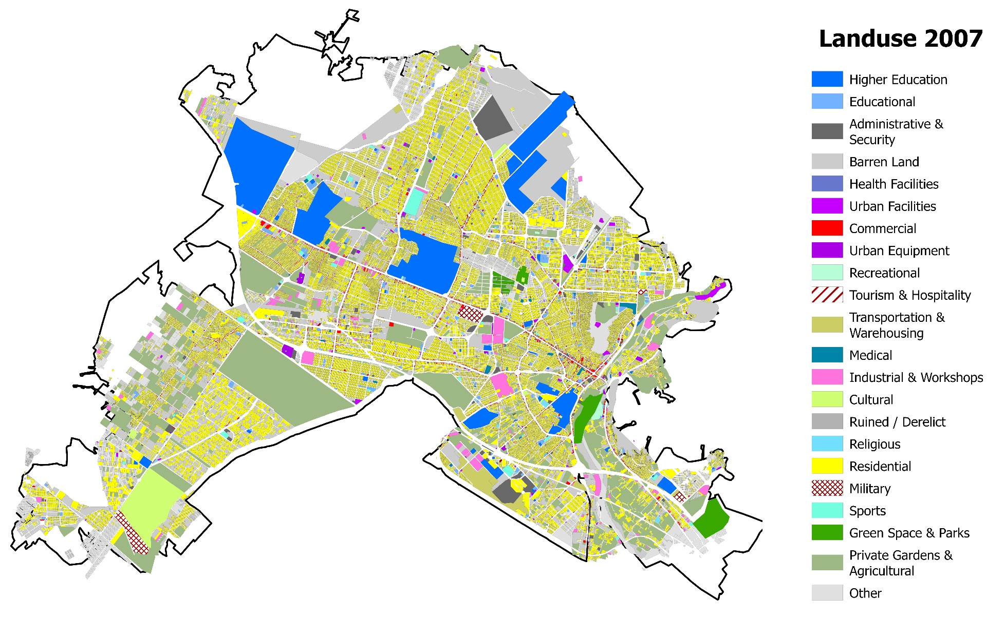
Fig. S1. Karaj Land Use, 2007. Source: Authors own work.

References
Abdulraheem, M. O., Oloyede, I. O., Amuda-Yusuf, G., Raheem, W. M., Kola Alade, A., & Chukwu, M. T. (2022). International Journal of Real Estate Studies INTREST Urban Green Space Accessibility in Ilorin City, Nigeria. 1, 24–36.
Fasihi H and Parizadi T (2020) Analysis of spatial equity and access to urban parks in Ilam, Iran. Journal of Environmental Management 260(January). Elsevier Ltd: 110122.
karaj municipality (2022) karaj municipality. Available at: https://english.karaj.ir/home/?246097/subportal-english (accessed 29 September 2023).
Statistical Center of Iran (2021). Available at: https://www.amar.org.ir/ (accessed 10 October 2021).
World Population Review (2023) The Middle East Cities by Population 2023. Available at: https://worldpopulationreview.com/continents/the-middle-east/cities (accessed 20 May 2023).

