Appendix 1. Priori Power Analysis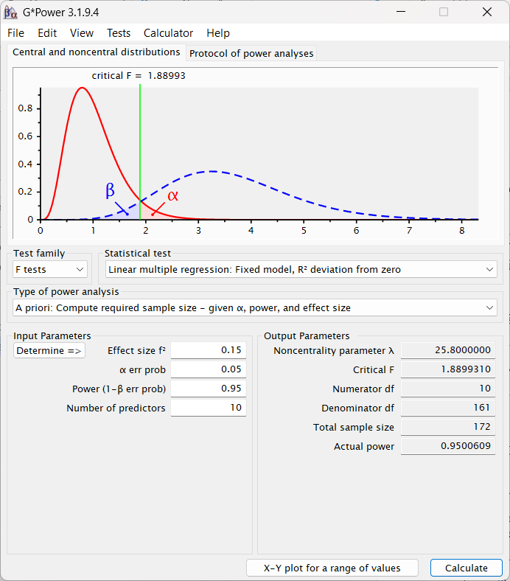

Appendix 2. Model composite mode B
Items | VIF | Weights | SIG
Access1 | 1.701 | 0.348 | 0.000
Access2 | 1.441 | 0.255 | 0.000
Access3 | 2.158 | 0.326 | 0.000
Access4 | 2.185 | 0.346 | 0.000
Info1 | 1,655 | 0.382 | 0.000
Info2 | 1,391 | 0.235 | 0.000
Info3 | 2,347 | 0.305 | 0.000
Info4 | 2,257 | 0.335 | 0.000
Intercat1 | 1,653 | 0.208 | 0.000
Interact2 | 2,888 | 0.305 | 0.000
Interact3 | 2,882 | 0.315 | 0.000
Interact4 | 3,005 | 0.332 | 0.000
Personal1 | 1,892 | 0.337 | 0.000
Personal2 | 1,385 | 0.252 | 0.000
Personal3 | 2,016 | 0.313 | 0.000
Personal4 | 1,982 | 0.352 | 0.000

Appendix 3. Importance of Performance Map Analysis
