APPENDIX 1.
Experimental research design
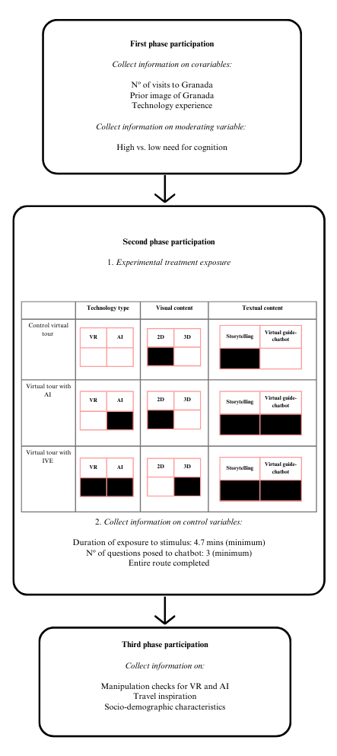
APPENDIX 2.

Table 1: Socio-demographic characteristics of the sample
Characteristics | Categories | Percentage of sample  (n=477) | Characteristics | Categories | Percentage of sample  (n=477)
Gender | Male | 53 | Level of education | No formal studies | 0.2
Gender | Female | 47 | Level of education | Primary level only | 2.5
Age | 18–24 | 6.1 | Level of education | Secondary education | 38.4
Age | 25–44 | 43.6 | Level of education | Higher education | 58.9
Age | 45–64 | 42.1 | Level of education | Higher education | 58.9
Age | ≥65 | 8.2 | Level of education | Higher education | 58.9

APPENDIX 3.
Experimental stimuli
Level 1: Virtual tour with 2D images (control)
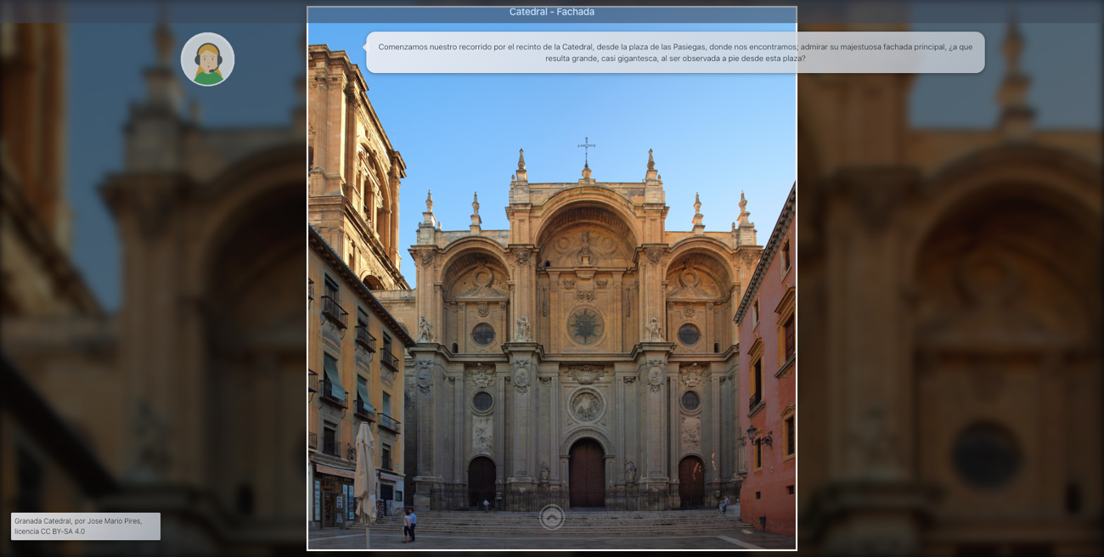
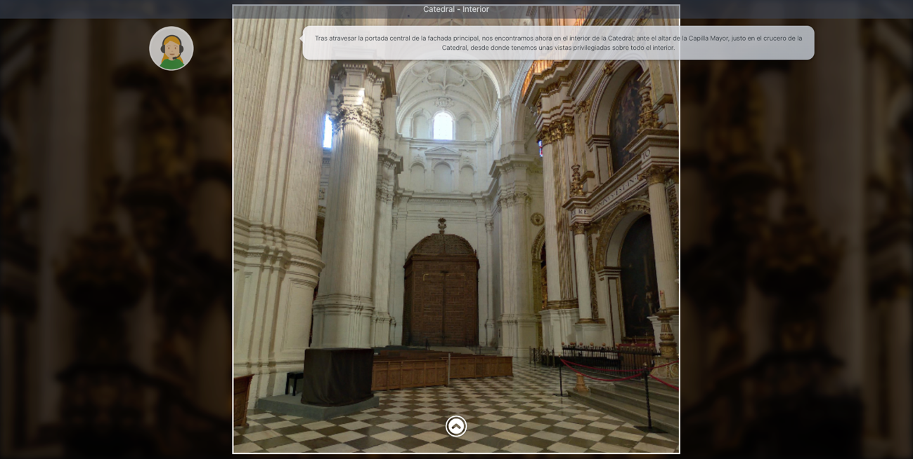
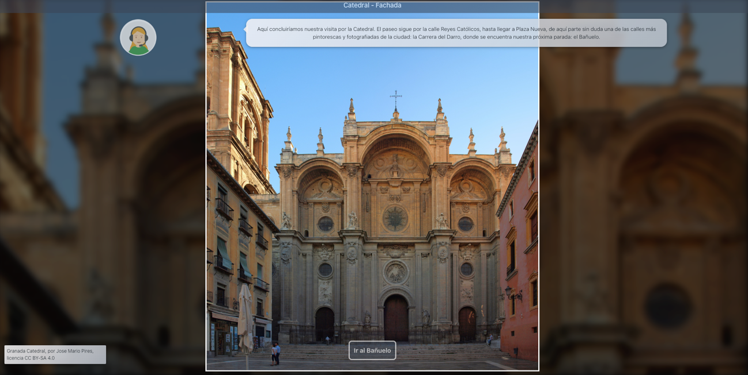

Level 2: Virtual tour with AI (2D images and intelligent chatbot)
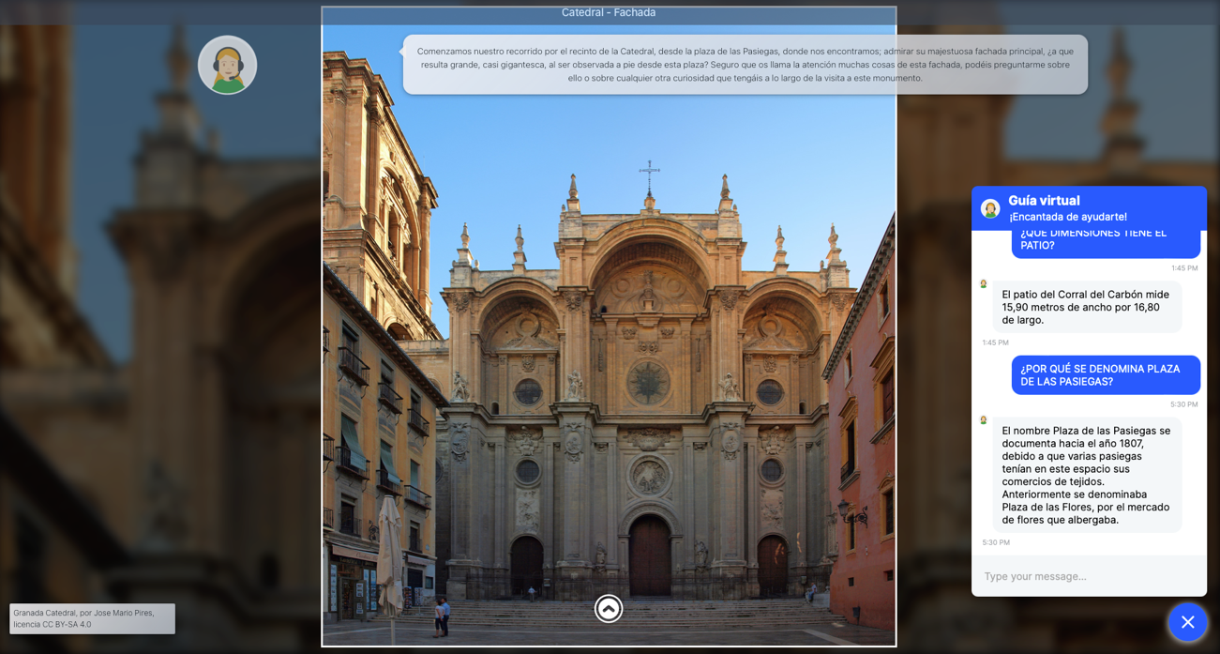
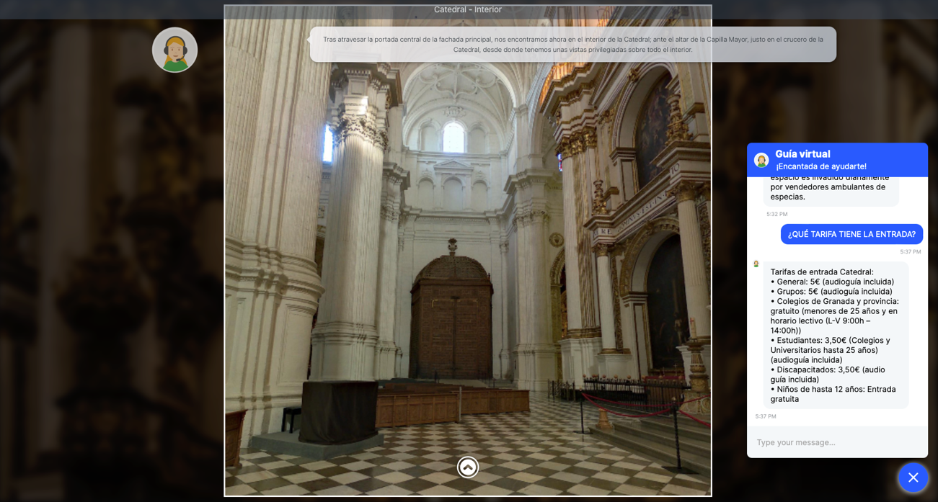
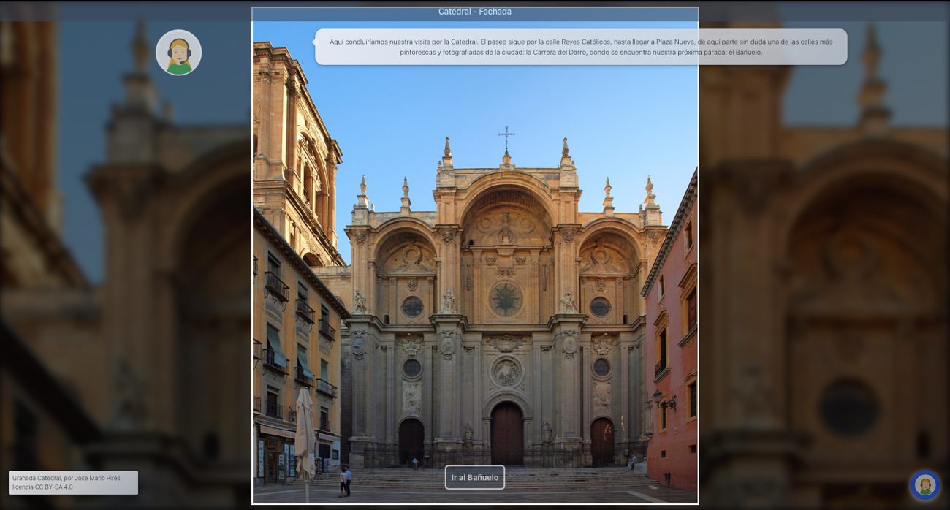

Level 3: Virtual tour with IVE (VR 360º images and intelligent chatbot)
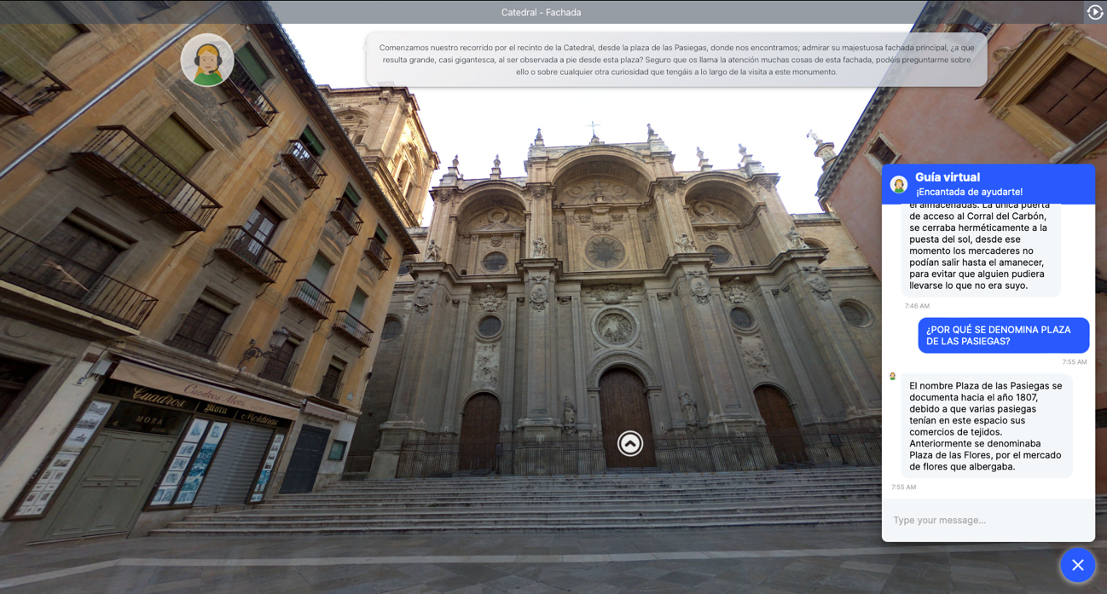
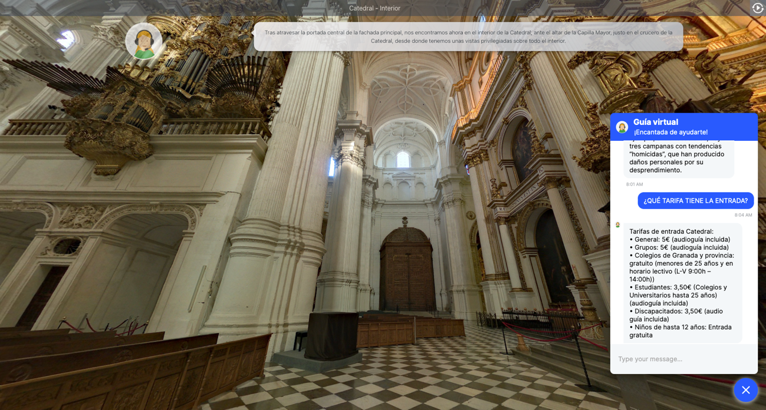
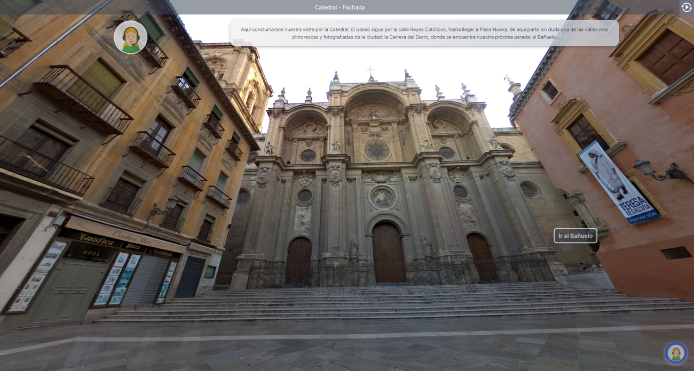

APPENDIX 4.
Measurement scales
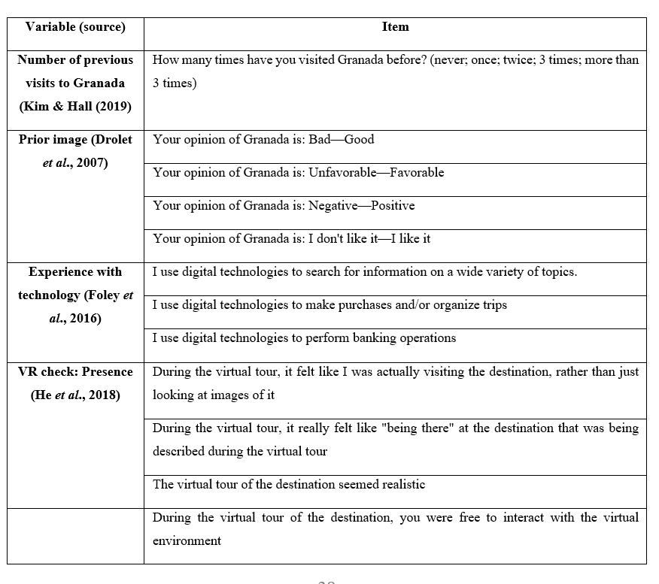
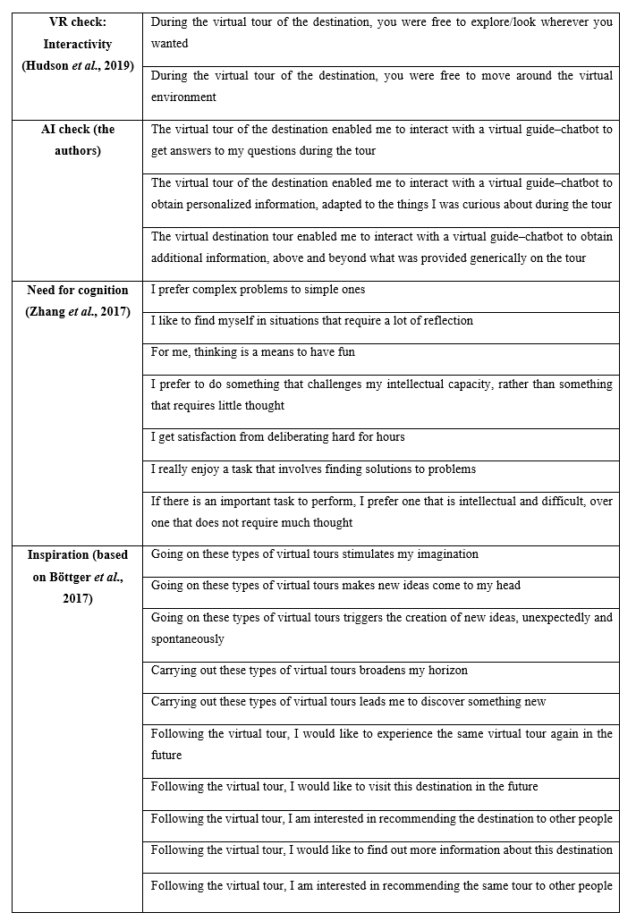

APPENDIX 5.
Individual reliability, composite reliability, and variance extracted
