Appendix

A. Table 1. A Step-by-Step Guide to Conducting Photovoice Research for Hotel Guest Experiences

Source: Adapted from Asaba et al. (2014), Bradbury (2015), Call-Cummings et al. (2019), Davis and Mitchell (2022) and Gabrielsson et al. (2022).
Step | Description | Detailed Example | Additional Notes
1. Study Design | Define purpose, scope and theoretical foundation. | • Explore guest experiences related to cleanliness, comfort and hospitality.  • Use EDT and SDL as guiding frameworks. | Ensure conceptual alignment between the research aim and methodological tools.
2. Participant Recruitment | Use purposive sampling to select diverse participants. | • Include business and leisure travelers.  • Ensure variation in age, gender and nationality. | Aim for maximum variation to enhance thematic richness.
3. Informed Consent | Explain the study purpose, data use and confidentiality. | • Participants understand their photos and narratives may be published.  • Consent is documented. | Reiterate the right to withdraw at any stage.
4. Participant Training | Train participants in ethical and technical aspects. | • Demonstrate examples (e.g. pristine lobby, broken AC).  • Teach framing, lighting and privacy respect. | Stress the importance of avoiding identifiable people without consent.
5. Photography | Participants photograph their experiences during/after their stay. | • Capture check-in, room, dining and staff interactions—both positive and negative. | Encourage diversity of content to reflect the whole experience spectrum.
6. Discussions/ Interviews | Conduct group or individual reflection sessions. | • Discuss photos showing a welcoming breakfast or service failure.  • Unpack emotions and expectations. | Use a safe space approach to encourage openness.
7. Visual Data Analysis | Code and theme the photographic content. | • Code for themes like “cleanliness” or “disappointment.”  • Note emotional tone. | Involve multiple coders to reduce subjectivity.
8. Textual Data Analysis | Analyze interview transcripts or narratives thematically. | • Identify themes like “staff friendliness” and “room layout.” | Triangulate with visual data to increase reliability.
9. Triangulation | Cross-check visual and textual data. | • Match the clean room photo with the narrative praise for hygiene.  • Detect inconsistencies. | Enhances the trustworthiness of findings.
10. Results | Present emergent themes and patterns. | • Guests emphasized comfort and personalized attention.  • Cleanliness appeared in most visuals. | Include select participant quotes for richness.
11. Discussion | Relate findings to theory and literature. | • Aligns with EDT: Meeting expectations drives satisfaction.  • SDL: Value co-creation in guest-staff interaction. | Critically interpret unexpected or contradictory findings.
12. Conclusion | Summarize key insights. | • Cleanliness, comfort and personalization were central.  • Photovoice captured nuances missed in surveys. | Reinforce the method’s ability to reveal emotional depth.
13. Implications | Offer theoretical and managerial contributions. | • Theoretical: Photovoice enriches qualitative methods.  • Practical: Use guest visuals in staff training and service redesign. | Suggest integrating Photovoice into post-stay evaluation protocols.
14. Limitations & Future Directions | Acknowledge constraints and suggest next steps. | • Limitations: Subjectivity in photo selection, small sample size.  • Future: Apply to budget segments or combine with surveys. | Propose mixed-method approaches or comparative cross-cultural studies.

Figure A.1. A simulated image created solely for conceptual illustration within this methodological study.
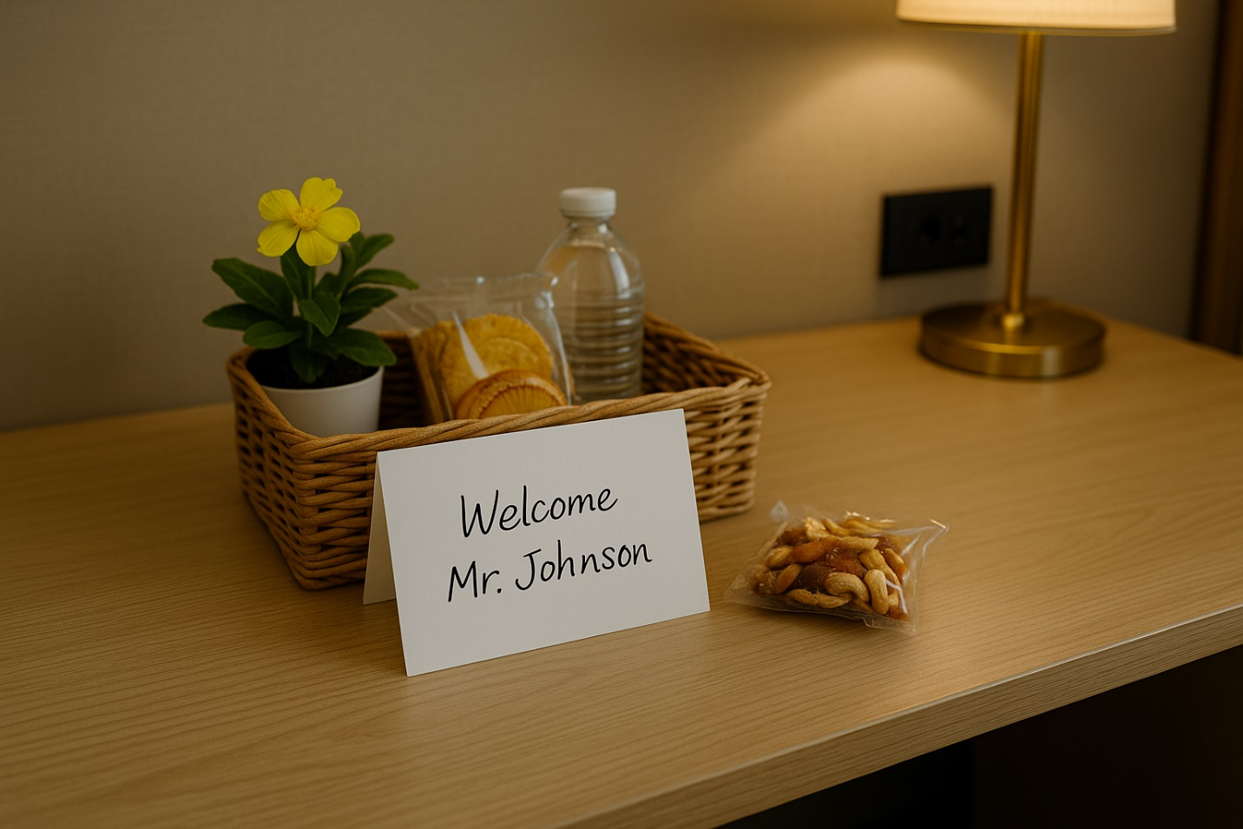
Figure A.1. Simulated Photovoice Image: Personalized Welcome Gesture Reflecting Positive Disconfirmation
Created by the authors.

‘This was waiting in my room when I checked in—local snacks, a small plant and a personal note with my name on it. It made me feel noticed and valued, like I was not just another room number. I had not expected this, and it positively shaped my first impression.’ [Simulated Sentiment of Guest]

These feelings of the guest demonstrate a clear positive disconfirmation, where the service experience exceeded the guest’s prior expectations (EDT). The participant’s sense of emotional recognition and surprise highlights the impact of personalized, low-cost gestures in enhancing the perceived value of service. Through the lens of SDL, the experience is co-constructed: the guest assigns meaning and emotional resonance to the moment, transforming it into a value-in-use episode. While simulated, this image exemplifies how Photovoice can reveal emotionally charged service moments that often remain invisible in traditional feedback mechanisms.

