Appendix A: The TPS Reflection Form
A.1. Blank TPS Reflection Form (Template)
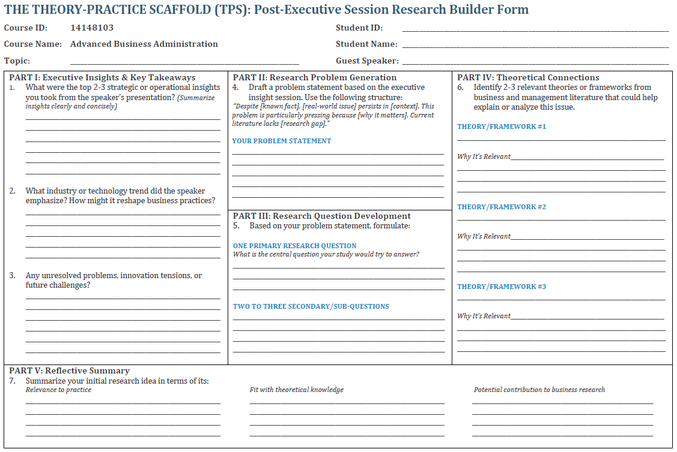

A.2. Example of a Completed TPS Reflection Form (Anonymized Authentic Submission)
The following example illustrates how practitioner-doctoral students used the Theory-Practice Scaffold to convert executive experience into theoretically anchored research framing. All identifying information has been removed in accordance with ethical protocols.
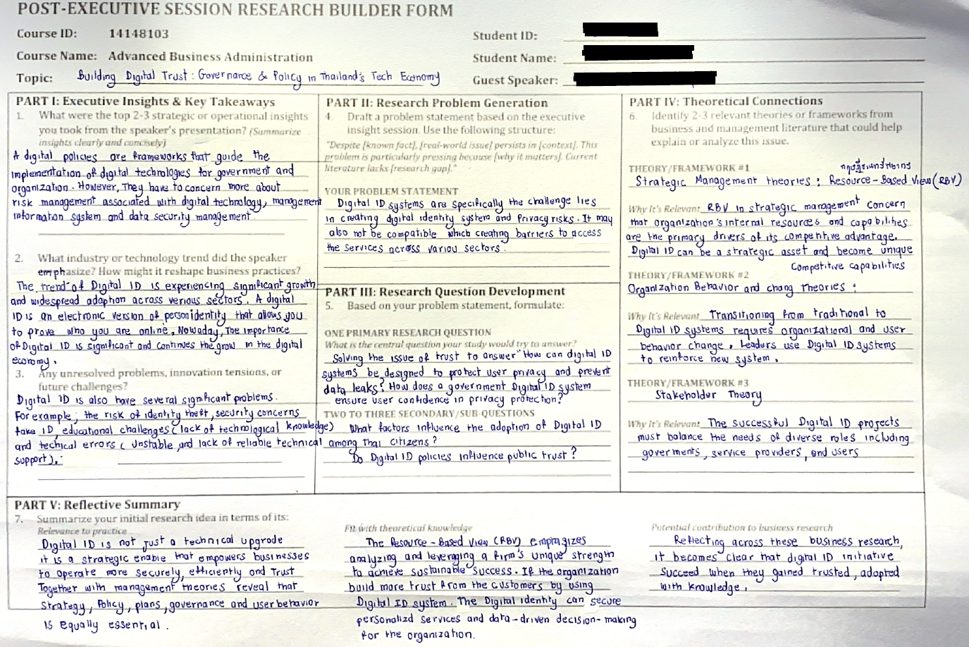

Appendix B: TPS Rubric: Evaluation
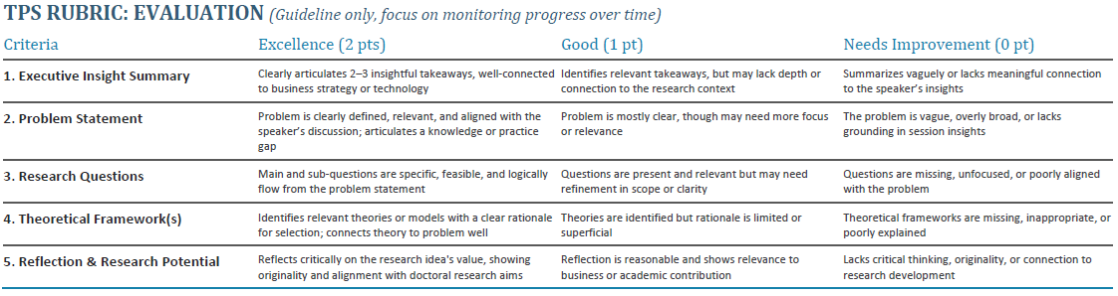

Appendix C: Participant Consent Statement
