Supplement 2. Invitation letter
Dear [organization] member:
We are happy to invite you to re-create [organization] as a better wellbeing community. For this purpose, we have built a new type of workplace training process designed to move us from words to action. The participative training asks members to define the desired objectives in order to create a concrete path toward a more desirable future together.
The training process includes four steps (please see the attached figure). We start with restorative interviews and continue with three workshops. The interviews will be scheduled personally, and the spring workshops will be organized for March 30 and May 16. The final workshop will be organized in August. You are warmly welcome to participate, even if you cannot attend all of the workshops, although we of course hope for active participation.
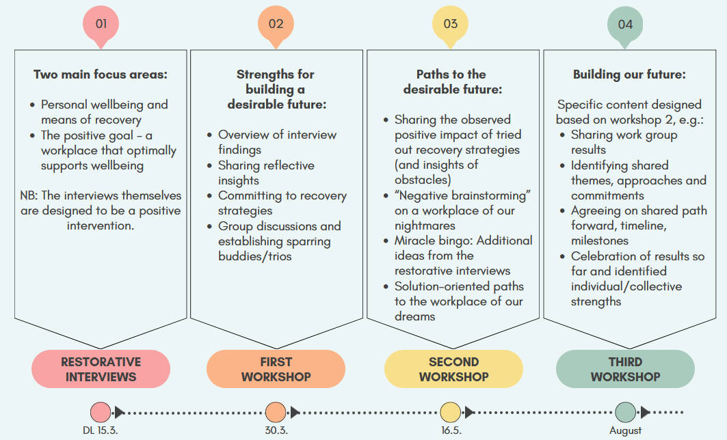
Sign up (latest 15.3) and questions: (authors).
We hope that many of you will take up this opportunity to develop our community together!
With warm regards,
(authors)

