Understanding workplace learning dynamics using experience sampling: insights from an event-based and a time-based sampling study – Supplementary material

Reflection quality codebook
Table S1. Reflection quality codebook including description, inclusion criteria & examples
Code | Description | Inclusion Criteria | Examples
Specific | The participant provides a detailed description of the learning outcomes in terms of what was learnt as part of conducting a learning activity | Clear explication of the acquired knowledge, skills or attitude | “I learned how and which databases can be useful whereby I think this also depends on your research topic at hand. I learned how to do a search log and understood the functions of Boolean operators and search strategies other than google scholar.”  “I learned that ethical considerations play an important role in designing studies and can vary. Also there are several study designs changing with the topic and goal of the study."  “I learned to stick to set goals even during a longer period of time whitout being distracted and focused on other problems. I was very focused on doing ONE thing and only that thing without going more in depth about other things I might have considered interesting as well. I saw how this resulted in much quicker and easier to pinpoint progress”
Unspecific | The participant describes a learning outcome that is related to the learning activity, but lacks the specificity to determine what was learned exactly | Mere description of a learning experience, or unclear and high-level indication of some sort of learning | “I got an external opinion on the precision of my texts and therefore also judging my progress and my ability to implement previously voiced suggestions. This was a great method to validate my perceived progress and help me more accurately rate it on development.”  " I learned about my goods and flaws about professional language use in the mails I written to the client so far."  “How to look at the problem from a different perspective”
Nonsensical | The participant fails to describe the learning outcomes, or provides unrelated or incoherent descriptions of outcomes | Description of outcomes without relation to activities, or unclear relation; not understandable, abstract or unserious description and missing descriptions | " It can be very boring, but also very useful”  “Teamwork makes the dream work"  "Feedback"  "."
Source: authors’ own work

Descriptive analysis of logs (time-based sampling study)
Participants in the time-based study reported 238 WPL experiences via 159 logs, with a mean of 1.5 (SD = 0.8) experiences per log, and medians between 1 to 3 experiences per log per participant (Figure S1). Due to having the option of logging multiple WPL experiences, time-based sampling resulted in longer sessions (median = 3.6 minutes) compared to event-based sampling (median = 2.8 minutes). Consecutively logged activities were on average shorter (e.g. median = 2.1 minutes for the first activity and median = 1.7 for the second (n = 57)) with a positive, moderate tendency (e.g. r_{s}(52) = .59, p < .001 between first and second experience). Logs shorter than 51.7 seconds (n = 3) and longer than 1448.5 seconds (n = 5) were found to be outliers.

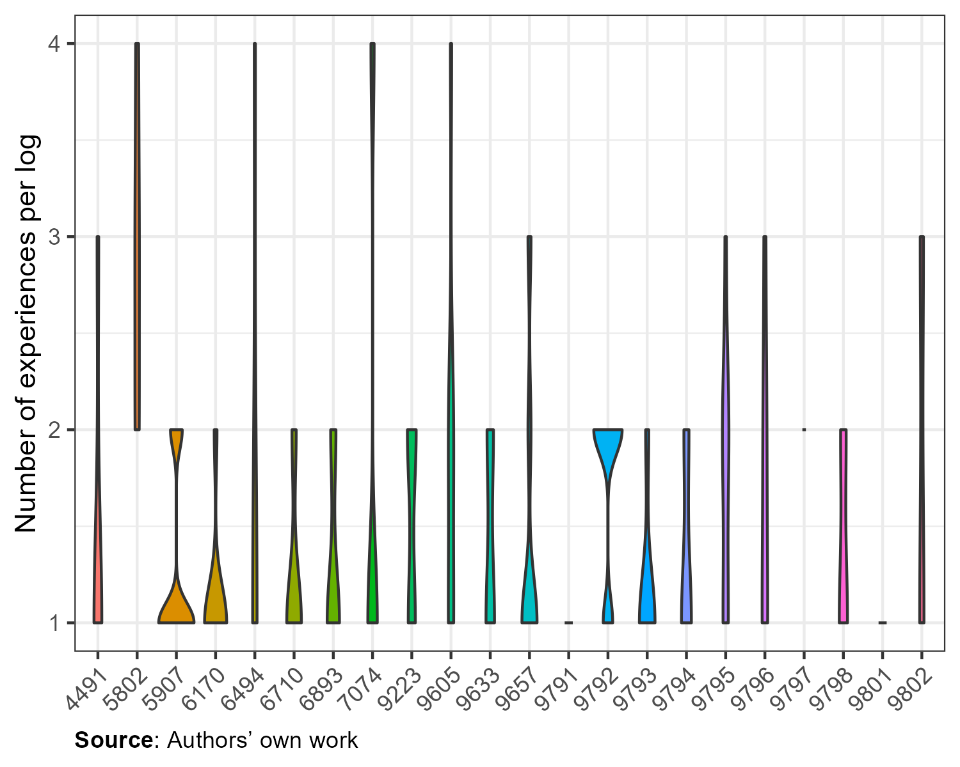Figure S1. Violin plot with frequencies of reported experiences within logs per participant in the time-based sampling study

Overview of data quantity by sample
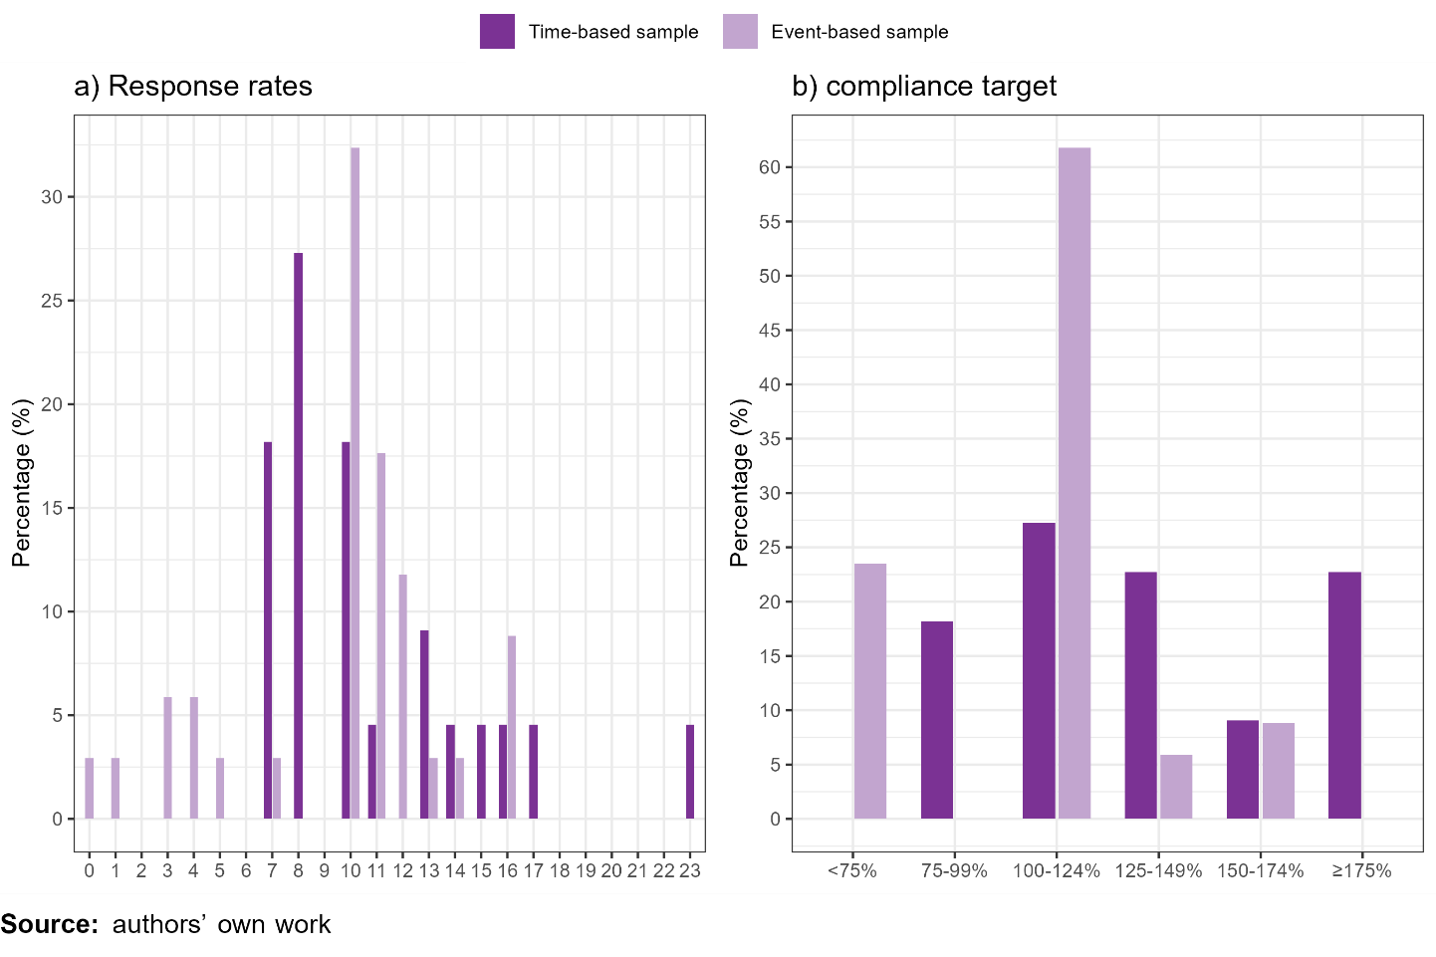
Figure S2. Frequencies of a) response rates and b) compliance target by sample
Note. The time-based study comprised 5 weeks with a compliance target of 8 responses, while the event-based study consisted of 6 weeks with a compliance target of 10 responses.

Variation in reflection quality
Figure S3. Frequencies of WPL experiences and reflection quality by participants of both studies

In-depth analysis of word count and response duration
For word counts (Figure S4), non-parametric tests showed little substantial difference between the two sampling approaches (W = 35,049, p = .05), with time-based sampling having on average slightly fewer words (median = 27, IQR = 15-52) than event-based sampling (median = 31, IQR = 18-57). In contrast, significant differences were observed between quality of reflections (H = 180, p < .001), with substantial more words by quality (specific: median = 47, IQR = 30-74; unspecific: median = 24, IQR = 15-39; nonsensical: median = 11, IQR = 6-16). For both samples combined, 2 or fewer words (n = 6) and 287 or more (n = 2) were outliers.
Figure S4. Violin plots and box plots of word count of learning experiences by reflection quality

Word count had a positive, strong correlation with duration (r_{s}(562) = .63, p < .001). Generally, specific reflections took slightly more time and words, while the opposite was true for nonsensical reflections (Figure S5).
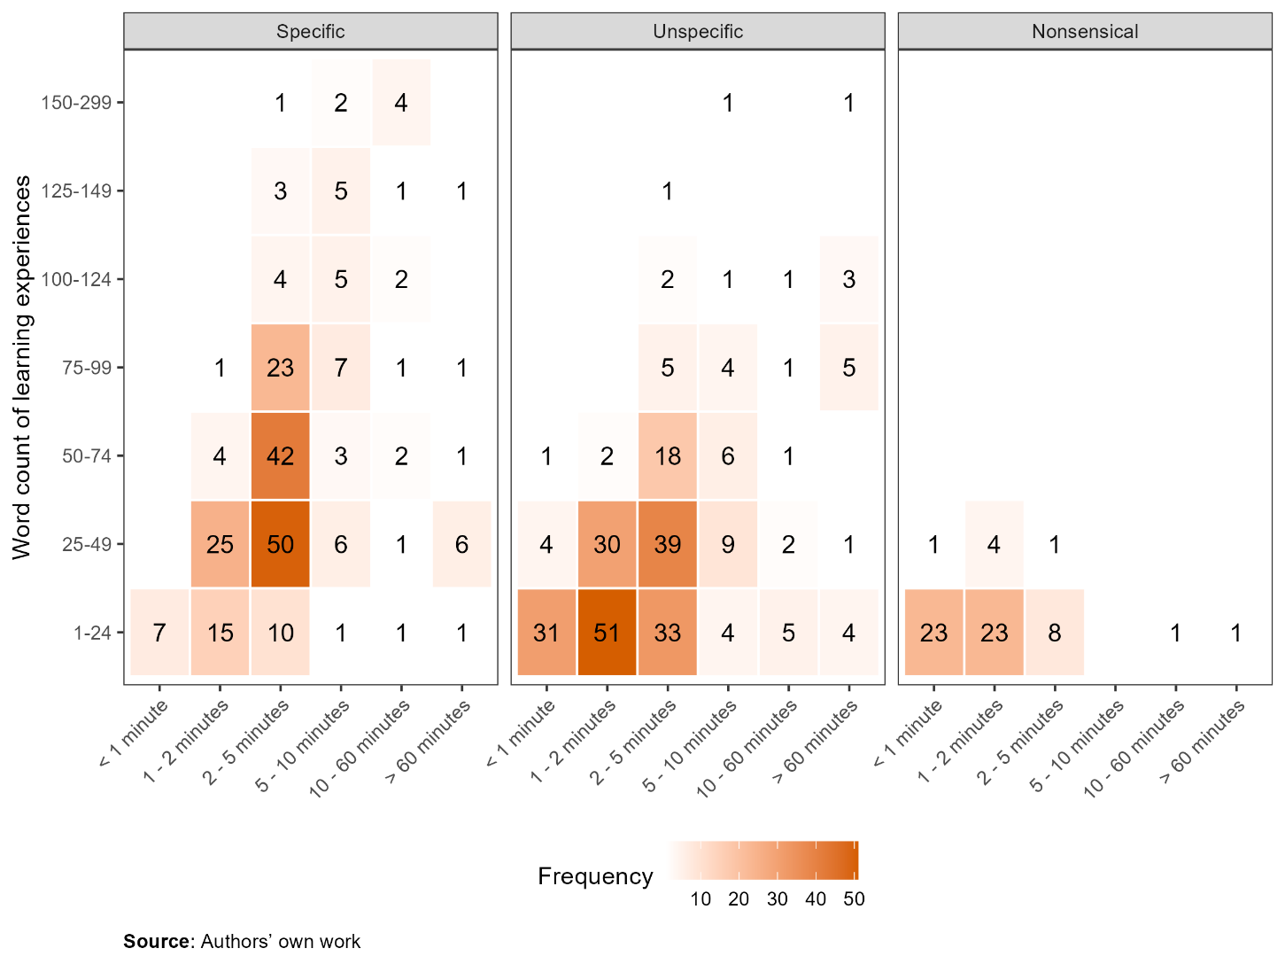
Figure S5. Heat grid of categorical duration and word counts of learning experiences by reflection quality

In both samples, most responses were completed within 5 minutes: 90% in the time-based and 76% in the event-based sample. Time-based responses were generally shorter (median = 1.9 minutes) than the event-based (median = 2.8). In the time-based sample, 45 (19%) responses were under one minute, and three (1.2%) exceeded 60 minutes. Responses shorter than 24.2 seconds (n = 1) and longer than 678.7 seconds (n = 9) were outliers. In the event-based sample, 7% (n = 22) were under one minute, with five participants repeatedly such short responses, and another 7% (n = 22) exceeded 60 minutes. Here, responses shorter than 68.8 seconds (n = 28) or longer than 1357.6 seconds (n = 24) were outliers.

Neither duration nor word count changed substantially over time (i.e. number of observations) on average (Figure S6), although large variations both within and between participants were observed. While this would suggest that – as potential indicators of data quality – quality does not deteriorate over time (e.g. towards the end of the study), as suggested by Figure S6, interpretation is hindered by the large variation in number of observations within participants (see also Figures S2 and S3), as well as variation in when these observations occurred (e.g. observation 12 at the mid of or end of the study period).
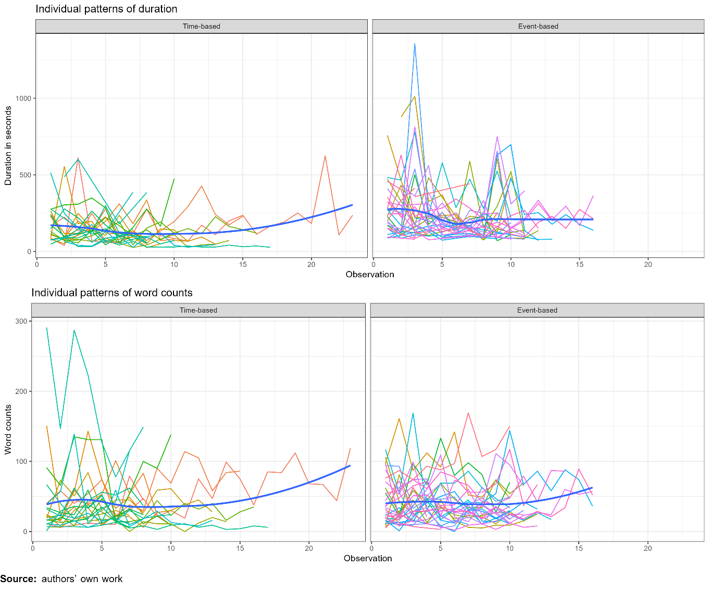
Figure S6. Patterns of response behaviours over time with mean line in blue

Table S2. Frequencies of reflection quality over a) weeks and b) days of the study and c) time of day
 | Time-based |  |  |  | Event-based
 | Specific | Unspecific | Nonsensical |  | Specific | Unspecific | Nonsensical
Week
1 | 13 (43%) | 12 (40%) | 5 (17%) |  | 21 (49%) | 18 (42%) | 4 (9%)
2 | 22 (38%) | 31 (53%) | 5 (9%) |  | 26 (47%) | 27 (49%) | 2 (4%)
3 | 18 (32%) | 30 (54%) | 8 (14%) |  | 32 (49%) | 29 (45%) | 4 (6%)
4 | 14 (45%) | 13 (42%) | 4 (13%) |  | 16 (38%) | 24 (57%) | 2 (5%)
5 | 22 (35%) | 29 (46%) | 12 (19%) |  | 27 (43%) | 27 (43%) | 9 (14%)
6 | - | - | - |  | 25 (43%) | 26 (45%) | 7 (12%)
Weekday
Monday | 16 (36%) | 25 (57%) | 3 (7%) |  | 14 (52%) | 11 (41%) | 2 (7%)
Tuesday | 14 (36%) | 21 (54%) | 4 (10%) |  | 8 (44%) | 10 (56%) | 0 (0%)
Wednesday | 11 (44%) | 10 (40%) | 4 (16%) |  | 9 (38%) | 14 (58%) | 1 (4%)
Thursday | 17 (31%) | 28 (52%) | 9 (17%) |  | 31 (52%) | 25 (42%) | 4 (7%)
Friday | 26 (41%) | 27 (42%) | 11 (17%) |  | 53 (47%) | 50 (45%) | 9 (8%)
Saturday | 0 (0%) | 1 (100%) | 0 (0%) |  | 29 (37%) | 38 (48%) | 12 (15%)
Sunday | 5 (46%) | 3 (27%) | 3 (27%) |  | 3 (50%) | 3 (50%) | 0 (0%)
Time of day
< 10.00 | 2 (100%) | 0 (0%) | 0 (0%) |  | 4 (31%) | 7 (54%) | 2 (15%)
10.00–10.59 | 3 (30%) | 7 (70%) | 0 (0%) |  | 7 (58%) | 5 (42%) | 0 (0%)
11.00–16.59 | 38 (40%) | 48 (51%) | 8 (9%) |  | 84 (51%) | 73 (44%) | 8 (5%)
17.00–17.59 | 15 (34%) | 21 (48%) | 8 (18%) |  | 17 (34%) | 25 (50%) | 8 (16%)
18.00–0.00 | 31 (35%) | 39 (44%) | 18 (20%) |  | 35 (42%) | 38 (46%) | 10 (12%)
> 0.00 | - | - | - |  | 0 (0%) | 3 (100%) | 0 (0%)
Note: Proportions of reflection quality are calculated per row by sample.
Source: authors’ own work

Reflection quality by time
Figure S7. Heat grid with frequencies of activities per hour by reflection quality
Note: Black lines represent time of notifications.
Figure S8. Heat grid with frequencies of activities per day by reflection quality
Notes: Numbers within each cell indicate frequency of logs in the evening or at night. The time-based study ran one week shorter.

Potential of data quality indicators
To summarise, three types of data quality indicators were analysed: low response rates, nonsensical answers by way of reflection quality and careless answering (i.e. low response duration, outliers in response duration, and briefer outcomes). Table S3 presents these indicators comparing all experiences and quality of reflections. Shorter response durations (i.e. rapid responses), brief remarks, logging closer to deadlines (end of week and end of project), and logging later in the evening resulted more often in nonsensical reflections and may therefore be investigated closely to inform data cleaning. However, none of these indicators by themselves reliably predicted low-quality reflections. For example, while almost all nonsensical reflections were brief, simply omitting all brief responses would remove many higher quality reflections as well. A combination of all indicators provided the highest number of nonsensical reflections (89%), but encompassed 44% of all experiences. A stepwise investigation of indicators relevant to the study design (e.g. responses close to the deadline) might work best for data cleaning. Additionally, investigating these indicators show interesting implications. To illustrate, higher-quality reflections were almost always longer and reported throughout the workday, but responses at the end of week were not necessarily worse. Consequently, these indicators suggest, first, when reflecting on and reporting WPL events may ideally take place and, second, when prompting to log these events may ideally occur.

Table S3. Overview of potential low-quality data indicators
Indicator | Total experiences  (N = 564) | Specific reflections  (N = 236) | Unspecific reflections  (N = 266) | Nonsensical reflections  (N = 62) | Proportion nonsense ª
Rapid (<2 minutes) | 222 (39%) | 52 (22%) | 119 (45%) | 51 (82%) | 23%
Brief (<25 words) | 219 (39%) | 36 (15%) | 140 (53%) | 58 (94%) | 26%
End of project + rapid or brief | 109 (19%) | 28 (12%) | 53 (20%) | 28 (45%) | 26%
End of week + rapid or brief | 201 (36%) | 44 (19%) | 109 (41%) | 48 (74%) | 24%
End of day  + rapid or brief | 99 (18%) | 13 (6%) | 59 (22%) | 27 (42%) | 27%
Combined indicators ^{b} | 249 (44%) | 52 (22%) | 142 (53%) | 55 (89%) | 22%
Notes: ª proportion of nonsensical reflections within indicator; ^{b} (<2 minutes or <25 words) and (end of project or end of week or end of day).
Source: authors’ own work

Reported WPL experiences over time
Table S4. WPL experiences per learning goal over time presented with median (interquartile range)
 | Reported experiences | Days per learning goal | Days between experiences*
First learning goal (N = 55) | 6 (4-7) | 15 (11-28) | 2 (1-3)
Time-based (N = 22) | 6 (4-7) | 16 (9-36) | 2 (1-3)
Event-based (N = 33) | 6 (4-7) | 15 (12-22) | 3 (2-4)
Second learning goal (N = 51) | 4 (3-6) | 22 (7-30) | 1 (0-4)
Time-based (N = 20) | 4 (3-6) | 24 (7-32) | 1 (0-4)
Event-based (N = 31) | 5 (3-6) | 14 (7-29) | 1 (0-3)
Note: *Per participants, the median of days between each experience was calculated.
Source: authors’ own work

