Appendix A

All machine learning models were implemented in Python (version 3.9.13). The scikit-learn library (version 1.2.2) was used for model development in creating the ElasticNet, RandomForestRegressor, and LinearRegression models, as well as for cross-validation and performance evaluation. Data manipulation was handled using pandas (version 1.5.3) and numpy (version 1.23.5), while matplotlib (version 3.6.3) was used for visualization. The statsmodels package (version 0.13.5) supported time series and econometric modeling. Although xgboost, tensorflow, and keras were initially explored for potential inclusion, they were not retained in the final model implementation due to inferior performance compared to simpler ensemble-based approaches.
Model training and evaluation were conducted in a JupyterLab environment running on Windows 11 with an Intel i7 processor and 16 GB of RAM. For large-scale data preprocessing and trade flow aggregation, computations were performed on George Mason University’s Hopper high-performance computing cluster. Unless explicitly stated, model hyperparameters were used at their default settings.
Appendix B
Figure A1 shows the materials produced in the various steps of LIB production. Initially, lithium is extracted from sources, such as hard rock ore and brine. Then, it is refined into basic chemicals, such as lithium carbonate, lithium hydroxide, lithium chloride, and lithium concentrate (Tran and Luong 2015). These chemicals serve as crucial components in producing battery-grade and technical-grade materials.
As per Figure A1, battery-grade materials, with a purity of 99.5 percent, are utilized in manufacturing LIB cathode materials and electrolytes, including lithium cobalt oxide (LCO), lithium manganese oxide (LMO), lithium iron phosphate (LFP), lithium nickel cobalt manganese oxide (NCM), lithium nickel cobalt aluminum oxide (NCA), and lithium hexafluorophosphate (LiPF6) (Refining section of Figure A1) (Sun et al., 2017). LIBs, made from battery-grade materials (e.g., cathode materials and electrolytes), are integrated within larger applications, such as battery electric vehicles (BEVs), plug-in hybrid electric vehicles (PHEVs), and energy storage systems (ESSs) (Ahmad et al., 2021). To analyze the SC, the respective Harmonized System (HS) codes for these materials were extracted from different sources as summarized in Table A1 (LaRocca, 2020). The flows of these commodities were extracted from UNCOMTRADE data based on these HS codes.
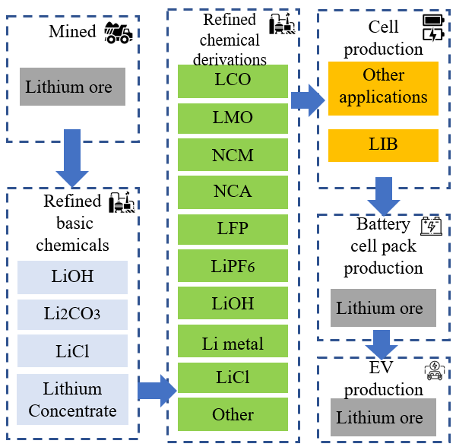
Figure A1. Details of materials used in LIB by step (adopted from Sun et al., 2017)
Table A1. HS codes associated with the LIB SC (adopted from LaRocca, 2020)
Step | Commodity name | HS code
Mining | Lithium ore | 253090
Raw material processing | Lithium carbonate | 283691
Raw material processing | Lithium hydroxide | 282520
Raw material processing | Lithium chloride | 282739
Raw material processing | Lithium concentrate | 282690
Battery Cell material production (refining) | LMO | 284169
Battery Cell material production (refining) | LCO | 284190
Battery Cell material production (refining) | LFP, NCM, NCA, | 284290
Battery Cell material production (refining) | LiPF6 | 282690
Battery cell pack production | LIBs | 850760

