Supplementary Material:

Example of the Linguistic and Visual Condition
This document contains 2 examples of screens for both the linguistic and visual condition. The original was in Dutch.
Screen 4: External rating (linguistic condition)
External rating

ENF frequently measures customer satisfaction among consumers. The Net Promoter Score is used for this purpose.

This score distinguishes between three categories: 1) Promoters: people who are enthusiastic about the organization, 2) Criticasters: people who are highly likely to be dissatisfied with the organization, and 3) Passively satisfied people.

The large-scale customer satisfaction survey for the first 6 months of 2018, conducted by a specialized agency, found that ENF's customer base was 47% Promoters, 9% Criticasters and 44% Passively Satisfied customers. By comparison, in 2017 the scores were Promoters 52%, Criticasters 8% and Passively satisfied customers 40%; in 2016, Promoters 54%, Criticasters 5%, and Passively satisfied customers 41%.

Screen 4: External rating (visual condition)
External rating

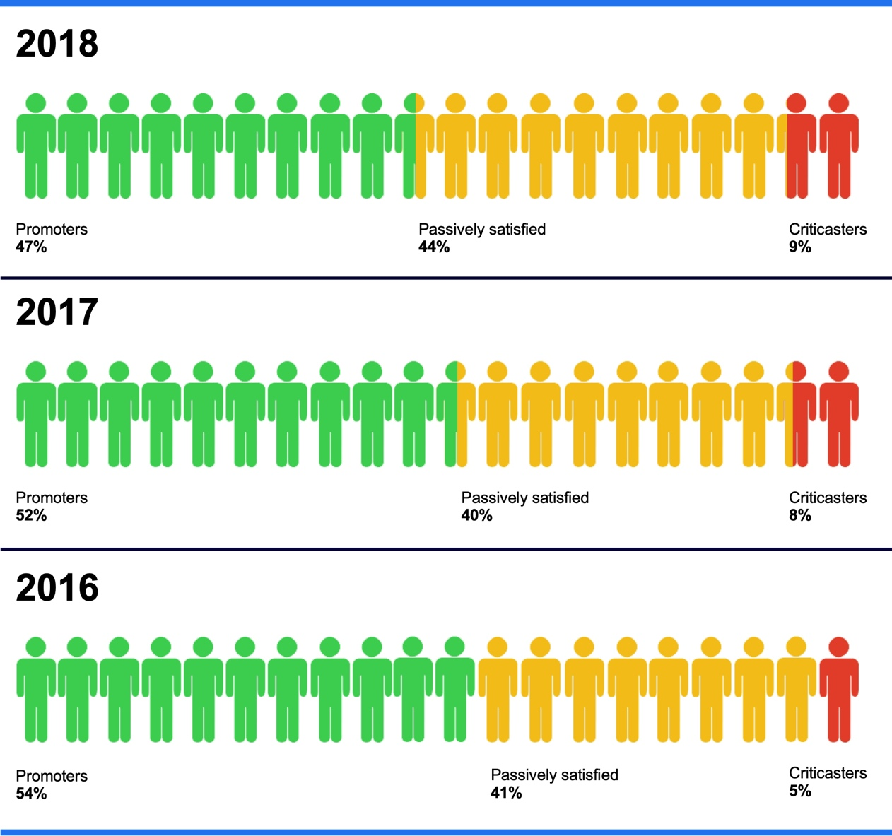
Index:
 | People who are enthusiastic about the organization
 | Passively satisfied people
 | People most likely to be dissatisfied with the organization

Screen 6: Management Targets (linguistic condition)
Management Targets
Annually, the ENF Management Board sets the bonus plan for the following year. The Management Board adopted a bonus plan for calendar year 2018 at the end of 2017.
The purpose of the bonus plan is to reward employees who make a significant contribution to ENF's successes. By doing so, ENF wants to show that the efforts of employees are extremely appreciated.

ENF has a bonus system for directors, management, and commercial functions (purchasing and sales). These positions receive compensation based on a base salary (50%), the extent to which the budgeted profit target for the fiscal calendar year was met (40%), and the achievement of longer-term goals (10%).
At the end of the fiscal calendar year, the extent to which targets have been is met determined. The bonus is paid after ENF's results are determined and published. This bonus system was put into operation to underline the importance of ENF’s profit growth.

Screen 6: Management Targets (visual condition)
Management Targets
The attached memo is on file by your team:

Topic: Approved Bonus Plan for 2018.
The purpose of the bonus plan is to reward employees who make a significant contribution to ENF's successes for doing so. By doing so, ENF wants to show that the efforts of employees are exceptionally appreciated. In short, the Bonus Plan entails the following:
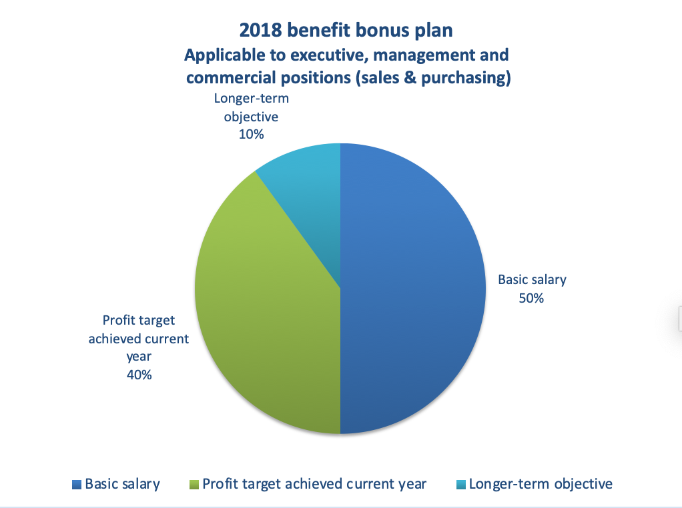
- At the end of the fiscal calendar year, the extent to which targets have been met is determined.
- The bonus is paid after ENF's results are determined and published;
- This bonus system was introduced to highlight the importance of ENF's earnings growth in particular.

On behalf of the full board,
A.C. van Heerewaarden-Keunings
Executive Chairman

