Appendix
Appendix 1. Research team members and external figures description.
Table A1 (see Table file, Appendix: Tables, Table A1) gives details of the research team (both academics and practitioners) and the four external HRA experts who worked together on developing the HRAMM, including their organisations, position and expertise in the HRA field and role in the project.
Table A1. Description of the research team and external professionals
Project role | Institution | Position | Expertise | Project role
Research team (researcher) | The university is a leading technical university in Italy, renowned for its excellence in engineering, innovation and management education and research. The research team operates in a Joint Research Centre focused on HR Analytics and the digitalisation of Human Resources Management. | Full Professor | Full professor of leadership, innovation, and management courses, teaching different subjects ranging from digital innovation to organisational behaviour theories for over 30 years. Is the founder of various research centres and consultancy firms, integrating academic research and managerial practice on Human Resources Management. | Project leader on the academic side  Active participation in all project phases (1 to 8)
Research team (researcher) |  | Associate Professor | Associate professor of business process management, organisation design, and digital innovation courses for over 15 years. Sit on the board of an international research network for continuous innovation and is the head of the Joint Research Centre for HR Analytics, promoting research and consulting projects on Human Resources Management and digital transformation | Manager of academic-managerial relationship  Active participation in all project phases (1 to 8)
Research team (researcher) |  | Post doctoral researcher | Post-doctoral research in HR Analytics, Organisational Behaviour, and the digitalisation of Human Resources Management. Has been an active member of the Joint Research Centre on HR Analytics for over 4 years, integrating academic research and managerial needs for different national and international organisation. | Operational leader on the academic side  Active participation in all project phases (1 to 8)
Research team (practitioner) | The organisation is a global consulting firm specialising in talent management, HR digitalisation, HR controlling and HRA development. The firm has over 25,000 employees and operates in over 40 countries. | Senior Principal | Leader of the HR Transformation and Organisational Effectiveness services of the firm. Has been working in consultancy companies for over 25 years. | Strategic support  Active participation in all project phases (1 to 8)
Research team (practitioner) |  | Associate Principal | Responsible for the business unit providing People Insight solutions, which combine HR Analytics, Employee Listening capabilities and Data Analytics solutions. Has been working in the field of Organisation and Human Resources Management for over 10 years. | Project leader on the practitioner side  Active participation in all project phases (1 to 8)
Research team (practitioner) |  | Manager | Has been leading different projects in the field of HR Analytics, Engagement and Organisational Behaviour for over 3 years, working for national and international companies in various industries. | Operational leader on the practitioner side  Active participation in all project phases (1 to 8)
Research team (practitioner) |  | Senior Consultant | Has been working on the development of different projects in the field of HR Analytics, Engagement and HR digitalisation for over 5 years. Is completing an executive doctoral programme on Human Resources Management. | Operational support  Active participation in all project phases (1 to 8)
External HR Analytics expert | The organisation is a network of independent companies specialising in assurance, accounting, tax, corporate and financial consulting. It has over 57,000 employees operating in more than 120 countries | Human Resource Leader | Has been working on the development of HR and HR Analytics systems for over 2 years, after holding the role of Innovation Manager for more than 5 years | 3.3.3. Model refinement with experts: refining, evaluating, and conceptually validating the model  3.6. Future intervention and interdependencies analysis: evaluating dimensional interdependencies and the interdependencies matrix
External HR Analytics expert | The organisation is a global leader in professional services, operating in 143 countries and with over 265,000 employees. The company offers a wide range of multidisciplinary services, including management, audit, advisory, tax and legal services | Senior Manager | Has been working in management consulting for over 15 years. In recent years, has been working on HR Analytics systems and how analytics results can support decision-making and management processes
External HR Analytics expert | The organisation operates in the fields of IT consulting, professional services and outsourcing. The firm has over 340,000 employees operating in more than 50 countries worldwide | Head of Compensation & Benefit and HR Analytics | Has worked for more than 5 years in the HR departments of different companies, focusing on compensation and rewarding issues. In the past 2 years, has specialised in the development and management of HR Analytics systems
External HR Analytics expert | The organisation is an Italian bank with over 700 employees | Human Resources Manager | Has been working for more than 14 years in the bank’s HR departments. For the past 5 years, has been working on increasing the maturity of his information and HR Analytics systems, with a focus on information management and data integration
Source(s): Table by authors

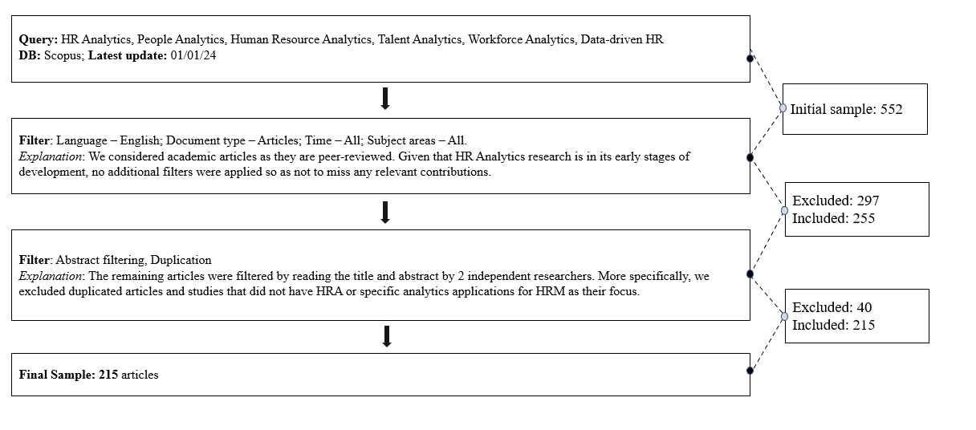
Appendix 2. Figure: Search process for the literature review on HR Analytics. Source: Authors’ own work.

Appendix 3. Figure: Search process for the literature review on data analytics, business analytics, and business intelligence maturity models. Source: Authors’ own work.
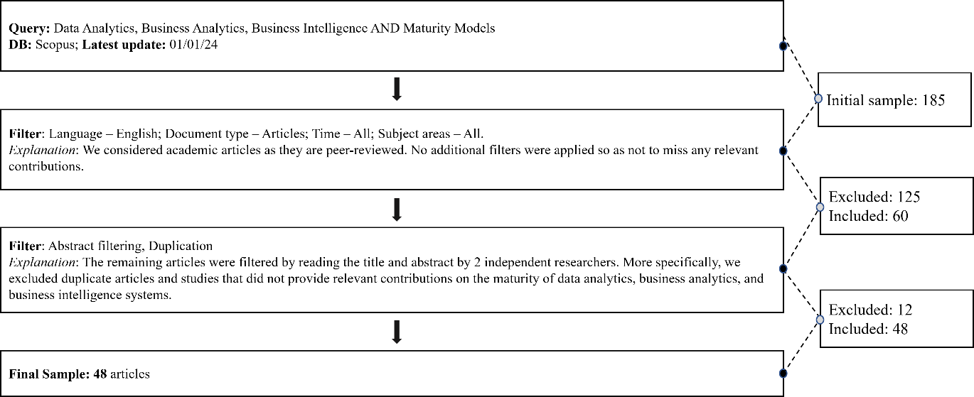

Appendix 4. Preliminary HRAMM: areas, dimensions, components and references.
The preliminary HRAMM is shown in the Table file (see Table file, Appendix: Tables, Table A4).
Table A4. Preliminary HRMM: areas, dimensions, components and references.
Area | Dimensions | Components | Sentences
Technological | T1. HRA architecture | 1.1. Technological standards | “Analytics is a highly resource-intensive function, including the use of technology infrastructure. HR analysts need data infrastructure to perform data analysis using different analytical techniques and computational intelligence” (Shet et al., 2021)  “…an integrated IT infrastructure is needed to facilitate the use of multi-source data in analyses […], the development of HR analytics will be characterized by integration, with data and IT infrastructure integrated across disciplines and even across organizational boundaries” (van den Heuvel and Boundarouk, 2017)
Technological | T1. HRA architecture | 1.2. Technological integration
Technological | T2. Data management | 2.1. Data storing | “Marler and Boudreau (2017) […] argue that it should be capable of storing and processing a sufficient data quantity and quality and sharing the results with decision-makers” (Peeters et al., 2020)  “[…] cloud-based data warehouses and blazing-fast computing speeds have made it possible to gather and access the data in ways that were hardly conceivable only a few years ago” (Boudreau and Cascio, 2017)
Technological | T2. Data management | 2.2. Data modelling
Technological | T2. Data management | 2.3. Data collection frequency | “[…] analytics developments are seen […] in automating data collection and data preparation activities, which are currently perceived as taking up considerable time by the HR analytics professionals.” (van den Heuvel and Boundarouk, 2017)
Technological | T2. Data management | 2.4. Data granularity | “The data collected for people analytics tend by their nature to be very sensitive, granular and personal” (Giermindl et al., 2021)
Technological | T2. Data management | 2.5. Data integration | “To be sure, data management remains a significant obstacle to more widespread adoption of HR analytics. It includes issues such as disparate systems that cannot “talk” to each other, data integration, and ensuring error-free data” (Boudreau and Cascio, 2017)  “The development of HR analytics will be characterized by integration, with data and IT infrastructure integrated across disciplines and even across organizational boundaries” (van den Heuvel and Boundarouk, 2017)
Technological | T3. HRA application | 3.1. Software for analytics | “Scholars need to keep working in the development of statistical and optimization models and specific software that allow predictive and prescriptions analysis” (Fernandez and Gallardo-Gallardo, 2020)  “Furthermore, HR analytics needs IT and software like HCM software to collect, manipulate and report data.” (Qamar and Samad, 2021)
Technological | T3. HRA application | 3.2. Software for visualisation | “[…] HR analytics results typically rely on visualization such as charts, graphs, heat maps, and dashboards on which the data is displayed with specialized graphics to better illustrate underlying relationships” (Hamilton and Sodeman, 2019)  “The definitions above highlight a number of key elements about HR analytics: […] it adopts systematic methods of analysis and visualization of HR data” (Margherita, 2021)
Technological | T4. Interface | - | “Here, the affordances of the epistemic technologies in place played a key role as they allowed the flexible adoption of the dashboard interface to customize analytical outputs towards the needs expressed by the HR board member […]” (Elmer and Richel, 2021)
Organisational | O5. HRA competencies | 5.1. Team competencies | “[…] multidimensional capabilities are needed: 1. […] develop logic models to understand relationships within variables and numbers; 2. […] include HRA within a general business intelligence department; 3. […] knowing about HR processes and variables, data, etc.; 4. […] ability to sell HRA to businesses presenting results in a convincing manner; 5. […] ability to conduct statistical analysis also with cutting edge developments such as machine learning; 6. […] ability to provide adequate solutions for warehousing; 7. […] ability to provide adequate software solutions” (Van den Heuvel and Boundarouk, 2017).  “Because these competencies are difficult to find in a single individual, success often comes from forming workforce analytics teams comprised of employees from diverse backgrounds” (McIver et al., 2018)
Organisational | O5. HRA competencies | 5.2. Technological presidium | “[…] important to understand where the data is, who is responsible for it, and where and how it is archived and transmitted or communicated.” (Hamilton and Sodeman, 2020)
Organisational | O5. HRA competencies | 5.3. Organisational experience | “[…] organizations at the aspirational stage of analytics justify actions with analytics. Organizations at the experienced stage of analytics guide actions with analytics, […] report that organizations at the transformed stage of analytics prescribe actions with analytics” (Lunsford, 2019)
Organisational | O6. Operating model | 6.1. Defined processes | “[…] development of HRA at the processes level requires: (a) building systems and establishing work-flows to continuously support data quality, (b) linking the results of analytics projects with existing organizational processes, and (c) encouraging experimentation and enabling follow-up actions via HR Business Partners. […] In order to build analytical competencies, analytics projects must be linked with existing organizational processes, especially HR processes” (Minbaeva, 2018).
Organisational | O6. Operating model | 6.2. Dedicated resources | “Extant literature argues that building business relevant HRA requires organizations to establish particular skills and resources at the individual and organizational level […]” (Elmer and Reichel, 2021)
Organisational | O6. Operating model | 6.3. Defined roles | “The role of HR professionals has evolved throughout history — from “personnel administrators” and “industrial relations professionals" in the 20th century to “HR managers” and “people managers” in the 21st century” (Kryscynski et al., 2018)
Organisational | O6. Operating model | 6.4. Defined responsibilities | “The HRA team at the very centre is responsible for overseeing current HRA projects, including the processing and delivery of analytical outputs” (Elmer and Reichel, 2021)
Organisational | O7. HRA strategy | 7.1. Dedicated budget | “Financial readiness is the availability of financial resources to learn and incorporate a new system […] however, in many organizations, the top-management is not interested in investing large amounts of money in HRA” (Shet et al., 2021)
Organisational | O7. HRA strategy | 7.2. Strategic definition | “HRA […] can be used strategically to optimise organisational effectiveness, efficiency and outcomes, and improve employee experience” (Tursunbayeva et al., 2018)  “Companies that lack support from the C-suite will likely face greater practical and bureaucratic barriers to effective analysis” (Hamilton and Sodeman, 2019)
Organisational | O7. HRA strategy | 7.3. Strategic alignment | “[…] analytics framework should be built highlighting connections and relationships between HR variables and business strategy as well as individual and collective behaviours” (Boudreau and Cascio, 2017)  “[…] when closely linked to an organization’s business strategy the effective use of analytics may be the biggest contributor to the building of great, sustainable organizations in the future” (Minbaeva, 2018).
Organisational | O7. HRA strategy | 7.4. Board and upper management support | “[…] gaining support and direction from the top management is crucial in order to give a long-term footprint to HR core goals and a strong expertise regarding firm's business model to HR personnel, so to contingently converge their resources towards firm's competitive advantage” (Hamilton and Sodeman, 2020)  “Generating business relevant HRA outputs requires an HRA team having the ability to customize analytical outputs and speaking a language of numbers” (Elmer and Reichel, 2021)
Organisational | O7. HRA strategy | 7.5. Decision-makers’ understanding of analytics | “[..] HRA need to be rooted in a keen understanding of data and the context in which it is collected if it is to generate meaningful insight” (Angrave et al., 2016)  “[…] HR executives must attain a top-level understanding of how analytics processes are conducted” (Hamilton and Sodeman, 2019)
Functional | F8. Data governance | 8.1. Data integrity | “[…] data quality is one of the most crucial barriers to the development of credible organizational human capital analytics” (Minbaeva, 2018)  “Data quality refers to the availability and consistency of the data required for the adoption of HRA” (Shet et al., 2021)  “[…] when formal, centralized coordination of data collection is lacking, data duplication, wrong entries, and other problems are common” (Minbaeva, 2018)
Functional | F8. Data governance | 8.2. Data accuracy
Functional | F8. Data governance | 8.3. Data completeness
Functional | F8. Data governance | 8.4. Data confidentiality
Functional | F8. Data governance | 8.5. Data availability
Functional | F9. Measurement | - | “[…] standardization of measurements […] implies the development of reliable and valid measurements […] with the purpose of facilitating organizations in conducting cross-country and cross-cultural HR analytics” (Van den Heuvel and Boundarouk, 2017).
Functional | F10. Reporting | 10.1. Report frequency | “[…] advances in real-time analysis and reporting, as well as the availability of powerful personal devices, suggests we may be entering an era where leaders can call up HCA in real-time as they face the decisions to which the analytics would contribute” (Boudreau and Cascio, 2017)  “[…] it was perceived that HR analytics would reach a certain level of maturity by 2025, implying higher levels of standardization, resulting in automated calculations and dashboards automatically reporting the effect-sizes of relationships.” (Van den Heuvel and Boundarouk, 2017).
Functional | F10. Reporting | 10.2. Report distribution
Functional | F10. Reporting | 10.3. Visualisation effectiveness | “[…] what is striking to us is that the effectiveness of the analytics in driving decisions is often not so much a function of the statistical or methodological sophistication, but rather presenting results in a visually striking way […] turning analytical insights into concrete business actions begins with effective storytelling with data” (Boudreau and Cascio, 2017)
Functional | F11. Analysis | 11.1. Explanatory | “First, “descriptive” analytics, aiming to answer questions related to what happened, why it happened, and what is happening […]. Second, “predictive analytics”, answering questions such as what will happen and why will it happen in the future […]. Third, “prescriptive” analytics, aimed to answer questions such as what should I do and why should I do it” (Margherita, 2021)
Functional | F11. Analysis | 11.2. Predictive
Functional | F11. Analysis | 11.3 Prescriptive
Diffusion | D12. Accessibility | - | “What is new and notable is the growing recognition of the potential impact of analytics via talent's impact on business success and the accessibility of data and computational tools that make such analyses possible” (Huselid, 2018)
Diffusion | D13. Adoption | 13.1. Objectives’ support | “[…] a fundamental requirement is that HCA address key strategic issues that affect the ability of senior leaders to achieve their operating and strategic objectives” (Boudreau and Cascio, 2017)  “[….] initiatives will be driven by the C-suite in support of overall corporate objectives as HR big data analytics are instrumental in gaining long-term competitive advantage in the marketplace” (Hamilton and Sodeman, 2019)
Diffusion | D13. Adoption | 13.2. Decisional support | “The key output from workforce analytics is not a dashboard or an attrition number, but the actions that decision makers and companies take that alter the business to add value” (McIver et al., 2018)
Diffusion | D14. Culture | 14.1. Analytics credibility | “[…] analytics users must believe the analytics (familiar in the logic, reasonable variances, limited outlying results), […] must believe that the analytics suggest effects that are large and compelling enough to merit attention or action […], muse see must see implications for their actions or decisions”  (Boudreau and Cascio, 2017)
Diffusion | D14. Culture | 14.2. Analytics dictionary | “Additionally, they [HR professionals] are also more likely to understand and appreciate analytical insights that come from HR professionals who can speak the language of analytics and put HR issues into these analytical terms” (Kryscynski et al., 2018)
Diffusion | D14. Culture | 14.3. Analytics culture | “The development of HCA as an organizational capability requires the development of social structures and an organizational culture conducive to analytics.” (Minbaeva, 2018)  “Culture is considered another top barrier to HR analytics adoption” (Fernandez and Gallardo-Gallardo, 2020)  “As such, the establishment of an evidence-based culture will likely directly influence the effectiveness and added value of people analytics teams” (Peeters et al., 2020)
Source(s): Table by authors.

Appendix 5. HRA capability maturity levels.
The HRA capability maturity levels are defined in the Table file (see Table file, Appendix: Tables, Table A5).
Table A5. HRAMM levels and references.
N. | Level | Definition | References
1 | Initial | The company does not have the necessary HRA capabilities to implement HRA practices. Most of the HRA dimensions are not present or their implementation path is in its infancy | Lukman et al. (2011); Cosic et al. (2012); Raber et al. (2013); Boonsiritomachai et al. (2016); Gastaldi et al. (2018) Gokalp et al. (2021)
2 | Limited | The company has limited HRA capabilities and, thus, has implemented simple and/or isolated HRA practices. Most of the HRA dimensions are present but their implementation path has been developed in a limited manner | Lukman et al. (2011); Cosic et al. (2012); Raber et al. (2013); Boonsiritomachai et al. (2016); Gastaldi et al. (2018); Gokalp et al. (2021)
3 | Systematic | The company has the appropriate HRA capabilities to systematically implement HRA practices for different people-related issues. Most of the HRA dimensions are fully implemented and systematically managed | Lahrman et al. (2011); Raber et al. (2013); Cosic et al. (2012); Arunachalam et al. (2018); Gastaldi et al. (2018); Gokalp et al. (2021)
4 | Strategic | The company’s HRA capabilities gives it a competitive advantage through enhanced people-related decision-making. Most of the HRA dimensions are fully implemented and strategically exploited | Lahrman et al. (2011); Raber et al. (2013); Cosic et al. (2012); Gastaldi et al. (2018)
Source(s): Table (A5) by authors.

Appendix 6. Structure of meetings to identify interdependencies between dimensions
The collaborative thinking sessions were predominantly unstructured to facilitate processes of idea generation and association among the participants. We did, however, use questions during the meetings to guide the discussion and reasoning on HRA capability development and its dimensional interdependencies:
- Q1. Considering the current maturity results obtained through the implementation of the HRAMM, how do you plan to achieve the desired maturity status?
- Q2. Considering the Technological Area (or Organisational Area or Functional Area or Diffusion), which is the dimension you plan to operate on most? Why?
- Q3. What effect could investments in the various dimensions of the Technological Area (or Organisational Area or Functional Area or Diffusion) have on HRA maturity? And on the other HRA dimensions?
- Q4. What relationship you do think there is between the dimensions of the Technological Area (or Organisational Area or Functional Area or Diffusion) and those of the other areas?

Appendix 7. Coding process to generate the Interdependencies Matrix: Technological Area.
Table A7 (see Table file, Appendix: Tables, Table A7) sets out examples of quotes relating to the Technological Area, showing the transition from the initial statements made by people in the organisation to defining the final interdependencies among the dimensions.
Table A7. Coding process for the generation of the Interdependencies Matrix: Technological Area.
Dimension | Components | Quotes | Variable X | Variable Y | Interdependencies
T1. HR Analytics Architecture | Technological standards  Technological integration | “[…] until we start work on the systems’ interoperability, we can’t actually access the data we need” – HR Information Systems Engineer | T1. Technological standards | T2. Data management | Synergy
T1. HR Analytics Architecture | Technological standards  Technological integration | “[…] we should integrate data from different information systems so business-relevant reports are generated automatically” – Head of Talent Management | T1. Technological integration | F10. Reporting | Prerequisite
T1. HR Analytics Architecture | Technological standards  Technological integration | “[…] but also, to build reliable metrics, we really need our systems to start talking to each other” – HR Director | T1. Technological standards | F9. Measurement | Strong prerequisite
T1. HR Analytics Architecture | Technological standards  Technological integration | “[…] as soon as we integrate the systems that deal with performance (Performance Management System) and HR metrics management (HR Information System), we can seriously consider structuring our reporting processes” – HR Information Systems Engineer | T1. Technological integration | F10. Reporting | Prerequisite
T1. HR Analytics Architecture | Technological standards  Technological integration | “[…] we need to work on integrating HR systems and business systems, so that we can invest in analysis and visualisation software (i.e. PowerBI) worthwhile” – HR Business Partner (1) | T1. Technological integration | T3. HR Analytics applications | Strong synergy
T2. Data Management | Data storing  Data modelling  Data collection frequency  Data granularity  Data integration | “[…] if we want to start measuring the effectiveness of our training processes, we first need to think about how and when to collect data” – HR Business Partner (3) | T2. Data collection frequency | F11. Analysis | Prerequisite
T2. Data Management |  | “[…] we used to collect engagement at the unit level, but then we realised it was useless. We need individual data to make meaningful analyses” – HR Business Partner (2) | T2. Data granularity | F11. Analysis | Prerequisite
T2. Data Management |  | “[…] why haven’t we ever had reports on certain things? It’s simple [...], we didn't have the data” – HR Analyst | T2. Data storing | F10. Reporting | Prerequisite
T2. Data Management |  | “[…] let's remember that collecting and storing data comes at a cost... so we need to line up with the business unit, try to understand their needs as well” – HR Director | T2. Data storing | O7. HR Analytics strategy | Strong synergy
T2. Data Management |  | “[…] data should help us to draw up our business and strategic definitions” – HR Business Partner (1) | T2. Data storing | O7. HR Analytics strategy | Strong synergy
T3. HR Analytics Application | Software for analytics  Software for visualisation | “[…] just think, up to few months ago, we had no visualisation software, so it was very difficult, if not impossible, to generate effective reports” – HR Analyst | T3. Visualisation software | F10. Reporting | Strong prerequisite
T3. HR Analytics Application | Software for analytics  Software for visualisation | “[…] analysis software and the skills of those who use it must go hand in hand, otherwise it's like giving a Lamborghini to someone who can't drive” – HR Director | T3. Analytics software | O5. HR Analytics competencies | Strong synergy
T3. HR Analytics Application | Software for analytics  Software for visualisation | “[…] at first, we only used Excel sheets or Word for simple calculations... now that there are people who know about analysis, and we have learned to use more complicated software as well” – HR Business Partner (2) | T3. Analytics software | O6. Operating model | Synergy
T3. HR Analytics Application | Software for analytics  Software for visualisation | “[…] to improve, we absolutely must understand how to use visualisation software (i.e. PowerBI) systematically, automating the generation of reports and metrics... process rules must be defined, otherwise we risk wasting time” – HR Information Systems Engineering | T3. Visualisation software | O6. Operating model | Synergy
T3. HR Analytics Application | Software for analytics  Software for visualisation | “[…] we would also like to understand how to prepare structured analytics outputs for the managers […], it would help everyone understand the results” – HR Director | T3. Visualisation software | F11. Analysis | Strong prerequisite
T4. Interface | - | “[…] yes, interfaces are essential if we want our reports to be visible and accessible to users” – HR Director | T4. Interface | D12. Accessibility | Prerequisite
T4. Interface | - | “[…] for now, we have no interfaces that our line managers can access directly, but we would like to work on them in the future, so they are better at using HR Analytics results to support their decisions” – HR Business Partner (2) | T4. Interface | D13. Adoption | Strong prerequisite
T4. Interface | - | “[…] I imagine that if decision-makers could access these interfaces in the future, HR Analytics would spread more rapidly in Ebe” – HR Director | T4. Interface | D13. Adoption | Strong prerequisite
T4. Interface | - | “[…] looking at investing in interfaces, it’s the same reasoning we had for data... we need to understand what matters to the business, to get management’s support, and at the same time show them the results” – HR Business Partner (3) | T4. Interface | O7. HR Analytics strategy | Synergy
T4. Interface | - | “[…] if we don't coordinate ourselves with the company's strategy, it's difficult to come up with effective interfaces” – HR Analyst | T4. Interface | O7. HR Analytics strategy | Synergy
Source(s): Table by authors

