SUPPLEMENTARY MATERIAL
Gender: Female
Age: 50 years
Occupation: Laboratory Manager (PEMEX)
Geographic Location (delegation or municipality): Tuxpan, Veracruz
Nationality: Mexican
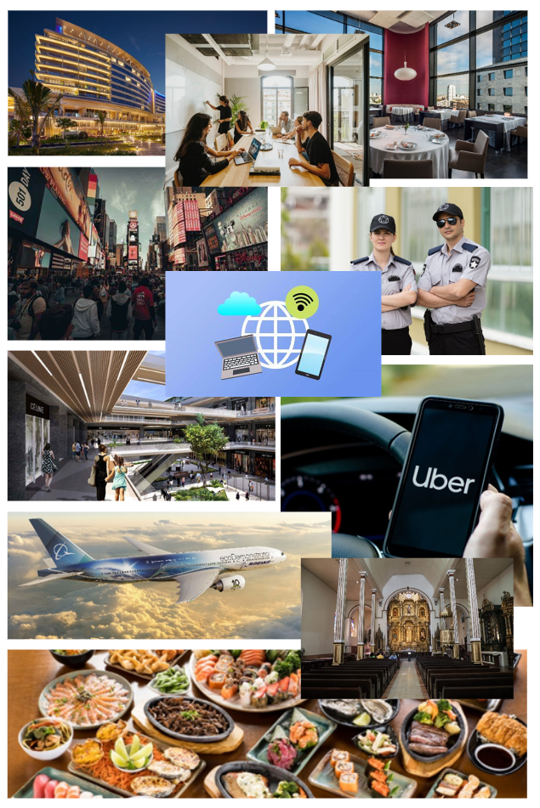
A well-located hotel with a beautiful view and a good internet connection offers a comfortable stay and is a place where I can rest and generate new business ideas. Additionally, it is very useful to have a quiet and private restaurant, as it represents an ideal space to conduct business comfortably and easily, away from the hustle and bustle. In this city, the tall, modern buildings highlight the importance of the city's growth and the variety of corporations present, fostering the emergence of new projects and ideas. The existence of plazas is due to the need for spaces of entertainment and leisure, which are important to avoid stress and boredom during business trips. The safety of the city is paramount, providing tranquility and confidence, which are essential for anyone traveling on business. For transportation, Uber and the airplane symbolize safety, comfort, and even the speed of getting around the city, whether to the hotel, restaurant, or any other location. I believe the church represents a place of refuge that provides tranquility, clarity, and confidence, especially for those with religious beliefs, where I can find assurance in my decisions. Food highlights the importance of good nutrition, which is essential for maintaining energy and well-being during trips. Internet services are crucial as a means of communication for all aspects of business travel, necessary for working and staying in touch, as well as improving meeting spaces. In the hotel, the need for suitable places to handle important project details and successfully close deals is evident.
Gender: Male
Age: 22 years
Occupation: Student
Geographic Location (delegation or municipality): Cuajimalpa de Morelos, CDMX
Nationality: Mexican
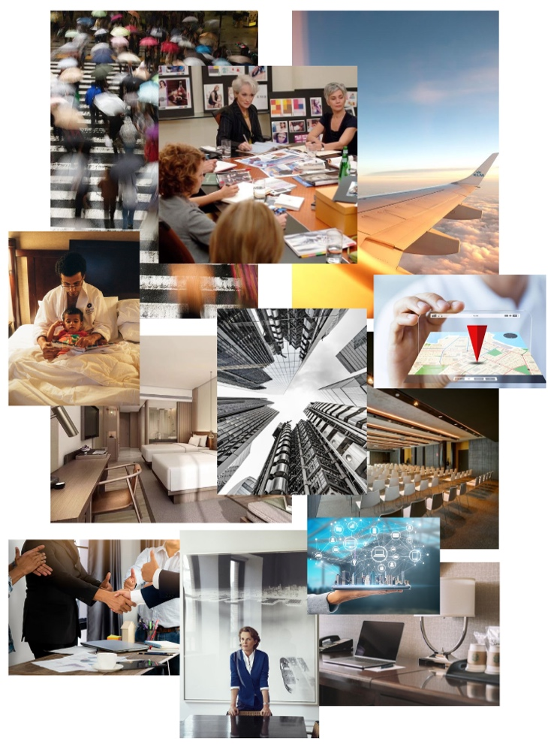
The Business Traveler’s Journey. In this collage, we can see the rhythm of a fast-paced city, full of modern and imposing corporate buildings, representing the energy that emanates from such cities. Also, in the image of the meeting, we can see the tense emotions experienced in business meetings. As for the airplane, it symbolizes the comfort and speed with which you can reach your destinations, demonstrating their efficiency for executives. The image of the executive room shows the need for comfortable and well-equipped workspaces. Business conferences require an adequate space to be conducted correctly, as the environment greatly influences people's moods. The image of the seriousness of the meetings encapsulates the professionalism and focus required in business trips. Besides all this, the hotel needs to be in an excellent location, near key places and business centers, and the workspace highlights the necessary functionality and comfort for efficient work, as well as the connectivity and technology needed for excellent infrastructure to develop projects. Finally, I believe the image of the goal of closing successful deals reflects the primary objective of business trips: creating and building fruitful relationships.
Gender: Male
Age: 55 years
Occupation: Business Executive
Geographic Location (delegation or municipality): Azcapotzalco
Nationality: Mexican
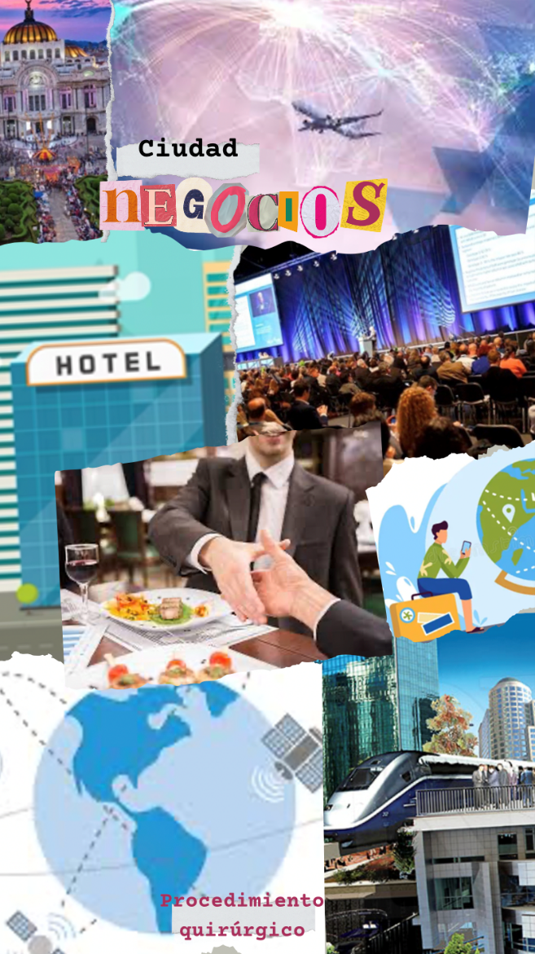
The central image of the handshake mainly reminds me of the objective of the business trip, which could be a negotiation to close an agreement or to open new markets. The peripheral images also remind me of all the logistics and planning required to arrange these meetings. It also makes me think of all the feelings involved in traveling to a different place, as well as the technological tools I need to continue working across borders.
Gender: Female
Age: 20 years
Occupation: Student
Geographic Location (delegation or municipality): Azcapotzalco
Nationality: Mexican
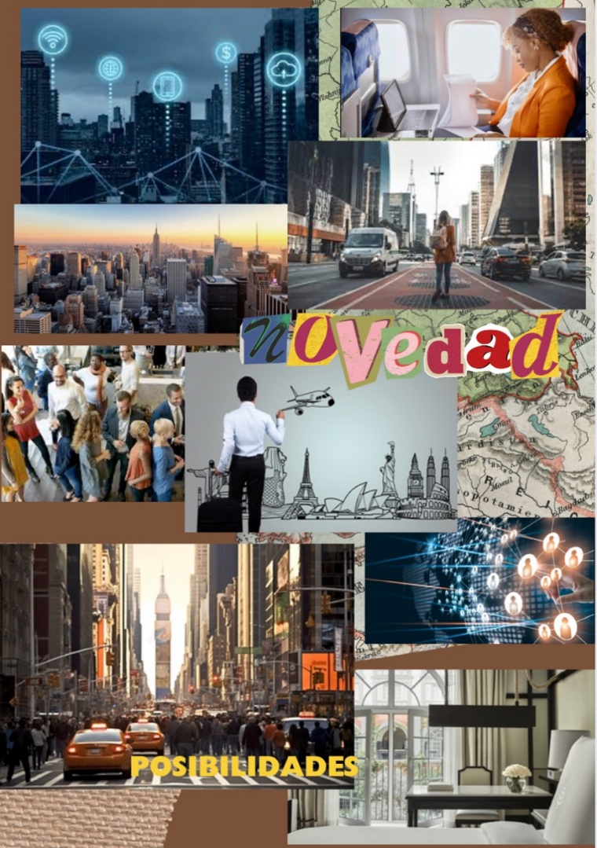
To begin with, a business city represents a highly interconnected place, with networks that connect the entire city. It has the necessary resources to host and accommodate events of this type, with the technological resources required. It is a city where people from all over the world converge, representing an exchange point. For me, it is also a city that conveys comfort, security, and makes you feel at home, even if you are miles away, thanks to the care received during the journey to the destination and the amenities the city offers, such as lodging and interactions with people. On the other hand, there is also the work aspect, the reason you're here, whether it is to achieve a specific goal, like closing a deal, or perhaps you are there to expand your network, gain experience, receive training, acquire new knowledge, etc. In a large city, like I consider a business city, there are plenty of possibilities and opportunities for growth. However, at times, this type of trip may carry a deeper emotional weight, like the pressure of not letting anyone down, even yourself, or the overwhelming feeling of unfamiliarity in a new city, feeling small in front of a big city, facing the unknown, contrasting with feelings of excitement and intrigue.

