Supplementary material.

Appendix A: Scenarios

Using public Wi-Fi
Pat is an employee of your company working in the finance department and has been given authorized access to a company database that stores sensitive financial information. One day during the weekend, Pat walked to a coffee shop 5 minutes away from home to meet with a friend for an hour. Halfway through the meeting, Pat received a call from a coworker asking Pat to check a financial number in the database right away. Your company policy prohibits accessing this database using public Wi-Fi because most free wireless connections and communications are not encrypted and may be intercepted by hackers. Pat was aware of this company policy. However, Pat didn't want to end the meeting to walk back home to use private Wi-Fi. Instead, Pat chose to use the public Wi-Fi in the coffee shop to access the company database.

Sending an unencrypted confidential email
Pat is an employee of your company working in the finance department. One day at work, Pat was asked to send some confidential financial data to a coworker immediately. Your company policy requires employees to encrypt confidential outgoing emails because unencrypted emails may be intercepted and read by hackers, although the policy doesn’t literally specify any punishment for violation or rewards for compliance. Pat was aware of this company policy. However, it was already time to leave work and the encryption software needed to be updated before encrypting the email. Pat needed to hurry for a live concert that evening and Pat didn’t want to update the encryption software and be late for it. Instead of updating the encryption software and encrypting the email, Pat chose to send out the financial data without encryption.

Not using VPN
Pat is an employee of your company working in the finance department and has been given authorized access to a company database that stores sensitive financial information. One day on a business trip, Pat received a call from a coworker asking Pat to check a financial number in the database immediately. Your company policy requires employees to use VPN when accessing company database remotely because unsecured connections and communications may be intercepted by hackers, although the policy doesn’t literally specify any punishment for violation or rewards for compliance. Pat was aware of this company policy. However, Pat’s laptop already ran out of storage and Pat didn’t want to delete personal files for the VPN software installation. Instead, Pat chose to use the local Wi-Fi without VPN to access the company database.

Appendix B: Additional Figure B1 and Tables B1-B3
Figure B1: Research Model
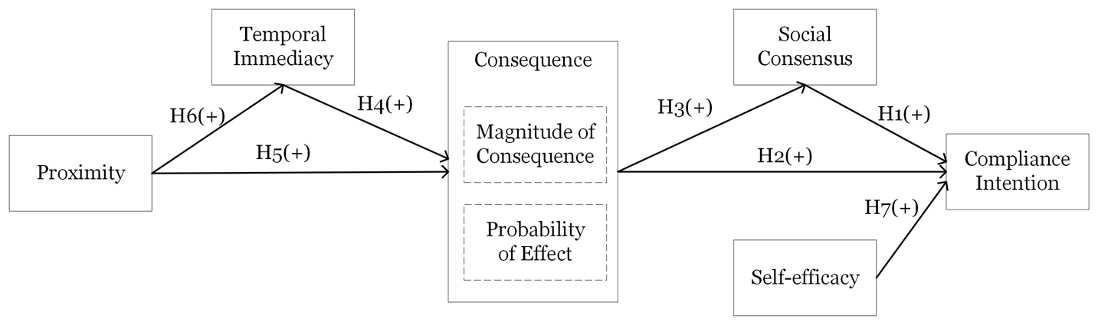

Table B1: Measurement items; Source(s): By authors
Constructs
Magnitude of consequence
MGN1: I anticipate that the overall damage to my company (if any) resulting from Pat’s action would be significant.
MGN2: I anticipate that the negative effects of Pat's action on my company would be serious.
MGN3: I anticipate there would be ______ (none - significant) damage to my company resulting from Pat’s action.
Probability of effect
PRB1: I anticipate that Pat’s action would have a strong likelihood of having a negative impact on my company.
PRB2: I anticipate that Pat’s action would have a high probability of exposing the company data to hacks.
PRB3: I anticipate that the probability of significant damage to my company resulting from Pat's action would be _________ (0% - 100%).
Temporal immediacy
I anticipate that any negative consequences for my company caused by Pat’s action would likely occur _______.
TI1: after a long time – immediately
TI2: slowly – quickly
TI3: gradually - rapidly
Social consensus
SC1: I believe most people in my company would consider Pat’s action wrong in that situation.
SC2: I believe most people in my company would agree that sending a confidential email without encryption is the wrong thing to do in that situation.
SC3: I believe most people in my company would agree that Pat's action in that situation is unethical.
Proximity
PROX1: This is MY company.
PROX2: I feel a very high degree of personal ownership for my company.
PROX3: I sense that this is MY company.
PROX4: I always think about my company as MINE.
Self-efficacy
SE1: If I were in Pat’s situation, updating the encryption software and encrypting the confidential email would be entirely under my control.
SE2: If I were in Pat’s situation, I would have the freedom to update the encryption software and encrypt the confidential email.
SE3: If I were in Pat's situation, it would be easy for me to update the encryption software and encrypt the confidential email.
Compliance intention
INT1: I would not have done what Pat did in that situation.
INT2: I couldn’t see myself sending the confidential email without encryption as Pat did in that situation.
INT3: If I were in Pat's situation, I would have updated the encryption software and encrypted the confidential email.

Table B2: Sample demographics (N=469); Source(s): By authors
Variable | Category | Number of respondents | Percentage (%)
Age | 18-25  26-35  36-45  46-55  >55 | 26  172  139  87  45 | 5.54  36.67  29.64  18.55  9.59
Gender | Male  Female  Other | 236  232  1 | 50.32  49.47  0.21
Education | Some college  2-year college degree  4-year college degree  Postgraduate degree | 58  34  275  102 | 12.37  7.25  58.64  21.75
Job experience | 2 to 3 years  3 to 10 years  Over 10 years | 107  242  120 | 22.81  51.60  25.59
IT/IS position | Yes  No | 87  382 | 18.55  81.45
Managerial role | Yes  No | 149  320 | 31.77  68.23
Industry | Information  Finance and Insurance  Manufacturing  Retail Trade  Health Care and Social Assistance  Educational Services  Professional, Scientific, and Technical Services  Other | 112  65  59  43  41  33  28  88 | 23.88  13.86  12.58  9.17  8.74  7.04  5.97  18.76
Firm size | <10  11–250  251–500  501–1,000  1,001–5,000  5,001–10,000  >10,000 | 18  137  94  84  62  28  46 | 3.84  29.21  20.04  17.91  13.22  5.97  9.81

Table B3: Results of mediation effect testing; Source(s): By authors
Path |  | Est. (β) | Mean | SE | t | 95% C.I. | 95% Bias-corrected C.I.
Path: PROX→TI→CNS
a | PROX→TI | 0.26** | 0.26 | 0.05 | 5.10 | (0.16, 0.35) | (0.16, 0.35)
b | TI→CNS | 0.37** | 0.37 | 0.05 | 7.76 | (0.28, 0.47) | (0.28, 0.47)
c’ | PROX →CNS | 0.37** | 0.37 | 0.05 | 7.36 | (0.27, 0.46) | (0.27, 0.46)
a×b | PROX→TI→CNS | 0.10** | 0.1 | 0.02 | 4.08 | (0.05, 0.14) | (0.05, 0.15)
C | PROX →CNS | 0.46** | 0.46 | 0.05 | 10.18 | (0.37, 0.55) | (0.37, 0.55)
 | Effect size: | 20.8%
Path: PROX →CNS→INT
a | PROX →CNS | 0.37** | 0.37 | 0.05 | 7.36 | (0.27, 0.46) | (0.27, 0.46)
b | CNS→INT | 0.28** | 0.27 | 0.06 | 4.95 | (0.17, 0.38) | (0.17, 0.39)
c’ | PROX →INT | -0.11** | -0.11 | 0.04 | 2.92 | (-0.19, -0.04) | (-0.19, -0.04)
a×b | PROX→CNS→INT | 0.10** | 0.1 | 0.02 | 4.07 | (0.06, 0.15) | (0.06, 0.16)
C | PROX →INT | 0.11** | 0.11 | 0.05 | 2.47 | (0.03, 0.2) | (0.03, 0.21)
 | Effect size: | 90.30%
Path: CNS→SC→INT
a | CNS→SC | 0.52** | 0.52 | 0.04 | 13.4 | (0.44, 0.59) | (0.44, 0.59)
b | SC→INT | 0.49** | 0.49 | 0.07 | 7.09 | (0.35, 0.62) | (0.36, 0.63)
c’ | CNS→INT | 0.28** | 0.27 | 0.06 | 4.95 | (0.17, 0.38) | (0.17, 0.39)
a×b | CNS→SC→INT | 0.25** | 0.25 | 0.04 | 5.95 | (0.17, 0.34) | (0.18, 0.34)
C | CNS→INT | 0.53** | 0.53 | 0.05 | 9.7 | (0.42, 0.63) | (0.42, 0.63)
 | Effect size: | 47.70%
Path: TI→ CNS→ INT
a | TI→ CNS | 0.37** | 0.37 | 0.05 | 7.76 | (0.28, 0.47) | (0.28, 0.47)
b | CNS→ INT | 0.28** | 0.27 | 0.06 | 4.95 | (0.17, 0.38) | (0.17, 0.39)
c’ | TI→ INT | -0.08* | -0.08 | 0.04 | 1.94 | (-0.16, 0) | (-0.16, 0)
a×b | TI→ CNS→ INT | 0.10** | 0.1 | 0.02 | 4.22 | (0.06, 0.15) | (0.06, 0.16)
C | TI→ INT | 0.12** | 0.12 | 0.05 | 2.57 | (0.03, 0.21) | (0.03, 0.21)
 | Effect size: | 87.30%
Note: CNS=consequence; TI=temporal immediacy; SC=social consensus; PROX=proximity; INT=intention
SE: Standard error; 95% C.I.: 95% confidence interval; Bias-corrected 95% C.I.: Bias-corrected 95% confidence interval
**p<0.01; *p<0.05

