APPENDIX

Voice Behavior (Van Dyne & LePine, 1998)
- I develop and make references to my supervisor concerning issues that affect my work
- I speak up and inspire others in my work unit to get involved in issues that affect our work
- I communicate my opinions about work issues to others in my company even if others disagree with me
- I am knowledgeable about issues at work where my opinions can be useful
- I get involved in issues that affect the quality of life in my department
- I speak up to my manager with ideas for new ideas for new projects or changes in procedures at work

Power Distance (Dorfman & Howell, 1988)
- Managers should make most decisions without consulting subordinates
- It is frequently necessary for a manager to use authority and power when dealing with subordinates
- Managers should seldom ask for the opinions of employees
- Managers should avoid off-the-job social contacts with employees
- Employees should not disagree with management decisions
- Managers should not delegate important tasks to employees

Security Concerns (Workman et al, 2008)
  - I take measures to protect my information from security violations
  - I take precautions against information security violations
  - I use information security protections
  - I have witnessed information security violations
- I have personally experienced information security violations

Affective Commitment to the Organization (Allen & Meyer, 1990)
  - I would be very happy to spend the rest of my career with this organization
  - I enjoy discussing my organization with people outside it
  - I really feel as if this organization’s problems are my own
  - I could not easily become as attached to another organization as I am to this one
  - I feel like part of the family at my organization
  - I feel emotionally attached to this organization
  - This organization has a great deal of personal meaning to me
  - I feel a strong sense of belonging to my organization
Intention to Change Due to Voice (Dutton & Ashford, 1993; Oc et al., 2015)
As the manager in the scenario above, rate how likely you would respond to the recommended security changes:
- Likelihood of change
  - Speed of change
  - Resources allocated to change
  - Investigate how other organizations have proceeded with this recommendation
Table A1. List of Scales and Items. All items ranged from 1-Strongly Disagree to 5-Strongly Agree.

Voice Type | Combinations of Employee (E) and Manager (M)
Voice Type | Male E  Male M | Male E  Female M | Female E  Male M | Female E Female M
Promo | 4.22 (0.5)  N = 18 | 4.55 (0.4)  N = 18 | 4.25 (0.6)  N = 16 | 4.19 (0.6)  N = 19
Prevent | 4.27 (0.6)  N = 17 | 4.44 (0.5)  N = 18 | 4.11 (0.8)  N = 17 | 4.28 (0.6)  N = 18
Prohibit | 4.11 (0.5)  N = 17 | 4.12 (0.6)  N = 19 | 3.96 (0.6)  N = 18 | 4.05 (0.5)  N = 19
Hostile | 4.09 (0.5)  N = 18 | 4.20 (0.8)  N = 16 | 3.62 (0.9)  N = 17 | 3.86 (0.6)  N =18
Table A2. Descriptive statistics for behavioral intent to change, Means (SD).

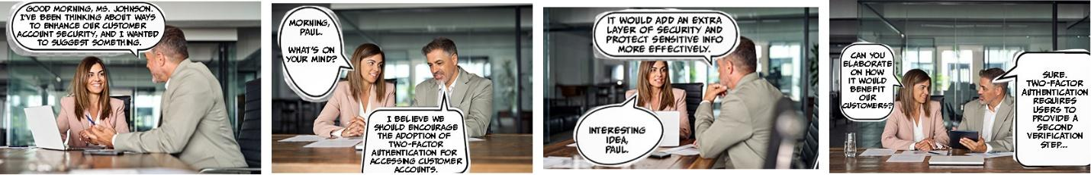

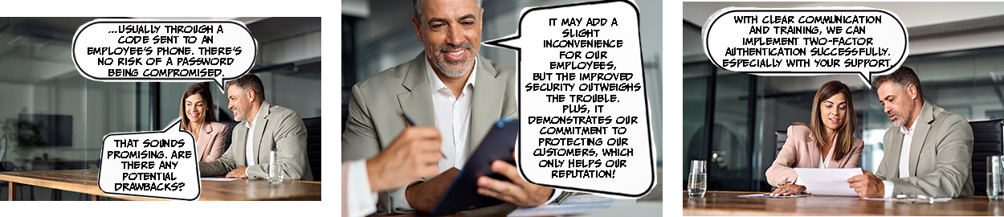
Figure A1. Example vignette (promotive voice from male employee to female manager)

