Appendices
Appendix A: Survey questions for studies 1, 2 and 3
Job pursuit intention – Studies 1 and 2
Very likely | Likely | Somewhat  likely | Neither likely or unlikely | Somewhat unlikely | Unlikely | Very unlikely
How likely would you be to contact the company for more information about the job being offered?
(1) | (2) | (3) | (4) | (5) | (6) | (7)
How likely would you be to ask for a job application?
(1) | (2) | (3) | (4) | (5) | (6) | (7)
How likely would you be to complete the job application process?
(1) | (2) | (3) | (4) | (5) | (6) | (7)
How likely is it that you will actually receive a job offer from this company?
(1) | (2) | (3) | (4) | (5) | (6) | (7)
How likely would you be to accept the job if it were offered to you?
(1) | (2) | (3) | (4) | (5) | (6) | (7)

Job appeal – Studies 1, 2 and 3
Agree completely | Agree | Somewhat  agree | Neither agree or disagree | Somewhat disagree | Disagree | Disagree completely
This job is appealing.
(1) | (2) | (3) | (4) | (5) | (6) | (7)
I think I could enjoy this job.
(1) | (2) | (3) | (4) | (5) | (6) | (7)
This is not a job I would want.
(1) | (2) | (3) | (4) | (5) | (6) | (7)
This company would be a good employer.
(1) | (2) | (3) | (4) | (5) | (6) | (7)
This job looks interesting.
(1) | (2) | (3) | (4) | (5) | (6) | (7)
This company seems like a great place to work.
(1) | (2) | (3) | (4) | (5) | (6) | (7)

Job fit – studies 1 and 2
Very likely | Likely | Somewhat  likely | Neither likely or unlikely | Somewhat unlikely | Unlikely | Very unlikely
I could fit in well at this company.
(1) | (2) | (3) | (4) | (5) | (6) | (7)
I’m similar to the people who work in this career.
(1) | (2) | (3) | (4) | (5) | (6) | (7)
My values and this company’s values are similar.
(1) | (2) | (3) | (4) | (5) | (6) | (7)
The type of people who would apply for this job are very different from me.
(1) | (2) | (3) | (4) | (5) | (6) | (7)

Ad informativeness – study 1, 2, and 3
Agree completely | Agree | Somewhat  agree | Neither agree or disagree | Somewhat disagree | Disagree | Disagree completely
This job advertisement provides potential applicants with a comprehensive picture of the jobs being offered.
(1) | (2) | (3) | (4) | (5) | (6) | (7)
In general, this job ad provides a good description of the company.
(1) | (2) | (3) | (4) | (5) | (6) | (7)
I believe this job advertisement is very informative.
(1) | (2) | (3) | (4) | (5) | (6) | (7)
The advertisement provided enough detail for me to decide whether the job openings would be a good fit for me.
(1) | (2) | (3) | (4) | (5) | (6) | (7)

Personality traits – study 2
I see myself as someone who… | Agree strongly | Agree a little | Neither agree or disagree | Disagree a little | Disagree strongly
- is reserved | (1) | (2) | (3) | (4) | (5)
- is generally trusting | (1) | (2) | (3) | (4) | (5)
- tends to be lazy | (1) | (2) | (3) | (4) | (5)
- is relaxed, handles stress well | (1) | (2) | (3) | (4) | (5)
- has few artistic interests | (1) | (2) | (3) | (4) | (5)
- is outgoing, sociable | (1) | (2) | (3) | (4) | (5)
- tends to find fault with others | (1) | (2) | (3) | (4) | (5)
- does a thorough job | (1) | (2) | (3) | (4) | (5)
- gets nervous easily | (1) | (2) | (3) | (4) | (5)
- has an active imagination | (1) | (2) | (3) | (4) | (5)
AI usage in HR - study 3
Have you used any artificial intelligence (AI) tool such as ChatGPT to develop or improve a job ad? a) Never b) Rarely c) Occasionally d) Very often
- Always
To what extent do you think the task of job ad writing job ads can be done automatically by using AI? a) Not at all b) Seldom c) Reasonable/sometimes d) Often
e) Almost always
What parts of the task of writing a job ad can be mainly done by an AI? (you can select several)
- Profile of the company b) Main tasks and roles in the job c) Profile of a candidate such as knowledge and skills, training and educational level, competencies d) Determining the salary level and range e) None of the above

Demographic information (see below)
What is your gender? a) Male b) Female c) Gender variant/non-conforming d) Not listed: e) Prefer not to say (all studies)
What is your age in years? (all studies)
What is your industrial experience in years? a) I don’t have any b) 0-2 years c) 3-6 years d) 7-12 years e) more than 12 years (all studies, slightly modified to include only experience in HR for study 3)
Have you ever applied to a job in the industry? A) yes B) no (studies 1 and 2)
Have you been involved in advertisement, recruitment and selection of a candidate for a position? a) No, I haven't been b) Yes, about 1-2 positions c) Yes, 3-5 positions d) Yes, 6-15 positions f) Yes, more than 15 positions (study 3)
Appendix B: Job Advertisements characteristics and example of the ad
Table B1: Characteristics of the three advertisements tested in the experiment
Advertisement characteristic | Advertisement
Advertisement characteristic | Real ad | AI-generatedn ad | Expert-written ad
Overall length | 553 words | 532 words | 547 words
Industry | Automotive (electrification of freight transport)
Required KSAOs (knowledge, skills, abilities and other characteristics) | Communication skills  Knowledge of MS office or related software and ERP systems  Knowledge of legal aspects of purchasing  Ability to compile information and make decisions  Ability to work under pressure  Organization skills and attention to detail
Other requirements | Bachelor’s degree in supply chain related field (preferred)  Experience in retail, purchasing or supply chain management  Some physical requirements such as office work and willingness to attend travel shows
Responsibilities | Assisting in the procurement of raw materials, products and services  Evaluate suppliers and negotiate contracts  Work with cross-functional teams  Manage inventory levels  Develop and maintain relationships  Conduct market research  Assist in development of purchasing strategies
Ad structure | Structured in bullet points with following headings:  Job summary Supervisory responsibilities  Duties/Responsibilities; skills/Abilities  Education and experience  Physical requirements  About company  Average Base Salary Estimate  Company overview | Structured in bullet points with following headings:  Industry:  Responsibilities  Qualifications  Physical requirements  Salary range  Why work for the company?  How to apply | Semi-structured in paragraphs with following headings:  Our company  The challenge  Procurement organization  Purchase category  Required skills  Rewards and benefits
Salary | Specified as an estimated range from the job board | Specified as a range | Specified as a range
Source: authors own work

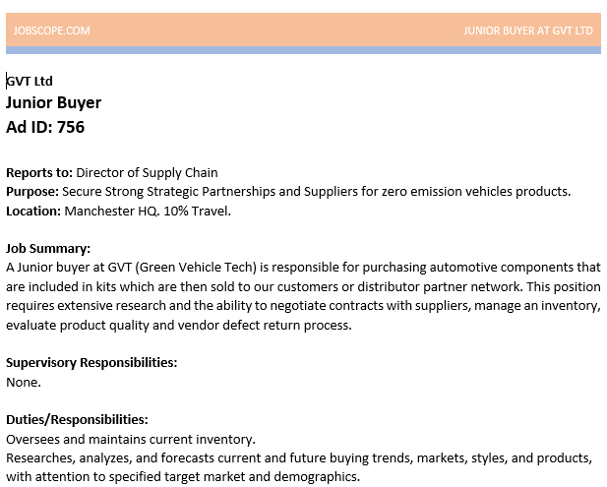
Figure B1: Example of the job advertisement shown to the respondents
Source: authors own work
Appendix C: Arguments for perceived and actual ad creator in Study 3
Table C1: Participant justifications for perceived authorship of job advertisements, categorized by actual and perceived creator
 | Actual creator |  | Perceived creator |  | Proportion |  | Participant justifications
Human |  | Correct  (human) |  | 28.6% |  | - Natural and cohesive language  - Feels personal, natural sentence structure  - No grammatical or spelling errors  - Invokes a conversation with a real person
 |  | Incorrect  (AI) |  | 71.4% |  | - Feels monotonous, lacks emotion  - Precise, perfect in every way, sounds very professional  - Too perfect to be human
AI |  | Correct  (AI) |  | 50% |  | - Feels generic, details are not personal  - Fact based, does not reflect company culture  - Contains strange sentences
 |  | Incorrect  (human) |  | 50% |  | - Factual and straight to the point  - Relatable wording and use of natural English  - Specific, containing large amount of detail  - Simple enough, not exaggerated
Note: Table C1 displays respondents’ explanations for their attribution of job advertisement authorship, organized by the actual creator (human or AI) and whether the ad was perceived as human- or AI-generated.
Source: authors own work

Table C2: Themes and illustrative quotes from HR professionals’ explanation of advertisement authorship
Theme | Description | Illustrative quote
Ambiguity | Respondents explicitly state they could not tell who authored the advertisement | “I could not tell the difference.”  “I’m not sure, to be honest.”
AI cues | AI authorship associated with monotony, keyword overuse or perfection | “Too perfect to be human.”  “Monotonous, just listing all details and requirements.”
Human cues | Human authorship linked to creativity, personal tone or professional expression | “Had a personalized touch only a human would add.”  “The use of expressions like ‘getting your hands dirty’ felt human”.
Note: Quotes are shortened for clarity. Themes are based on respondents’ explanations regardless of whether their attribution of authorship was correct or incorrect.

