Table SI The SAs of superhydrophobic surface sprayed with different ratios of stearic acid to TiO₂
Spraying times | SA (°)
Spraying times | 1:5 | 2:5 | 3:5 | 4:5
1 | 15.67 | 10.67 | 7.30 | 14.00
2 | 7.67 | 10.67 | 9.00 | 12.00
3 | 12.30 | 9.00 | 7.30 | 10.00
4 | 9.30 | 9.30 | 8.00 | 13.30
5 | 9.00 | 10.30 | 9.00 | 12.67
Authors own work

Table SII The CAs of the superhydrophobic surfaces prepared from TiO₂/PDMS hybrid system with or without sonication
Spraying times | CA (°)
Spraying times | with sonication |  | without sonication
1 | 152.09 | 150.20
2 | 155.04 | 150.38
3 | 155.48 | 151.33
4 | 150.95 | 151.22
5 | 151.35 | 149.58
Authors own work

Table SⅢ EDS analysis of original fabric, PDMS cotton fabric and SA-TiO₂/PDMS cotton fabric
Samples | Element weight (%) |  |  |  |  | Element atomic (%)
Samples | C |  | O | Si | Ti | C | O | Si | Ti
Original fabric | 45.08 | 54.92 |  | — | — | 52.23 | 47.77 | — | —
PDMS fabric | 42.67 | 52.23 |  | 5.10 | — | 50.76 | 46.64 | 2.60 | —
SA-TiO₂/PDMS fabric | 25.62 | 48.93 |  | 6.60 | 18.84 | 36.65 | 52.55 | 4.04 | 6.67
Authors own work

Table SⅣ Table of orthogonal analysis of factors influencing SA-TiO2/PDMS fabrics
Factors  Test No. | A (Proportion) | B (Times) | Blank | Experimental indicators
Factors  Test No. | 1 | 2 | 3 | CA(°)
1 | 1 (2:5) | 1 (2) | 1 | 147.72
2 | 1 | 2 (3) | 2 | 149.66
3 | 1 | 3 (4) | 3 | 148.47
4 | 2 (3:5) | 1 | 2 | 150.38
5 | 2 | 2 | 3 | 151.33
6 | 2 | 3 | 1 | 151.22
7 | 3 (3:5) | 1 | 3 | 148.64
8 | 3 | 2 | 1 | 150.06
9 | 3 | 3 | 2 | 148.99
K1j | 445.85 | 446.74 | 449 | T=$\sum_{i=1}^{9}{y_{i}}$=1346.47  $\overline{y}=\frac{T}{9}$=149.61
K2j | 452.93 | 451.05 | 449.03
K3j | 447.69 | 448.68 | 448.44
$$K_{\overline{1j}}$$ | 148.62 | 148.91 | 149.67
$$K_{\overline{2j}}$$ | 150.98 | 150.35 | 149.68
$$K_{\overline{3j}}$$ | 149.23 | 149.56 | 149.48
Rj | 7.08 | 4.31 | 0.59
Factor primary to secondary | A B
Optimum solution | A₂B₂
Authors own work

An orthogonal study of the experimental affecting factors was conducted using statistical analysis, and the results are presented in Table 2. The ratio of stearic acid, followed by the frequency of spraying, had the greatest impact on the fabric's superhydrophobic qualities. The ideal stearic acid to TiO2 ratio was 3:5, and three sprays were the ideal number. The orthogonal analysis and the experimental findings were in agreement.

Figure S1 Settling effect of TiO₂ nanoparticles in aqueous solution for different times, (a) 0 s; (b) 10 s; (c) 1 min; (d) 2 min; (e) 5 min; (f) 10 min
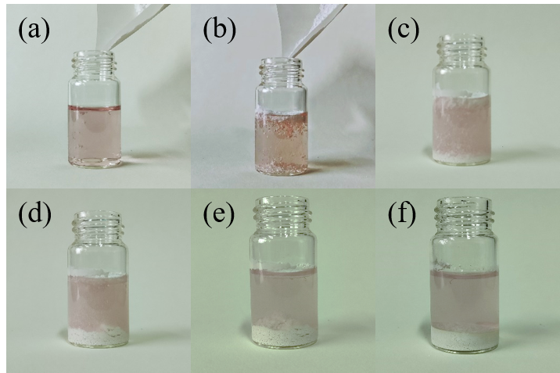
Authors own work

Figure S2 Settling effect of SA-TiO₂ nanoparticles in aqueous solution at different times, (a) 0 s; (b) 10 s; (c) 1 min; (d) 2 min; (e) 5 min; (f) 10 min
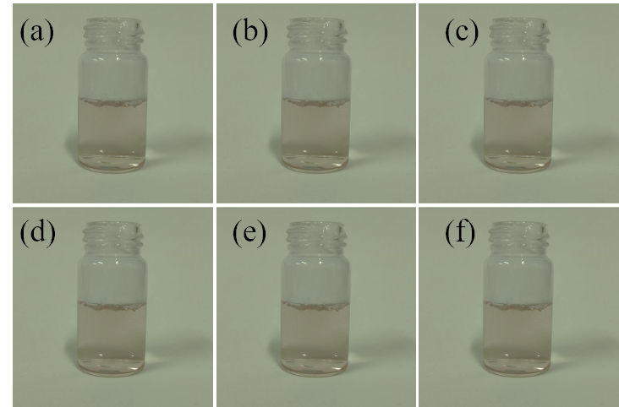
Authors own work

Figure S3 The CAs of fabric surface prepared with or without tension applied

Authors own work

Figure S4 The SAs of fabric surface prepared with or without tension applied
Authors own work

Figure S5 The mass of: (a) SA-TiO₂/PDMS fabric before slight flicking; (b) SA-TiO₂/PDMS fabric after slight flicking; (c) TiO₂/PDMS fabric before slight flicking; (d) TiO₂/PDMS fabric after slight flicking; (e) PDMS fabric before slight flicking; (f) PDMS fabric after slight flicking
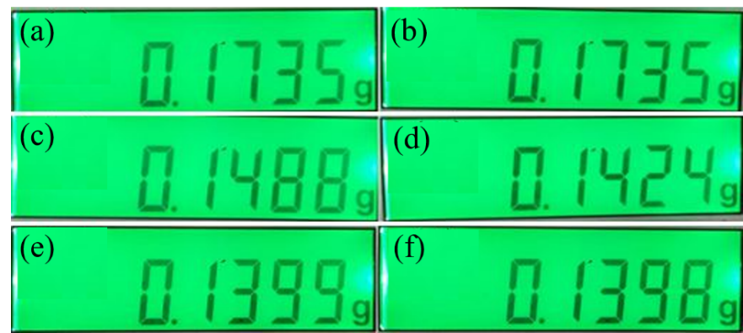

Authors own work

Figure S6 Residuals of six droplets after 1 minute on the surface of TiO₂/PDMS cotton fabric
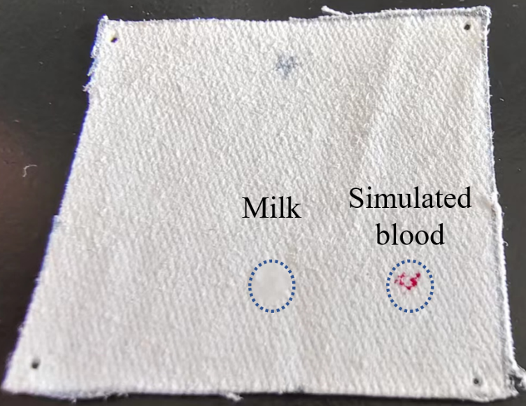
Authors own work

