SUPPLEMENTARY MATERIAL
Supplementary Figure 1. The reaction pathway of 7-diethylamino-3-acetylcoumarin dye. (Source: Authors own work)

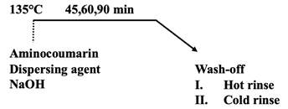  (a) | 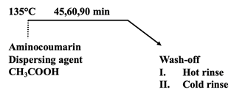  (b)
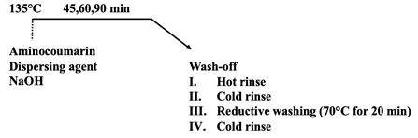  (c) | 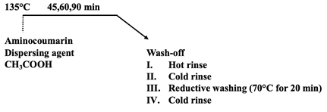  (d)

Supplementary Figure 2. Dyeing diagrams under different conditions: (a) Alkaline condition, after dyeing without reductive washing; (b) acidic condition, after dyeing without reductive washing; (c) alkaline condition, after dyeing with reductive washing; (d) acidic condition, after dyeing with reductive washing. (Source: Authors own work)

Supplementary Table 1. Codes of fabrics and their explanation (Source: Authors own work)
Sample Code |  | A45 | A45R | A60 | A60R | A90 | A90R
A: Acidic Condition | Minutes | 45 | 45 | 60 | 60 | 90 | 90
A: Acidic Condition | Reductive washing | - | + | - | + | - | +
Sample Code |  | B45 | B45R | B60 | B60R | B90 | B90R
B: Alkaline condition | Minutes | 45 | 45 | 60 | 60 | 90 | 90
B: Alkaline condition | Reductive washing | - | + | - | + | - | +

Supplementary Table 2. CIELab values of the conventionally dyed polyester fabric. (Source: Authors own work)
Samples |  | L* | a* | b* | C* | h | X | Y | Z | x | y
A45 | D65/10 | 75,12 | 17,58 | 75,66 | 77,68 | 76,92 | 52,41 | 48,47 | 7,25 | 0,4847 | 0,4483
A45R | D65/10 | 77,72 | 16,60 | 77,52 | 79,28 | 77,91 | 56,42 | 52,74 | 7,97 | 0,4817 | 0,4502
B45 | D65/10 | 79,11 | 20,49 | 65,59 | 68,72 | 72,65 | 60,49 | 55,12 | 12,78 | 0,4712 | 0,4293
B45R | D65/10 | 80,07 | 19,89 | 66,93 | 69,82 | 73,45 | 62,00 | 56,81 | 12,90 | 0,4707 | 0,4313
A60 | D65/10 | 72,20 | 18,32 | 72,45 | 74,73 | 75,81 | 47,99 | 43,95 | 6,77 | 0,4862 | 0,4453
A60R | D65/10 | 74,77 | 16,61 | 73,61 | 75,46 | 77,29 | 51,46 | 47,92 | 7,64 | 0,4809 | 0,4477
B60 | D65/10 | 72,01 | 21,17 | 63,96 | 67,37 | 71,69 | 48,73 | 43,67 | 9,07 | 0,4802 | 0,4304
B60R | D65/10 | 73,21 | 19,65 | 63,53 | 66,50 | 72,81 | 50,07 | 45,48 | 9,87 | 0,4750 | 0,4314
A90 | D65/10 | 70,32 | 19,07 | 58,59 | 61,61 | 71,97 | 45,38 | 41,20 | 9,86 | 0,4706 | 0,4272
A90R | D65/10 | 71,49 | 18,51 | 57,10 | 60,03 | 72,04 | 46,97 | 42,91 | 11,05 | 0,4654 | 0,4251
B90 | D65/10 | 71,08 | 15,60 | 69,28 | 71,02 | 77,31 | 45,32 | 42,30 | 7,09 | 0,4785 | 0,4466
B90R | D65/10 | 71,49 | 12,47 | 66,48 | 67,64 | 79,37 | 44,84 | 42,90 | 8,05 | 0,4681 | 0,4478

Acidic (A45)  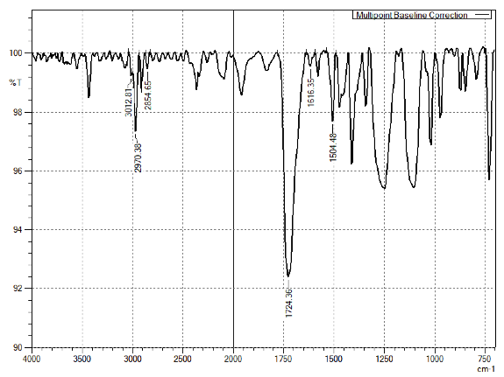 | Alkaline (B45)  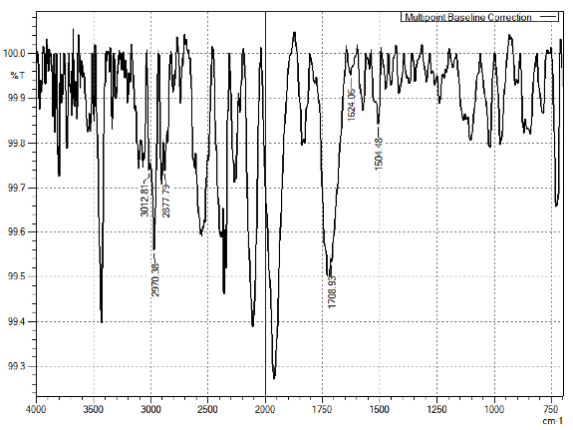
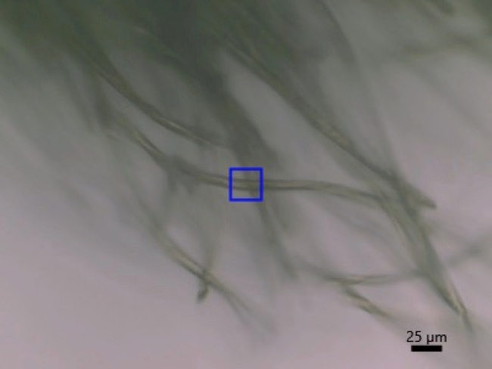 | 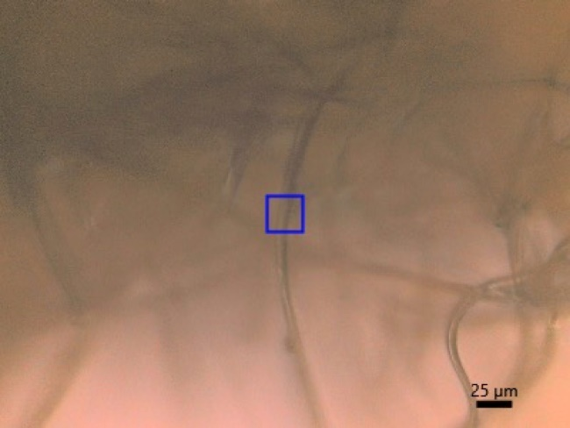

Supplementary Figure 3. The Micro FT-IR spectra of coumarin dyed polyesters (A45 and B45) in acidic and alkaline conditions. (Source: Authors own work)
Supplementary Figure 4. Intermolecular interaction of 7-diethylamino-3-acetylcoumarin on the polyester surface modeled by DFT. (Source: Authors own work)

