Appendix #1 Participant List (anonymized with assigned pseudonyms)
EMMMP2M | 1 | Mateo
EMBLP1M | 2 | Brian
EMLJP4F | 3 | Leslie
SDADP1F | 4 | Kaylee
SDRWP2F | 5 | Leigh
SDKEP3F | 6 | Amy
RLKYP1F | 7 | Kelsey
RLESP2F | 8 | Liz
RMBNP2X | 9 | Luna
MDNCP1M | 10 | Tim
MDATP2M | 11 | James
MDSRP3X | 35 | Jules
MDSTP5F | 12 | Amber
VMBAP1F | 13 | Ava
VMOHP2X | 14 | Oscar
VMMCP3F | 15 | Eve
ZHKDP1F | 16 | Olivia
ZHIHP2F | 17 | Aria
ZHAWP3F | 18 | Annie
LSRRP1F | 19 | Brittany
LSCAP2M | 20 | Rowan
LSDFP3M | 21 | Blake
SMRWP1M | 22 | Lucas
SMCCP2F | 23 | Charlotte
SMOMP3M | 24 | Asher
MDEPP1M | 25 | Noah
MDSBP3M | 26 | Ezra
STNGP1M | 27 | Louis
STCTP2M | 28 | George
EKAKP1M | 29 | David
EKDTP2F | 30 | Zuri
EKAVP3F | 31 | Maya
HMACP1F | 32 | Ashley
HMPCP2F | 33 | Mila
HMETP3M | 34 | Evan

Authors work

Appendix #2 Interview Questions
Engagement Questions
- What are you involved in?
  - Prompt: sports, arts, community, school
- Why are you involved in these activities?
  - Internal drivers like, fit, learning something new, getting good at something, mastery
  - External drivers like, social, feedback, coaching, rewards
- What do you like about being involved in these activities?
  - Prompt: relevant, interesting, something you are passionate about
- What do you get out of these activities?
  - Prompt: meaningful, belonging
- If you stopped an activity, why did you stop?
- What gets in the way of you being involved?
  - Prompt: barriers like money, distance, supports, pandemic, school
- Because school occupies a lot of your time, does school also provide an outlet for you to explore your passions?
  - Prompt: clubs, sports, activities
- Are there many options for you? Are options limited? Why?
- Tell me about the adults that support the activities you are involved in? What good characteristics do they have?
  - Prompt: supportive, committed, fun, understanding
- How do we get you involved, what motivates you to try something new?
- Do you play games, what do you like about games?
  - Prompt: mastery, rewards, social, fun
- Does learning something new and getting good at something help you stay involved?

Authors work
Table #1 Examples of Engagement Activities
Form of Engagement | Example | Form of Engagement | Example
Formal | Volunteering | Informal | Crafts
Skilled | Work | Unskilled | Tasks or Chores
Individual | Hobbies | Collective | Events or Holidays
Obligatory | Homework | Pleasure-Seeking | Rest
Physical | Sports | Body-Fixed | Games
Educational | Academics | Nescient | Social Media

Authors work
Table #2 Motivations
Motivations
Motivation | Definition | Examples
Responsibility | A desire to please or satisfy others, care for others. A duty or formal obligation. | “Well, I'm involved in work to get paid, because I need to pay my bills […] But yeah, work because like, that’s something everyone has to do” [David].  “I'm working at [place of work]; um, I need the money to pay my bills. It's good, because it's a good learning experience. Socialization is good. Um, [I like] being able to meet new people, being able to socialize, being able to help the customers, my coworkers. [I get] a sense of belonging maybe, being there” [Eve].
Altruism | Demonstrating selflessness, prioritizing others and their needs; authentic and sincere | “I mean, mostly, some of the stuff I do is to help my nan and other stuff; just because” [Louis].  “I have been trying to volunteer- sometimes many people have volunteered and only so many are needed- around the community a bit, [for example at] used book sales. I have also made a commitment to help make and sell items in a booth on some holidays as a fundraiser. I have volunteered my time to help teach the young kids at the gym” [Olivia].  “[Being involved] makes me feel more like I'm doing something with my life […] I like to do things, because it makes me feel like I'm putting more into my life” [Aria].
Accomplishment | A feeling of satisfaction, pride, completion and external validation. A desire for praise. | “I like feeling the, the improvement and feeling success of all the hard work I've put into the activities. It's mostly just seeing myself improved. That keeps me going” [Evan].  “My brain thinks that if I do more things throughout the day, and I like, try and volunteer, or do more things just in general that's not just sitting in my room rotting; I feel like a better person. I feel like I can grow more” [Oscar].  I got a better perspective on life, a way to channel emotions of what I’m feeling into something, a sense of belonging and being a part of something. I also get lots of dopamine from being a part of these activities, which I believe is an amazing benefit as it makes me feel happy” [Olivia].
Proficiency | Fluent and knowledgeable, confident and deeply skilled. | “Learning something new would definitely help me get involved. Because like if I'm already doing something that I like, but like you know when you're stuck at like a standstill? Because you, you know what you're doing. But like it almost like, you get more in-depth to the situation already because you learn something new about it? That's why I like it, because you already are kind of good at it… and then you keep learning something new and then you get to do like, expanding further. That's fun, because then you get to like, switch it up. You know?” [David].  “For art, well, that's... the one thing that I get, like, the sense- a sense of belonging in. And like I've always felt like, that's where I need to be, and what I need to do. And that's where I know everything. Or not everything, but I mean, that's just where I, I know how to do this. And I can tell people how to do it without feeling confused or anything; like, I just know” [Kaylee]
Enjoyment | Feelings of joy, passion, euphoria, fun, promoting positive emotions. | “Baking. Yean, I enjoy that” [David].  “Decorating stuff. Like doing crafts, making bracelets. I love doing that because that’s just awesome” [Zuri].  “When it comes to games and stuff like that, I'm usually doing them because it's competitive and it's fun” [Asher].
Pressure | Pressures to represent, to participate, to compete, or even to disrupt or challenge. | “Well, I think, like, what motivates me is wanting to become somebody someday. I want to be a little bit famous with it” [Charlotte].  “To just show people that I can do it. Not really anything else” [Louis].  “Well, I’m involved in GSA because I am queer, and I would like to spread awareness. And just kind of, um, it’s kind of my mojo; so, I’m a part of that to…explain who I am and who I’m becoming and how it’s okay to be who you are ‘n stuff” [Lucas].
Social Connection | To interact with others. To be with friends and/or family or to make new connections. | “I think something that motivates me to try something new is, um, my friends doing it. I feel like, it's kind of like the extra reassurance that I'm not going into something by myself, and I have people with me for it” [Asher].  “Um, I like the feeling of, when I play soccer, staying as a team and working together with people” [Evan].  “I feel like the people who most impact me and my choices and the things that I want to branch out and do, even if I don’t wanna do them, but trying new things - definitely my friends” [Lucas].
Education Imperative | A desire to learn, to become better, gain knowledge and grow. | “I would say the thing that motivates me the most to try something new is just for that new experience. You know, I think to myself, ‘What would my life be like if I hadn't done this? What am I missing out on?” [Evan].  “Well, I'm involved in the environment club, because I'm interested in it. And I also feel like, it would help me, you know, pursue the education I want to pursue after high school” [Brittany].  “I find I get like, better [over time] with like, certain skills. They’re transferable” [Charlotte]
Escapism | To retreat, to distract from other things, including obligations or pressures. | Like for me, I find that I lose... like I lose myself in things sometimes [Noah].  “I do play video games. Not as much as I used to, but I do play them. And it's just like a way to like, not think about everything in like… like future stuff, or like, my life. I just kind of unwind and just play the game” [Mateo].  “[When] I get to play with my friends, it sometimes can take me out of the real world and I just get to like... chillax” [Ezra].

Authors work
Table #3 Barriers and Enablers
Enabler or Barrier | Examples (Positive and Negative)
Adult Involvement | “Um, for school-wise, absolutely not. Um, it is very, like- you do kind of the same things every day, and there’s not a lot of teachers out there who will kind of form their own like criteria and stuff like around the students” [Lucas].  “Well, my coach on the swim team has really pushed me to keep getting better, and I really thank her for that. All of my coaches actually have been really helpful. And my parents being there for me; driving me everywhere. Yep. Super supportive.” [Evan]  “Well, I think it's very good for adults to facilitate different activities and stuff to motivate, like, youth leadership and stuff. Because when kids are doing activities, they're not usually doing it to be told what to do. It's the opposite. So, it's very nice when the person facilitating that makes a point of kind of putting you in charge of how to... how you want to handle stuff” [Blake].
Access | “Previously, like without having a license, I couldn't get drives” [Mila].  “Um, when I was younger, I used to do gymnastics. And I'm in a military family, so I had to move away. And there were no gymnastic places within like an hour” [Evan].  “I mean, I never really have the opportunity to like to get into stuff because usually other people are already there first. First come first serve” [Louis].  “I- there's a lot of, a bit of everything you can do, for... Yeah, about anything; at school.” [Mila].
Availability | “There's quite a lot of options […] Well, there's lots of stuff you can do” [Ezra].  “I think they are very limited, because the school with its extracurriculars tries to, I don't know, give a wide variety of different things. But a lot of them are not things that I would ever be interested in. Yeah, just my personal point of view” [Aria]  Yeah, because they [school] have a bunch of sports teams and groups of like, things I'm interested in. And you can see all your friends, maybe you're out there or they’re on the same team as you. Yeah, there's many options. I think it's like most mostly what you like, personally. And if you have friends, then you can play with them… and like, you have a fun time.” [George]
Time | “Genuinely just time [gets in the way of involvement]; my schedule is usually either very busy or empty. It's all or nothing. Honestly, I- lately; it's been everything. I'm very busy currently, and it's not fun” [Oscar].  Because I don't have a lot of time. I mean, that's probably the main reason I don't [get involved with more]. I go to school most of the day; I work mostly- like, four or five nights out of the week. So, I don't have a lot of time” [Brittany].
Physical Ability | “My options are limited because I'm [disabled]. And semi-poor (laughs)” [Annie].  “When you get good at something it, like, pushes you to keep going. If you're not good at it, then you would not want to keep going” [Mila].  “I had to stop playing hockey because it was hurting my back too much” [Amy].
Mental & Emotional Ability | “So, I did end up recently stopping volleyball; I was not exactly halfway through the year- well, the club season. But I had to stop it just because I [was] deal[ing] with a lot of stress. And stress can really make me not feel motivated to do a whole lot of stuff. And I really needed to take that motivation and use it for my art because I, that's where I want to be in the future” [Kaylee].
Technology | “Writing, like, I really enjoy it. But like, I don't even have like a computer anymore. So when am I ever gonna go write? Am I gonna hand-write stuff?” [David].  I used to but it’s not something I’m super interested in now, mainly because the Wi-Fi is so slow that nothing is able to work” [Asher].
Environment | “I feel like it's definitely important just to make sure that like you're creating a space where everyone feels comfortable to be involved in an activity of some sort” [Brittany].  “I stopped theatre as the school year is over, and the production only lasted so long. I stopped dance as I had to change dance teachers and was tired of constantly being criticised and told I'm not doing things/movements properly when I don’t have enough joint mobility to do so and had made that clear. Mixed martial arts got too competitive, and everything was about the next competition and the next chance to win and was no longer fun, as well as being there were only adult males that I had the opportunity to fight with” [Olivia].  “I really like the fact that I can be surrounded by people who understand me as a person and I can understand them as people, um, and that it’s just there’s a wide variety of people” [Lucas].  “Because I've been doing them for years, so it's like family, the people. And it's good for me” [Ashley].  “Like I, I like having that little family that we go to. Even, even if like, we don't play on the same team” [Kaylee].

Authors work
Table #4 Locus of Control
External Locus of Control | Internal Locus of Control
“Usually, if I’m not very good at something, I won’t continue doing it” [Brittany]. | “I play video games. You can play with your friends. You can talk to them. And you can try to win; it’s fun” [George].
“Okay, I’d say… at the moment not really, just because I don’t have my driver’s license. Not my fulls [full driver’s licence], anyway; um, so it’s kind of hard living in a certain area” [Lucas]. | “Definitely go out and learn new stuff. Because if you don’t then you’re going to be really bored […] it doesn’t matter if you don’t like it or not, at least try” [Zuri].
“That gets in the way of almost everything; my lack of time due to being [disabled]” [Annie]. | “I have a passion for them. I get to meet new people. And overall, I just enjoy spending time doing these things” [Ezra].
“[Options are] sort of limited? Because of like, location. Yeah, I can't always go like from where I live on the [area name redacted] to like, say [town name redacted] every day. Like mainly it's gas [price] wise, and just travel” [Noah]. | A lot of people are afraid to try new things because they're afraid they're aren't going to be good at it. That's also another thing. But um, that's kind of the whole point. Once you try it, get used to it, get good at it, then it's just something that becomes part of you” [Amy].

Authors work

Figure #1 Fact Sheet
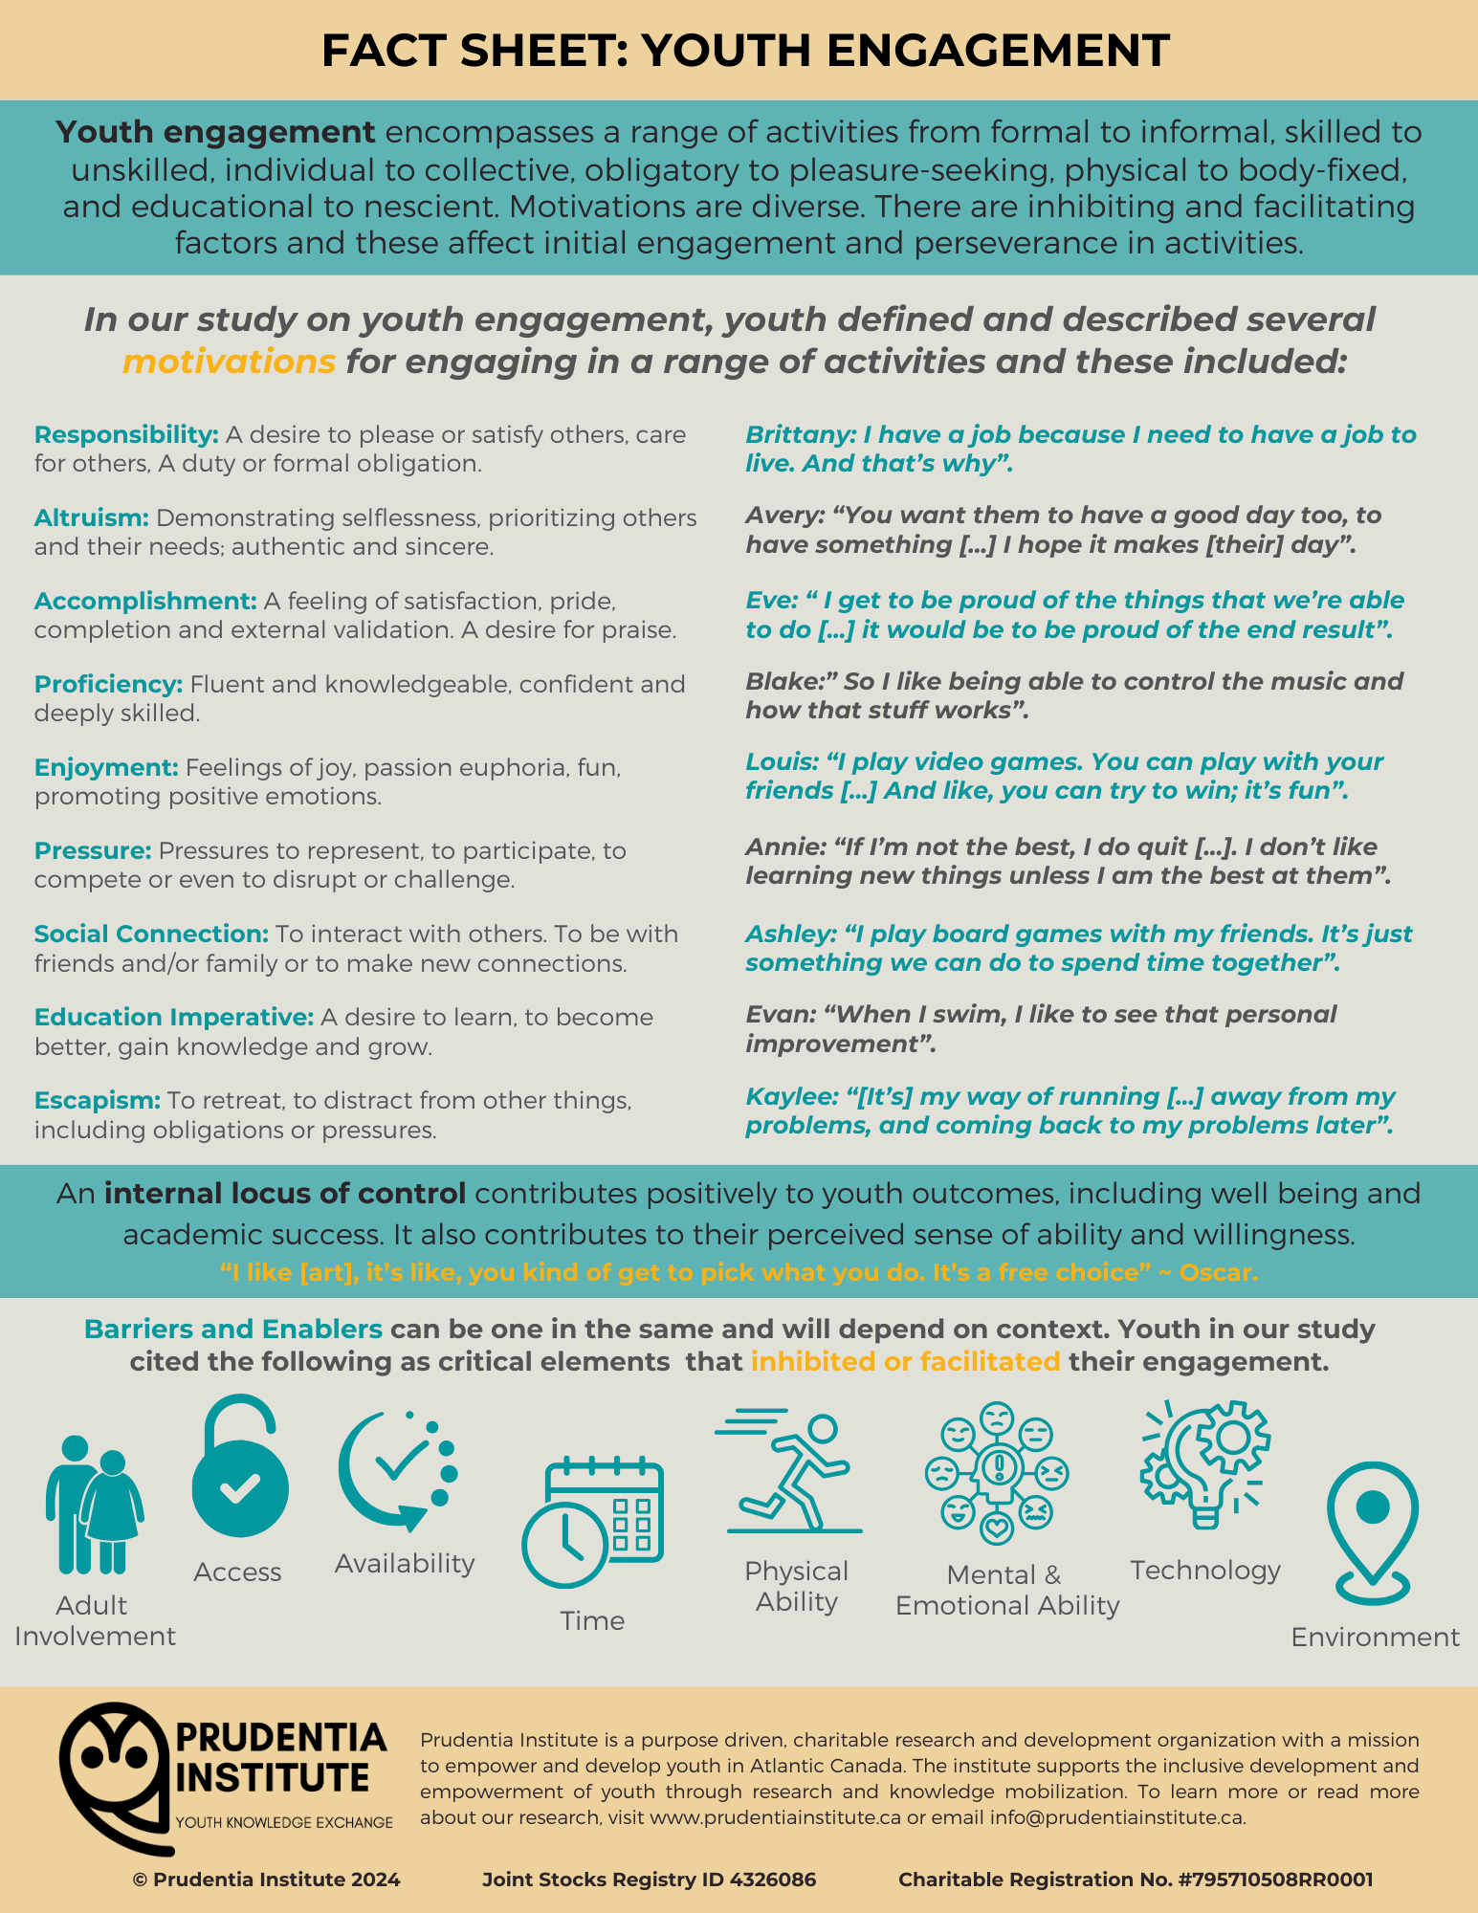Authors Work
Figure #2 A: Insights from the YPAR Model
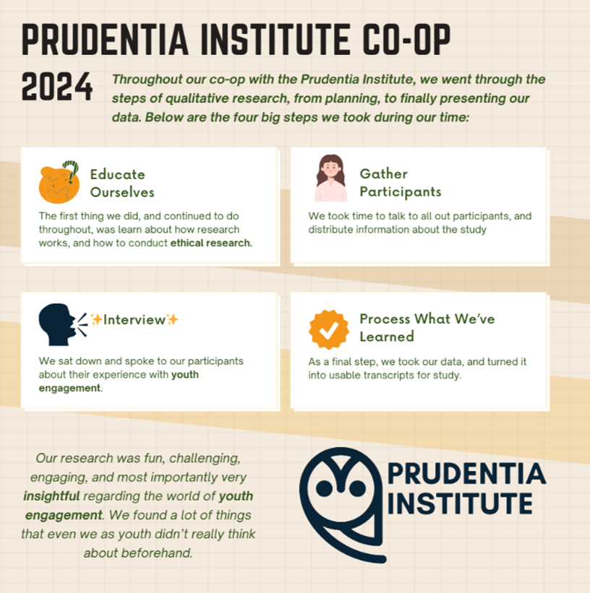

Youth Researcher

Figure #2 B: Insights from the YPAR Model
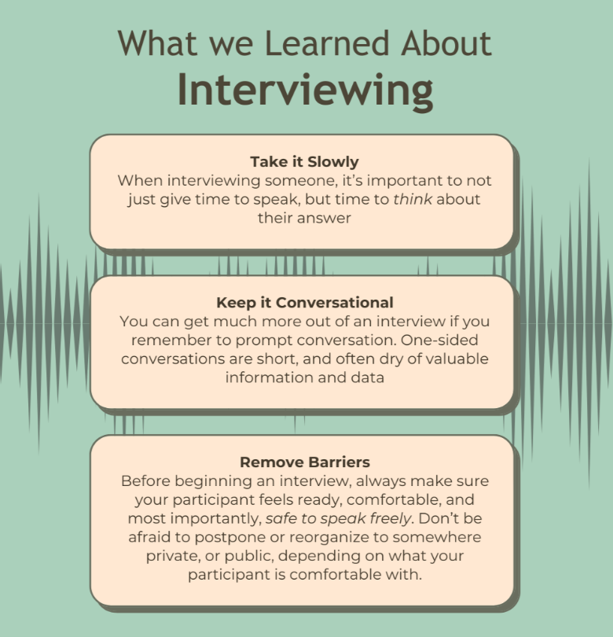
Youth Researcher

Figure #2 C: Insights from the YPAR Model
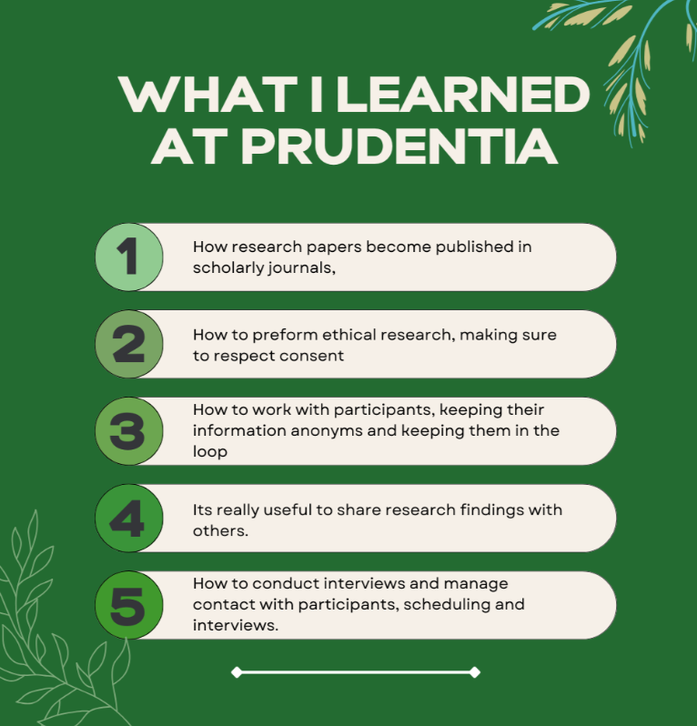
Youth Researcher

Figure #3 A: Insights from the Data
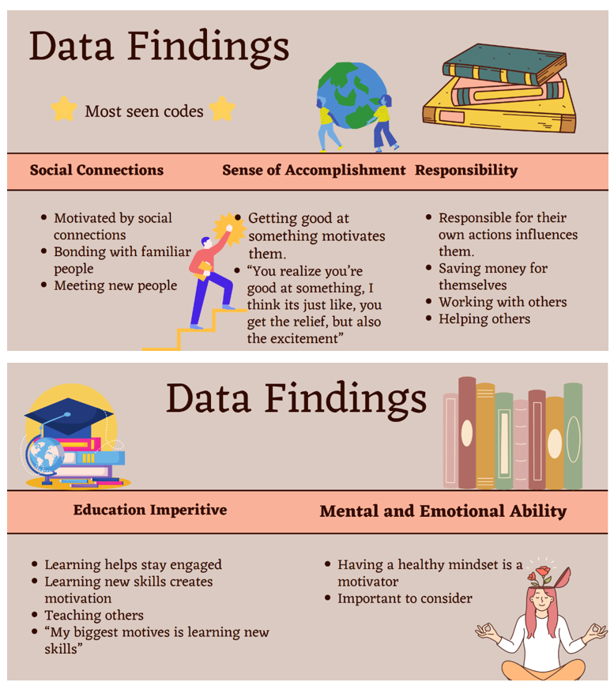
Youth Researcher

Figure #3 B: Insights from the Data
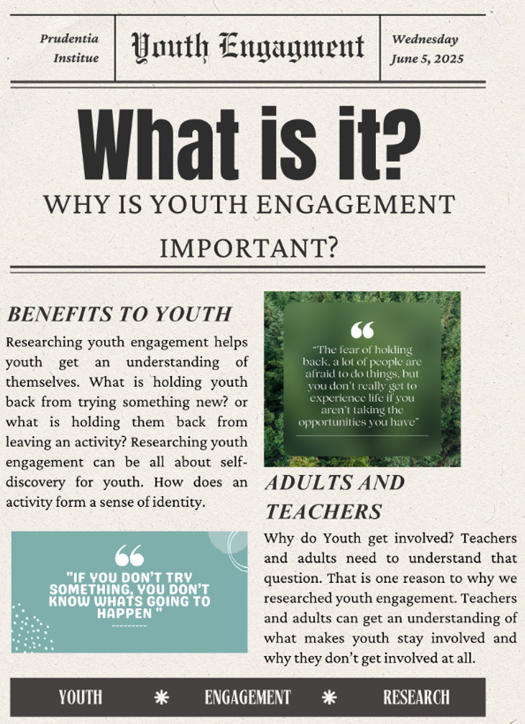
Youth Researcher

Figure #3 C: Insights from the Data
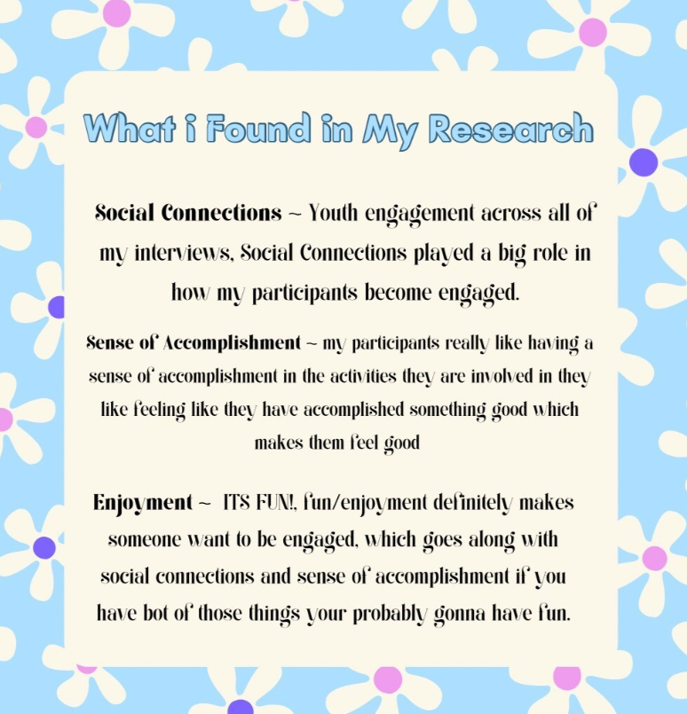
Youth Researcher

Figure #4: Conceptualizing Agentic Youth Engagement
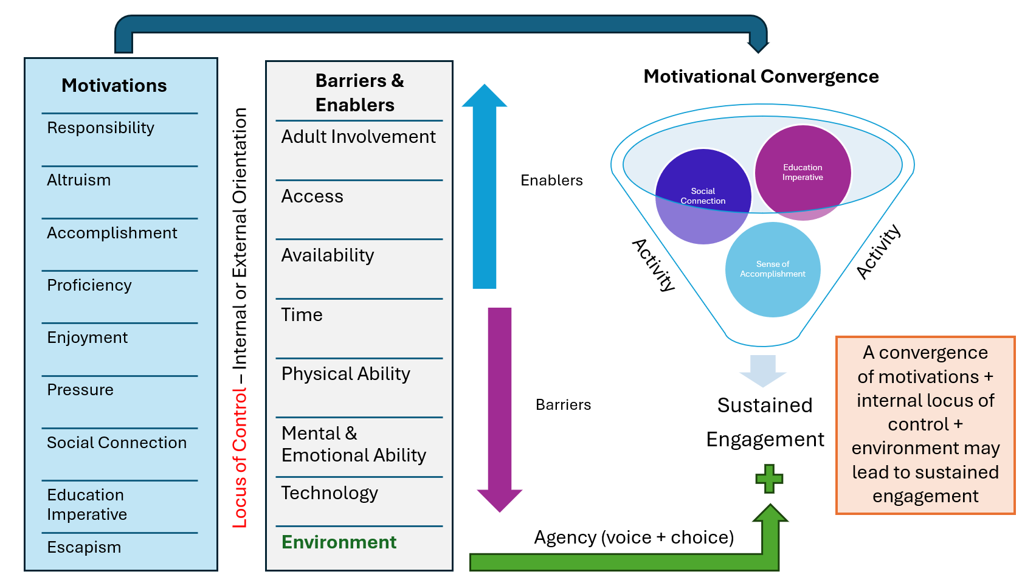
Authors Work

