Appendix
Table 1
Table -1 Sample characteristics
(Source: Author’s own elaboration)
Variables | Frequency | Percentage
Gender
Male | 19 | 82.61%
Female | 4 | 17.39%
Age Group (Years)
31-40 | 9 | 39.13%
41-50 | 6 | 26.01%
51-60 | 5 | 21.74%
Above 60 | 3 | 13.04%
Position
Chief Executive Officer | 1 | 0.04%
Vice President / Assistant Vice President | 12 | 52.17%
Chief Technology Office | 6 | 26.01%
General Managers | 4 | 17.39%
Education
Graduate | 5 | 27.78%
Postgraduate and above | 18 | 78.26%
Experience (Years)
5-10 | 4 | 17.39%
11-15 | 13 | 56.52%
Above 15 | 6 | 26.09%

Table 2
Table 2 – Identified Themes
(Source: Author’s own elaboration)

Themes | Number of Occurrences
Digital Transformation | 53
Artificial Intelligence | 47
Customer Experience | 44
Operational Efficiency | 40
Internet of Things | 35
Virtual Reality | 29
Blockchain Technology | 20
Robotics | 17

Figure 1
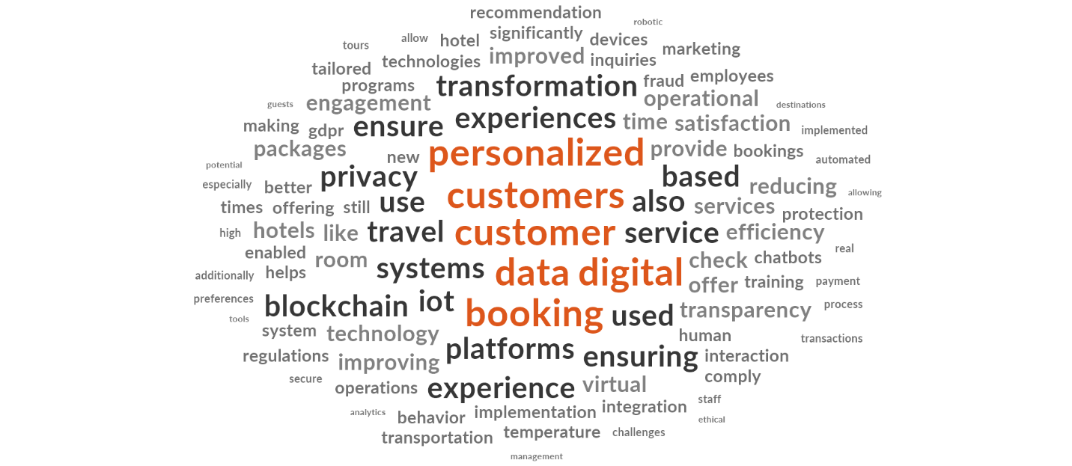
Figure 1- World Cloud
(Source: Nvivo)
Figure 2
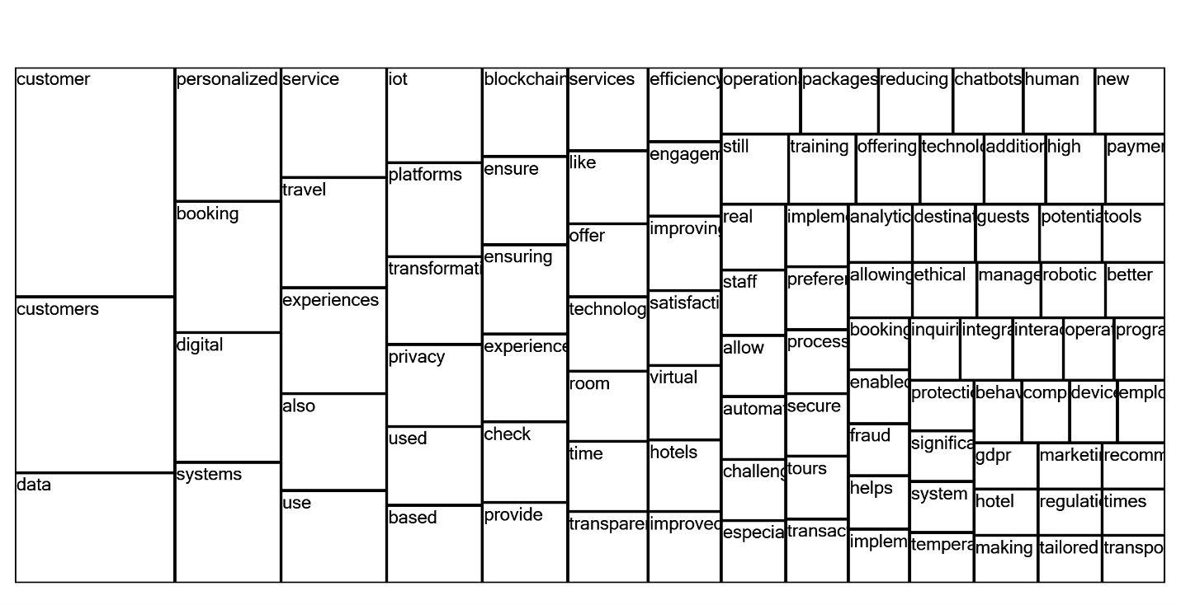
Figure 2 - Tree Map
(Source: Nvivo)

