Appendix I. Data Description

A. SUMMARY STATISTICS

Variable |  | Mean | Std. Dev. | Min | Max | Observations
Total Outlets | overall | 14.8831 | 100.9266 | 0 | 3393 | N = 4782
 | between |  | 100.8064 | 0.3333333 | 3211.333 | n = 1594
 | within |  | 5.338059 | -166.4502 | 196.5498 | T = 3
Entrepreneurial Capital | overall | 0.4473531 | 0.209744 | 0.025613 | 2.173509 | N = 4782
 | between |  | 0.1559658 | 0.1349028 | 1.774169 | n = 1594
 | within |  | 0.1402761 | -0.3383802 | 0.8466928 | T = 3
Business Fabric | overall | 0.5351011 | 0.1887086 | 0.0836459 | 2.141744 | N = 4782
 | between |  | 0.1808249 | 0.1233596 | 1.82744 | n = 1594
 | within |  | 0.0541013 | 0.2970453 | 0.9174432 | T = 3
Governance for Development | overall | 0.5247353 | 0.1837884 | 0 | 2.224779 | N = 4782
 | between |  | 0.1677566 | 0.1360558 | 1.708583 | n = 1594
 | within |  | 0.0751512 | 0.1725563 | 1.040931 | T = 3
Productive Organization | overall | 0.442707 | 0.1442967 | 0.1236062 | 1.727131 | N = 4782
 | between |  | 0.1341321 | 0.1432985 | 1.602587 | n = 1594
 | within |  | 0.0532697 | 0.1637446 | 0.7054385 | T = 3
Competitive Insertion | overall | 0.4800226 | 0.185714 | 0.0611654 | 1.59572 | N = 4782
 | between |  | 0.1774527 | 0.1033624 | 1.457678 | n = 1594
 | within |  | 0.0548945 | 0.2610623 | 0.7260638 | T = 3
Population | overall | 100532.6 | 404385.7 | 1694 | 1.24E+07 | N = 4782
 | between |  | 404418.6 | 1723.667 | 1.22E+07 | n = 1594
 | within |  | 6468.951 | -90149.07 | 268047.9 | T = 3
GDP | overall | 4078761 | 2.34E+07 | 14978 | 8.29E+08 | N = 4782
 | between |  | 2.33E+07 | 19639 | 7.59E+08 | n = 1594
 | within |  | 2299048 | -7.14E+07 | 7.45E+07 | T = 3
Education | overall | 0.5407078 | 0.1403064 | 0.0042532 | 0.9683987 | N = 4782
 | between |  | 0.094035 | 0.2030436 | 0.8819903 | n = 1594
 | within |  | 0.1041489 | 0.0723222 | 0.8338169 | T = 3
Entrepreneurial Education | overall | 0.0099401 | 0.0519943 | 0 | 0.9032905 | N = 4782
 | between |  | 0.0349639 | 0 | 0.4142569 | n = 1594
 | within |  | 0.0384895 | -0.3395106 | 0.5992035 | T = 3
Business Conditions | overall | 0.3838173 | 0.2089682 | 0.0095514 | 1 | N = 4782
 | between |  | 0.1610281 | 0.0177259 | 0.9079514 | n = 1594
 | within |  | 0.1332235 | -0.0269229 | 0.6985236 | T = 3
Business Networks | overall | 0.3124543 | 0.1395211 | 0.0091781 | 1 | N = 4782
 | between |  | 0.1358901 | 0.0215284 | 0.9181769 | n = 1594
 | within |  | 0.0317451 | 0.1304678 | 0.5094031 | T = 3
Solidarity Values | overall | 0.7064687 | 0.1528911 | 0.03963 | 0.970924 | N = 4782
 | between |  | 0.1491492 | 0.2274799 | 0.9569704 | n = 1594
 | within |  | 0.0337566 | 0.4336601 | 0.9150641 | T = 3
Articulation | overall | 0.1438903 | 0.2082654 | 0 | 1 | N = 4782
 | between |  | 0.1816296 | 0 | 1 | n = 1594
 | within |  | 0.1019755 | -0.5227764 | 0.8105569 | T = 3
Participation and Social Control | overall | 0.5422187 | 0.1297335 | 0 | 1 | N = 4782
 | between |  | 0.1123038 | 0.0424083 | 0.8888677 | n = 1594
 | within |  | 0.0649917 | 0.1562538 | 0.8432283 | T = 3
Fiscal Management | overall | 0.3301826 | 0.1638307 | 0 | 1 | N = 4782
 | between |  | 0.1225246 | 0.0752144 | 0.7556631 | n = 1594
 | within |  | 0.1087864 | -0.1002915 | 0.7580458 | T = 3
Planning | overall | 0.675975 | 0.3218128 | 0 | 1 | N = 4782
 | between |  | 0.212888 | 0 | 1 | n = 1594
 | within |  | 0.2413734 | 0.050975 | 1.298197 | T = 3
Productive Structure | overall | 0.6016893 | 0.1796596 | 0.0116031 | 0.9951224 | N = 4782
 | between |  | 0.1061702 | 0.018576 | 0.9879489 | n = 1594
 | within |  | 0.1449489 | 0.3453062 | 0.9604077 | T = 3
Consumption and Credit Potential | overall | 0.3613654 | 0.1463423 | 0.0580554 | 0.962979 | N = 4782
 | between |  | 0.1158506 | 0.1114283 | 0.9281961 | n = 1594
 | within |  | 0.0894445 | 0.0693289 | 0.5448226 | T = 3
Sanitation | overall | 0.5970097 | 0.2651932 | 0 | 1.0001 | N = 4782
 | between |  | 0.2186902 | 0 | 0.9896133 | n = 1594
 | within |  | 0.1500735 | -0.0648281 | 1.229993 | T = 3
Innovation | overall | 0.0200628 | 0.0600693 | 0 | 1 | N = 4782
 | between |  | 0.0484037 | 0 | 1 | n = 1594
 | within |  | 0.0355863 | -0.2624276 | 0.5070012 | T = 3
Environmental Impact | overall | 0.7833217 | 0.0839529 | 0.0858889 | 1 | N = 4782
 | between |  | 0.0616383 | 0.1714577 | 0.9243952 | n = 1594
 | within |  | 0.0570122 | 0.4545824 | 1.142782 | T = 3
International Trade | overall | 0.4783899 | 0.3117708 | 0 | 0.9822833 | N = 4782
 | between |  | 0.2970258 | 0 | 0.9597685 | n = 1594
 | within |  | 0.0949398 | -0.0733796 | 1.020412 | T = 3
Tourism and Creative Economy | overall | 0.2173722 | 0.1860306 | 0 | 1 | N = 4782
 | between |  | 0.1621135 | 0 | 1 | n = 1594
 | within |  | 0.0913105 | -0.203092 | 0.6281509 | T = 3
Connectivity | overall | 0.3527653 | 0.1987873 | 0.0320073 | 1 | N = 4782
 | between |  | 0.1329121 | 0.0665181 | 0.778342 | n = 1594
 | within |  | 0.147845 | -0.1506351 | 0.7144926 | T = 3
Complexity | overall | 0.6067642 | 0.1434998 | 0.0491926 | 1 | N = 4782
 | between |  | 0.1389721 | 0.095778 | 0.9931914 | n = 1594
 | within |  | 0.035875 | 0.472216 | 0.7575544 | T = 3
Table by authors

B1. Correlation Matrix
 | Total Outlets | Entrepreneurial Capital | Business Fabric | Governance for Development | Productive Organization | Competitive Insertion | Population | GDP | Education | Entrepreneurial Education | Business Conditions | Business Networks | Solidarity Values
Total Outlets | 1
Entrepreneurial Capital | 0.041 | 1
Business Fabric | 0.141 | 0.451 | 1
Governance for Development | 0.098 | 0.418 | 0.725 | 1
Productive Organization | 0.191 | 0.816 | 0.724 | 0.672 | 1
Competitive Insertion | 0.161 | 0.621 | 0.713 | 0.610 | 0.758 | 1
Population | 0.970 | 0.014 | 0.142 | 0.110 | 0.194 | 0.182 | 1
GDP | 0.961 | 0.016 | 0.134 | 0.082 | 0.173 | 0.159 | 0.957 | 1
Education | 0.033 | 0.629 | 0.002 | -0.075 | 0.294 | 0.331 | 0.019 | 0.026 | 1
Entrepreneurial Education | 0.332 | -0.019 | 0.103 | 0.074 | 0.107 | 0.093 | 0.394 | 0.361 | -0.069 | 1
Business Conditions | 0.057 | 0.587 | 0.048 | -0.065 | 0.266 | 0.344 | 0.031 | 0.045 | 0.733 | -0.046 | 1
Business Networks | 0.276 | 0.063 | 0.444 | 0.159 | 0.178 | 0.461 | 0.323 | 0.288 | 0.292 | 0.148 | 0.331 | 1
Solidarity Values | 0.094 | 0.110 | 0.409 | 0.047 | 0.115 | 0.400 | 0.107 | 0.117 | 0.350 | 0.084 | 0.503 | 0.626 | 1
Articulation | -0.019 | -0.039 | 0.018 | 0.084 | -0.028 | 0.024 | -0.022 | -0.009 | 0.019 | -0.034 | 0.026 | 0.113 | 0.077
Participation and Social Control | 0.131 | -0.048 | 0.164 | 0.296 | 0.088 | 0.245 | 0.187 | 0.146 | 0.056 | 0.160 | 0.074 | 0.376 | 0.263
Fiscal Management | 0.173 | 0.356 | 0.097 | 0.168 | 0.267 | 0.465 | 0.196 | 0.154 | 0.481 | 0.031 | 0.540 | 0.443 | 0.350
Planning | 0.064 | -0.231 | 0.114 | 0.452 | -0.105 | 0.069 | 0.097 | 0.077 | -0.128 | 0.083 | -0.074 | 0.283 | 0.222
Productive Structure | 0.133 | 0.489 | -0.093 | -0.068 | 0.315 | 0.355 | 0.161 | 0.130 | 0.722 | -0.001 | 0.720 | 0.354 | 0.287
Consumption and Credit Potential | 0.286 | 0.474 | 0.118 | 0.070 | 0.367 | 0.472 | 0.311 | 0.280 | 0.673 | 0.128 | 0.745 | 0.512 | 0.497
Sanitation | 0.081 | -0.034 | 0.255 | 0.005 | 0.190 | 0.238 | 0.103 | 0.102 | 0.157 | 0.108 | 0.227 | 0.471 | 0.554
Innovation | 0.655 | -0.105 | 0.199 | 0.136 | 0.159 | 0.162 | 0.703 | 0.671 | -0.096 | 0.567 | -0.069 | 0.347 | 0.183
Environmental Impact | 0.032 | -0.220 | 0.173 | 0.148 | -0.021 | 0.030 | 0.043 | 0.037 | -0.230 | 0.071 | -0.202 | 0.164 | 0.092
International Trade | 0.123 | 0.044 | 0.266 | 0.112 | 0.123 | 0.616 | 0.167 | 0.154 | 0.273 | 0.116 | 0.306 | 0.598 | 0.623
Tourism and Creative Economy | 0.070 | 0.258 | 0.046 | 0.057 | 0.158 | 0.449 | 0.090 | 0.068 | 0.384 | -0.028 | 0.480 | 0.349 | 0.296
Connectivity | 0.174 | 0.526 | 0.113 | 0.064 | 0.364 | 0.531 | 0.185 | 0.152 | 0.686 | 0.005 | 0.754 | 0.465 | 0.420
Complexity | 0.207 | 0.154 | 0.238 | 0.130 | 0.216 | 0.599 | 0.273 | 0.244 | 0.420 | 0.151 | 0.425 | 0.720 | 0.597
Table by authors

B2. Correlation Matrix (cont.)
 | Articulation | Participation and Social Control | Fiscal Management | Planning | Productive Structure | Consumption and Credit Potential | Sanitation | Innovation | Environmental Impact | International Trade | Tourism and Creative Economy | Connectivity | Complexity
Articulation | 1
Participation and Social Control | 0.052 | 1
Fiscal Management | 0.018 | 0.217 | 1
Planning | 0.038 | 0.218 | -0.011 | 1
Productive Structure | 0.033 | 0.127 | 0.641 | -0.075 | 1
Consumption and Credit Potential | 0.047 | 0.271 | 0.668 | 0.042 | 0.782 | 1
Sanitation | 0.064 | 0.255 | 0.149 | 0.149 | 0.096 | 0.246 | 1
Innovation | 0.001 | 0.274 | 0.062 | 0.192 | -0.006 | 0.195 | 0.205 | 1
Environmental Impact | 0.009 | 0.127 | -0.190 | 0.283 | -0.282 | -0.169 | 0.192 | 0.142 | 1
International Trade | 0.077 | 0.338 | 0.403 | 0.256 | 0.321 | 0.452 | 0.443 | 0.237 | 0.071 | 1
Tourism and Creative Economy | 0.054 | 0.132 | 0.535 | 0.063 | 0.539 | 0.431 | 0.130 | -0.020 | -0.025 | 0.331 | 1
Connectivity | 0.035 | 0.199 | 0.707 | -0.056 | 0.782 | 0.846 | 0.209 | -0.001 | -0.166 | 0.392 | 0.537 | 1
Complexity | 0.086 | 0.387 | 0.584 | 0.238 | 0.567 | 0.639 | 0.395 | 0.300 | 0.076 | 0.728 | 0.485 | 0.590 | 1
Table by authors

C. Distribution Density of the Dependent Variable (Total Outlets)

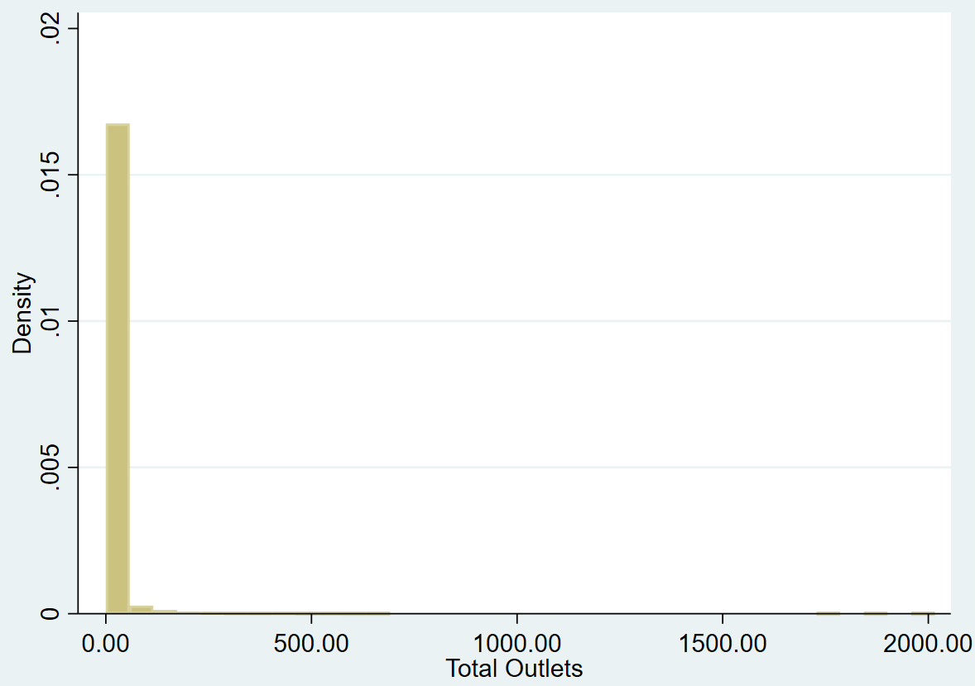
Figure by authors

