Figure 3a – Residual Analysis of SARIMA Model for Collection 1
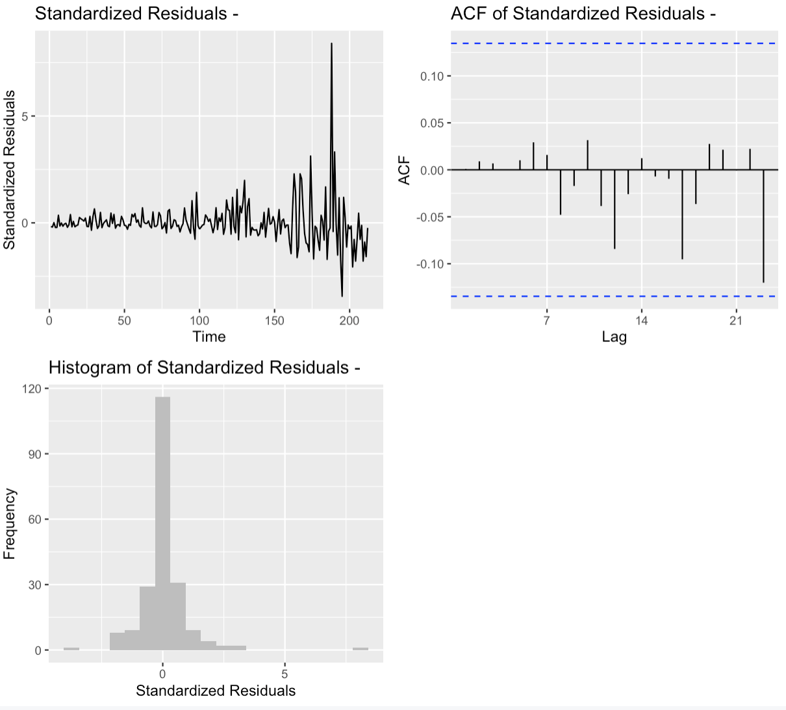

Figure 3b – Residual Analysis of SARIMA Model for Collection 2
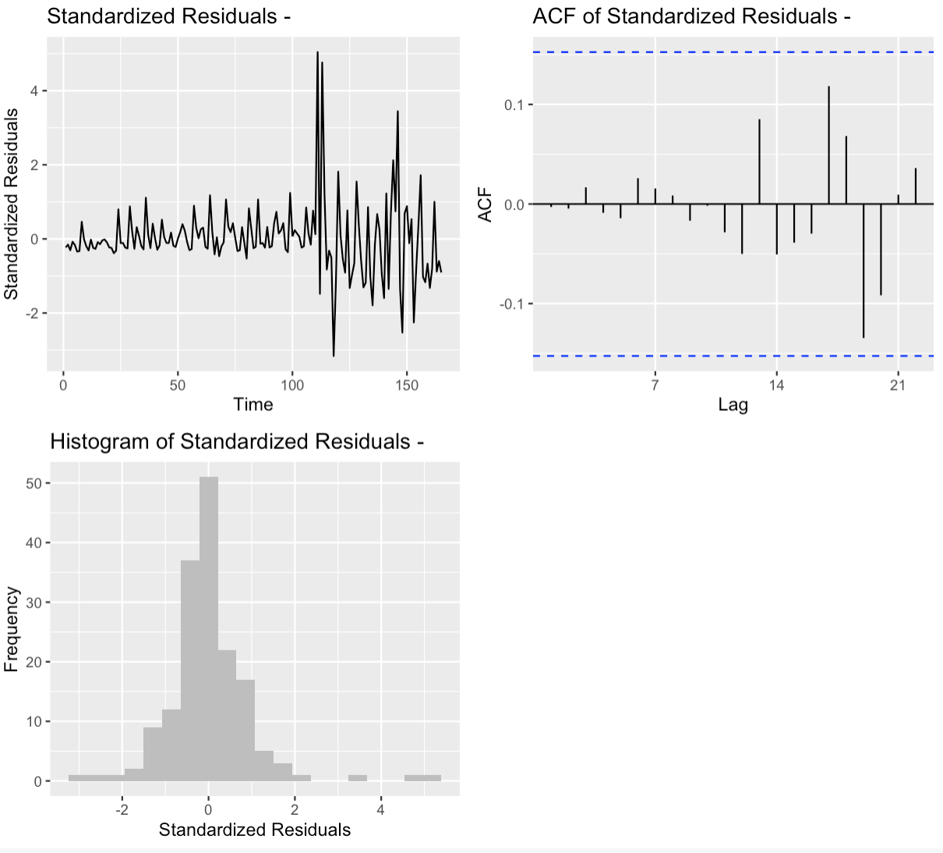
Figure 3b – Residual Analysis of SARIMA Model for Collection 3
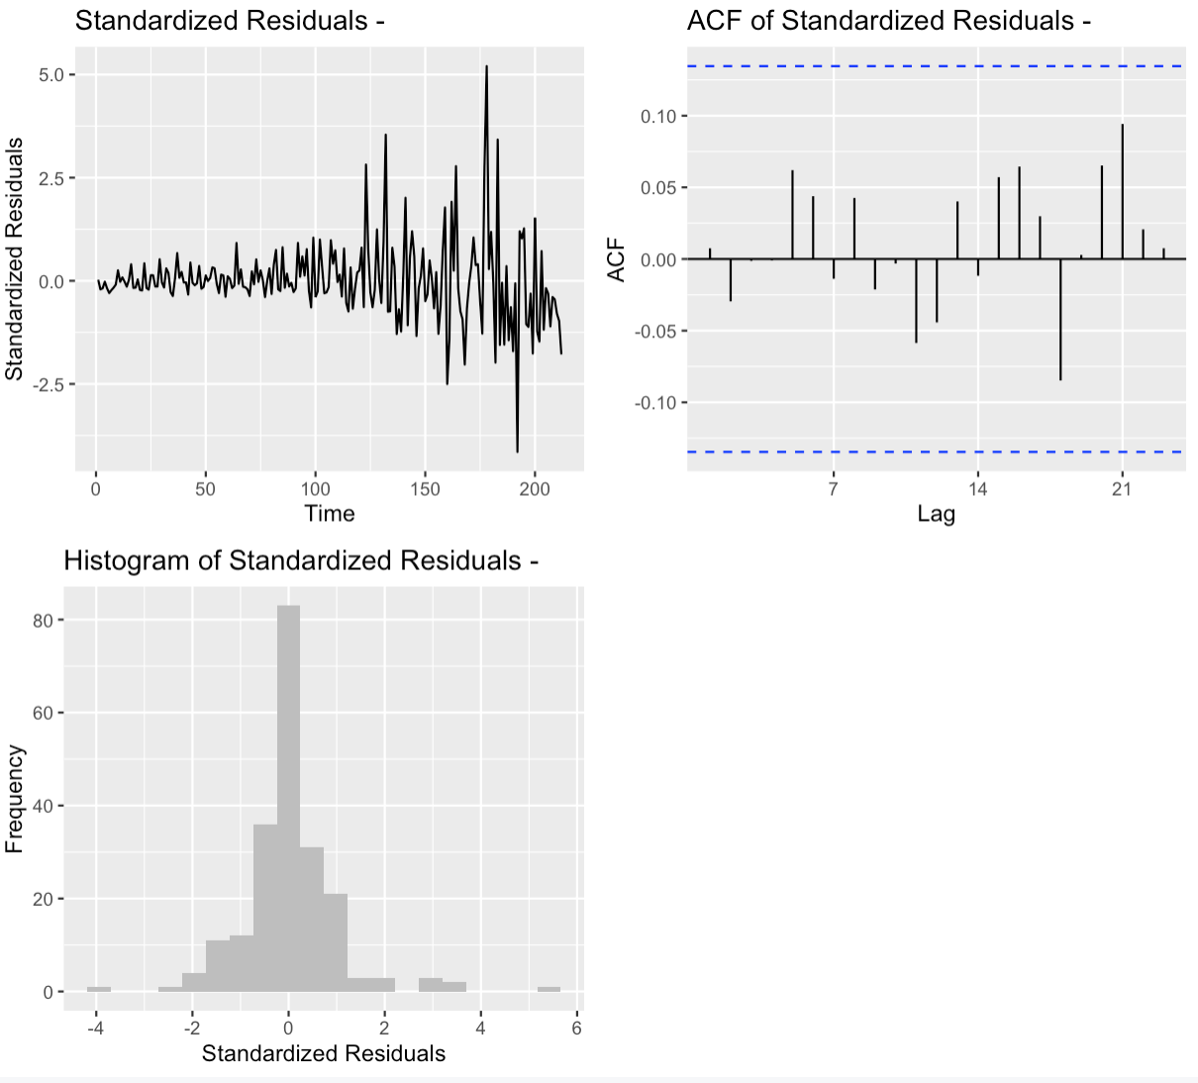

Figure 3b – Residual Analysis of SARIMA Model for Collection 4
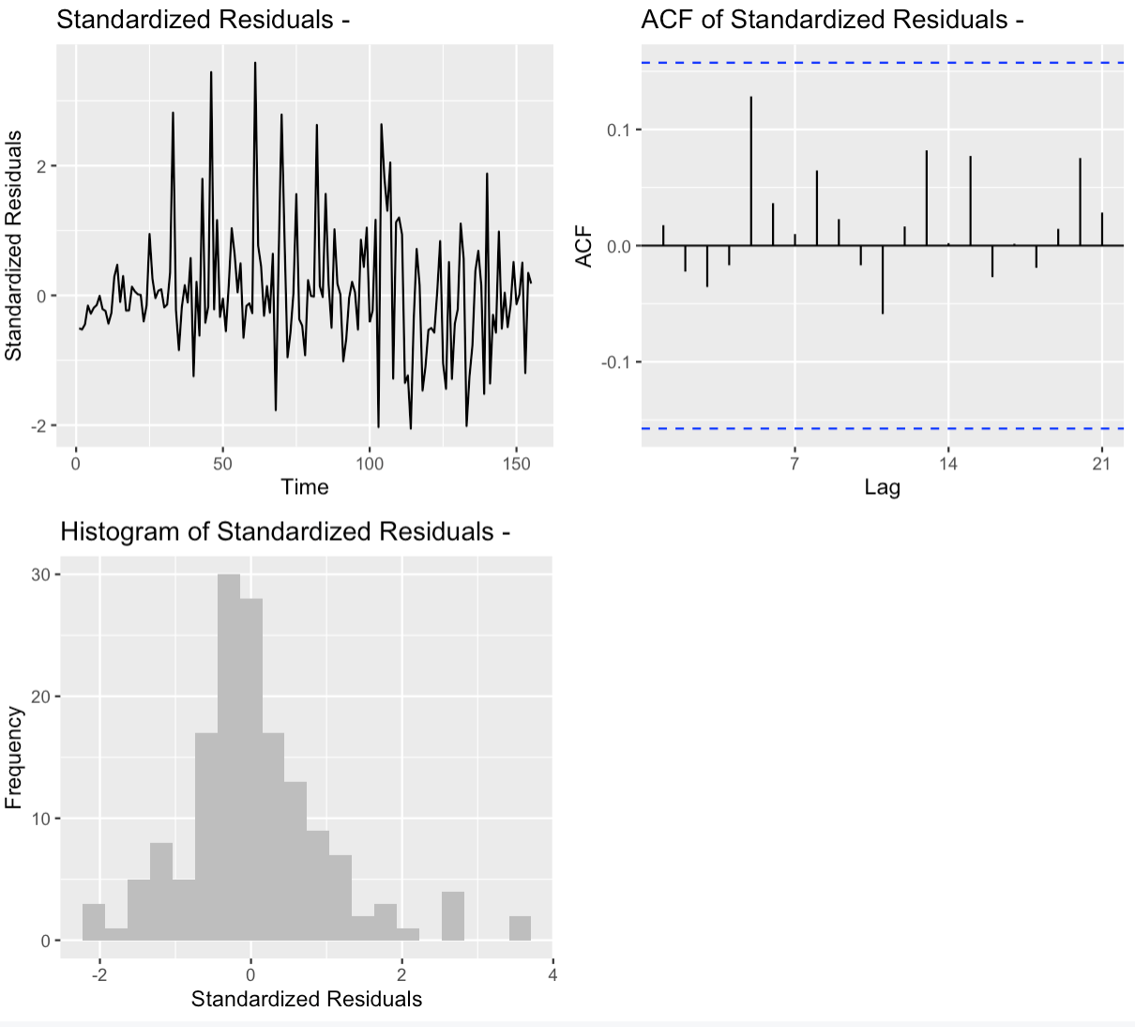
Figure 3b – Residual Analysis of SARIMA Model for Collection 5
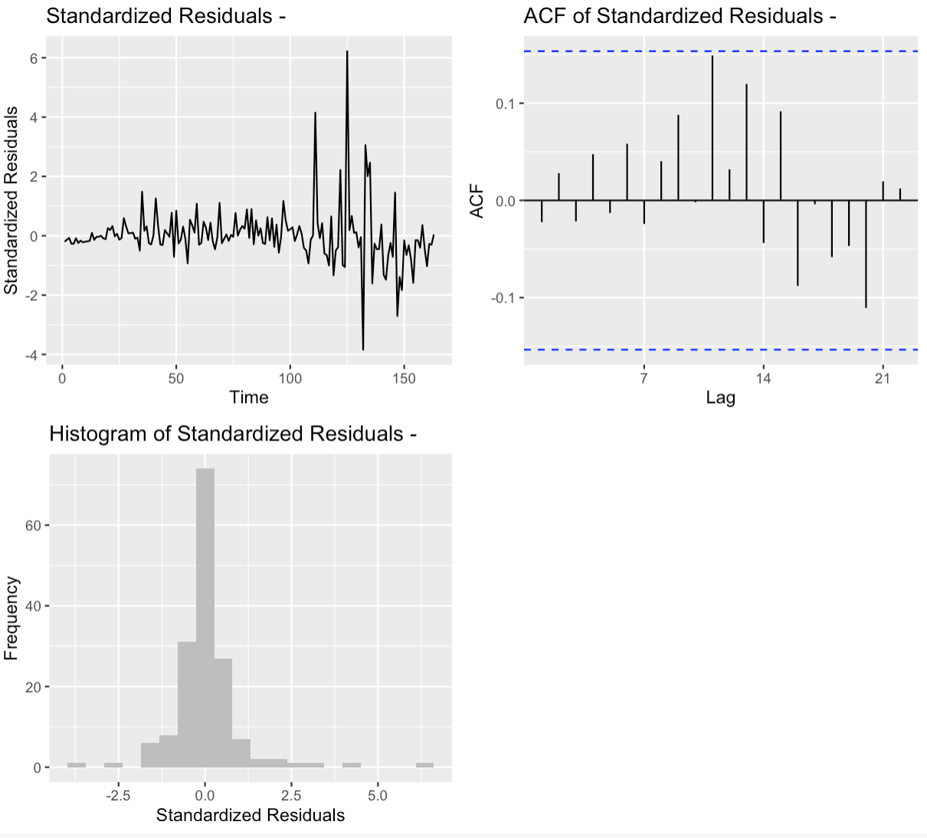

Figure 3b – Residual Analysis of SARIMA Model for Collection 6
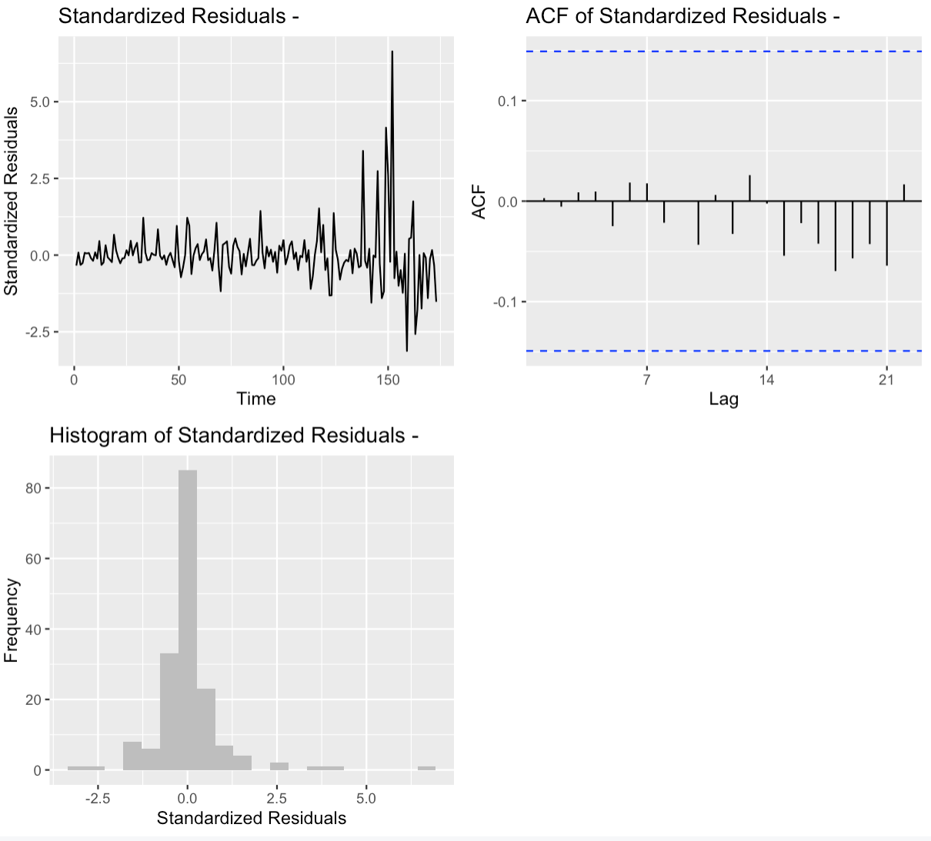

Figure 3b – Residual Analysis of SARIMA Model for Collection 7
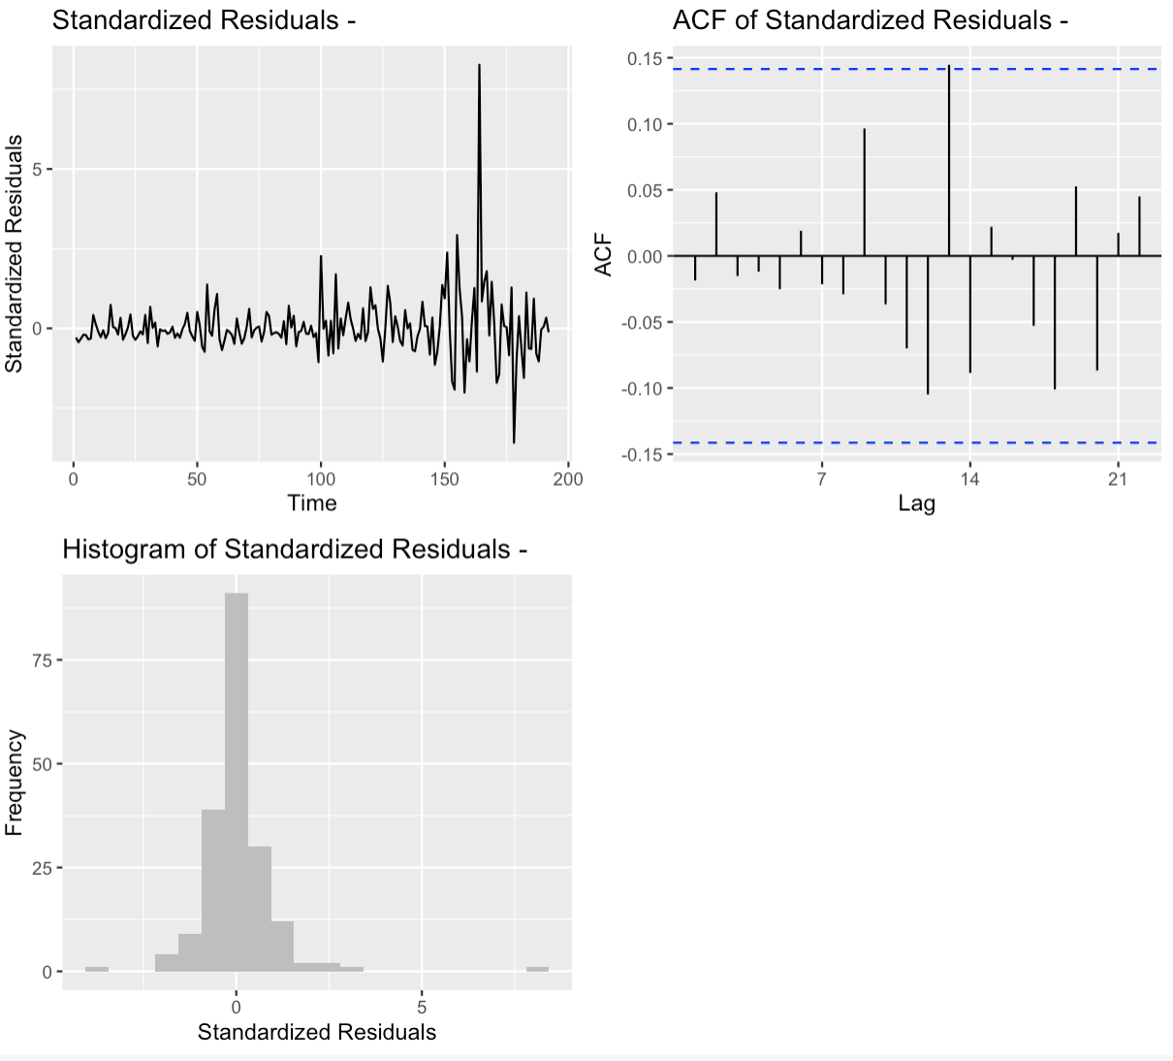

Figure 3b – Residual Analysis of SARIMA Model for Collection 8
