Appendices
Appendix 1. Descriptive Statistics
Descriptive Statistics
Variable | Obs | Mean | Std. Dev. | Min | Max
JDPjune | 324 | 0.461 | 0.133 | 0.097 | 0.711
JDPnov | 324 | 0.484 | 0.136 | 0.123 | 0.754
RPPjune | 324 | 0.189 | 0.12 | 0.009 | 0.575
RPPnov | 324 | 0.19 | 0.121 | 0.009 | 0.575
NMPjune | 324 | 0.146 | 0.079 | 0.006 | 0.449
NMPnov | 324 | 0.132 | 0.07 | 0.006 | 0.449
PDPjune | 324 | 0.12 | 0.2 | 0 | 0.849
PDPnov | 324 | 0.114 | 0.193 | 0 | 0.837
gdppercapita | 324 | 8.899 | 0.389 | 7.768 | 9.916
regionalgrowth | 324 | 0.011 | 0.034 | −0.069 | 0.105
agrishare | 324 | 0.151 | 0.075 | 0.001 | 0.415
filliteracyrate | 324 | 0.103 | 0.061 | 0.019 | 0.337
universityedu | 324 | 0.101 | 0.039 | 0.022 | 0.232
oldpopulation | 324 | 0.093 | 0.038 | 0.007 | 0.236
netmig | 324 | −0.027 | 0.154 | −1.013 | 1.215
hospitalbed | 324 | 5.503 | 0.345 | 4.127 | 6.485
crimerate | 324 | 0.004 | 0.036 | 0 | 0.65
terrorism | 324 | 0.012 | 0.031 | 0 | 0.255
Source(s): Author’s calculations

Appendix 2. Correlation Matrix for Independent Variables
Matrix of correlations
Variables | (1) | (2) | (3) | (4) | (5) | (6) | (7) | (8) | (9) | (10)
(1) gdppercapita | 1.000
(2) regionalgrowth | −0.194 | 1.000
(3) agrisahre | −0.454 | 0.162 | 1.000
(4) filliteracyrate | −0.785 | 0.390 | 0.313 | 1.000
(5) universityedu | 0.683 | −0.670 | −0.411 | −0.753 | 1.000
(6) oldpopulation | 0.247 | −0.263 | 0.128 | −0.342 | 0.269 | 1.000
(7) netmig | 0.440 | 0.123 | −0.231 | −0.302 | 0.172 | 0.071 | 1.000
(8) hospitalbed | 0.356 | −0.214 | −0.216 | −0.420 | 0.373 | 0.313 | 0.176 | 1.000
(9) crimerate | 0.021 | −0.042 | −0.084 | −0.024 | 0.045 | 0.054 | −0.028 | 0.068 | 1.000
(10) terrorism | −0.106 | 0.048 | −0.146 | 0.156 | −0.024 | −0.245 | −0.148 | −0.106 | −0.026 | 1.000
Source(s): Author’s calculations

Appendix 3. Comparison of OLS-FE and FGLS Results
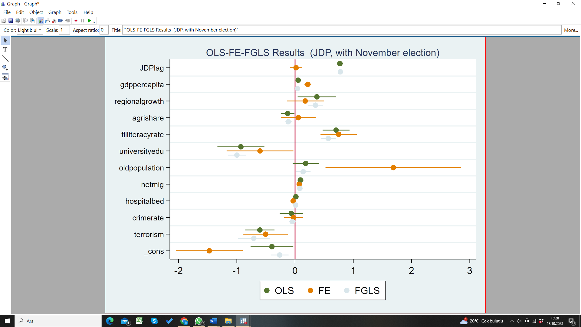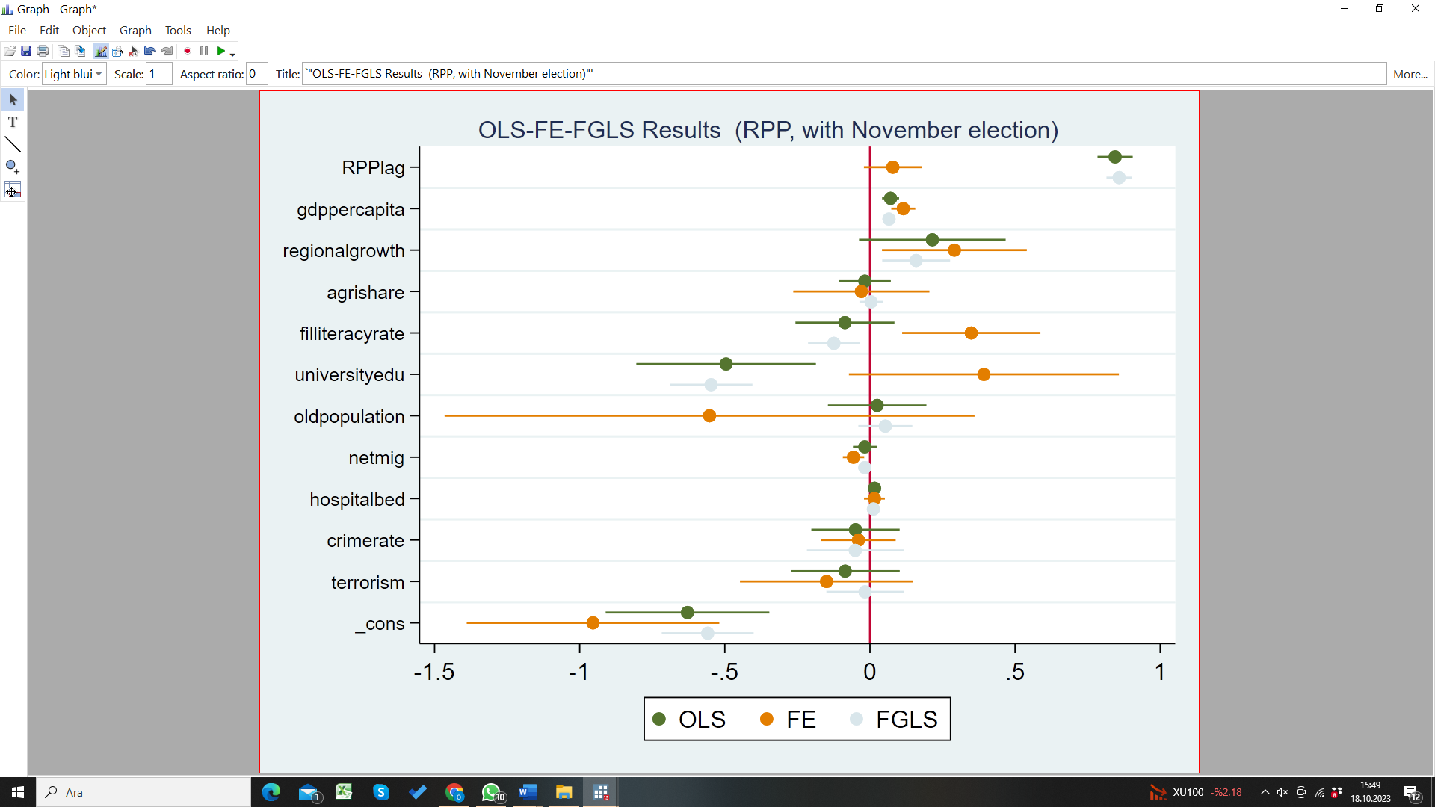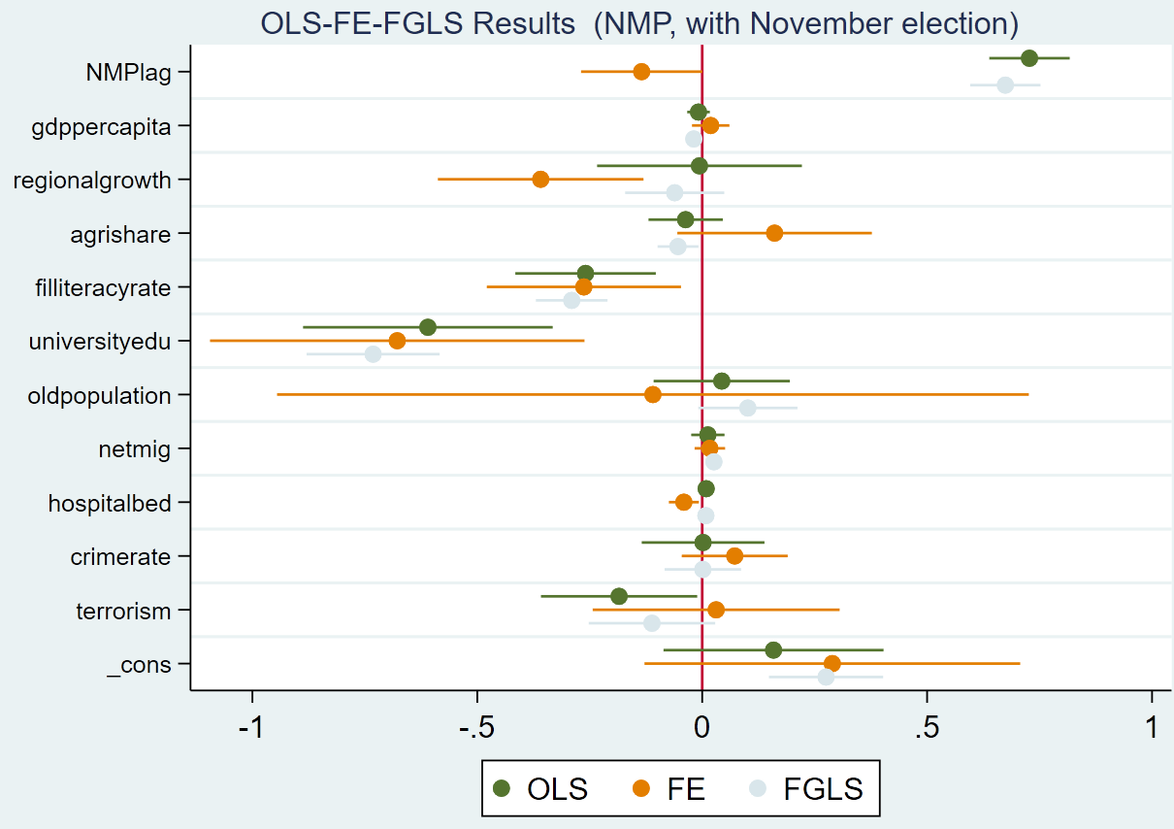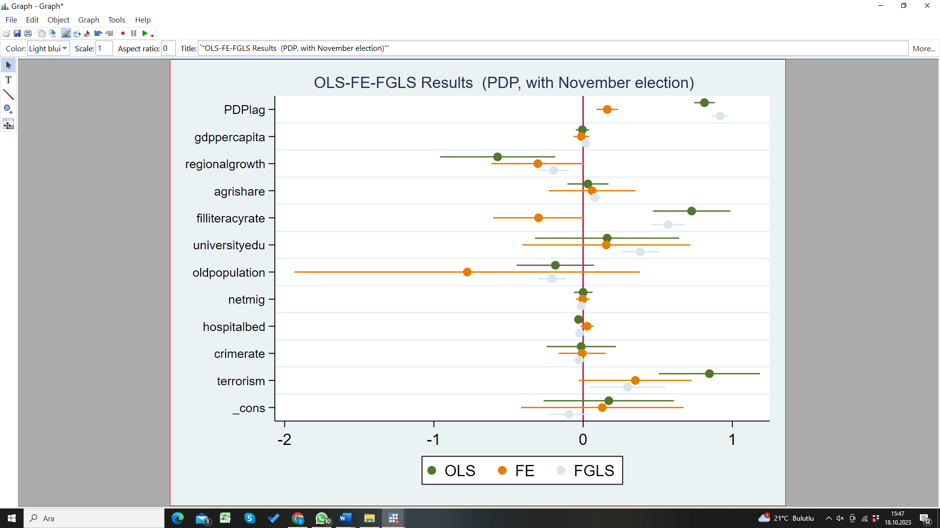
Source(s): Figure by authors

Appendix 4 Comparison of OLS-FE and FGLS Results (Istanbul, Ankara and Izmır excluded)
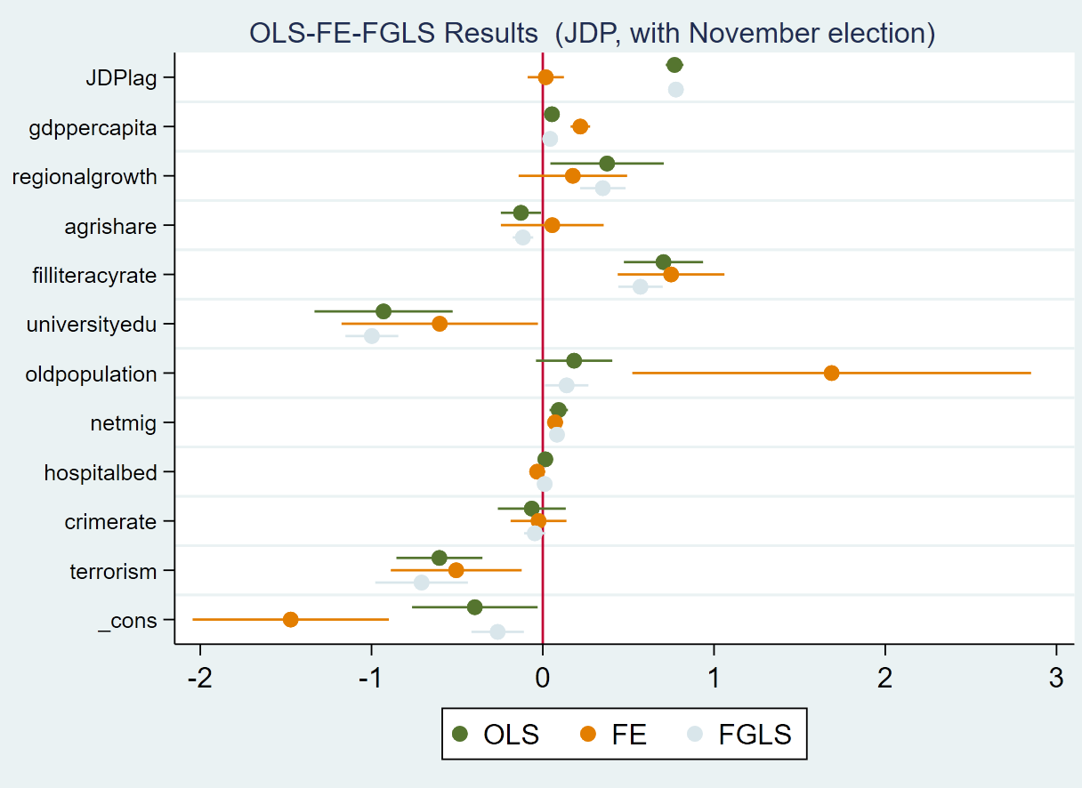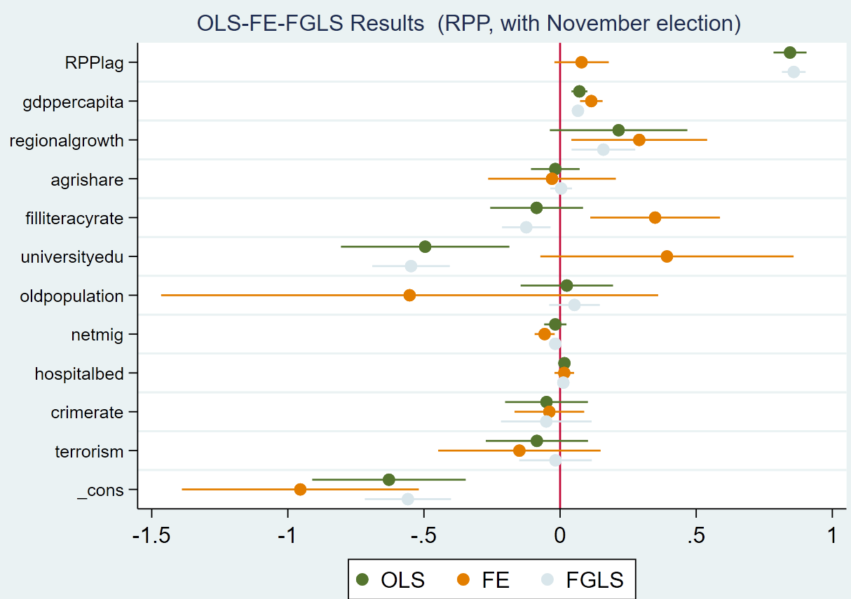
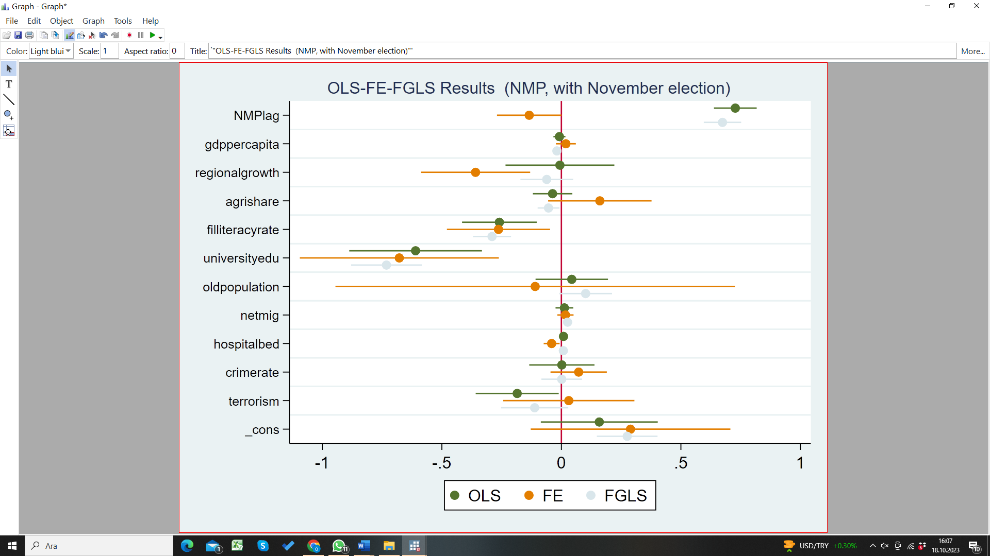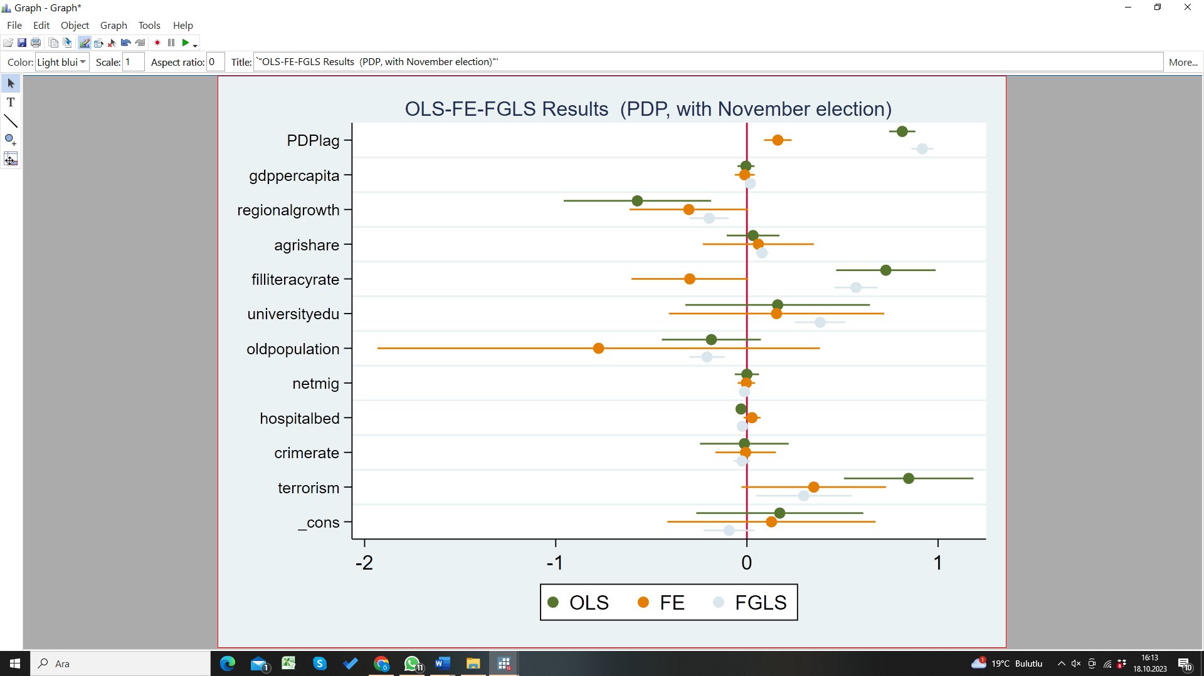
Source(s): Figure by authors

