Prototyping and characterisation of 316L stainless steel parts and lattice structures printed via metal fused filament fabrication
Supplementary Information

SI. 1 Additional figures and tables
Additional figures and tables are reported in this supplementary material.

Figure SI.1 shows the cross-section of the UF316L filament observed with the SEM in Secondary Electrons (SE) mode. The two regions composing the filament can be distinguished: the metal/binder composite is embedded in a polymeric shell, enveloping the entire filament.

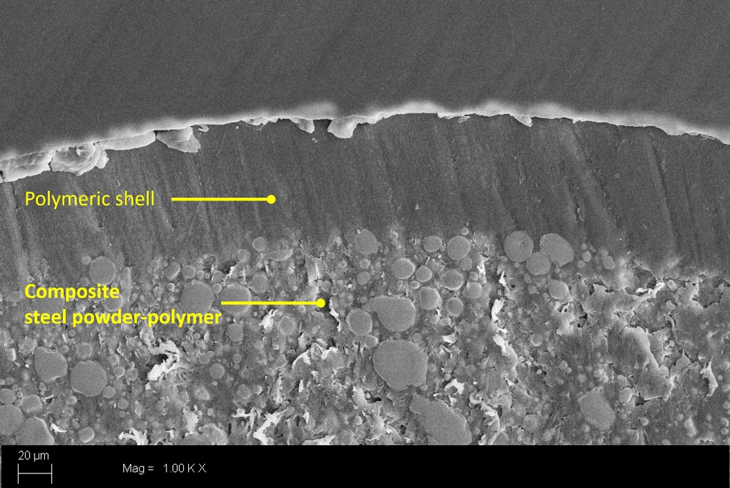
Figure SI.1: SE-SEM image of a section of the UF316L filament where the external polymeric shell, which protects the internal composite steel powder-polymer, is readily visible.
Source: Figure by authors
Figure SI.2 shows how the ImageJ software was used to measure porosity. The photo of the last layer of the sample (Figure SI2 a) was converted into a white/black format (Figure SI2 b). The borders of the photos were cropped appropriately to exclude features not related to the internal structure. The density was calculated as the percentage of white pixels inside the selected region.
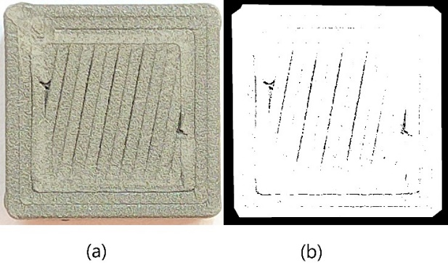
Figure SI.2: (a) Picture of a specimen. (b) The same image converted into a black/white format used to calculate the porosity level.
Source: Figure by authors

Figure SI.3 shows the orientation of the concentric infill samples with respect to the printer reference system.
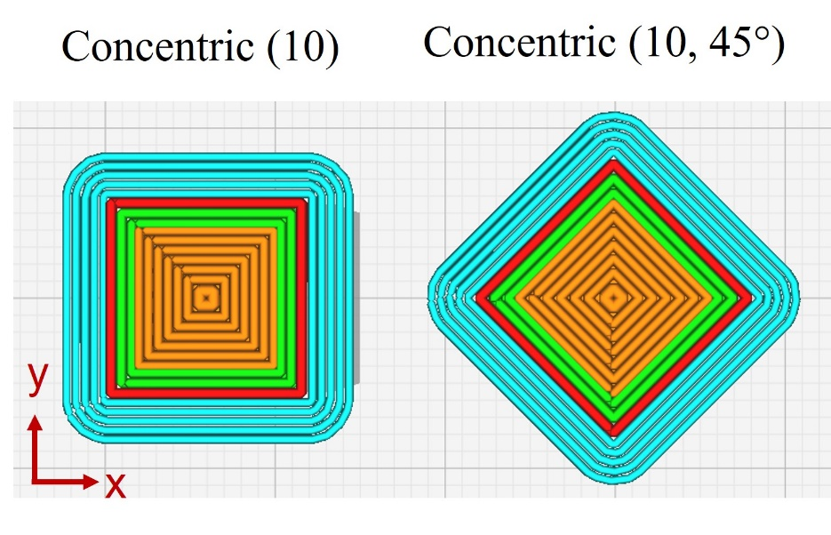
Figure SI.3: An example of a sample printed with a concentric infill and the same sample rotated at 45°. Source: Figure by authors

Table SI.I reports the details of the cells and structures printed in this study. The cell topology, the array dimensions, the cell size, and the volume fraction are the necessary and sufficient inputs for recreating the structure in the Flatt Pack software (Maskery et al., 2022). The table also indicates the nozzle diameter used, if post-processing was performed, and provides some useful notes.
Table SI.I. Detail of the unit cells and cellular structures considered in this study. The dimensions refer to the digital model. These details can be used as inputs for generating the 3D models using the Flatt Pack software (Maskery et al., 2022).
Source: Table by authors
Topology | Array | Cell size [mm] | Volume Fraction [%] | D&S | Nozzle diameter [mm] | Notes
Body-Centred Cubic (BBC) | 1x1x1 | 15 | 10 |  | 0.6 | - Smallest beam dimension ≈ 1 mm  - Printed with and without a PVA brim
Simple Cubic (SC) | 2x2x3 | 7 | 40 | x | 0.4 | - Smallest beam dimension ≈ 3 mm
Simple Cubic (SC) | 3x3x4 | 5 | 25 | x | 0.4 | - Smallest beam dimension ≈ 1.6 mm
Matrix-based Primitive (P) | 2x3x5 | 5 | 30 | x | 0.4 | - Smallest thickness ≈ 0.85 ÷ 0.7 mm  - Created as a 20x30x50 mm³ and then scaled by 50% inside Cura)
Network-based IWP (IWP) | 3x3x5 | 7 | 30 | x | 0.4 | - Smallest thickness ≈ 0.75 mm
Matrix-based Gyroid (MG) | 1x1x1 | 15 | 20 |  | 0.6 | - Smallest thickness ≈ 1.5 mm  - Printed with PVA as support material
Network-based Gyroid (G) | 1x1x1 | 15 | 25 |  | 0.6 | - Lateral walls were added (side skin 0.8mm thickness)  - Printed with and without a PVA brim
Network-based Gyroid (G) | 1x1x1 | 12 | 50 | x | 0.6 | - Created as a 12x12x12 mm³ and with a side skin of 1.2 mm
Network-based Gyroid (G) | 1x1x1 | 12 | 20 | x | 0.6 | - Created as a 12x12x12 mm³ and with a side skin of 1.2 mm
Network-based Gyroid (G) | 2x2x2 | 8 | 50 | x | 0.6 | - Created as a 16x16x16 mm³ and with a side skin of 0.8 mm
Network-based Gyroid (G) | 1x1x2 | 12 | Graded (50-20) | x | 0.6 | - Graded and linear material distribution: from 50% at the bottom to 20% at the top  - Created as a 12x12x24 mm³ and with a side skin of 1.2 mm

SI. 2 Preliminary analysis of printing parameters
A preliminary analysis of the printing parameters was conducted starting from the parameters suggested by BASF (BASF, 2021). The line width was fixed at 0.6mm, while the infill density value was 100%. The chosen infill type was Lines. Ten tests were performed with the printing parameters shown in Table SI.II. The model chosen for these tests is a cube of 10 mm. Pictures of the most significant steps are shown in Figure SI.4.

Table SI.II: The evolution of the printing parameters during the first printing test with the UF316L filament. Test 1 parameters correspond to those specified in (BASF, 2021). The parameters varied from the previous test are indicated in bold.
Source: Table by authors
Test | Layer height [mm] | Print speed [mm/s] | Print temperature [°C] | Bed temperature [°C] | Flow [%] | Plate adhesion
1 | 0,1 | 35 | 240 | 100 | 100 | Skirt
2 | 0,1 | 25 | 240 | 100 | 105 | Brim
3 | 0,15 | 5 | 240 | 100 | 105 | Brim
4 | 0,15 | 5 | 240 | 100 | 102 | Brim
5 | 0,15 | 5 | 240 | 95 | 105 | Brim
6 | 0,15 | 5 | 245 | 95 | 103 | Brim
7 | 0,15 | 5 | 245 | 90 | 105 | Brim
8 | 0,15 | 5 | 240 | 90 | 104 | Brim
9 | 0,15 | 7 | 240 | 90 | 104 | Brim
10 | 0,2 | 7 | 240 | 80 | 104 | Brim

Figure SI.4. The most significant steps of the preliminary analysis of the printing parameters.
Source: Figure by authors
Printing parameters selected for tests 1 and 2 were very close to that suggested by BASF: it is evident that the result is not acceptable. In test 1, the main problem was the adhesion to the build plate, so the skirt was substituted with a brim. Moreover, the printing speed, already reduced from test 1 to test 2, was significantly lowered in test 3: the printhead was moving too fast, and the deposited material did not have enough time to solidify. The reduction of the printing speed allowed for obtaining cubes with the right shape and only a slight deformation at the bottom of the part. The main reason for this problem was the heat coming from the machine's build platform. This temperature was thus reduced with improved outcomes. Once this issue was solved, the printing speed was slightly increased again (tests 9 and 10, Table SI.II) to speed up the printing. Test 10 parameters were considered effective. They correspond to the set A0 of the paper.
Some lattice structures were printed and subjected to D&S (BASF standard process) using these parameters. Figure SI.5 shows the CAD models (obtained using the Grasshopper plugin of Rhinoceros). Figure SI.5a shows a simple cubic cell with a cell size of 6 mm and circular beams of 3 mm diameter. This structure was already printed by (Shaikh et al., 2021) using a Ti6Al4V filament. Figure SI.5b depicts a more complex cubic lattice with square beams. It comprises 9 layers, each made by 5 equidistant parallel beams with a square section (2x2x18 mm). The beams in two consecutive layers are perpendicular. Eventually, Figures SI.5c and d show the same 2x2x2 body-centered cubic (BCC) structure (cell size 8 mm): in the first case, the thickness of the beams is constant and equal to 2.5mm, while in the second one, it has been varied from the bottom (2.5mm) to the top (1.5mm) according to a linear gradient. The resulting relative density is 46% for the homogeneous structure and 32.5% for the graded one. The printing results are acceptable in all cases, even if the BCC structure with the beam diameter gradient has low accuracy in its upper portion.
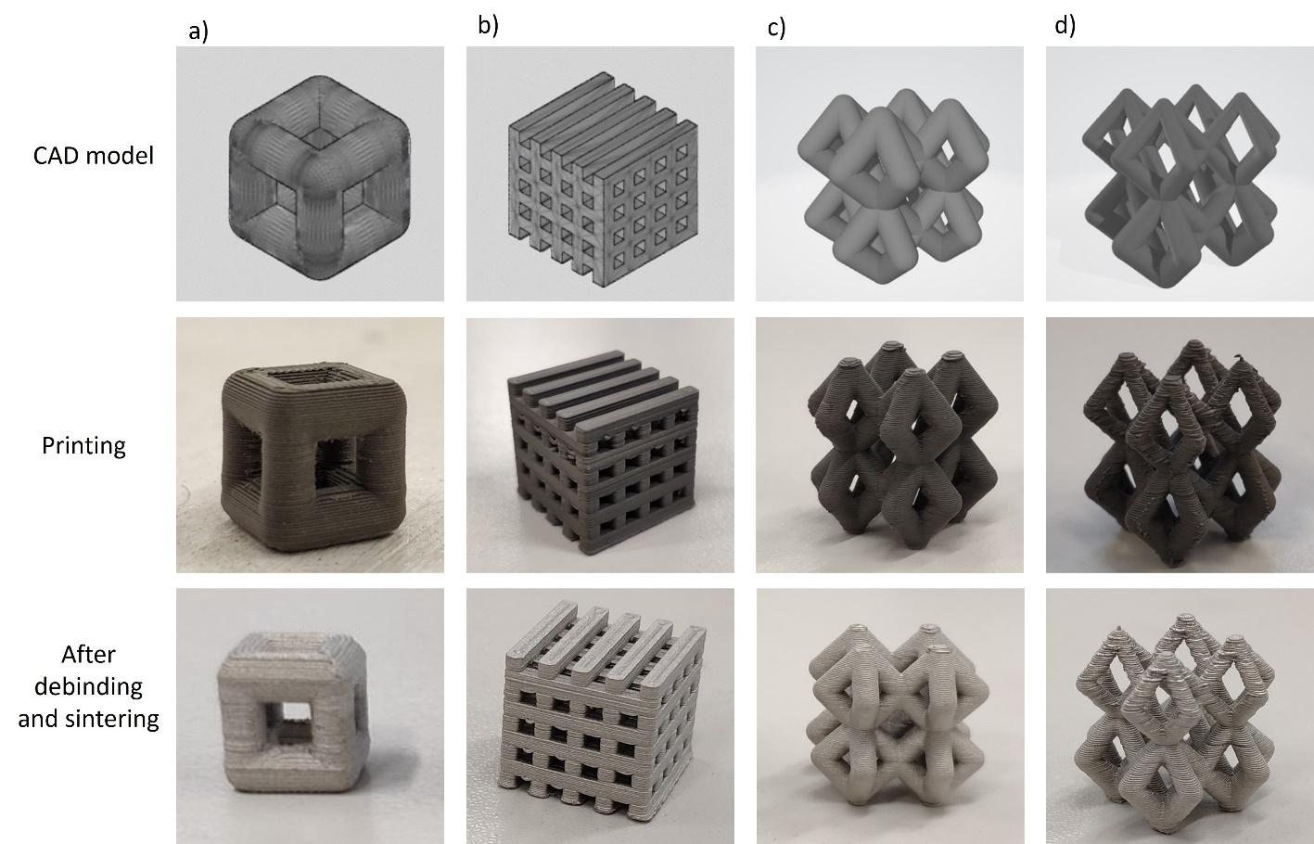
Figure SI.5: Examples of lattice structures printed after the preliminary analysis on printing parameters: a) simple cubic cell; b) complex cubic lattice; c) 2x2x2 structure of BCC unit cells with uniform beam thickness; d) 2x2x2 structure of BCC unit cells with a gradient of beam thickness. For each structure, the CAD model is shown in the first row, the green part in the second, and the metal part obtained after debinding and sintering in the third.
Source: Figure by authors

References
BASF. (2021), “Ultrafuse ® Metal Filaments Technical Data Sheet for 3D Printing Metal Parts”, available at: https://move.forward-am.com/hubfs/AES Documentation/Metal Filaments/316L/TDS/Ultrafuse_316L_TDS_EN_v1.1.pdf (accessed 12 September 2023).
Maskery, I., Parry, L.A., Padrão, D., Hague, R.J.M. and Ashcroft, I.A. (2022), “FLatt Pack: A research-focussed lattice design program”, Additive Manufacturing, Vol. 49 No. November 2021, available at:https://doi.org/10.1016/j.addma.2021.102510.
Shaikh, M.Q., Graziosi, S. and Atre, S.V. (2021), “Supportless printing of lattice structures by metal fused filament fabrication (MF3) of Ti-6Al-4V: design and analysis”, Rapid Prototyping Journal, Vol. 27 No. 7, pp. 1408–1422.

