Section A – Complementary information on differential scanning calorimetry (DSC)

Table A1 – Details of experimental characterization of TPUs using DSC found in literature. NA: Not Available.
Source | Material | Temperature range of the analysis [°C] | Sample  Mass [mg] | Temperature change rate [°C/min] | Nitrogen feeding rate [ml/min] | $T_{g}$ [°C] | $T_{m}$ [°C]
(Frick and Rochman, 2004) | TPU 80 SH(A) | [30, 300] | 3.6 | 20 | NA | NA | [230, 250]
(Arifvianto et al., 2021) | Generic TPU | [25, 300] | NA | 10 | NA | 100 | 170
(Mian et al., 2024) | Raise3D  TPU 95A | [20, 250] | 10 | 10 | 50 | NA | NA
(Haryńska et al., 2019) | S-TPU(PCL) | [-85, 220] | [7, 8] | 10 / 20 | 20 | [-57, -54] | [132, 138]
(Haryńska et al., 2020) | Bioflex® | [-80, 250] | 5 | 10 | 20 | -69 | 189
(Kasmi et al., 2022) | TPU (Pollen AM) | [-80, 250] | 5 | 10 | 50 | -51 / 81* | [215]*
(León-Calero et al., 2021) | TPU 95A (Ultimaker) | [-80, 240] | NA | NA | NA | [-54, -34] | [220, 238]*
(León-Calero et al., 2021) | Flexfill (98A) |  |  |  |  | [-18, 9] | [174, 203]*
(León-Calero et al., 2021) | Smartfil Flex (93A) |  |  |  |  | [-49, -27] | [198, 226]*
(León-Calero et al., 2021) | PolyFlex (95A) |  |  |  |  | [-32, -8] | [160, 191]*
(León-Calero et al., 2021) | eFlex (87A) |  |  |  |  | [-59, -31] | [165, 194]*
(León-Calero et al., 2021) | Filaflex (95A) |  |  |  |  | [-57, -19] | [174, 218]*
(León-Calero et al., 2021) | Filaflex (82A) |  |  |  |  | [-57, -33] | [163, 184]*
(León-Calero et al., 2021) | Filaflex (70A) |  |  |  |  | [-69, -51] | [64, 180]*
(León-Calero et al., 2021) | Flexi Smart (88A) |  |  |  |  | [-35, -19] | [164, 191]*
* Includes reference temperatures for the hard segment of the material.

The two upper curves in Figures A1(a) and A1(b) refer to the cooling step, while the four lower curves refer to the heating step. In the glass transition temperature region of Figure A1, the displayed values represent the lowest to highest temperatures ($T_{on-set}$, $T_{middle}$, $T_{end-set}$), from left to right, respectively. An estimate of the heat capacity jump between the glassy and rubbery phases is also provided, shown in units of J/(g.ºC).
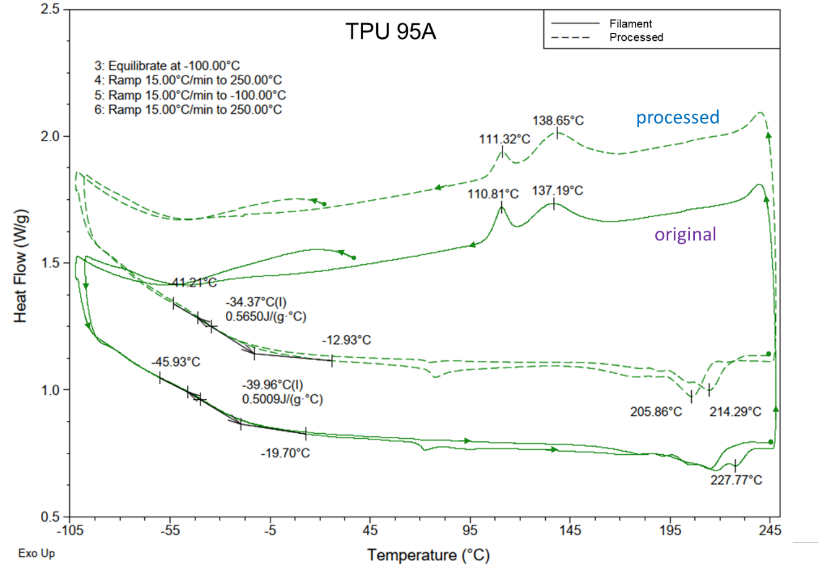
(a)
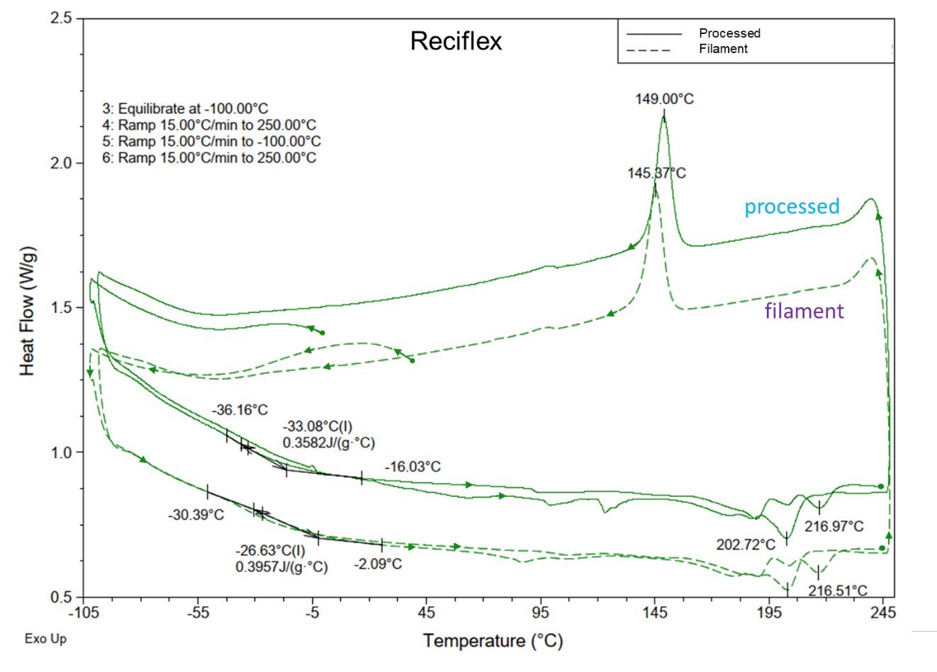
(b)
Figure A1 – Result of the DSC analysis, comparing filament and FFF processed: (a) TPU 95 A; (b) Reciflex. (Exo up)
References

Arifvianto, B., Nur Iman, T., Tulung Prayoga, B., Dharmastiti, R., Agus Salim, U. and Mahardika, M. (2021), “Tensile properties of the FFF-processed thermoplastic polyurethane (TPU) elastomer”, Int J Adv Manuf Technol, Vol. 117, pp. 1709–1719, doi: 10.1007/s00170-021-07712-0.
Frick, A. and Rochman, A. (2004), “Characterization of TPU-elastomers by thermal analysis (DSC)”, Polymer Testing, Vol. 23 No. 4, pp. 413–417, doi: 10.1016/j.polymertesting.2003.09.013.
Haryńska, A., Carayon, I., Kosmela, P., Szeliski, K., Łapiński, M., Pokrywczyńska, M., Kucińska-Lipka, J., et al. (2020), “A comprehensive evaluation of flexible FDM/FFF 3D printing filament as a potential material in medical application”, European Polymer Journal, Elsevier Ltd, Vol. 138, doi: 10.1016/j.eurpolymj.2020.109958.
Haryńska, A., Kucinska-Lipka, J., Sulowska, A., Gubanska, I., Kostrzewa, M. and Janik, H. (2019), “Medical-grade PCL based polyurethane system for FDM 3D printing-characterization and fabrication”, Materials, MDPI, Vol. 12 No. 6, doi: 10.3390/ma12060887.
Kasmi, S., Ginoux, G., Labbé, E. and Alix, S. (2022), “Multi-physics properties of thermoplastic polyurethane at various fused filament fabrication parameters”, Rapid Prototyping Journal, Emerald Group Holdings Ltd., Vol. 28 No. 5, pp. 895–906, doi: 10.1108/RPJ-08-2021-0214.
León-Calero, M., Reyburn Valés, S.C., Marcos-Fernández, Á. and Rodríguez-Hernandez, J. (2021), “3D printing of thermoplastic elastomers: Role of the chemical composition and printing parameters in the production of parts with controlled energy absorption and damping capacity”, Polymers, MDPI, Vol. 13 No. 20, doi: 10.3390/polym13203551.
Mian, S.H., Abouel Nasr, E., Moiduddin, K., Saleh, M. and Alkhalefah, H. (2024), “An Insight into the Characteristics of 3D Printed Polymer Materials for Orthoses Applications: Experimental Study”, Polymers, Multidisciplinary Digital Publishing Institute (MDPI), Vol. 16 No. 3, doi: 10.3390/polym16030403.

Section B – Complementary information on scanning electron microscopy (SEM) results

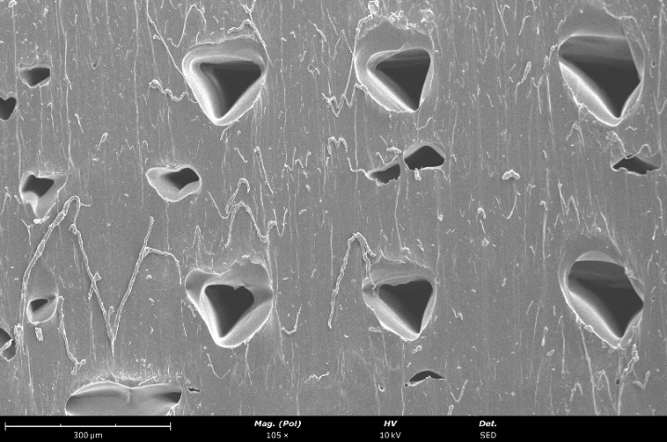 | 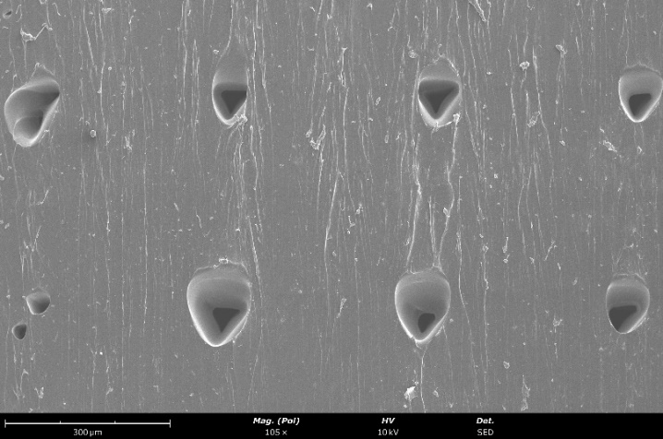
(a) | (b)
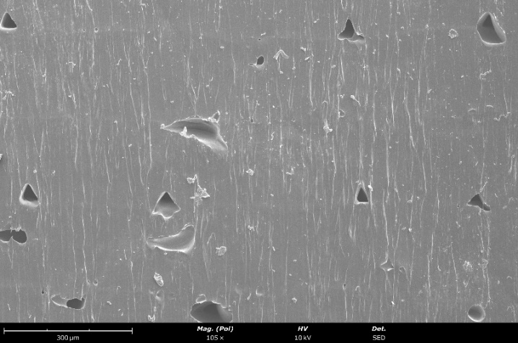 | 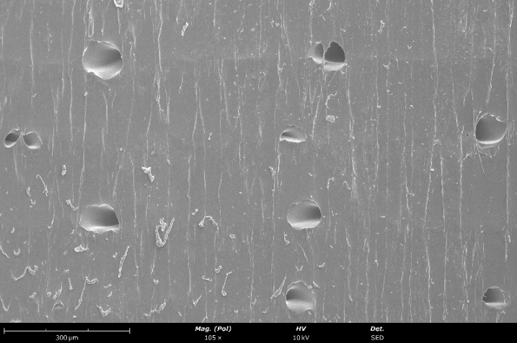
(c) | (d)
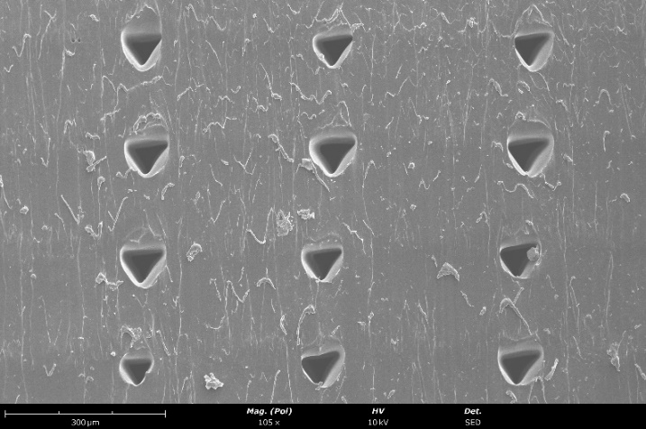 | 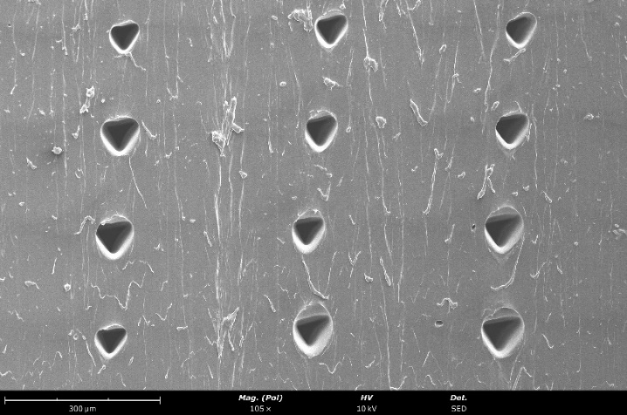
(e) | (f)
Figure B1. SEM results of TPU 95A specimens: (a) T1_TPU_T225_0_90; (b) T2_TPU_T235_0_90; (c) T3_TPU_T240_0_90; (d) T4_TPU_T235_45_-45; (e) T5_TPU_T235_Concentric; (f) T6_TPU_T235_0_0.

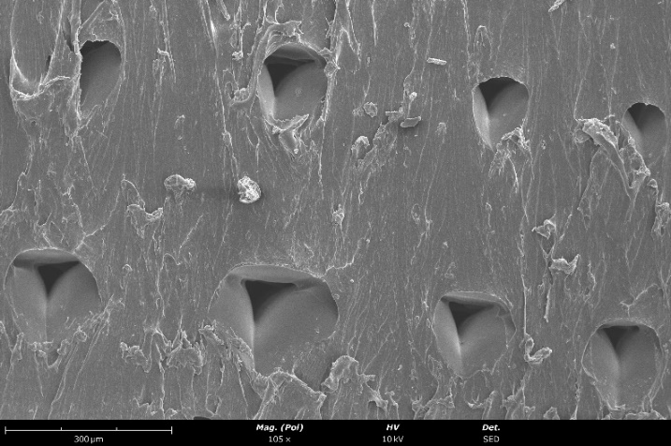 | 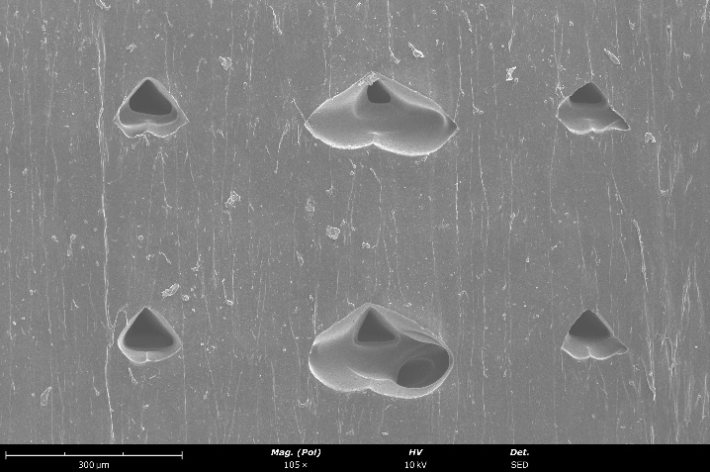
(a) | (b)
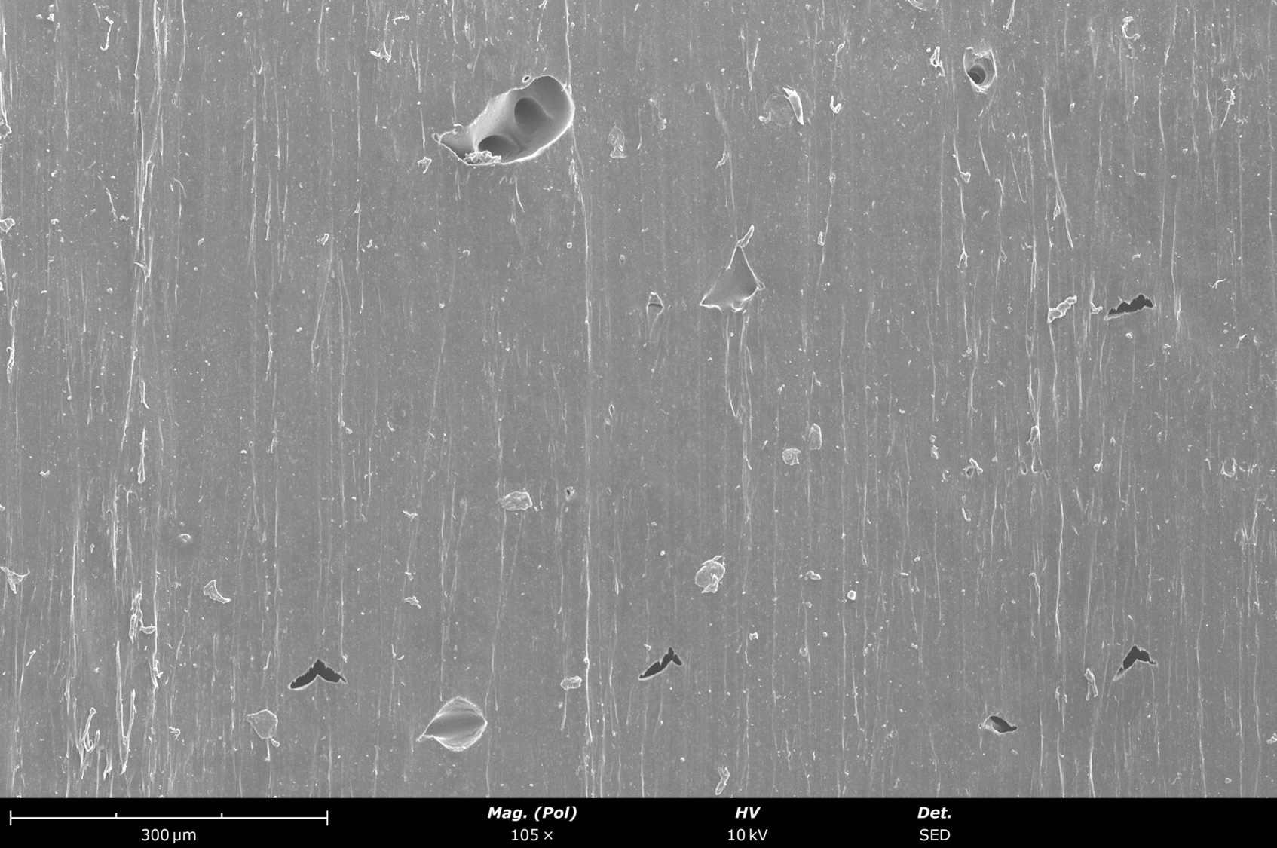 | 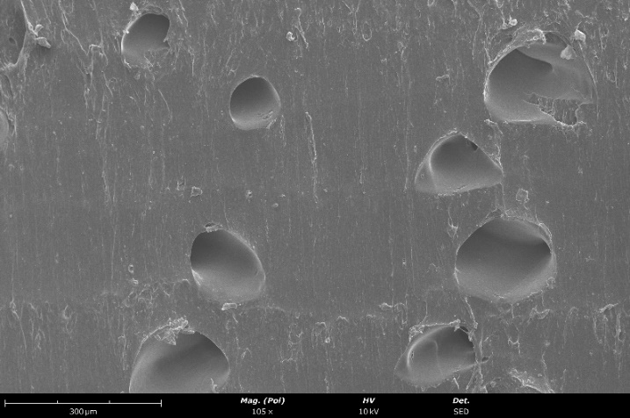
(c) | (d)
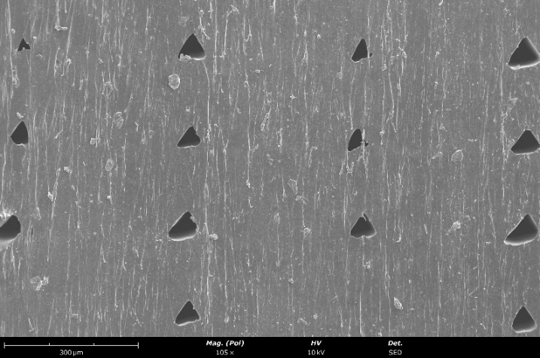 | 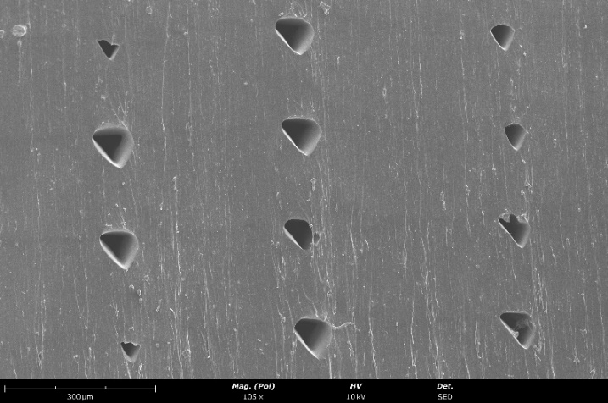
(e) | (f)
Figure B2. SEM results of Reciflex specimens: (a) T7_Reci_T220_0_90; (b) T8_Reci_T225_0_90; (c) T9_Reci_T230_0_90; (d) T10_Reci_T225_45_-45; (e) T11_Reci_T225_Concentric; (f) T12_Reci_T225_0_0.

Section C – Complementary information on tensile test results

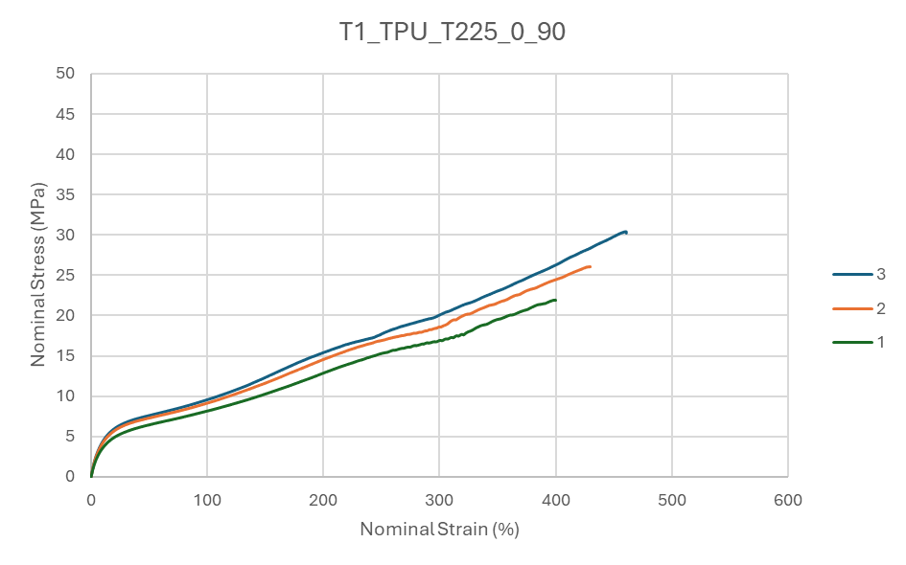
Figure C1 – Nominal stress-strain plot of the tensile tests performed on the batch of TPU 95A specimens (T1_TPU_T225_0_90).

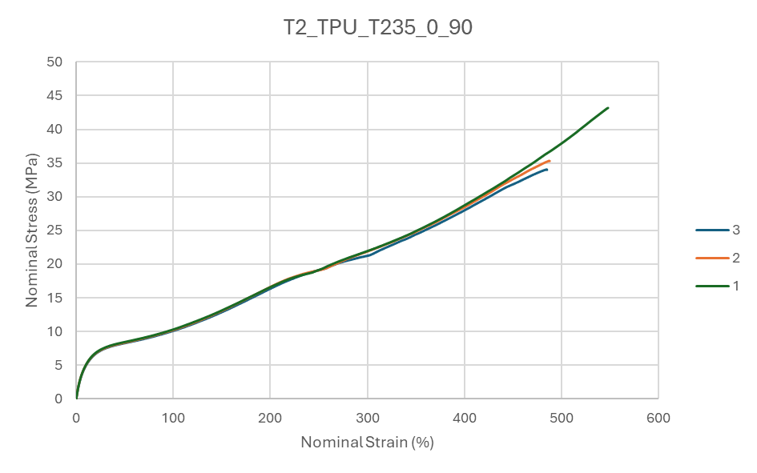
Figure C2 – Nominal stress-strain plot of the tensile tests performed on the batch of TPU 95A specimens (T2_TPU_T235_0_90).
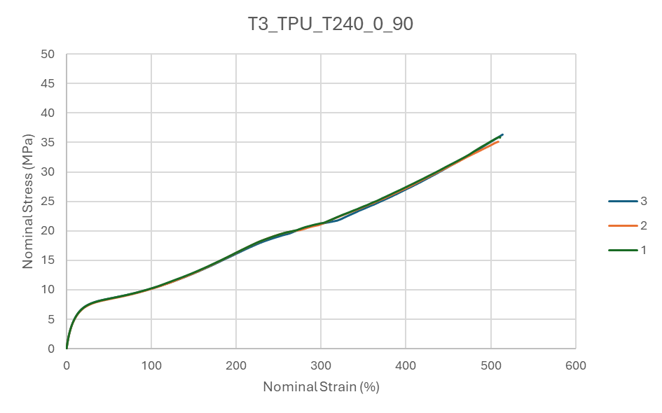
Figure C3 – Nominal stress-strain plot of the tensile tests performed on the batch of TPU 95A specimens (T3_TPU_T240_0_90).
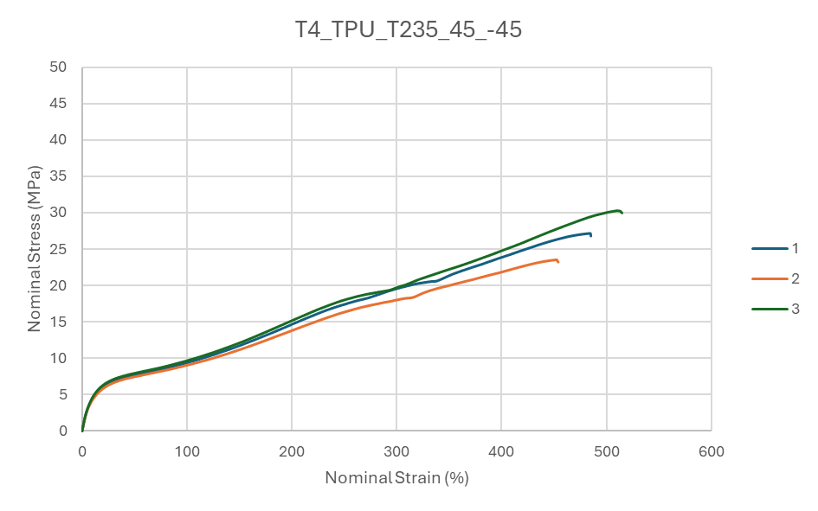
Figure C4 – Nominal stress-strain plot of the tensile tests performed on the batch of TPU 95A specimens (T4_TPU_T235_45_-45).
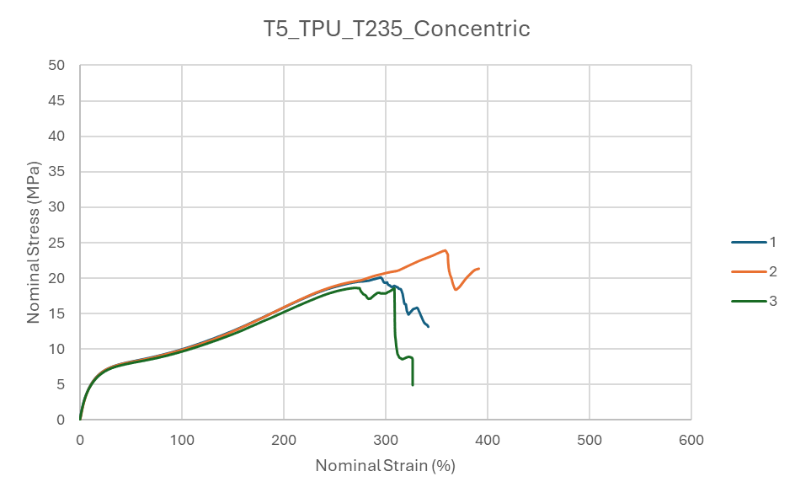
Figure C5 – Nominal stress-strain plot of the tensile tests performed on the batch of TPU 95A specimens (T5_TPU_T235_Concentric).

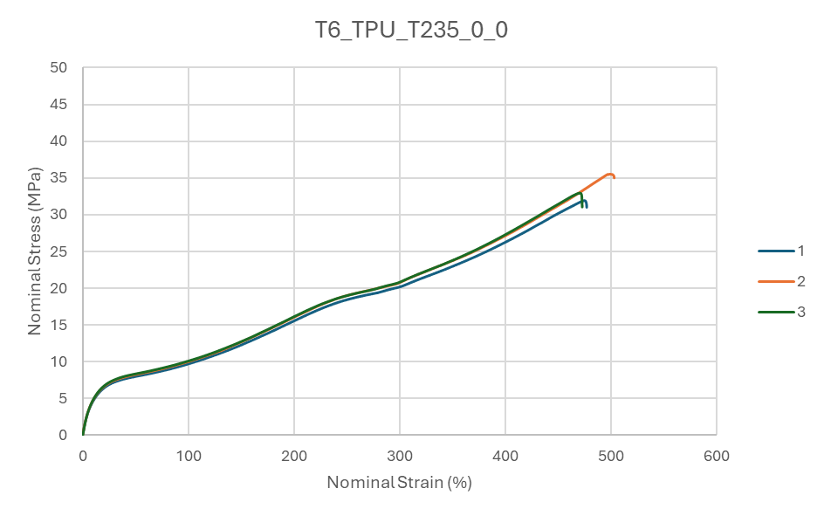
Figure C6 – Nominal stress-strain plot of the tensile tests performed on the batch of TPU 95A specimens (T6_TPU_T235_0_0).

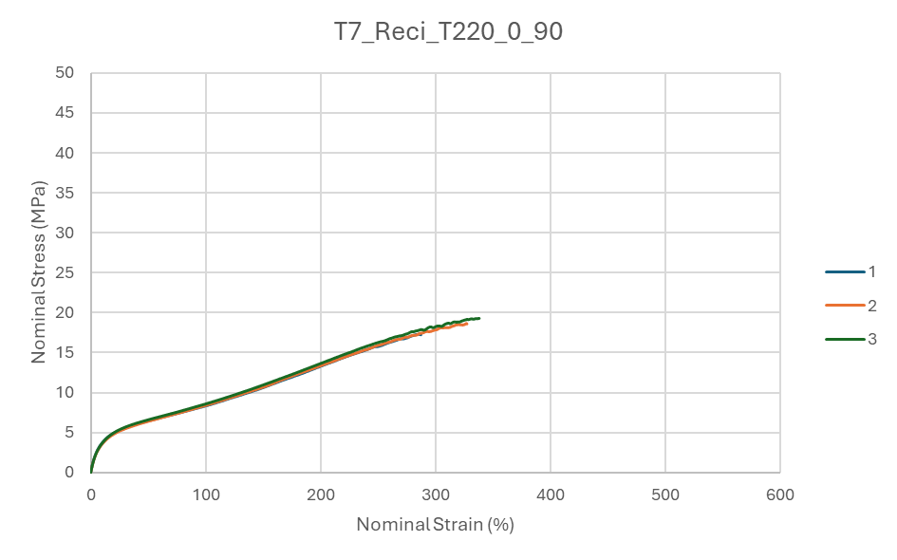
Figure C7 – Nominal stress-strain plot of the tensile tests performed on the batch of Reciflex specimens (T7_Reci_T220_0_90).
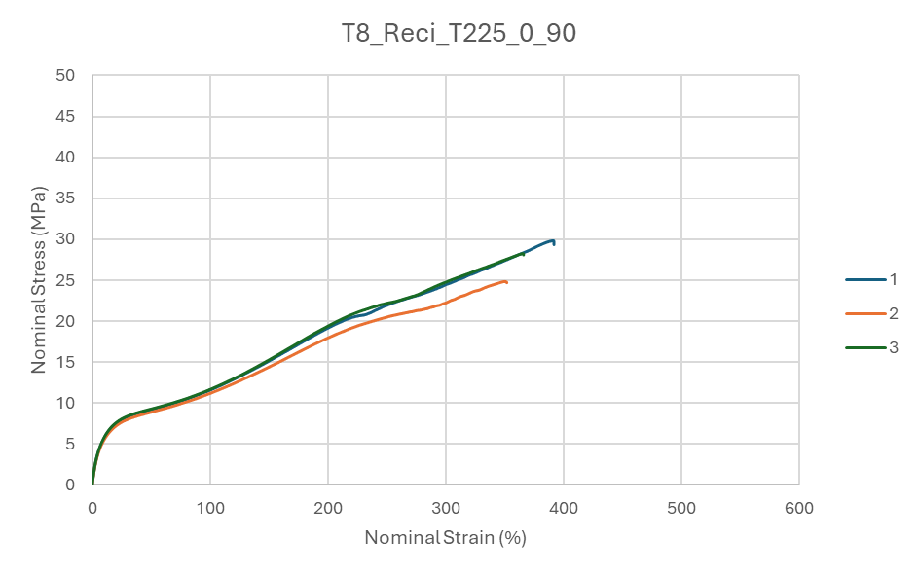
Figure C8 – Nominal stress-strain plot of the tensile tests performed on the batch of Reciflex specimens (T8_Reci_T225_0_90).
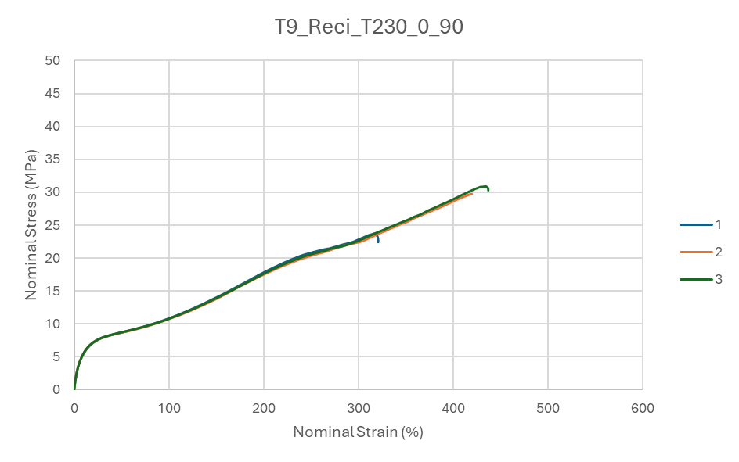
Figure C9 – Nominal stress-strain plot of the tensile tests performed on the batch of Reciflex specimens (T9_Reci_T230_0_90).

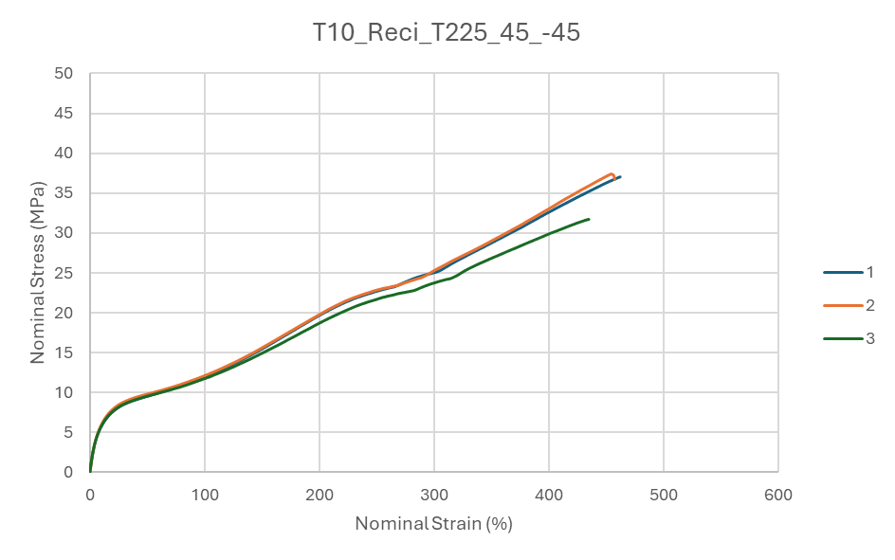
Figure C10 – Nominal stress-strain plot of the tensile tests performed on the batch of Reciflex specimens (T10_Reci_T225_45_-45).

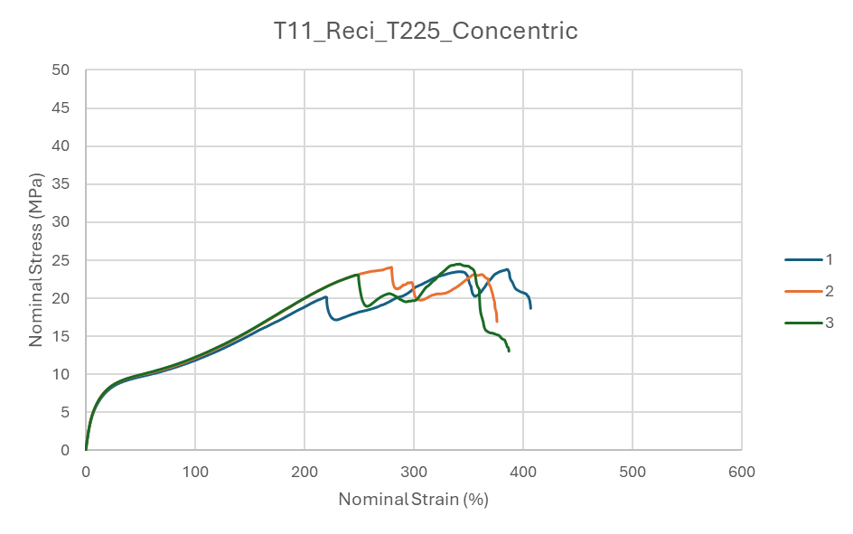
Figure C11 – Nominal stress-strain plot of the tensile tests performed on the batch of Reciflex specimens (T11_Reci_T225_Concentric).

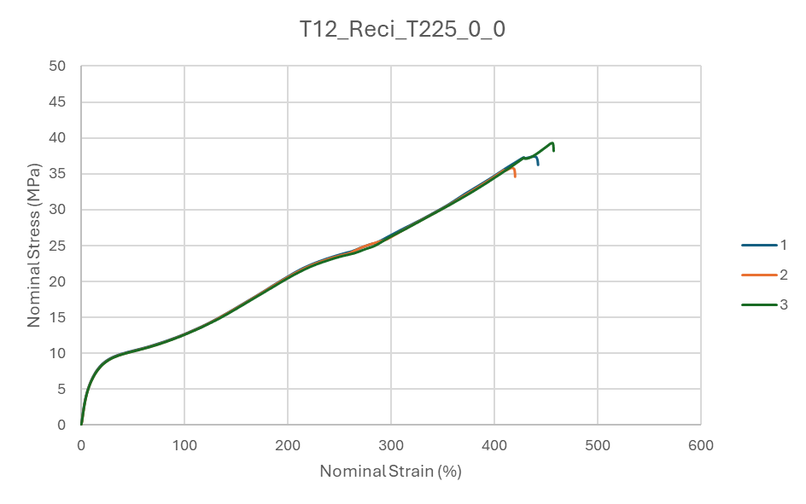
Figure C12 – Nominal stress-strain plot of the tensile tests performed on the batch of Reciflex specimens (T12_Reci_T225_0_0).

Section D – Complementary information on compression test results

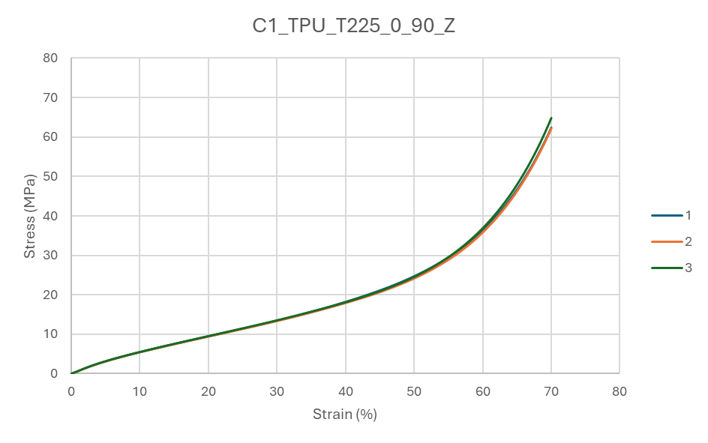
Figure D1 – Nominal stress-strain plot of the compression tests performed on the batch of TPU 95A specimens (C1_TPU_T225_0_90_Z).

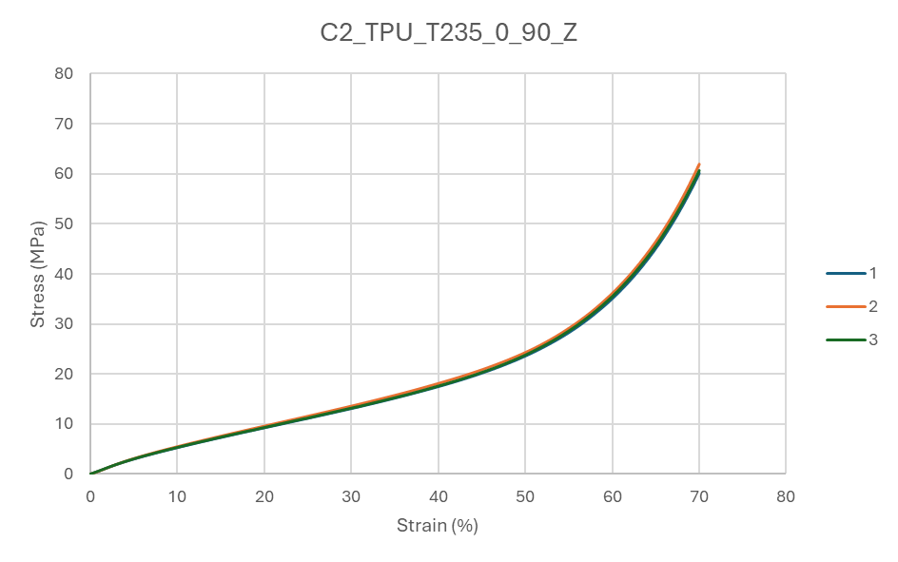
Figure D2 – Nominal stress-strain plot of the compression tests performed on the batch of TPU 95A specimens (C2_TPU_T235_0_90_Z).

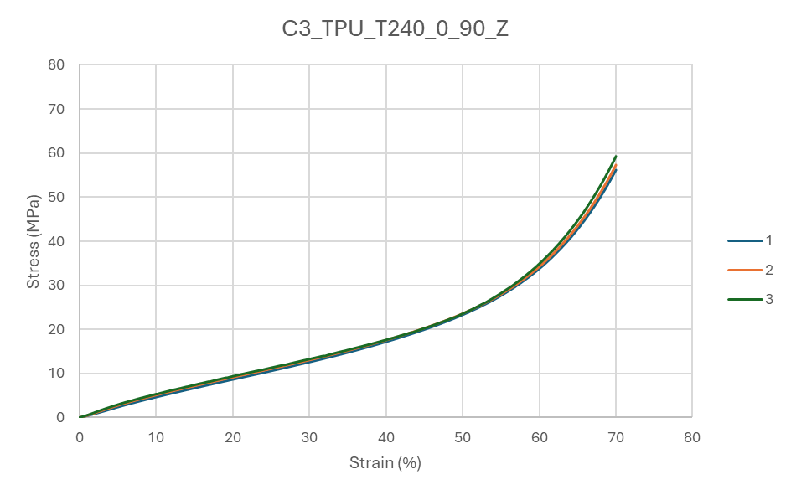Figure D3 – Nominal stress-strain plot of the compression tests performed on the batch of TPU 95A specimens (C3_TPU_T240_0_90_Z).

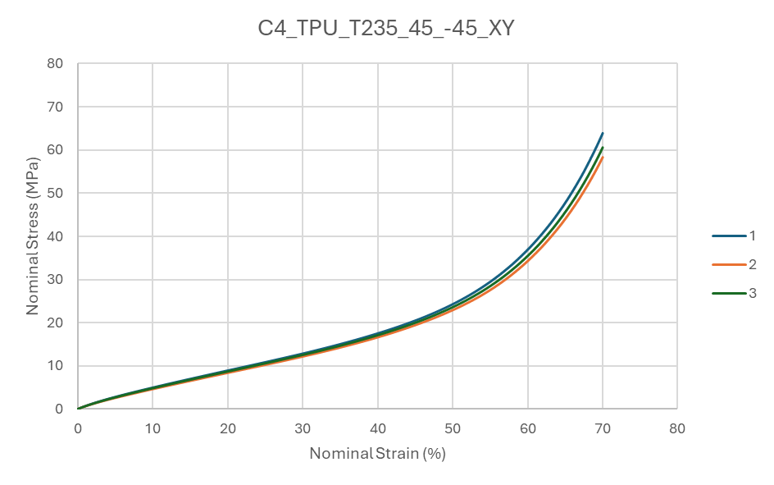
Figure D4 – Nominal stress-strain plot of the compression tests performed on the batch of TPU 95A specimens (C4_TPU_T235_45_-45_XY).

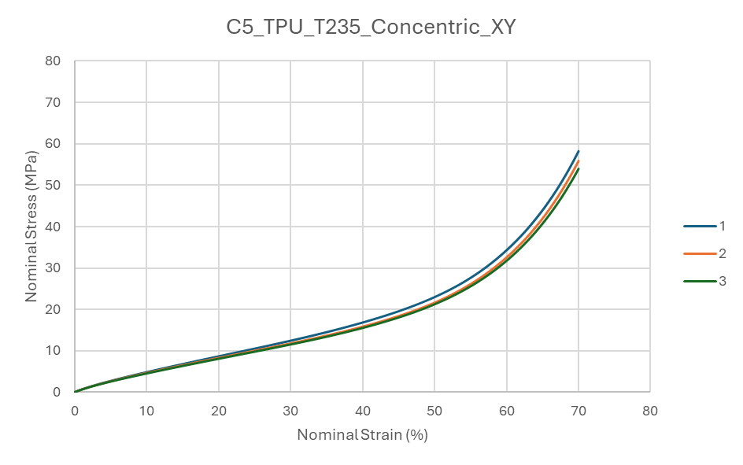
Figure D5 – Nominal stress-strain plot of the compression tests performed on the batch of TPU 95A specimens (C5_TPU_T235_Concentric_XY).

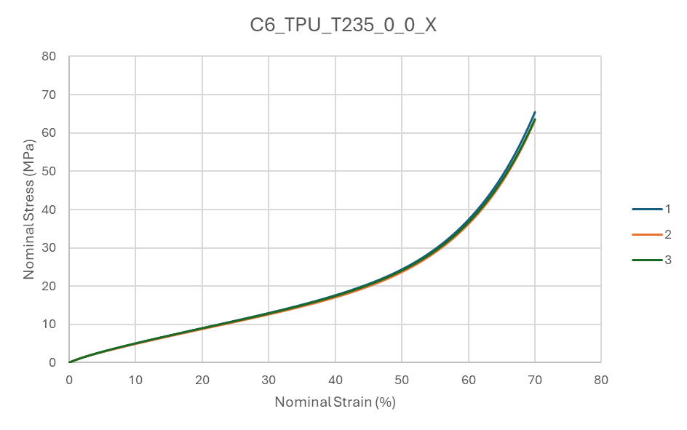
Figure D6 – Nominal stress-strain plot of the compression tests performed on the batch of TPU 95A specimens (C6_TPU_T235_0_0_X).

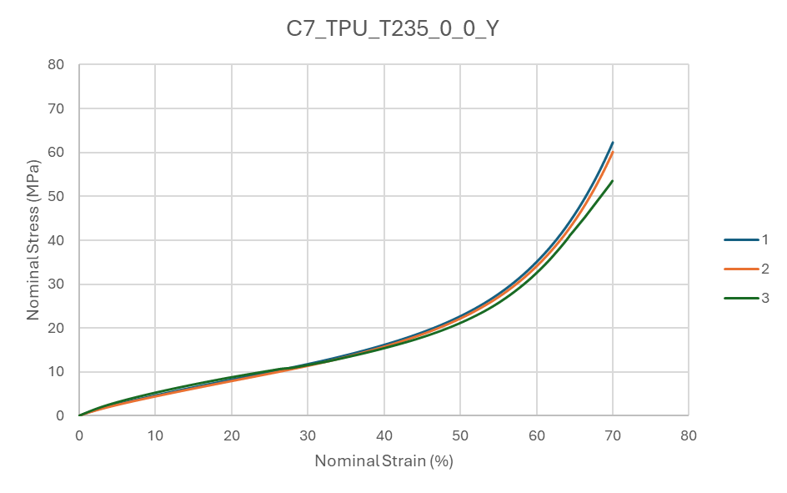
Figure D7 – Nominal stress-strain plot of the compression tests performed on the batch of TPU 95A specimens (C7_TPU_T235_0_0_Y).

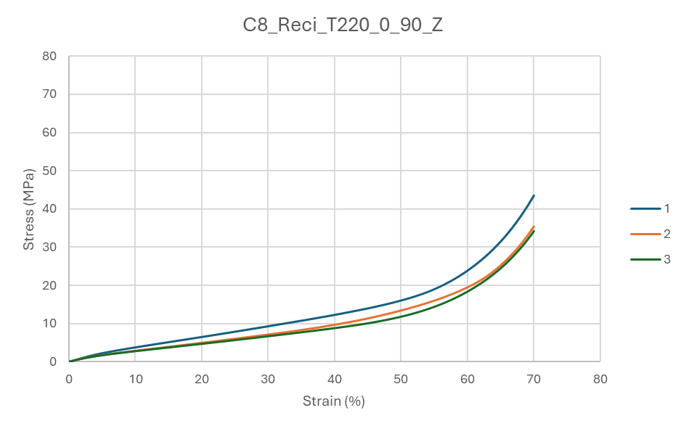
Figure D8 – Nominal stress-strain plot of the compression tests performed on the batch of Reciflex specimens (C8_Reci_T220_0_90_Z).

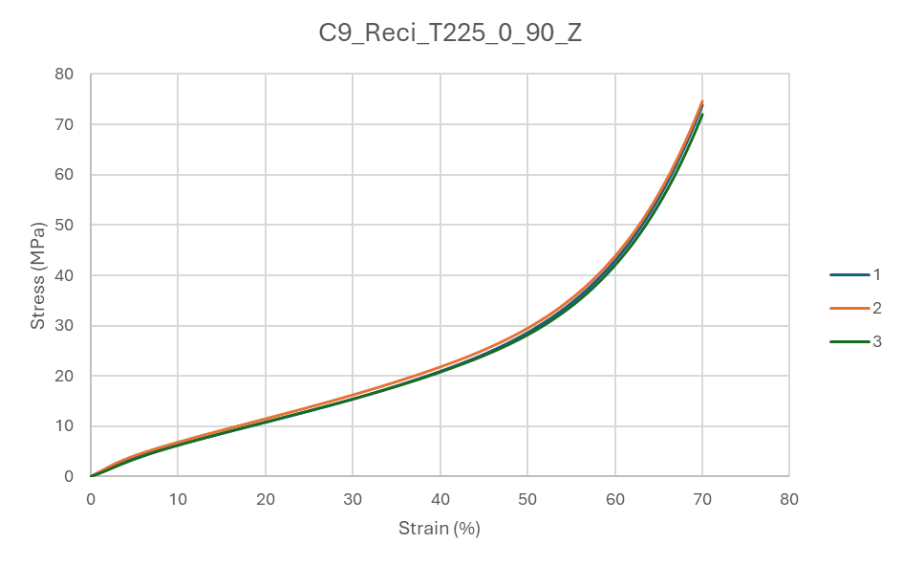
Figure D9 – Nominal stress-strain plot of the compression tests performed on the batch of Reciflex specimens (C9_Reci_T225_0_90_Z).

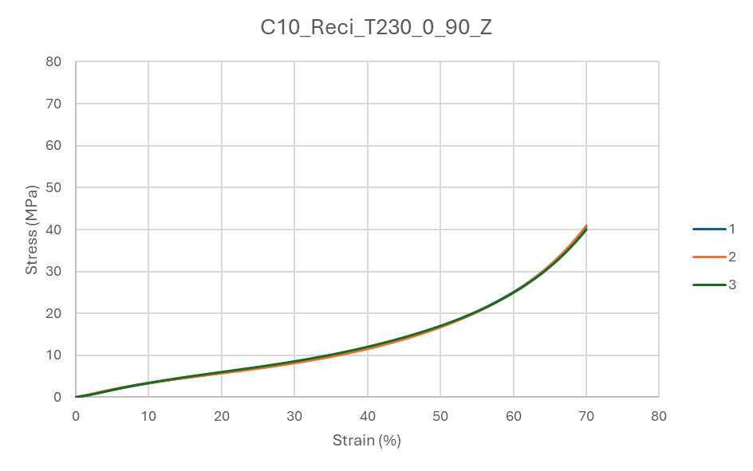
Figure D10 – Nominal stress-strain plot of the compression tests performed on the batch of Reciflex specimens (C10_Reci_T230_0_90_Z).

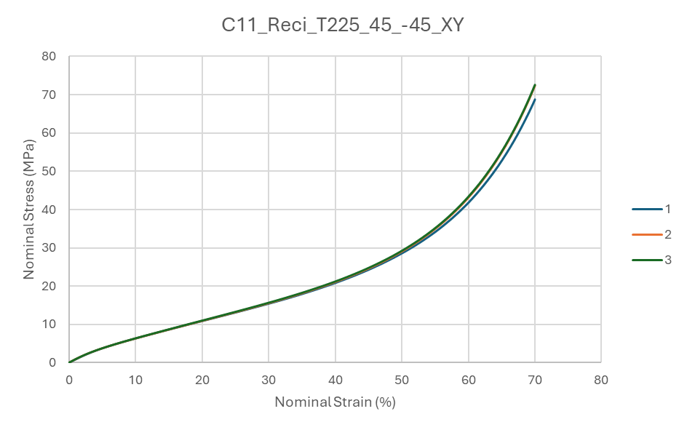
Figure D11 – Nominal stress-strain plot of the compression tests performed on the batch of Reciflex specimens (C11_Reci_T225_45_-45_XY).

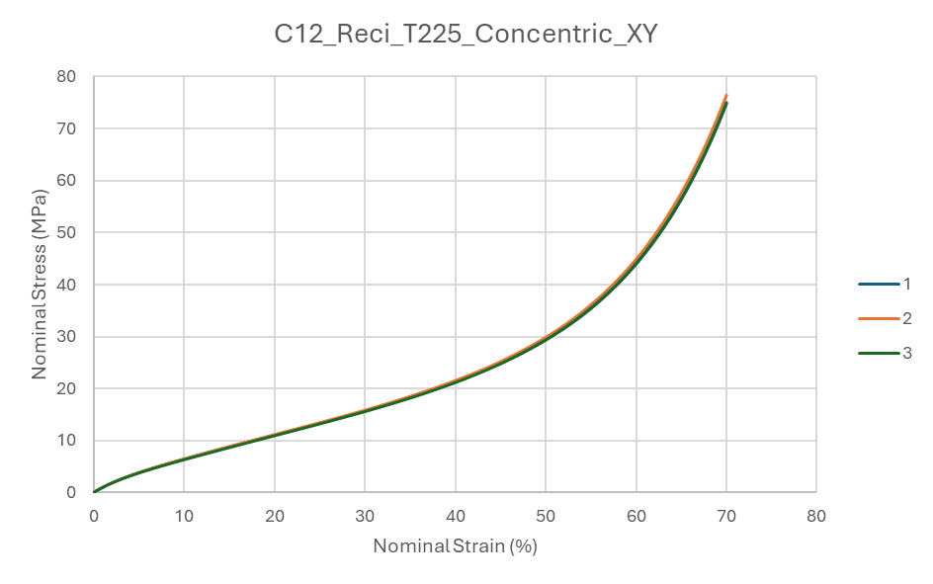
Figure D12 – Nominal stress-strain plot of the compression tests performed on the batch of Reciflex specimens (C12_Reci_T225_Concentric_XY).

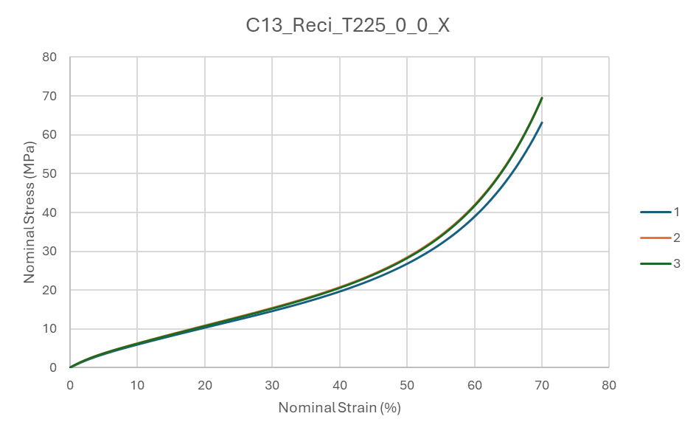
Figure D13 – Nominal stress-strain plot of the compression tests performed on the batch of Reciflex specimens (C13_Reci_T225_0_0_X).

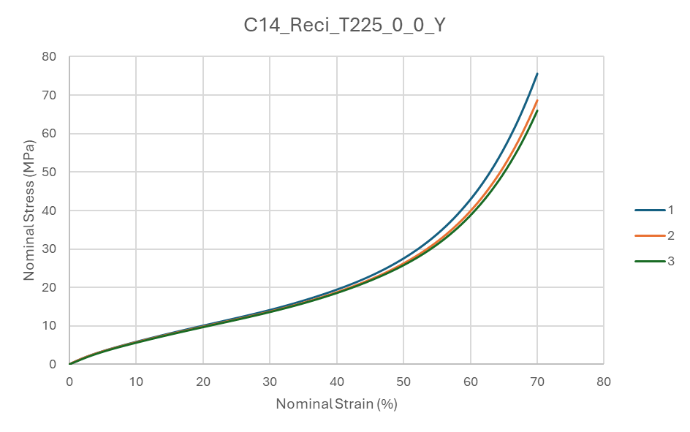
Figure D14 – Nominal stress-strain plot of the compression tests performed on the batch of Reciflex specimens (C14_Reci_T225_0_0_Y).

CREDIT LINE FOR ALL TABLES AND FIGURE
Source: Author’s Own Work

