Supplementary Material

Development of Biobased Photocurable Resin for LCD 3D Printing of Reprocessable Catalyst-free Vitrimer

S.1 Methods
S1.1. Real-Time Photorheometry
UV/Vis curing tests were performed on a MCR302 rheometer (Anton Paar) equipped with the plate/plate measuring system. The measuring gap was set to 0.1 mm and the samples were irradiated by UV/Vis light using light filter in a wavelength range of 400-450 nm through the glass plate using UV/Vis spot curing system OmniCure S2000 (Lumen Dynamics Group Inc.). The temperature was 25 °C. Shear mode with the frequency of 10 Hz and shear strain of 1% were used in all cases.
S1.2. Fourier transformation infrared spectroscopy
Fourier transformation infrared spectroscopy (FT-IR) spectra were recorded using a Spectrum BX II FT-IR spectrometer (Perkin Elmer, Llantrisant, UK). The reflection was measured during the test. The range of wavenumbers was (650-4000) cm⁻¹.
S1.3. The Soxhlet extraction
The Soxhlet extraction was used to determine the yield of insoluble fraction. Polymer samples of 0.5 g were extracted with acetone for 24 h. After 24 h the insoluble fractions were dried under vacuum until no changes of the weight were observed. The yield of insoluble fraction was calculated as the difference of the weight before and after the extraction and drying.
S1.4. The swelling test
The swelling values of the cross-linked polymer specimens were obtained by measuring the mass of specimens swollen in solvent at 25 °C. The polymer film specimens of 20 (±0.1) mm length, 10 (±0.05) mm width, and 1 (±0.05) mm thickness were used. The change of mass was measured every 60 min and the percentage change in mass was calculated. Water, acetone and toluene were selected as solvents.
S1.5. Dynamical mechanical thermal analysis
Dynamical mechanical thermal analysis (DMTA) was performed on an MCR302 rheometer (Anton Paar). The Peltier-controlled temperature chamber was used. The temperature was increased from 25 °C to 115 °C, with a heating rate of 3 °C/min. The normal force was set to 5 N during the measurement. In all cases, the torsion mode was used with a frequency of 1 Hz and a torsion strain of 0.1%.
S1.6. Thermogravimetric analysis
Thermogravimetric analysis (TGA) was performed on a Pyris TGA 9 apparatus (Perkin Elmer) with a heating rate of 30 °C/min under nitrogen atmosphere (20 mL/min). The temperature range of 50−600 °C was used.
S1.7. Mechanical properties
Mechanical properties of the synthesized polymers were investigated by the tensile test. The tensile test was performed on a Testometric M500-50CT testing machine (Testometric Co Ltd) at the room temperature (25°C). The dimensions of the test specimens were 70 (±0.00) x 10 (±0.00) x 1 (±0.15) mm. test was performed at the speed of 5 mm/min until the break of the specimen.
S1.8. Self-welding behaviour
The self-welding experiment was carried out by cutting the LCD 3D printed (Elegoo Mars Pro 3D printer) sample (70 x 10 x 1 mm) into two equal pieces which were placed on top of each other with 1 cm² overlap and heated in the temperature chamber at 180 °C for 30 min. No additional pressure was applied to the samples. After that, samples were cooled down to room temperature, and a tensile test was performed.
S1.9. Reprocessability
Vitrimer samples were crushed into fine powder using electric coffee grounder Esperanza. The Lap 40 press (Gottfried Joos Mschinenfabrik GmbH & Co. kg) was used for the reprocessability test. 1 g of powder was placed in a (70 x 10 x 1) mm Teflon frame and heated at 180 °C for 1 h. The applied pressure was 2 MPa. After that, the heating was turned off and the samples were allowed to cool to room temperature (25 °C) before being removed from the press.
S1.10. Statistical data analysis
The collected data were statistically analyzed using ANOVA for the Microsoft Excel programme. 5 Parallel specimens were used for the investigation of all properties. The results were presented as the average values ± standard deviation. The estimated p-value was below 0.05 within the groups.
S1.11. LCD 3D Printing
The LCD 3D printer Elegoo Mars Pro with a 405 nm LED source with the printing volume of (192 x 120 x 280) mm was used. Exposure time was 12 s for 50 µm layer. Z axis lift distance was set to 5 mm with lifting and retract speed of 4 mm/s. The exposure time of the bottom layers was 120 s (number of bottom layers was 5), and the exposure off time was 5 s. After printing, polymer samples were washed with isopropyl alcohol and post-cured for 5 min under a UV/Vis lamp with 310 mW/cm² intensity.
S2. Results
The chemical structure of the vitrimer N5 was confirmed by FT-IR spectroscopy. The signals of the alkene group (1720-1727 cm⁻¹) and C-O-C group (1055-1119 cm⁻¹) in the GDGDA, GLYFOMA and DPEPA spectra were decreased in polymer spectra. The signals of the epoxy group (856 cm⁻¹, 908 cm⁻¹ and 1245 cm⁻¹) in the RTE spectrum were also decreased in the polymer spectra. This indicates that polymers were formed during photocuring. The other characteristic signals were also visible: hydroxy group (3441-3480 cm⁻¹), carbonyl group (1718-1719 cm⁻¹), aromatic C-H (3052-3053 cm⁻¹), and aliphatic C-H at (2918-2924 cm⁻¹). The FT-IR spectra of RTE, GDGDA, GLYFOMA, DPEPA and vitrimer N5 are presented in Figure S1.

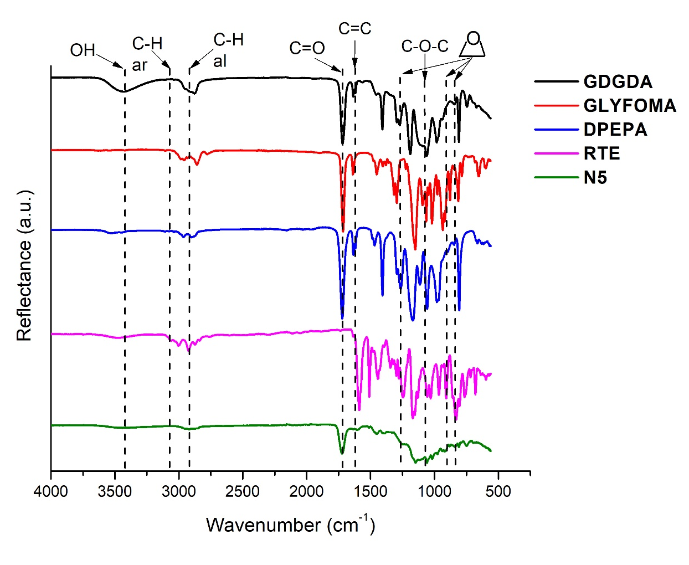
Figure S1. FT-IR spectra of GDGDA, GLYFOMA, DPEPA, RTE and vitrimer N5

The dependency of swelling degree on time of vitrimer N5 is presented in Figure S2 and Figure S3 -S4
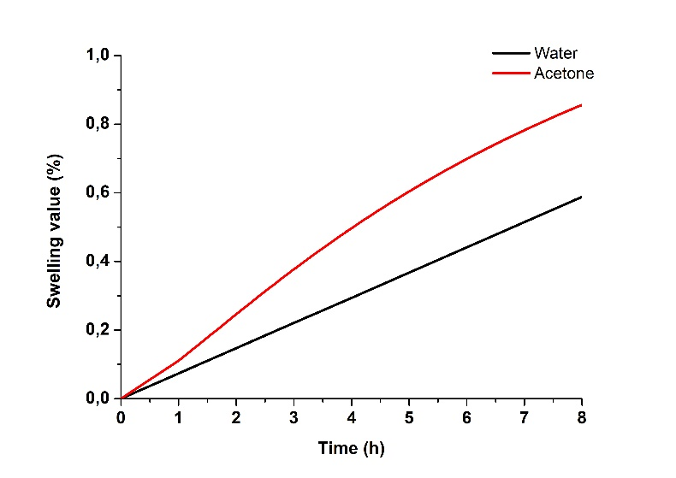
Figure S2. The dependency of vitrimer N5 specimen swelling degree on time
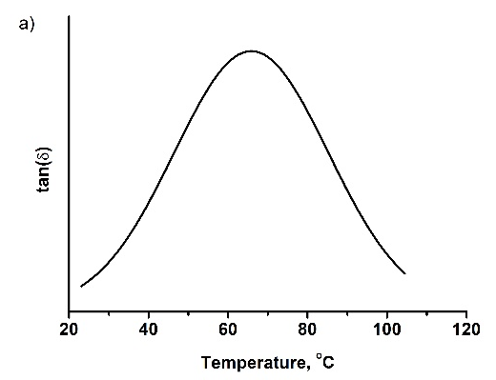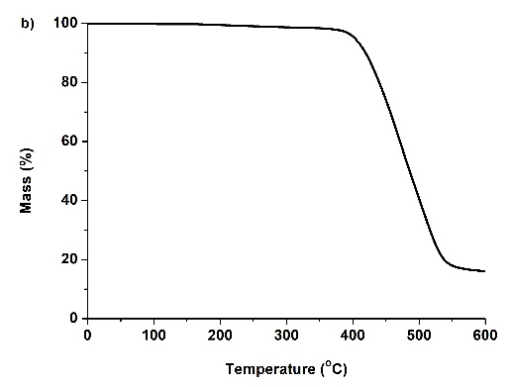

Figure S3. DMTA (a) and TGA (b) curves of vitrimer N5

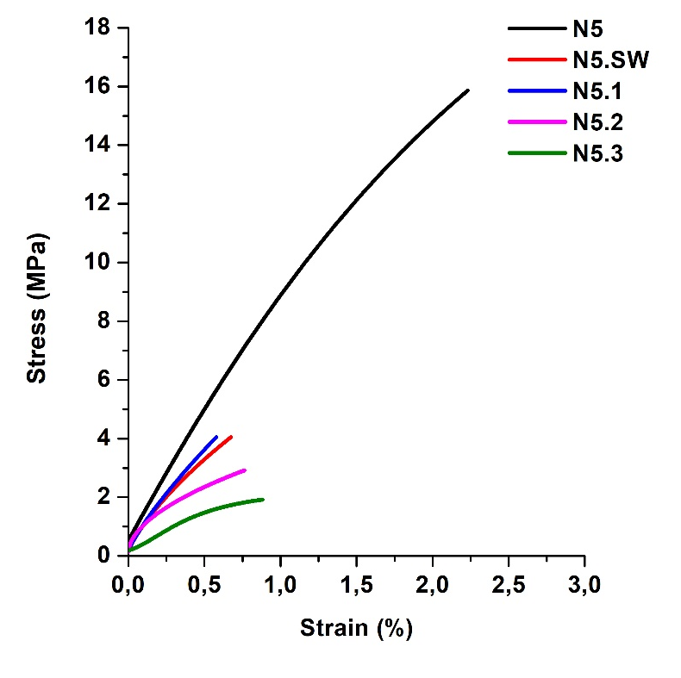
Figure S4. Tensile stress-strain curves of vitrimers

