Supplementary Material

Table S1. The selected process parameters for the 316L LB-PBF process.
Sample ID | Laser Power  (W) | Scan  Speed  (mm/s) | Hatch Spacing (μm) | Scanning Pattern Angle (°) | Heat treatment temperature (°C)
1 | 150 | 650 | 60 | 36 | 20
2 | 150 | 700 | 65 | 40 | 425
3 | 150 | 750 | 70 | 45 | 650
4 | 150 | 800 | 75 | 60 | 870
5 | 150 | 850 | 80 | 72 | 1150
6 | 175 | 650 | 65 | 45 | 870
7 | 175 | 700 | 70 | 60 | 1150
8 | 175 | 750 | 75 | 72 | 20
9 | 175 | 800 | 80 | 36 | 425
10 | 175 | 850 | 60 | 40 | 650
11 | 200 | 650 | 70 | 72 | 425
12 | 200 | 700 | 75 | 36 | 650
13 | 200 | 750 | 80 | 40 | 870
14 | 200 | 800 | 60 | 45 | 1150
15 | 200 | 850 | 65 | 60 | 20
16 | 225 | 650 | 75 | 40 | 1150
17 | 225 | 700 | 80 | 45 | 20
18 | 225 | 750 | 60 | 60 | 425
19 | 225 | 800 | 65 | 72 | 650
20 | 225 | 850 | 70 | 36 | 870
21 | 250 | 650 | 80 | 60 | 650
22 | 250 | 700 | 60 | 72 | 870
23 | 250 | 750 | 65 | 36 | 1150
24 | 250 | 800 | 70 | 40 | 20
25 | 250 | 850 | 75 | 45 | 425

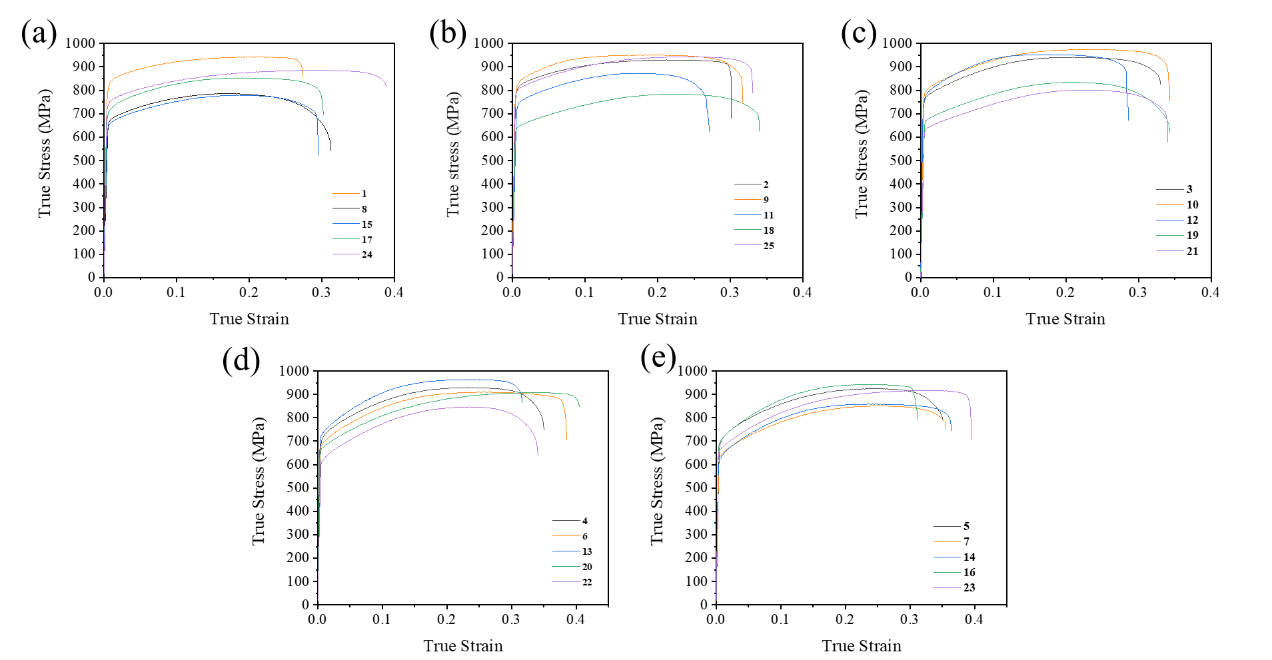
Figure S1. The tensile curves for samples in (a) as printed state and (b) heat treated at 425 °C, (c) 650 °C, (d) 870 °C, and (e) 1150 °C temperatures. The observed numbers in the legends correspond to the test number mentioned in Table 3.

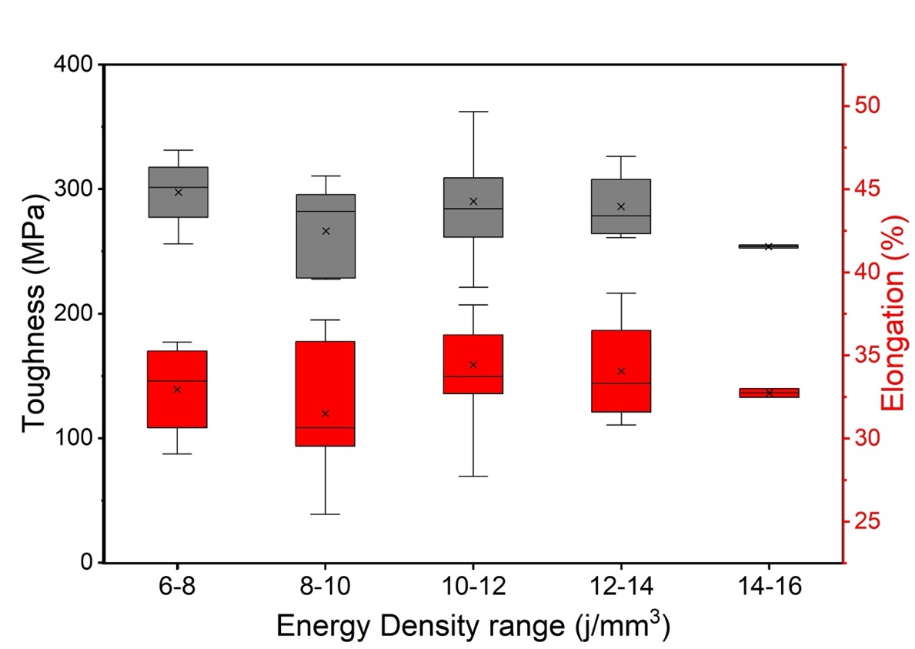
Figure S2. Variation in mechanical performance among printed samples as a function of the designed energy density range.

Table S2. The variation of the energy density with respect to the processing parameters used in this study.
Laser Power (W) | Scan Speed (mm/s) | Hatch Spacing (µm) | Energy Density  (J/mm³)
150 | 650 | 60 | 8.82
150 | 700 | 65 | 8.19
150 | 750 | 70 | 7.64
150 | 800 | 75 | 7.17
150 | 850 | 80 | 6.74
175 | 650 | 65 | 10.29
175 | 700 | 70 | 9.55
175 | 750 | 75 | 8.92
175 | 800 | 80 | 8.36
175 | 850 | 60 | 7.87
200 | 650 | 70 | 11.76
200 | 700 | 75 | 10.92
200 | 750 | 80 | 10.19
200 | 800 | 60 | 9.55
200 | 850 | 65 | 8.99
225 | 650 | 75 | 13.23
225 | 700 | 80 | 12.28
225 | 750 | 60 | 11.46
225 | 800 | 65 | 10.75
225 | 850 | 70 | 10.12
250 | 650 | 80 | 14.70
250 | 700 | 60 | 13.65
250 | 750 | 65 | 12.74
250 | 800 | 70 | 11.94
250 | 850 | 75 | 11.24

