Supplementary material

Section S1. SEM image processing and quantitative defect analysis
For quantitative assessment, the images were processed using ImageJ software (NIH, USA) (Huang et al., 2012). At least five representative micrographs were analyzed for each formulation. The procedure was as follows:
- Image pre-processing: converting images to greyscale and applying an automatic threshold (Otsu method) to segment defects and cavities from the polymer matrix.
- Measurement of cavities and defects: determining the projected area of each cavity, the equivalent circular diameter, and, in the case of elongated cavities, the major axis length. This provided size ranges and a morphological distribution.
- Determination of fiber pull-out size: measuring the lengths and widths of imprints associated with fiber extraction, allowing estimation of the characteristic size range of the embedded OW particles.
- Defect density calculation: counting the number of cavities per analyzed area (mm²), resulting in a relative defect density value for each formulation.
- Statistical analysis: results were expressed as mean values ± standard deviation, derived from at least 50 measurements per sample.
This methodology enabled quantitative comparisons between the different formulations and complemented the qualitative evaluation of surface morphology and matrix–particle interfacial interactions.

Section S2. Colour calculations (CIELAB)
Colour coordinates were calculated in accordance with CIE recommendations (ISO 11664-4:2019). Reflectance spectra R(λ) were combined with the spectral power distribution of illuminant A and the CIE 1931 2° standard observer colour-matching functions x̄(λ), ȳ(λ), z̄(λ) to obtain the tristimulus values X, Y, Z via discrete integration.
Tristimulus values
$$X\text{=}k\sum_{λ}{R\left(λ\right) S_{A}\left(λ\right) \overline{x}\left(λ\right) ∆λ}$$ | (S1)
$$Y\text{=}k\sum_{λ}{R\left(λ\right) S_{A}\left(λ\right) \overline{y}\left(λ\right) ∆λ}$$ | (S2)
$$Z\text{=}k\sum_{λ}{R\left(λ\right) S_{A}\left(λ\right) \overline{z}\left(λ\right) ∆λ}$$ | (S3)
where $S_{A}(λ)$ is the illuminant A spectrum, $Δλ$ is the spectral interval (0.5 nm), and $k$ is a normalization factor defined as:
$$k=\frac{100}{\sum_{λ}{S_{A}\left(λ\right) \overline{y}\left(λ\right) ∆λ}}$$ | (S4)

CIELAB conversion
The tristimulus values were converted into CIELAB coordinates using the reference white values $X_{n},Y_{n},Z_{n}$corresponding to the perfect reflecting diffuser under the same illuminant and observer conditions:
$$L^{\text{*}}\text{=}116∙f\left(\frac{Y}{Y_{n}}\right)\text{-}16$$ | (S5)
$$a^{\text{*}}\text{=}500∙\left[f\left(\frac{X}{X_{n}}\right)\text{-}f\left(\frac{Y}{Y_{n}}\right)\right]$$ | (S6)
$$b^{\text{*}}\text{=}200∙\left[f\left(\frac{Y}{Y_{n}}\right)\text{-}f\left(\frac{Z}{Z_{n}}\right)\right]$$ | (S7)
with
$$f\left(t\right)\text{=}\left\{\begin{aligned}t^{1\text{/}3} t\text{>}δ^{3} \\ \frac{t}{3δ^{2}}\text{+}\frac{4}{29} t≤δ^{3}\end{aligned} where δ\text{=}\frac{6}{29}\right.$$ | (S8)
This procedure yields the CIELAB parameters $L^{*}$(lightness), $a^{*}$(green–red), and $b^{*}$(blue–yellow), which were used to quantify colour variations as a function of processing conditions.

Section S3. As-printed surface appearance under different processing conditions
Table S1. As-printed surface appearance for all PLA/OW formulations under different extrusion temperatures and printing speeds. Source: Authors’ own work.
Material | Speed | Extrusion temperature
Material | Speed | 180 °C | 200 °C | 220 °C | 240 °C | 260 °C | 280 °C
PLA/OW05 | 20 mm/s | 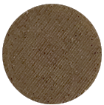 | 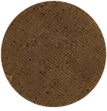 | 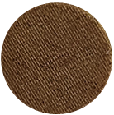 | 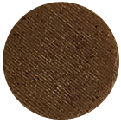 | 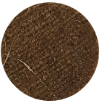 | 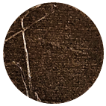
PLA/OW05 | 200 mm/s | 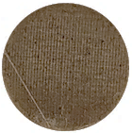 | 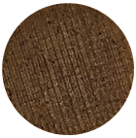 | 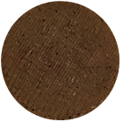 | 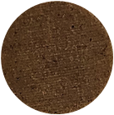 | 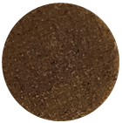 | 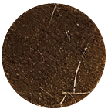
PLA/OW10 | 20 mm/s | 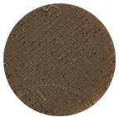 | 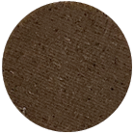 | 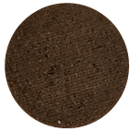 | 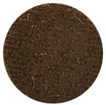 | 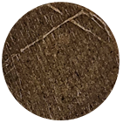 | 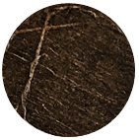
PLA/OW10 | 200 mm/s | 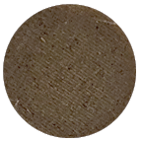 | 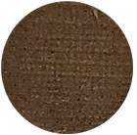 | 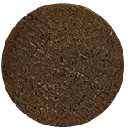 | 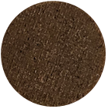 | 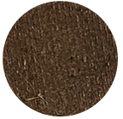 | 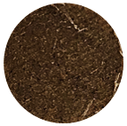
PLA/OW15 | 20 mm/s | 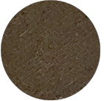 | 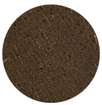 | 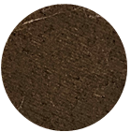 | 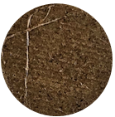 | 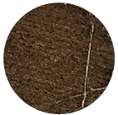 | 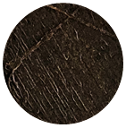
PLA/OW15 | 200 mm/s | 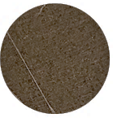 | 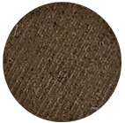 | 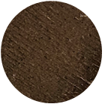 | 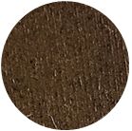 | 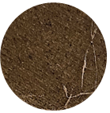 | 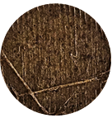
PLA/OW20 | 20 mm/s | 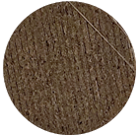 | 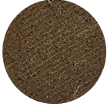 | 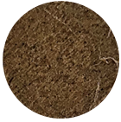 | 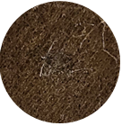 | 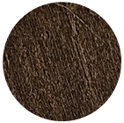 | 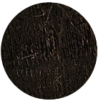
PLA/OW20 | 200 mm/s | 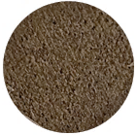 | 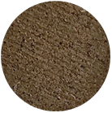 | 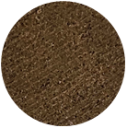 | 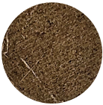 | 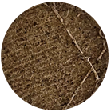 | 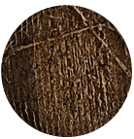

Section S4. Polynomial regression coefficients
Table S2. Polynomial regression coefficients for predicting L*, a*, and b* of PLA/OW05. Source: Authors’ own work.
Estimated coefficients | X_{r,i} | L* | a* | b*
c₀ | - | 48.2829 | -9.26508 | 9.35129
c₁ | T | -0.128382 | 0.18979 | 0.0110122
c₂ | V | 0.0153914 | -0.0222021 | -0.00077251
c₃ | T·T | 0.00021771 | -0.00047698 | -9.6655E-05
c₄ | T·V | -3.2842E-05 | 0.00010054 | 2.5426E-05

