Appendix A: Parameterization of slope protection combinations
Table B1 Parameters for side ditches
Side Ditch Number | Shape | Side Ditch |  |  |  | Medial platform | Outboard platform | Control point
Side Ditch Number | Shape | Depth | Width | Thickness | Slope Gradient | Medial platform | Outboard platform | Control point
Rectangular Side Ditch | Triangle | 0.8 | 0.6 | 0.2 | 0.0 | 0.5 | 2.0 | 0.74
Trapezoidal Side Ditch | Trapezoid | 0.8 | 0.6 | 0.2 | 1.0 | 0.5 | 2.0 | 0.00
Source: Authors' own work
Table B2 Typical parameters of subgrade slope
Slope Number | Class | Height | Slope Gradient | Protection Type | Platform Width | Platform Gradient | Control point
Embankment Slope 1 | 1 | 4 | 1.5 | Hollow Block | 0 | 0 | Shoulder
Embankment Slope 2 | 1 | 8 | 1.5 | Framework | 2 | 0.04 | Shoulder
Embankment Slope 2 | 2 | 8 | 1.75 | Framework | 2 | 0.04 | Shoulder
Embankment Slope 2 | 3 | 8 | 1.75 | Framework | 2 | 0.04 | Shoulder
Cutting Slope 1 | 1 | 4 | 1.5 | Hollow Block | 0 | 0 | Superior Facility
Cutting Slope 2 | 1 | 8 | 1.5 | Framework | 2 | 0.04 | Superior Facility
Cutting Slope 2 | 2 | 8 | 1.75 | Framework | 2 | 0.04 | Superior Facility
Cutting Slope 2 | 3 | 8 | 1.75 | Framework | 2 | 0.04 | Superior Facility
Source: Authors' own work
Table B3 Typical parameters of gravity retaining wall
Gravity Retaining Wall | Control Point | Wall Height | Top Width | Burial Depth | Front Slope | Back Slope | Base Slope | Platform Width | Platform Gradient
Gravity Retaining Wall | Control Point | H | b | h | 1:m | 1:m | m:1 | m | Platform Gradient
Embankment Gravity Retaining Wall | Absolute value | 6 | 2 | - | 0.15 | 0.15 | 0.1 | 2.0 | 0.04
Cutting Gravity Retaining Wall | Side ditch platform | 6 | 2 | 1.5 | 0.15 | 0.15 | 0.1 | 2.0 | 0.04
Source: Authors' own work
Table B4 Typical parameters of sheet pile wall
Sheet Pile Wall | Control Point | Pile Length | Cantilever Height | Section Length | Section Width | Platform Width | Platform Gradient
Sheet Pile Wall | Control Point | L | h | H | B | PW | Platform Gradient
Embankment Sheet Pile Wall | Absolute Value | 18 | - | 2 | 1.5 | 2 | 0.04
Cutting Sheet Pile Wall | Side Ditch Platform | 18 | 8 | 2 | 1.5 | 2 | 0.04
Source: Authors' own work
Table B5 Typical filling parameters
Filling Number | Thickness | Drainage Slope | Drainage Direction | Filling Type | Replacement required | Replacement angle | Replacement control point
Embankment Filling | 0.6 | 0.04 | Both sides | Upper subgrade | Yes | 1 | -
Embankment Filling | 1.9 | 0.04 | Both sides | Lower subgrade | Yes | 1 | -
Embankment Filling | +∞ | 0.04 | Both sides | Below subgrade | No | - | -
Cutting Filling | 0.6 | 0.04 | Both sides | Upper subgrade | Yes | 1 | Inside side ditch
Cutting Filling | 1. | 0.04 | Both sides | Lower subgrade | Yes | 1 | Inside side ditch
Source: Authors' own work
Table B6 Digital format of interactive design lines
Stratum Number | Upper filling attributes | Lower filling attributes | local coordinate point sets{x_{i},y_{i}}
Step Line | Bottom layer of subgrade | - | (-1.85,-0.27), (-0.85,0.27) …
Cut Line1 | Bottom layer of subgrade | - | (7.38,2.65), (9.04,1.54)
Cut Line1 | Bottom layer of subgrade | - | (9.04,1.54), (10.59,3.09)
Fill Line | - | bottom layer of subgrade | (6.51,3.25), (10.59,3.09)
Source: Authors' own work
Table B7 Typical parameters of foundation treatment (Unit: m)
Foundation Treatment Number | Cushion Type | Elevation of Cushion Bottom | Cushion Thickness | Pile Length | Left-Side Widening | Right-side Widening | Arrangement Form | Pile Spacing
CFG Pile | Rubble | Calculated value | 0.5 | 10.0 | 0.0 | 0.0 | Square | 2.0
Source: Authors' own work
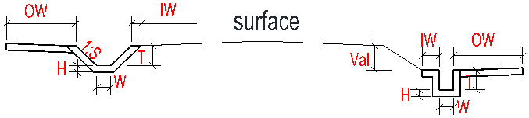
(a) Side ditch parameters and geometry
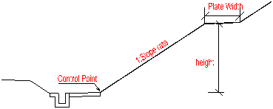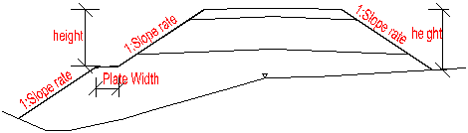
(b) Cutting and embankment slope
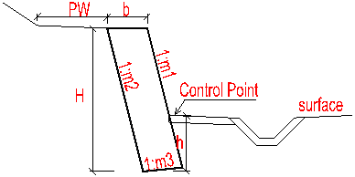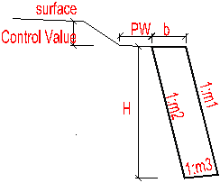
(c) Cutting and embankment gravity retaining wall
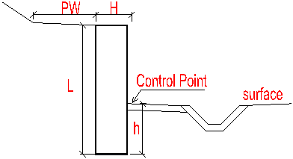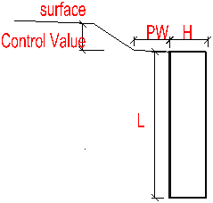
(d) Cutting and embankment sheet pile wall
Fig.B1 Schematic of series protection combinations
Source: Authors' own work

Appendix B: Key Code for Proposed Digital Design Program
横断面对象
Public Class ClsHDM

Public hdmMileage As Double’断面里程
Public hdmRegionCode As String’断面断链
Public hdmGroundEle As Double’断面地面点高程
Public hdmIsChangeFiller As Boolean
Public hdmJudgeRate, hdmJudgeHeight As Double
Public hdmstrLeftMeasure, hdmstrRightMeasure As String
Public hdmisLeftLudi, hdmisRightLudi As Boolean
Public hdmSurface As New CSurface’路基面
Public hdmFillers As New CSubgradeFiller’路基填料
Public hdmLeftSideDitch As New CLeftSideDitch’左侧侧沟
Public hdmRightSideDitch As New CRightSideDitch’右侧侧沟
Public hdmRightBLDitch As New CRightBlindDitch’右侧盲沟
Public hdmLeftBLDitch As New CLeftBlindDitch’左侧盲沟
Public hdmLeftSideSlope As New CLeftSideSlope’左侧边坡
Public hdmRightSideSlope As New CRightSideSlope’右侧边坡
Public hdmLeftGravityWall As New CLeftGravityWall’左侧重力墙
Public hdmRightGravityWall As New CRightGravityWall’右侧重力墙
Public hdmLeftSupportWall As New CLeftSupportWall’左侧悬扶壁墙
Public hdmRightSupportWall As New CRightSupportWall’右侧悬扶壁墙
Public hdmLeftSheetPile As New CLeftSheetPile’左侧桩板墙
Public hdmRightSheetPile As New CRightSheetPile’右侧桩板墙
Public hdmLeftFootWall As New CLeftFootWall’左侧脚墙
Public hdmRightFootWall As New CRightFootWall’右侧脚墙
Public hdmLeftDitch As New CLeftDitch’左侧水沟
Public hdmRightDitch As New CRightDitch’右侧水沟
Public hdmLeftFloodPro As New CLeftFloodPro’左侧浸水防护
Public hdmRightFloodPro As New CRightFloodPro’右侧浸水防护
Public hdmFloodProCushion(1) As CFiller’垫层线
Public hdmFoundation As New CFoundation’地基处理线
Public hdmGeoGroundLine As New CGeoGroundLine’地层线

'设计线
Public hdmlstExcavateLine As New List(Of CSoilLine)' 交互设计线

'填方计算
Public hdmTopSoilLine As New CSoilLine
Public hdmGroundSoilLine As New CSoilLine
Public hdmlstSoilLine As New List(Of CSoilLine)
Public hdmlstSoilProperty As New List(Of CSoilProperty)
Public hdmIsSoilRight As Boolean
Public hdmIsDimSoil As Boolean
Public hdmlstSoilFlag As New List(Of CSoilFlagLine)

'挖方计算
Public hdmBotGeoLine As New SGeoLine
Public hdmGroundGeoLine As New SGeoLine
Public hdmlstGeoLine As New List(Of SGeoLine)
Public hdmlstGeoProperty As New List(Of CGeoProperty)
Public hdmIsGeoRight As Boolean
Public hdmIsDimGeo As Boolean
Public hdmlstGeoFlag As New List(Of CGeoFlagLine)

Public hdmPtCenter As System.Drawing.PointF

Private Sub setPara(ByVal dMileage As Double, ByVal strRegionCode As String, ByVal isChangeFiller As Boolean, ByVal dJudgeRate As Double, ByVal dJudgeHeight As Double,
ByVal strLeftMeasure As String, ByVal strRightMeasure As String, ByVal isLeftLudi As Boolean, ByVal isRightLudi As Boolean)
hdmMileage = dMileage
hdmRegionCode = strRegionCode
hdmIsChangeFiller = isChangeFiller
hdmJudgeRate = dJudgeRate
hdmJudgeHeight = dJudgeHeight
hdmstrLeftMeasure = strLeftMeasure
hdmstrRightMeasure = strRightMeasure
hdmisLeftLudi = isLeftLudi
hdmisRightLudi = isRightLudi
End Sub

Public Sub New()
hdmIsSoilRight = True
hdmIsGeoRight = True
End Sub

End Class

