Enhancing the Circular Economy in Saudi Arabia’s Construction Sector: A Source Segregation Perspective Through Thematic Analysis
SUPPLEMENTARY MATERIALS (S1)
Detailed description of the thematic analysis process
S1.1 Participant selection and sampling strategy
An initial pool of 34 potential participants was identified through professional networks, academic contacts, and institutional directories within Saudi Arabia’s construction and waste management sectors. To ensure that the study captured diverse and informed perspectives, a purposive sampling strategy was employed. This approach focused on recruiting individuals who possessed first-hand knowledge or operational experience with construction and demolition (C&D) waste management and who could provide detailed reflections on source segregation practices.
Selection criteria included (see the following Figure (S1):
- Active involvement in construction, waste collection, recycling, or related regulatory activities.
- Minimum of three years of professional experience in the field.
- Awareness of national or local waste management initiatives.
- Willingness to participate in a 60–90-minute semi-structured interview.
Of the 34 initially contacted, 19 participants were selected based on their relevance to the research objectives and their availability. The final sample comprised: academics (2), construction contractors and C&D waste services providers (7), government organisation representatives (4), and recycling facility representatives (6).
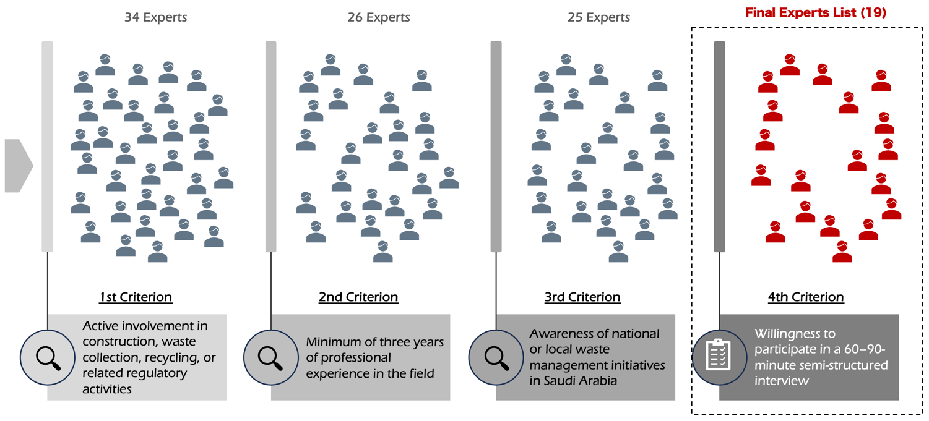
Figure S1. Selection criteria of the participants.

While the composition appears unbalanced, this distribution was intentional. The study prioritised participants directly involved in the operational implementation of segregation practices, where decision-making and behavioural change occur, rather than purely academic or policy perspectives. This purposeful emphasis aligns with Patton’s (2015) recommendation to privilege information-rich cases in applied qualitative research.
Data saturation was achieved by the 17th interview, when no new codes or subthemes emerged, two additional interviews were conducted to confirm the stability of the thematic structure.
S1.2 Data collection and preparation
Data were collected through semi-structured interviews conducted between February and March 2025. Each interview included 15 open-ended questions designed to elicit detailed insights into the participants' experiences, perceptions, and institutional contexts surrounding source segregation of C&D waste.
Interviews were conducted primarily in Arabic, either face-to-face or via secure online platforms. All sessions were audio-recorded with consent and transcribed verbatim immediately after completion. The questionnaire design was as follows:
Table S1. Interview details.
Interview
Research project title: | Enhancing Circular Economy in Saudi Arabia's Building and Construction Sector Through Source Segregation of Construction and Demolition Waste.
Investigator:
Why have you been approached? | Your expertise in C&D waste management has identified you as a significant contributor to this study. Your participation will help shape sustainable C&D waste management practices in Saudi Arabia.
Interview aim: | We aim to explore current practices, regulatory impacts, and the various factors influencing source segregation, as well as potential solutions to challenges in source segregation of C&D waste within the Saudi Arabian B&C sector.
Interview duration: | Approximately 90 minutes.
Confidentiality assurance: | Your information will be treated with the utmost confidentiality, with individual results not disclosed publicly.
Recording: | for the purpose of audio data transcription, the meeting will be recorded.
Personal information
Name:
Position:
Years of experience:
Interview questions
1) Can you describe the source segregation practices currently implemented in your organisation or, more broadly, within the B&C sector in Saudi Arabia? How effective are these practices in managing C&D waste? What are their influence on the source segregation?
2) What regulations specific to source segregation of C&D waste are you aware of in Saudi Arabia, and how are they being enforced?
3) In what ways do existing policies and stakeholder perspectives affect source segregation? Are there any needs for policy improvements regarding source segregation in KSA?
4) What technologies are utilised to facilitate source segregation in the building and construction waste sector?
5) Can you identify any challenges that hinder effective source segregation in your experience?
6) Do you have examples of successful source segregation initiatives within your organisation or the industry?
7) How do you believe social and cultural factors in Saudi Arabia influence source segregation practices?
8) What opportunities exist to improve source segregation in the C&D sector?
9) What policy changes would you recommend to enhance source segregation?
10) How do various stakeholders perceive the importance of source segregation?
11) What specific actions or initiatives would you propose to strengthen source segregation practices in Saudi Arabia?
12) How does source segregation contribute to the economy within the B&C sector in Saudi Arabia?
13) What value does source segregation add to the broader environmental aspect in the B&C sector?
14) How do you perceive the relationship between source segregation practices and the principles of a circular economy?
15) Is there anything we haven't covered that you think is important?

Given that the working language of analysis was English, the transcripts underwent a rigorous translation process to ensure fidelity of meaning and conceptual integrity. The process involved:
- Professional translation by a bilingual translator experienced in environmental and construction terminology.
- Back-translation of two randomly selected transcripts by researchers and with the aid of DeepL (a neural machine translation service developed by the German company DeepL SE), to detect any meaning drift.
- Bilingual verification by the research team, cross-checking technical terms and context-specific expressions.
- Participant validation, where four interviewees, one from each stakeholder group (AC_01, WC_06, GO_03, RF_04), reviewed translated excerpts to confirm that the English rendering accurately reflected their intended meanings.
S1.3 Thematic analysis procedure
The study employed thematic analysis following the six-phase framework developed by Braun and Clarke (2006, 2021). The analysis was both inductive (data-driven) and interpretive, allowing emergent meanings to surface while remaining grounded in the participants' lived experiences. All analyses were performed using ATLAS.ti 25 software.
Step 1: Familiarisation
Both researchers immersed themselves in the Arabic and translated English transcripts, reading each multiple times to gain a holistic understanding of the data. Reflective memos were used to record early observations and analytic insights.
Step 2: Generating initial codes
Through line-by-line reading, descriptive codes were assigned to capture concrete ideas or actions (e.g., “no on-site segregation”, “cost concerns”, “weak regulation”, etc.). Coding was open and inclusive to preserve nuance.
Step 3: Developing interpretive codes
Descriptive codes were then grouped into conceptual clusters representing higher-order meanings (e.g., “institutional inertia”, “cross-sector stakeholder collaboration”, “governmental support as a facilitator”, “technocratic optimism”). This stage moved from description to interpretation.
Step 4: Constructing themes
Interpretive codes were aggregated into preliminary themes reflecting patterns of meaning across participants. Five themes were identified:
- Current practices and benefits.
- Barriers and enablers.
- Policies and regulations.
- Stakeholder roles and collaboration.
- Circular economy integration and future opportunities.
Step 5: Reviewing and refining themes
Themes were iteratively reviewed against coded extracts and the entire dataset to ensure internal coherence and external distinctiveness. Ambiguities (e.g., between policy fragmentation and institutional incoherence) were discussed until conceptual clarity was reached.
Step 6: Defining and naming themes
Each theme was clearly defined and linked to representative quotations. The final thematic map captured both semantic meanings (explicit ideas) and latent meanings (underlying institutional and behavioural dynamics).
The following details the frequency of codes and themes across stakeholder groups and provides screenshots from the ATLAS.ti coding process:
(A) Number of quotations and codes within each theme, categorised by different participant groups:
Table S2. Themes frequencies.
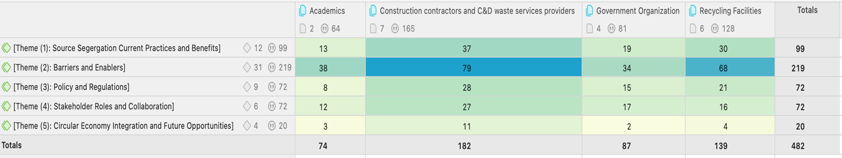
Table S3. Distribution of codes and quotes across themes and participant groups.
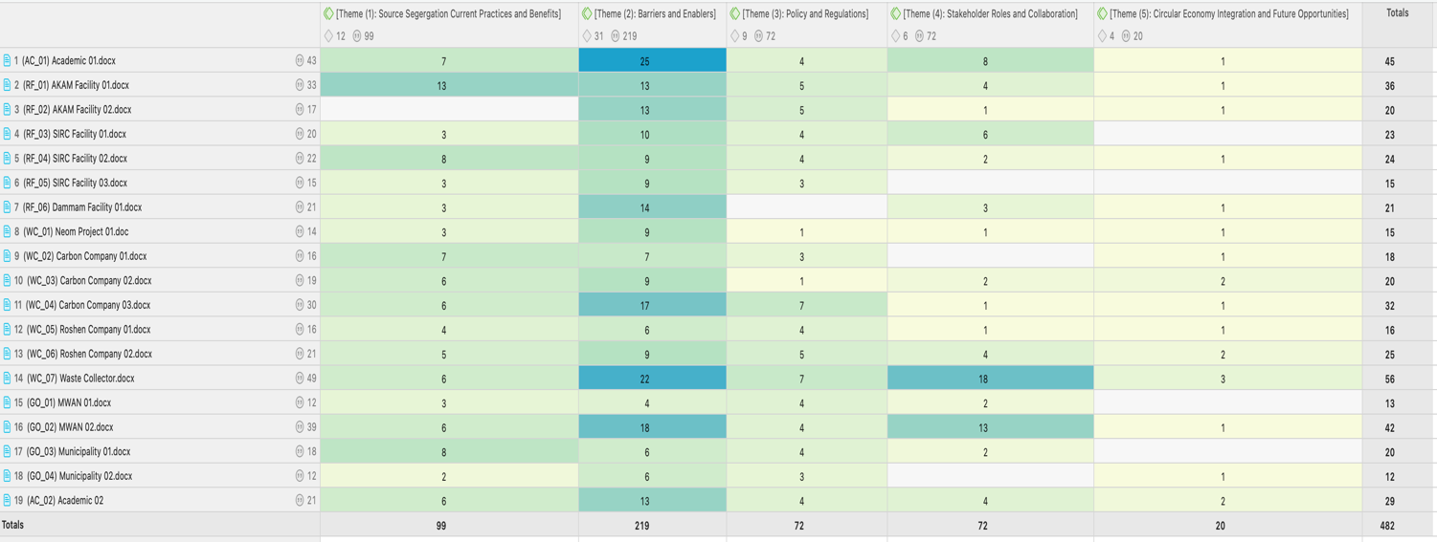

(B) Screenshots from the Thematic Analysis Process in ATLAS.ti.:
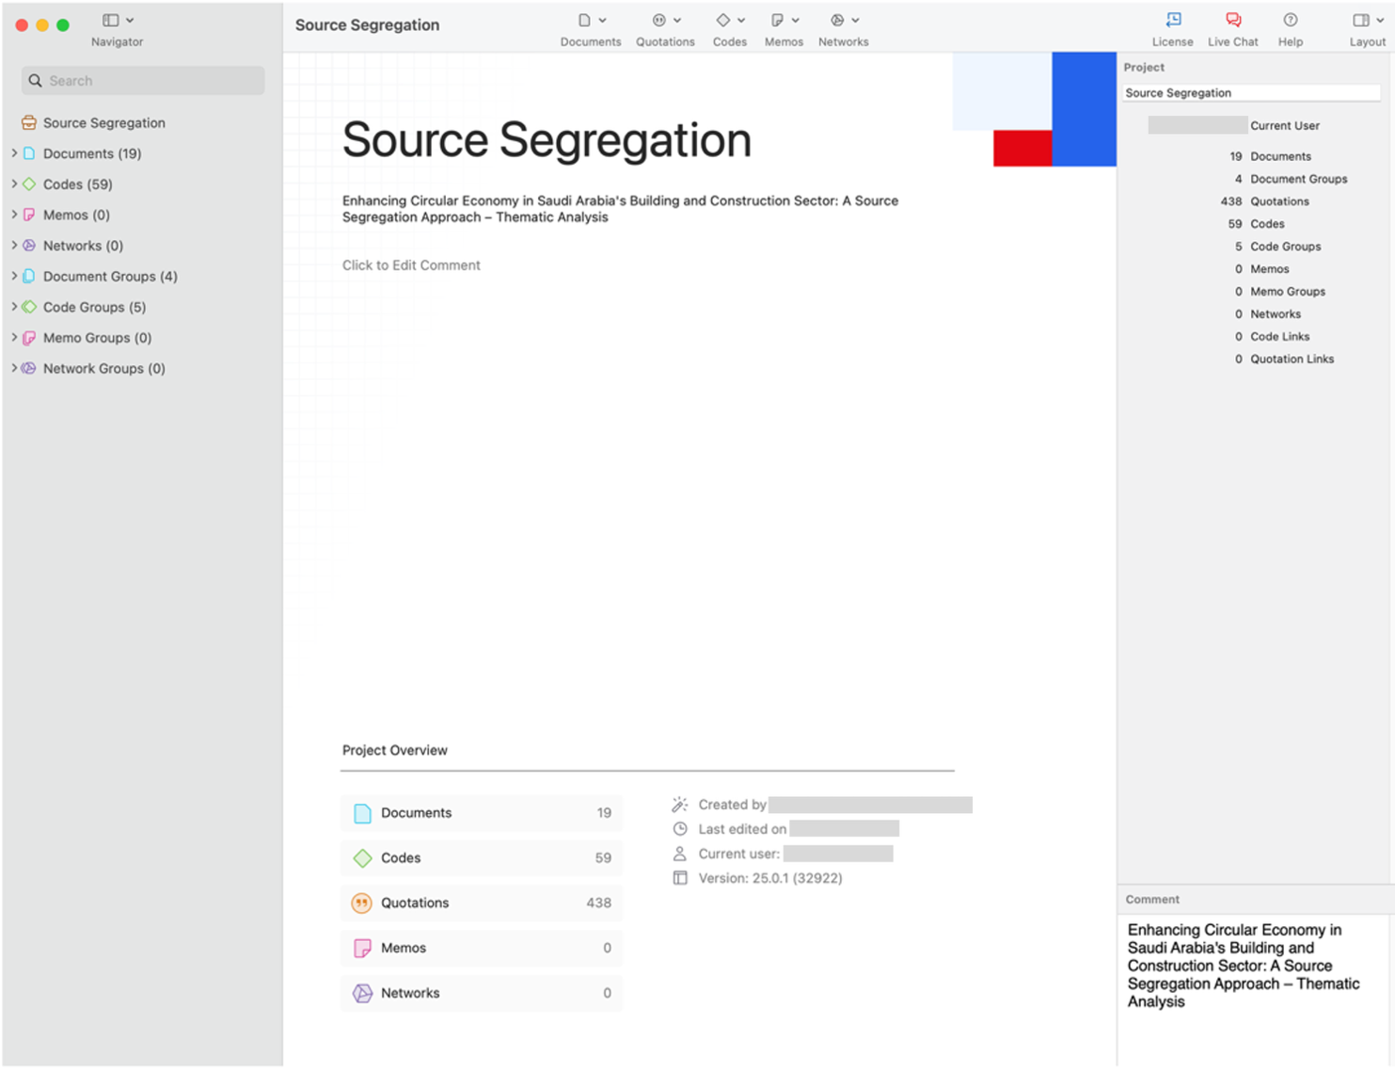
Figure S2. Main information from the project overview page in ATLAS.ti for thematic analysis of source segregation.
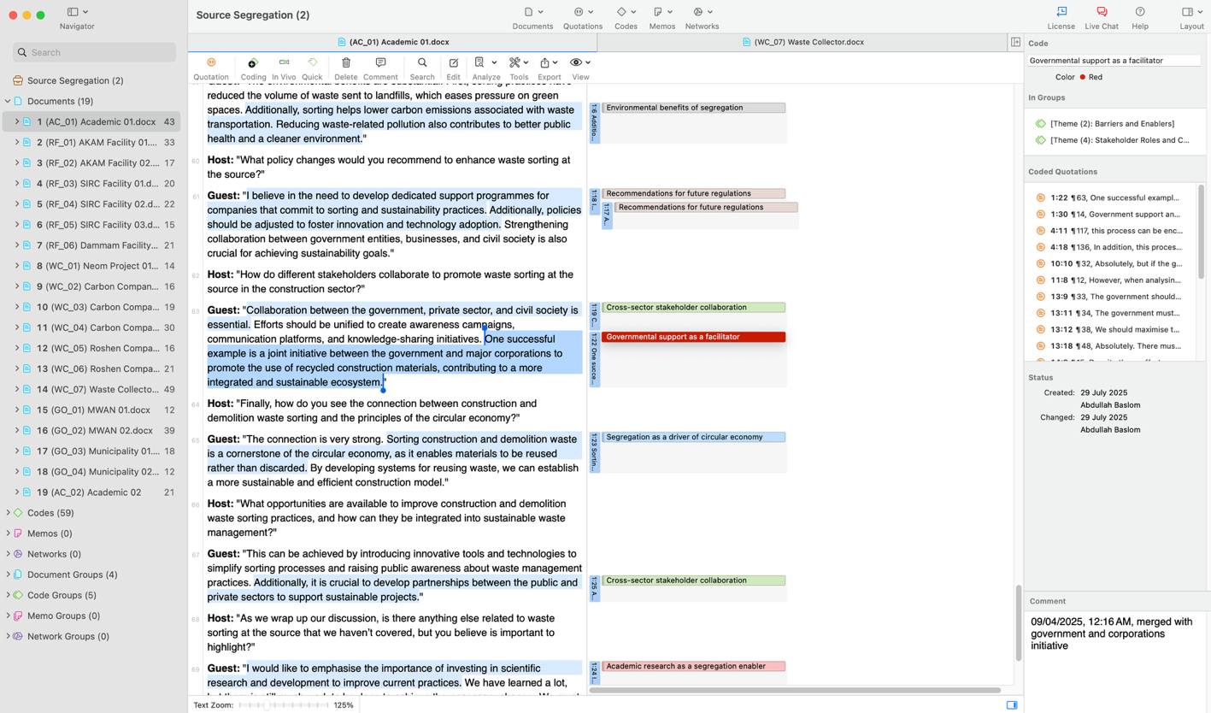
Figure S3. Example of code-quote linking in ATLAS.ti during thematic analysis.
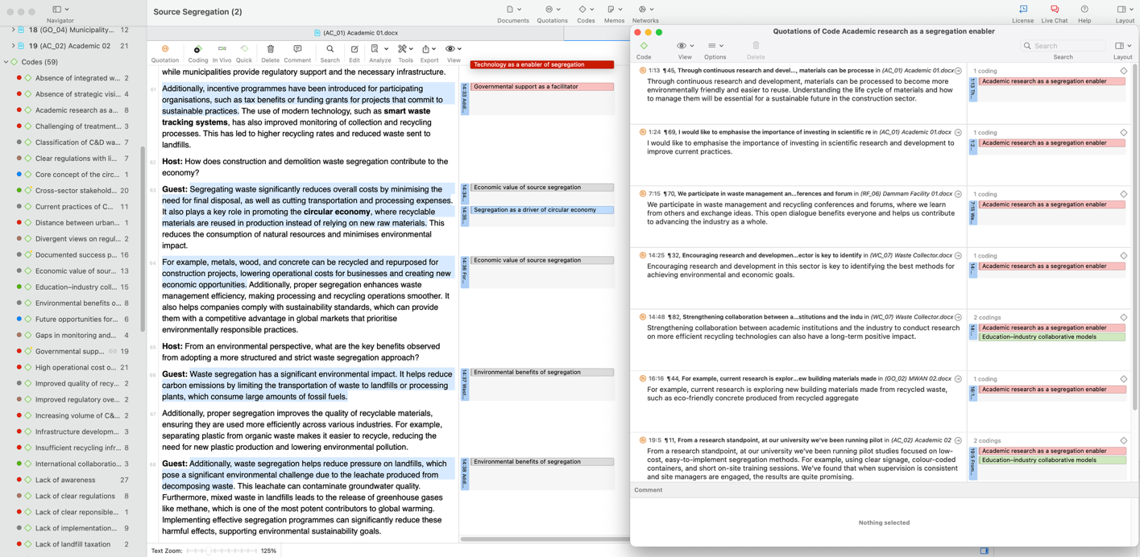
Figure S4. Cross-code view of academic contributions in the thematic analysis using ATLAS.ti.
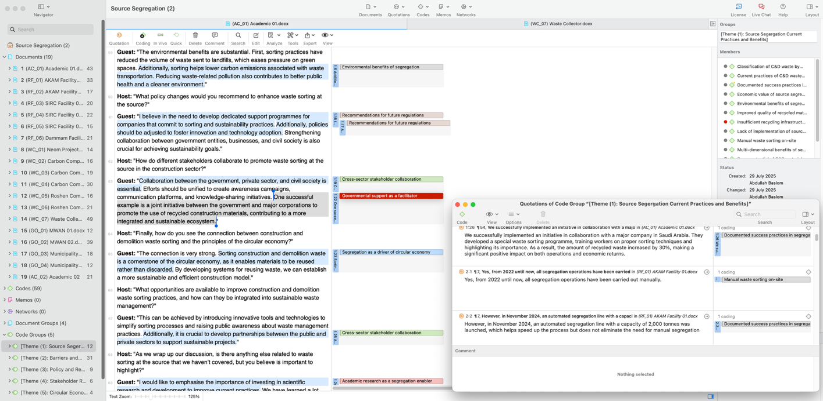
Figure S5. Theme-specific coding and quotation analysis in ATLAS.ti: source segregation current practices and benefits.
(B) Examples of quotations within each barrier:
Insufficient recycling infrastructure
“We have one C &D recycling facility but one is not enough. For the size of the construction going on here in NEOM, then we need one or two locals each project, not just one central one.” [WC_01)
“Furthermore, recycling facilities are not available in all regions.” [WC_04)
“Lack of recycling facilities – Since no infrastructure exists for recycling, all waste ends up in landfills.” [GO_03)
Price mismatch of recycled vs. raw materials
“One issue I have read about in Saudi Arabia is that the cost of recycled materials is sometimes higher than that of raw materials. For example, if a tonne of recycled block costs 10 riyals while the original raw materials cost only 5 riyals.” [RF_01)
“At times, the cost of recycling is higher than traditional disposal, making contractors less motivated to choose sustainable solutions.” [WC_07)
“One of the major challenges facing the recycling sector is the high cost of processing compared to using new raw materials. This makes many companies hesitant to adopt sustainable practices.” [GO_02)
Lack of transparency in segregation practices
“One of the main challenges in recycling operations is the lack of clarity regarding implementation mechanisms in some cases.” [RF_03)
“Moreover, many sectors struggle with a lack of transparency in waste processing.” [AC_01)
“However, actual practices may lack clarity. If we delve into the operations of large corporations, we'll find a clear lack of discipline in implementing policies and procedures.” [WC_04)
Variability in materials
“However, the variety of materials used in construction and demolition presents a challenge, as some materials require specialised processing techniques. For example, concrete needs crushing and repurposing technologies, metals are separated using powerful magnets, and plastics require precise classification based on type to ensure high-quality recycling.” [GO_02)
“One of the biggest difficulties is the variation in materials and their properties. Construction sites often contain a wide range of materials at the same time, making the sorting process complex and time-consuming.” [RF_06)
Logistical constraints
“Additionally, there are logistical challenges, such as ensuring proper storage locations for sorted waste. In some cases, limited workspace makes it difficult to implement effective sorting operations.” [AC_01)
“Transporting waste from construction sites to recycling centres is a major logistical challenge, especially for remote sites that lack the necessary infrastructure for efficient waste transportation.” [WC_07)
Social resistance to recycled materials
“Yes, there is indeed hesitation among people regarding the use of recycled products, as they frequently question their source and whether they match the quality of original products.” [RF_02)
“Regarding heavy materials, the community doesn't accept them despite the fact that they can be used without any issues. The rejection is largely due to the source of the product.” [RF_05)
“Resistance to change from traditional waste disposal methods.” [WC_05)
S1.4 Analytical rigour and inter-coder reliability
To ensure analytical credibility and reproducibility, two researchers analysed six randomly selected transcripts (around 30 % of the dataset). The resulting Cohen’s Kappa coefficient of 0.84 indicated strong inter-coder reliability.
Discrepancies were resolved through discussion and refinement of the shared codebook. The coding structure, analytical memos, and version histories were documented within ATLAS.ti, forming a transparent audit trail.
Also, peer debriefing sessions were conducted twice, after the initial coding phase and during theme consolidation, to challenge interpretations and mitigate individual researcher bias.
S1.5 Derivation of numerical data
Although qualitative in design, numerical indicators were derived from ATLAS.ti outputs to illustrate the relative prominence of certain codes and themes. Frequency counts (number of times a code appeared) were tabulated and compared across stakeholder groups to provide descriptive, not statistical, insights.
These counts supported visualisations (e.g., Table 2 in the main manuscript) that highlight which issues were most frequently emphasised, thereby enhancing interpretive transparency without reducing qualitative richness.
S1.6 Ensuring trustworthiness
The research followed Lincoln and Guba’s (1985) four-part framework to ensure the trustworthiness of qualitative findings:
Table S4. Measures to ensure the trustworthiness of qualitative data.
Criterion | Application in this study
Credibility | Achieved through triangulation of multiple stakeholder perspectives and member checking with three participants who reviewed thematic summaries.
Dependability | Secured by maintaining an audit trail of coding decisions, memos, and theme development within ATLAS.ti.
Confirmability | Strengthened through reflexive journaling and peer debriefing to minimise researcher bias.
Transferability | Enabled through rich contextual descriptions and representative participant quotations presented in the main article.
S1.7 Ethical considerations
Ethical approval was obtained from the RMIT University DSC College Human Ethics Advisory Network (CHEAN No: 2024-27526-25483). All participants provided informed consent, and their identities were anonymised during transcription and analysis.
References
- Braun V and Clarke V (2006) Using thematic analysis in psychology. Qualitative Research in Psychology 3(2). Routledge: 77–101.
- Braun V and Clarke V (2021) One size fits all? What counts as quality practice in (reflexive) thematic analysis? Qualitative Research in Psychology 18(3). Routledge: 328–352.
- Lincoln YS and Guba EG (1985) Naturalistic Inquiry. Sage Publications, Inc. Available at: https://us.sagepub.com/en-us/nam/book/naturalistic-inquiry (accessed 10 September 2025).
- Patton MQ (2015) Qualitative Research & Evaluation Methods: Integrating Theory and Practice. 4th Edition. Sage Publications, Inc. Available at: https://us.sagepub.com/en-us/nam/qualitative-research-evaluation-methods/book232962 (accessed 10 September 2025).

