Supplementary on-line material
- Life cycle inventory
Energy and water consumption associated to the football match direct processes
ENERGY CONSUMPTION
Energy source | Quantity used | Unit | Comment
Electricity | 1,910,084.00 | Kwh | Source of electricity: grid
Natural Gas | 52,318.00 | m³
Fuel |  | L | Used for field maintenance machinery, etc.
WATER CONSUMPTION
Water source | Quantity used | Unit | Comment
Water | 28,009.00 | m³

Electricity consumption (whole season)
 | STADIUM | TRAINING CENTRE | TOTAL
P1 | 122,463.00 | 58,401.00 | 180,864.00
P2 | 147,430.00 | 62,470.00 | 209,900.00
P3 | 75,072.00 | 40,631.00 | 115,703.00
P4 | 114,268.00 | 52,447.00 | 166,715.00
P5 | 182,160.00 | 79,193.00 | 261,353.00
P6 | 736,034.00 | 239,515.00 | 975,549.00
TOTAL | 1,377,427.00 | 532,657.00 | 1,910,084.00
Water consumption (whole season)
 | Total Consumption
STADIUM | 18,211.00
TRAINING CENTRE | 9,798.00
TOTAL | 28,009.00
- Production of sport apparel and equipment
 | Team | Merchandising
T-shirt | 2575 | 30,000
Shorts | 545 | 5,000
Balls | 200 | 5,000
- Production of waste materials associated to the football match
WASTE GENERATION
Waste Type | Quantity | Unit | Comment
Paper | 86,400.00 | litres | 8 containers of 400 litres per match: 8*400*27 (jointly paper, cardboard and organic waste)
Plastic | 86,400.00 | litres | 8 containers of 400 litres per match: 8*400*27 (light packaging)
TOTAL | 172,800.00 | litres
- Production of chemicals used for the football pitch and cleaning operations
CHEMICALS CONSUMPTION FOR MAINTENANCE OF NATURAL TURF
Chemical Type | Unit | Amount | Material/Composition
Paint | l/season | 400.00 | Atomic paint
Paint | l/season | 400.00 | Quantum paint
Synthetic oil | l/season | 30.00 | Engine oil 20W-40
Hidraulic oil | l/season | 50.00 | Hydraulic oil UTTO 10w-30
Synthetic oil | l/season | 5.00 | Lubricating oil mixture 2T
Fungicide | kg/season | 50.00 | Fosetyl 80%
Fungicide | l/season | 10.00 | Azoxystrobin 25%
Herbicide | l/season | 10.00 | Glyphosate 36%
Growth regulators | l/season | 6.00 | Trinexapac-etil 12.5%
Solid compost | kg/season | 1,000.00 | Active yaramila 20-07-10+10SO3+3MgO
Solid compost | kg/season | 1,000.00 | GREENBION-CRF (27-5-10 + 2CaO + 10SO3)
Solid compost | kg/season | 740.00 | Greenbion Micro 26-5-11+2CaO+2MgO+Fe
Solid compost | kg/season | 500.00 | UREA 46%
Solid compost | kg/season | 1,500.00 | Fertilent 20-5-10 + 2Mg + Micro
Solid compost | kg/season | 500.00 | Ammonium sulfate 21% N
Solid compost | kg/season | 2,000.00 | Marathon 16-4-08
Foliar fertilizer | kg/season | 90.00 | Agroleaf Power P
Foliar fertilizer | kg/season | 90.00 | Agroleaf Power Mn
Foliar fertilizer | kg/season | 75.00 | Agroleaf Power Magnesium
Foliar fertilizer | kg/season | 75.00 | Agroleaf Power Zn
Foliar fertilizer | kg/season | 100.00 | Greenmaster High N
Foliar fertilizer | l/season | 100.00 | H2Pro Flowsmart
Foliar fertilizer | l/season | 100.00 | H2Pro Dewsmart
Foliar fertilizer | l/season | 100.00 | Vitalnova aminobost
Foliar fertilizer | l/season | 50.00 | Vitalnova Silk
Foliar fertilizer | l/season | 100.00 | Vitalnova Stressbuster
Foliar fertilizer | kg/season | 50.00 | SPORTSMASTER WSF IRON 19.5%
Foliar fertilizer | kg/season | 30.00 | Si-football grass
Special fertilizer | kg/season | 20.00 | Rooting approach
Special fertilizer | l/season | 5.00 | Deep rooting
Special fertilizer | l/season | 5.00 | STYMBION (biostimulant aminoacids 10%)
Special fertilizer | kg/season | 15.00 | Naturmin 80%

REPLACED MATERIALS
 | Unit | Amount | Material/Composition
Natural turf | kg/season | 500 | m²/season of turf rolls
Geotextile | kg/season | 300,000 | 300 Tn/season of silica sand

Product/material used for cleaning operations | Unit | Amount
CHLORINATE CLEANER | Litres/season | 30.00
DEGREASING | Litres/season | 30.00
REMOVE INK | Litres/season | 15.00
DISHWASHER DETERGENT | Litres/season | 9.00
BLEACH | Litres/season | 400.00
FLOOR CLEANER | Litres/season | 60.00
POWER CLEANER | Litres/season | 35.00
AIR FRESHNER | Litres/season | 60.00
WC CLEANER | Litres/season | 15.00
AMMONIA | Litres/season | 15.00
DESCALING | Kg/season | 60.00
MOP SPRAY | Units/season | 12.00
MOP SPRARE | Units/season | 50.00
DISPOSAL BAG (LARGE SIZE) | Units/season | 600.00
DISPOSAL BAG (LARGE SIZE) | Units/season | 3,600.00
DISPOSAL BAG (MEDIUM SIZE) | Units/season | 3,750.00
DISPOSAL BAG (MEDIUM SIZE) | Units/season | 9,400.00
CLEANING WIPE (MICROFIBER) | Units/season | 648.00
BROOM | Units/season | 24.00
BROOMSTICK | Units/season | 16.00
MPO | Units/season | 5.00
MPO | Units/season | 48.00
DUSTPAN | Units/season | 8.00
HAND WIPPING | Kg/season | 7.20
- Number of spectators attending the football matches
Match | Overall Spectators | Competition
#1 | 45,337 | National League
#2 | 52,819 | National League
#3 | 50,426 | National League
#4 | 47,678 | National League
#5 | 39,881 | European League
#6 | 42,295 | National League
#7 | 41,973 | National League
#8 | 45,391 | European League
#9 | 37,855 | Europa League
#10 | 46,708 | National League
#11 | 34,467 | National Cup
#12 | 39,963 | National League
#13 | 48,524 | National League
#14 | 24,292 | National Cup
#15 | 52,992 | National League
#16 | 47,309 | National League
#17 | 39,181 | National Cup
#18 | 49,920 | National League
#19 | 55,558 | National Cup
#20 | 43,036 | National League
#21 | 43,638 | European League
#22 | 46,211 | National League
#23 | 53,443 | National League
#24 | 28,212 | National League
#25 | 42,263 | National League
#26 | 30,462 | National League
#27 | 28,078 | National League
Total | 1,157,912
Average | 42,886
- Production of food and beverages consumed during the football matches
Food & beverage consumption from catering services
 | Unit | Amount
Natural water | l/season | 28,384.00
Coca Cola | l/season | 20,486.00
Coca Cola Zero | l/season | 13,631.00
Juice | l/season | 18.00
Red wine (non-alcoholic) | l/season | 481.00
Coffee | l/season | 1,236.00
Beer (non-alcoholic) | l/season | 4,422.00
Rest of beverages | l/season | 13,512.00
Sandwiches | kg/season | 7,351.40
Total beverages | l/season | 82,170.00
Total glasses | number | 205,425
Total glasses | g | 698,445
- Environmental performance assessment
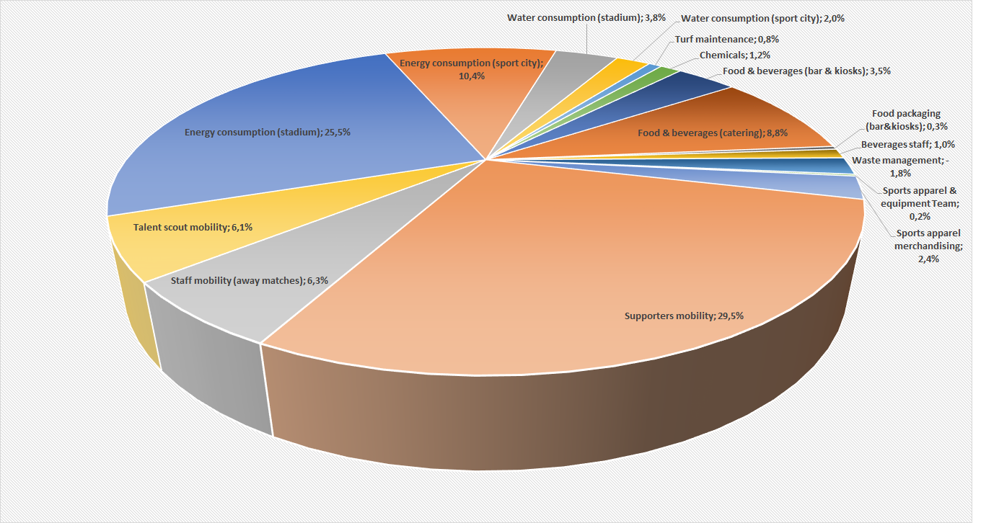
Figure 1 – Weighted results for one football match: % contribution of each life cycle phase
Source: Authors own creation

Impact category | Unit of measure |  | Total |  | Energy consumption (stadium) |  | Energy consumption (training) | Water consumption (stadium) |  | Water consumption (training) |  | Turf maintenance |  | Chemicals |  | Waste Management
Climate change | Pt |  | 9.219 |  | 2.08 |  | 0.88 | 0.02 |  | 0.01 |  | 0.06 |  | 0.11 |  | - 0.13
Ozone depletion | Pt |  | 0.395 |  | 0.04 |  | 0.02 | 4.11E-04 |  | 2.21E-04 |  | 1.46E-03 |  | 4.00E-03 |  | - 0.27
Ionizing radiation HH | Pt |  | 4.717 |  | 2.79 |  | 1.08 | 0.02 |  | 0.01 |  | 0.00 |  | 0.01 |  | - 0.05
Photochemical ozone formation | Pt |  | 7.686 |  | 1.44 |  | 0.57 | 0.01 |  | 0.00 |  | 0.06 |  | 0.06 |  | - 0.07
Respiratory inorganics | Pt |  | 2.711 |  | 4.52E-01 |  | 1.78E-01 | 5.22E-03 |  | 2.81E-03 |  | 1.17E-01 |  | 7.84E-02 |  | -4.58E-02
Human toxicity - non-cancer effects | Pt |  | 20.354 |  | 3.71E+00 |  | 1.45E+00 | 3.97E-02 |  | 2.14E-02 |  | 4.20E-01 |  | 2.33E-01 |  | -3.30E-02
Human toxicity – Cancer effects | Pt |  | 9.546 |  | 1.70E+00 |  | 6.74E-01 | 5.35E-02 |  | 2.88E-02 |  | 5.07E-02 |  | 7.51E-01 |  | 1.08E-02
Acidification | Pt |  | 8.389 |  | 2.45 |  | 0.96 | 0.02 |  | 0.01 |  | 0.09 |  | 0.12 |  | - 0.08
Freshwater eutrophication | Pt |  | 4.945 |  | 2.26 |  | 0.88 | 0.05 |  | 0.03 |  | 0.03 |  | 0.05 |  | - 0.07
Marine eutrophication | Pt |  | 4.882 |  | 0.75 |  | 0.30 | 0.00 |  | 0.00 |  | 0.06 |  | 0.05 |  | 0.05
Terrestrial eutrophication | Pt |  | 7.554 |  | 1.24 |  | 0.49 | 0.01 |  | 0.00 |  | 0.09 |  | 0.06 |  | - 0.04
Freshwater ecotoxicity | Pt |  | 3.709 |  | 0.33 |  | 0.14 | 0.01 |  | 0.00 |  | 0.05 |  | 0.19 |  | 0.09
Land use | Pt |  | 1.073 |  | 0.06 |  | 0.02 | 0.00 |  | 0.00 |  | 0.03 |  | 0.01 |  | - 0.00
Water resource depletion | Pt |  | 6.131 |  | 0.93 |  | 0.36 | 2.53 |  | 1.36 |  | 0.00 |  | 0.07 |  | - 0.05
Resource use, energy carriers | Pt |  | 18.225 |  | 5.83 |  | 2.38 | 0.04 |  | 0.02 |  | 0.07 |  | 0.22 |  | - 0.51
Resource use, mineral and metals | Pt |  | 0.368 |  | 1.10E-02 |  | 4.26E-03 | 1.15E-03 |  | 6.17E-04 |  | 1.00E-03 |  | 4.27E-02 |  | -6.28E-03
Food & Beverages (bar) |  | Food & Beverages (catering) |  | Food packaging |  | Staff beverages |  |  | Team sport equipment |  | Merchandising |  | Supporters’ mobility |  | Staff mobility |  | Talent Scout mobility
0.26 |  | 0.69 |  | 0.03 |  | 0.07 |  |  | 0.02 |  | 0.21 |  | 3.51 |  | 0.68 |  | 0.72
0.00 |  | 0.02 |  | 3.85E-04 |  | 1.28E-03 |  |  | 0.02 |  | 2.04E-01 |  | 2.38E-01 |  | 0.05 |  | 0.06
0.04 |  | 0.13 |  | 0.01 |  | 0.01 |  |  | 0.00 |  | 0.03 |  | 0.48 |  | 0.08 |  | 0.08
0.19 |  | 0.47 |  | 0.02 |  | 0.05 |  |  | 0.01 |  | 0.16 |  | 3.11 |  | 0.87 |  | 0.73
2.24E-01 |  | 5.16E-01 |  | 1.24E-02 |  | 6.09E-02 |  |  | 8.07E-03 |  | 1.04E-01 |  | 6.90E-01 |  | 2.23E-01 |  | 8.56E-02
3.39E+00 |  | 2.32E+00 |  | 2.71E-02 |  | 1.02E+00 |  |  | 1.87E-02 |  | 2.29E-01 |  | 5.28E+00 |  | 1.01E+00 |  | 1.21E+00
1.68E+00 |  | 2.86E+00 |  | 3.97E-02 |  | 4.51E-01 |  |  | 3.23E-02 |  | 4.00E-01 |  | 6.93E-01 |  | 6.84E-02 |  | 5.59E-02
0.37 |  | 0.79 |  | 0.02 |  | 0.10 |  |  | 0.01 |  | 0.12 |  | 2.33 |  | 0.57 |  | 0.51
0.22 |  | 0.51 |  | 0.04 |  | 0.06 |  |  | 0.01 |  | 0.16 |  | 0.70 |  | 0.01 |  | 0.01
0.41 |  | 0.73 |  | 0.01 |  | 0.12 |  |  | 0.00 |  | 0.05 |  | 1.53 |  | 0.44 |  | 0.37
0.46 |  | 0.93 |  | 0.01 |  | 0.13 |  |  | 0.01 |  | 0.07 |  | 2.67 |  | 0.77 |  | 0.65
0.77 |  | 0.94 |  | 0.02 |  | 0.24 |  |  | 0.01 |  | 0.07 |  | 0.64 |  | 0.10 |  | 0.11
0.16 |  | 0.71 |  | 0.02 |  | 0.05 |  |  | 0.00 |  | 0.00 |  | 0.01 |  | 0.00 |  | 0.00
0.24 |  | 0.46 |  | 0.01 |  | 0.08 |  |  | 0.01 |  | 0.07 |  | 0.05 |  | 0.00 |  | 0.00
0.37 |  | 0.97 |  | 0.08 |  | 0.09 |  |  | 0.04 |  | 0.51 |  | 5.76 |  | 1.13 |  | 1.20
4.93E-02 |  | 1.73E-01 |  | 5.36E-04 |  | 1.14E-02 |  |  | 2.69E-03 |  | 4.73E-02 |  | 2.17E-02 |  | 3.73E-03 |  | 4.45E-03
Table 1 - Normalised results for one football match

Source: Authors own creation

The following figure shows an in-depth analysis of the key contributors to the overall environmental footprint of one professional football match (the thickness of the arrow is proportional to its impact and any credit from recycling, if detectable, is shown with green arrows).
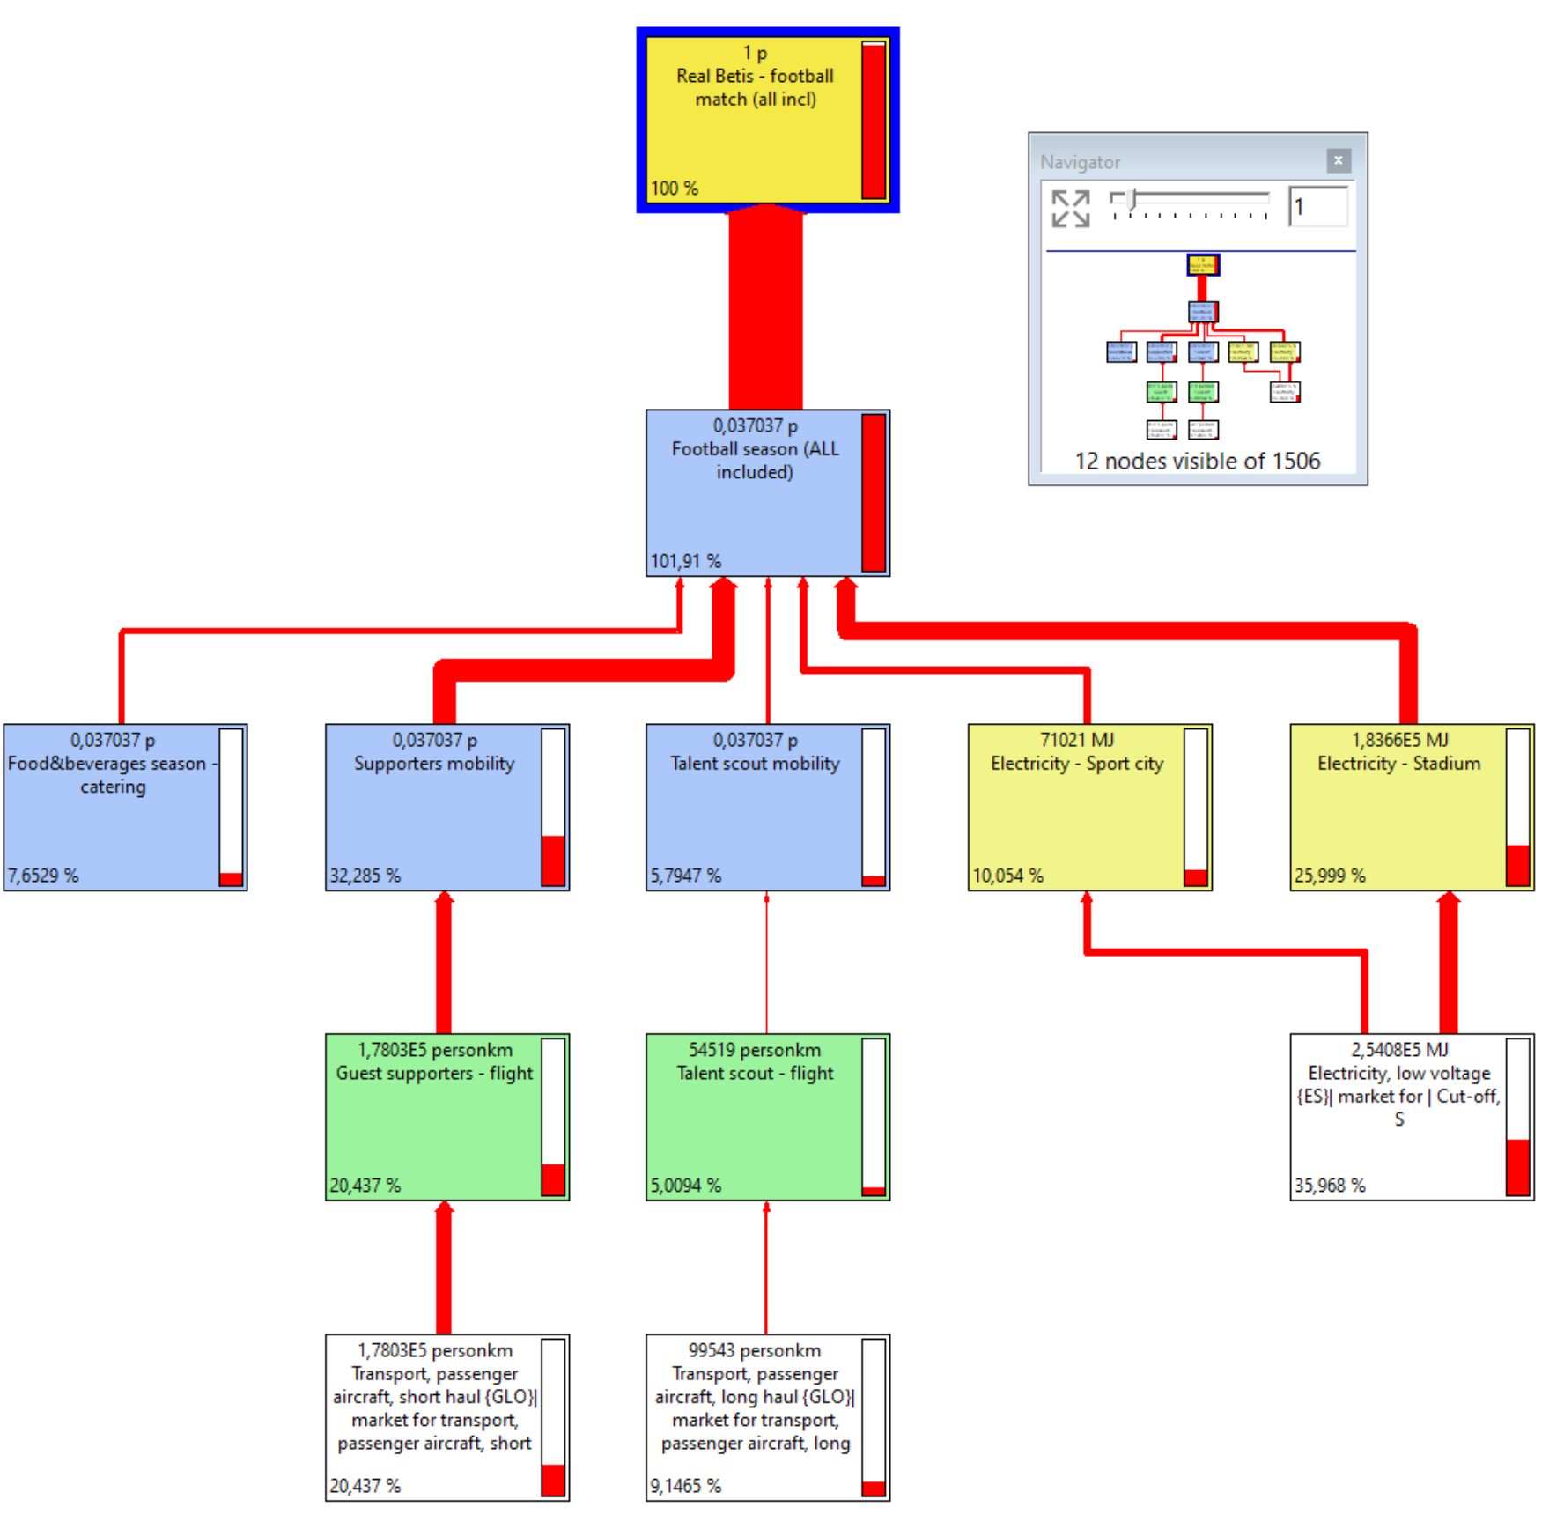
Figure 2 - Detailed analysis on overall environmental footprint key processes (weighted results -single score -for one football match) - Values in % on total. Source: Authors own creation

The top five contributing process, in absolute values, to the total environmental footprint of one professional football match are reported in the next table.

Process | Note
Electricity (National grid) | It refers to the electricity consumed at the stadium and at the sport city centre
Transport, passenger aircraft, short haul | It refers to the mobility of guest supporter
Transport, passenger aircraft, long haul | It refers to the mobility of talent scouts
Transport, passenger train | It refers to the mobility of supporters
Transport, passenger car, medium size, petrol, EURO 5 | It refers to the mobility of supporters
Transport, passenger car, medium size, diesel, EURO 5 | It refers to the mobility of supporters
The following figure shows an in-depth analysis of the key contributors to the carbon footprint of one professional football match (the thickness of the arrow is proportional to its impact and any credit from recycling, if detectable, is shown with green arrows). The results are very similar to those reported for the overall environmental footprint.

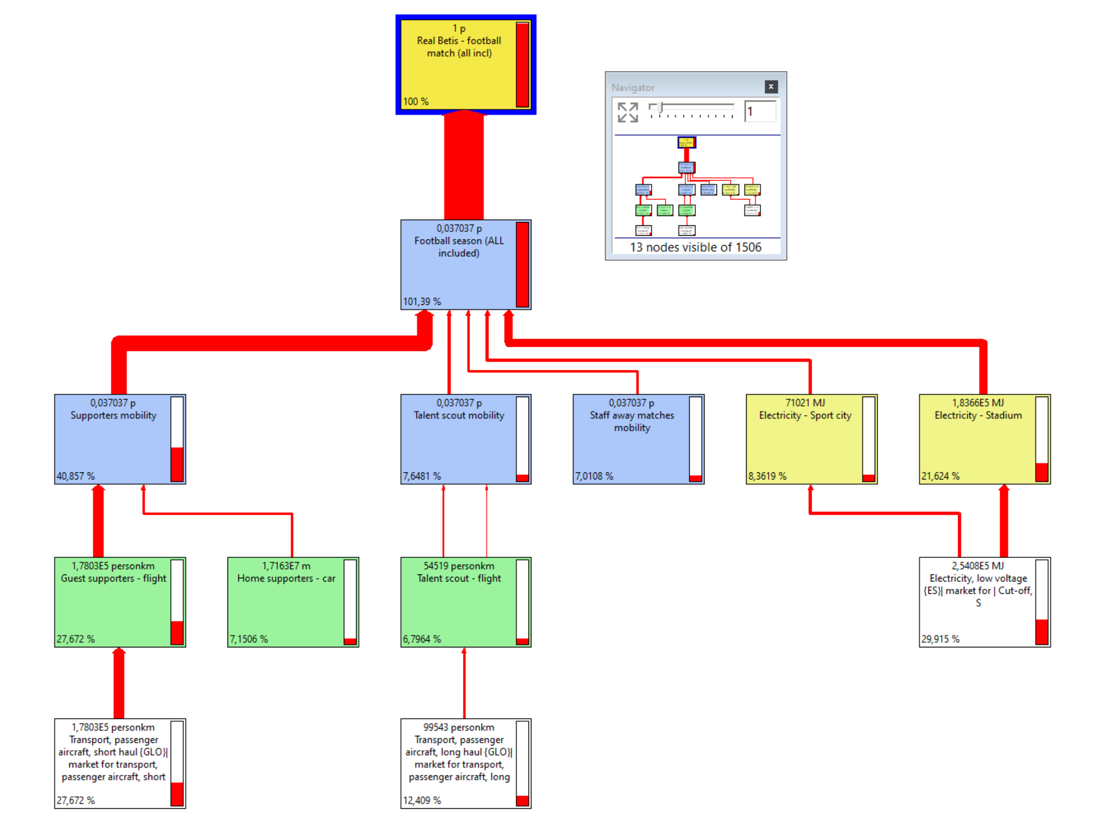
Figure 3 - Focus on carbon footprint (results for Climate Change impact category for one football match) - Values in % on total. Source: Authors own creation

Since the mobility processes proved to be, by large, the most relevant contributors to the carbon footprint of a professional football match, a more detailed analysis was carried out, as reported in the next figure.

Figure 4 - Focus on mobility: carbon footprint (results for Climate Change impact category for one football match) - Values in % on total mobility contribution. Source: Authors own creation

An additional analysis was done on food and beverages contribution to carbon footprint and to the overall footprint.

Figure 5 - Focus on food and beverages: carbon footprint (results for Climate Change impact category for one football match) - Values in % on total food and beverages contribution. Source: Authors own creation

Figure 6 - Focus on food and beverages: overall environmental footprint (single score results for one football match) - Values in % on total food and beverages contribution. Source: Authors own creation

- Data quality
A qualitative assessment of the quality of the data used in the LCA model was done according to expert judgement assessment, as reported in the next table.
Data quality rating | Criteria | Datasets
Excellent | Primary data collected specifically for the current study  Specific background Datasets – top quality | - Electricity consumed at the stadium and at the sport city center
Very good | Primary data collected specifically for the current study  Generic background Datasets – average quality | - Natural gas consumed at the stadium and at the sport city center  - Water consumed at the stadium and at the sport city center
Good | Primary data collected specifically for the current study (scenarios)  Generic background Datasets | - Staff away matched mobility  - Supporters’ mobility  - Talent scout mobility
Fair | Secondary datasets – not specific | - Chemicals and cleaning products consumed at the stadium  - Waste streams end of life
Poor | Secondary proxy data | - Turf maintenance  - Food & beverage processes (all types)  - Sport apparel & equipment
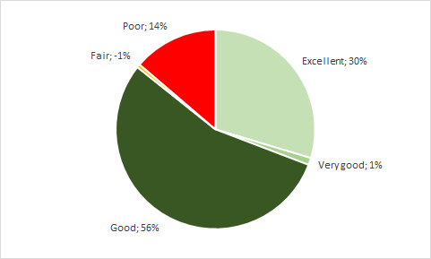
Figure 7 - Data quality rating. Source: Authors own creation

The total share of data with at least good quality is 87%. Still a significant (14%) share of data are of poor quality. This shall be taken into consideration in the interpretation of the results, especially for the contribution of the food & beverages processes, where several components have been modelled with proxy data. The following figure shows the impact of poor-quality data (framed in red colour).
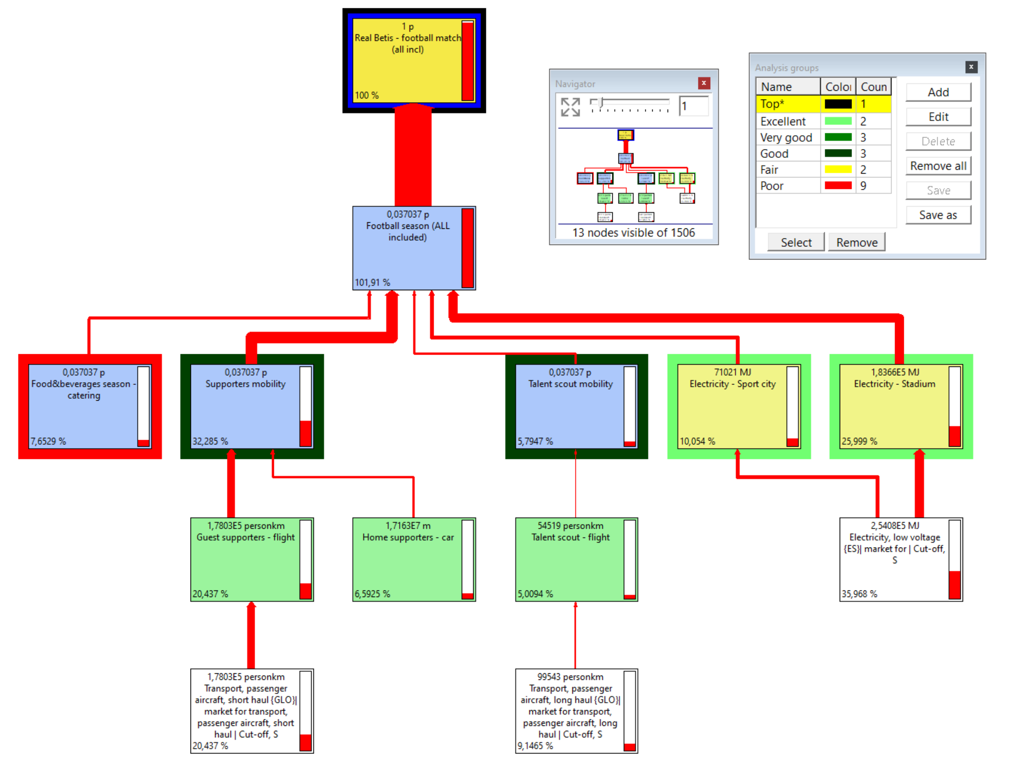
Figure 8 - Data quality rating – one professional football match (weighted results).
Source: Authors own creation

