Online Supplement
This document serves as an online supplement to the paper: ‘Beyond The Hype: How Blockchain Affects Supply Chain performance’ and contains the following sections:
- Papers selected for SLR
- Coding trees
- Interview protocols
- Updated frameworks based on secondary cases (per paper)
- Updated frameworks based on primary cases (per case)

Section A: Papers selected for SLR
Table A1: Papers included in the final selection of the SLR
Paper |  | Data source | No. of cases | Industry | BC type | Supply chain performance indicator | Journal
A. | Rogerson & Parry (2020) | Interviews | 4 | Food supply chain | Private (1) & Public (3) | Dependability | Supply Chain Management: An International Journal
B. | Danese et al. (2021) | Interviews | 5 | Food supply chain | Public | Dependability | International Journal of Operations and Production Management
C. | Azzi et al. (2019) | Archival data | 2 | Food & Health | Hybrid & Public permissioned | Dependability | Computers and Industrial Engineering
D. | Stranieri et al. (2021) | Interviews | 3 | Food supply chain | Unknown | Speed, Quality, Cost, Dependability | Food Control
E. | Tseng & Shang (2021) | Interviews | 3 | Health, Accounting, and Food | Unknown | Speed, Quality, Cost, Dependability | Sustainability
F. | Chang et al. (2020) | Archival data | 5 | Trade finance | Private (3) & unknown (2) | Speed, Cost, Dependability | Sustainability
G. | Luchoomun et al. (2020) | Implementation case | 1 | Automotive: Vehicle trade | Private | Speed, Quality, Dependability | Corporate Social Responsibility and Environmental Management
H. | Martinez et al. (2019) | Implementation case | 1 | Manufacturing: Order process | Private | Speed, Quality, Cost, Dependability | International Journal of Operations and Production Management

Section B: Coding trees

Table B1: Coding tree based on structured literature review
Quote | Blockchain element | Supply chain performance indictor
Through the automatic execution of the framework, all medical referral processes are paperless. The directness of data sharing in the blockchain-based framework improves the speed and error rate of data transmission. (Tseng & Shang, 2021, p. 10) | Digitization | Speed Quality
Blockchain is utilized as a shared ledger to store trading documents … participating parties, including banks and trading counterparties, are able to access on-chain data to track the flow of information and goods. (Chang et al., 2020, p. 6) | Shared immutable ledger | Dependability
The high cost of administrative procedures and high volume of paperwork is greatly reduced. (Chang et al., 2020, p. 7) … Using blockchain technology as a substitute for traditional trade documents, reduces transaction time from 10 days to less than three hours. (Chang et al., 2020, p. 9) | Digitization | Speed  Cost
The transaction histories of the vehicle are more transparent through the use of blockchain technology where distributed ledger is shared among all network participants. (Luchoomun et al., 2020, p. 76). | Shared immutable ledger | Dependability
The blockchain solution considerably improved processing time. While normally it would take two to four days for an order or modification to be processed and approved, the blockchain solution leads to instantaneous, automatic approval times (including the verification time against set rules) and a reduction in the amount of griefs, which improved efficiency – from two to four days to less than 1 min. (Martinez et al. 2019, p. 1007) | Smart contracts | Speed  Quality  Cost
The visibility of the order management process improved towards employees and customers’ employees in the supply chain … traceability of orders improved … the company never had this open and detailed traceability available for all its transactions in the past … now it is impossible for someone to alter previous transactions. (Martinez et al., 2019, p. 1008) | Shared immutable ledger | Dependability

Table B2: Coding tree based on interviews
Quote | Blockchain element | Supply chain performance indicator
Mapping the processes was done with all departments and stakeholders. Blockchain has mainly been implemented at our company to take a closer look at the processes and to prescribe good processes. We adjusted the processes several times to improve it, before implementation. (User 1) | Process Mapping | Speed
The process has been mapped. At first, the process consisted of 5 steps, but it turned out to be 55. So we have gained much more insight into the steps taken in the process. In this way, inefficiencies have been removed from the process. (User 2) | Process Mapping | Speed
Process mapping has its pros and cons for us. Some clients might say, we have mapped and optimized it so well, from here onwards we will take care of it ourselves. (Provider 3a) | Process Mapping | Speed
Blockchain is like a large value stream map in which all shared processes are laid along the line and analyzed for waste. (Provider 4a) | Process Mapping | Speed
The planning is visible on the blockchain for everybody, which should reduce the communication between departments. (User 1) | Digitization | Speed
The controller and the head of project development can view all the projects and their status in the system so that they can act when something is taking too much time. One can react faster when real-time insights in bottlenecks are available, in this way, the process will speed up. (User 2) | Digitization | Speed  Dependability
I believe that there is more consciousness since you can actually see the data. There is an extra set of eyes that can watch, track, and solve errors faster. In this way, we can check one another. Paperwork can be lost or unreadable. (User 1) | Digitization | Quality
The quality will increase because you will be collecting certain data about process steps. You can also see in real-time where and when some processes crash. So that you can make improvements in the future. Before, we had no insight into these processes. (User 2) | Digitization | Quality
By using a platform, one notices that everyone automatically becomes much sharper, and fewer discussions emerge. (Provider 3a) | Digitization | Quality
By sharing data through the system, the focus on data quality is enlarged. Especially within logistics, the quality of the data is a huge problem. (Provider 4a) | Digitization | Quality
The planning is visible on the blockchain for everybody, which should reduce the communication between departments (User 1) | Digitization | Dependability
One can look at the source of why a process was slow. From a process optimization perspective, this is a very effective solution. (User 1) | Data analysis | Speed
We collect data on internal and external process steps, risk analysis, and that kind of things. Before, we did not know how long the processes took. By adding more and more projects to the blockchain, the insight in data increases so that better decisions can be made and more complete KPIs can be analyzed to improve the process throughput. (User 2) | Data analysis | Speed
We flattened the communication between SC parties. We directly share information on logistics in the network. In this way, unnecessary communication can be eliminated because everybody works in the same channel and can see the same secured data in real-time. In this way, processes can be simplified and unnecessary communication can be eliminated. (Provider 4a) | Shared immutable ledger | Speed
There is no more need to work in different administration systems like web portals and Excel sheets. What happened before, is that 1 person registers something - often in Excel - and someone else in another Excel and you just continue with the daily activities, then you eventually have a total sum that is not correct. If you have a lot of skewed transactions, you have to find all the packing slips and you can attach them right away. In the event of a deviation, you as a user can then send the data directly from the system and the counterparty must prove otherwise. But you only have to take action on the points where discussion arises, so you can discuss it directly and it is still fresh in your memory. (Provider 3a) | Shared immutable ledger | Speed  Quality  Cost
Everybody has the same information at exactly the same time, which improves the focus on quality. (Provider 4a) | Shared immutable ledger | Quality
Non-value-adding activities can be eliminated by disintermediation of parties that perform data aggregation activities. (Provider 4a) | Shared immutable ledger | Cost
One can see which person at which moment made a mistake which led to rejected products, this trail of steps cannot be changed. (User 1) | Shared immutable ledger | Dependability
There are no balance discussions because all parties in the platform are looking at the same data. You look at exactly the same transaction together. (Provider 3a) | Shared immutable ledger | Dependability
Blockchain is well suited for contexts where many parties are competing with each other. In the platform, I've elevated everything to an asset, so everything has a unique ID. You can share each asset individually. Like an event, or document, or transaction, everything is an asset. And because you can assume that because of the guarantees of the entire crypto circus of a blockchain and its hashes: it becomes immutable. That you can rely on that, that is the key thing of the entire blockchain happening. Because that's basically it - you're looking at something that can't be messed with. The data is the data, whether it is good data or not, depends on the data you put into it. But you all look at the same thing, you can't cheat people in the chain. (Provider 4a) | Shared immutable ledger | Dependability
Certificates are automatically sent by the system when the previous steps are performed, the system also automatically indicates in the system that the step has been performed. These automatic steps take away manual handling. (User 1) | Smart contracts | Speed
When sales places an order in the system, the planner sees the order automatically appearing in her workflow, and for the lab and production, this will happen automatically as well. We cannot work around the formalized process anymore so that we cannot forget steps. Decreasing the error rate will lead to increased speed and reduced costs since solving problems requires a lot of time. (User 1) | Smart contracts | Speed  Quality  Cost
The system automatically reminds you of the next step. In this way, you will not forget steps, which increases throughput. (User 2) | Smart contracts | Speed  Quality  Cost
Certain processes have to be followed in order to not forget things, and to use a uniform working method. Everyone has to work in the same way to guarantee the quality that you want to guarantee. It is the intention to reduce the degree of deviation of the process. Before, we could for example opt for not putting an order in the system, now you have to. (User 1) | Smart contracts | Flexibility
People are now less flexible in the process in what they can do. First, they could do whatever they want between the two phase closures. And now you are guided by your process, and that is difficult for some who have been in the profession for a while. But others who are new to the profession will benefit from this because they now know which steps to take. (User 2) | Smart contracts | Flexibility

Section C: Interview protocols
Table C1: Interview protocol blockchain provider
Interview protocol: Blockchain provider
Case:
Interviewee:
Date:
Introduction
- Explain the overall goal of the research
- Ask permission for recording and using transcript
- Indicate the scope and duration of the interview
Questions
What is your role in the company?
What is your role in relation to the blockchain project?
What is the status of the project?
What supply chain challenges are you aiming to tackle with this blockchain application (for this specific case)?
What type of blockchain was used (for this specific case)?
What are the features of this blockchain application?
- What data is being stored on the blockchain?
- What is the use of smart contracts in your solution?
- What is the role of transferring (financial) value in your solution?
- What consensus mechanism is being used to approve transactions?
- How is data being distributed over the nodes?
- To what extent is it a decentralized solution?
- To what extent is the data stored on the blockchain immutable?
- To what extent is the data stored on the blockchain transparent?
Which impact on supply chain performance do you experience at your clients?
- And in terms of speed / quality / cost / dependability / flexibility?
- Any other observed impact on performance?
Ending
- Do you know anyone involved in blockchain projects I could talk to?

Table C2: Interview protocol blockchain user
Interview protocol: Blockchain user
Case:
Interviewee:
Date:
Introduction
- Explain the overall goal of the research
- Ask permission for recording and using transcript
- Indicate the scope and duration of the interview
Questions
What is your role in the organization?
What is your role in relation to the blockchain project?
In which supply chain process is blockchain used?
What is the status of the project?
What were the supply chain challenges that implementing blockchain technology should address?
To what extent are these challenges addressed?
What are the supply chain performance effects of this project?
- And in terms of speed / cost / quality / dependability / flexibility?
- Any other observed impact on performance?
- What specific features of the blockchain implementation result in these performance effects?
Ending
- Do you know anyone involved in blockchain projects I could talk to?

Section D: Updated frameworks based on secondary cases (per paper)
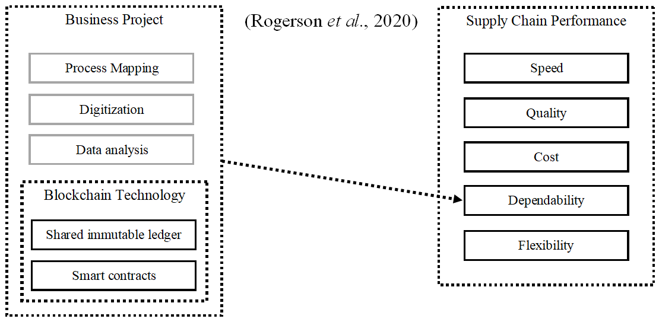

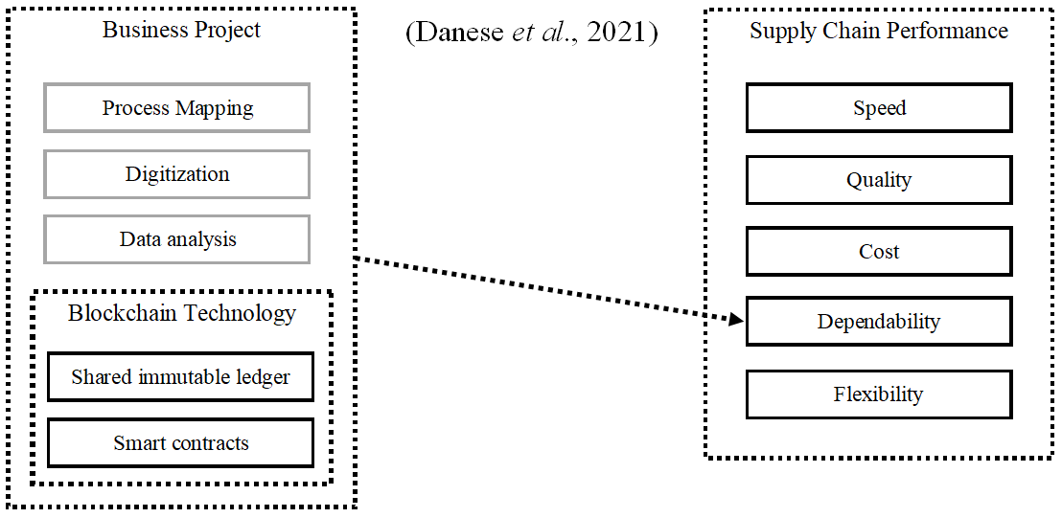
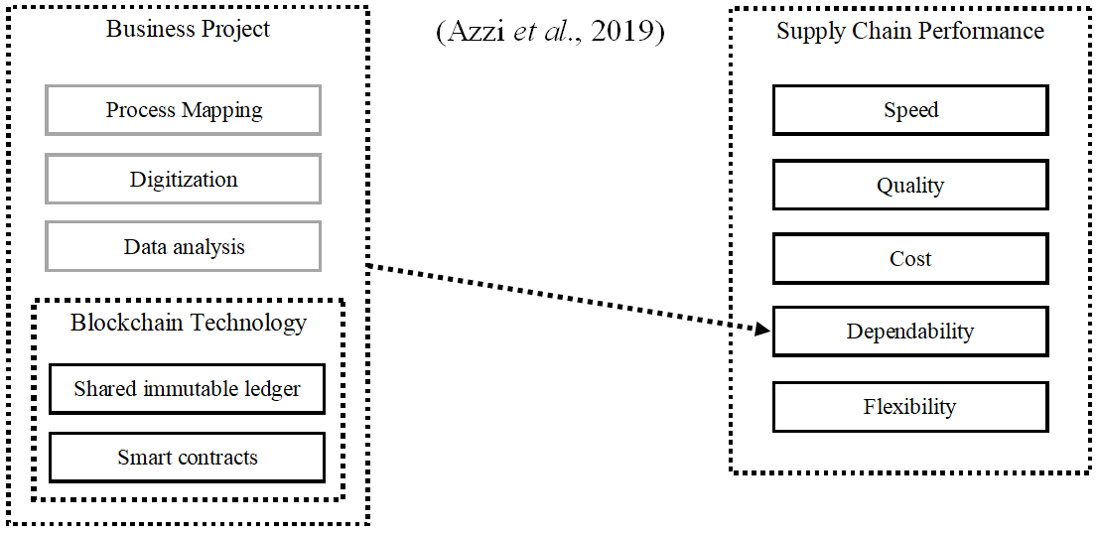
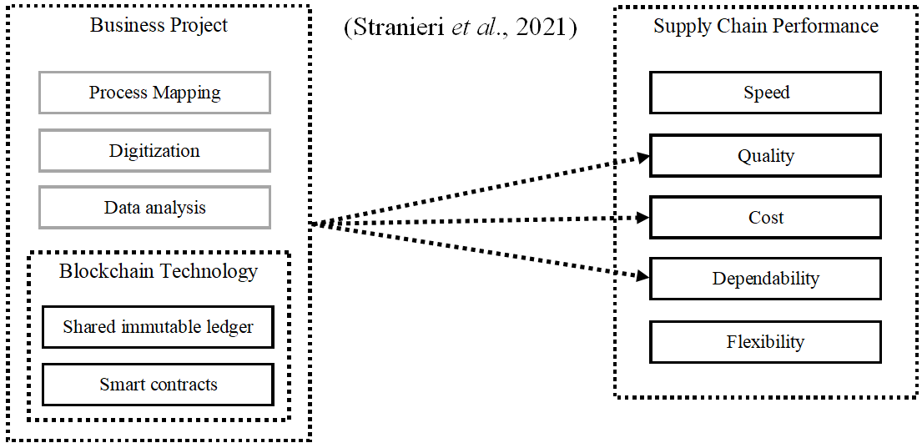

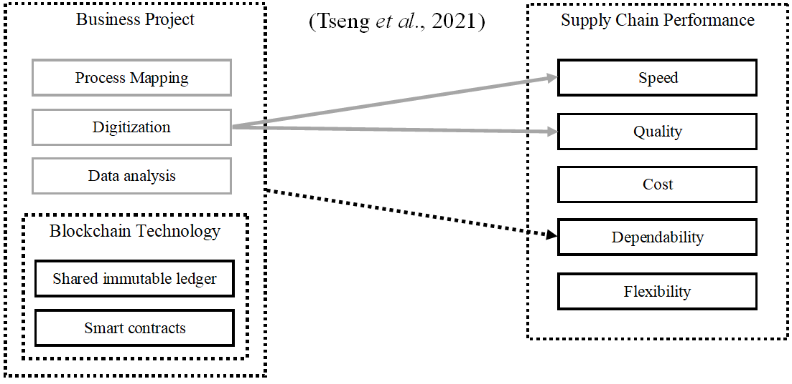
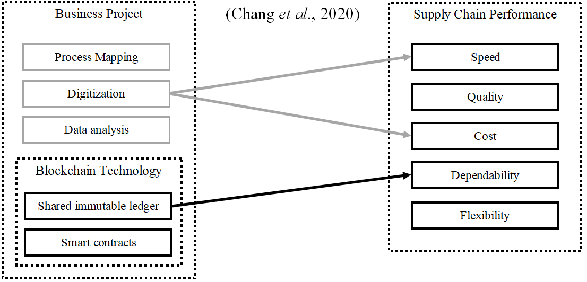
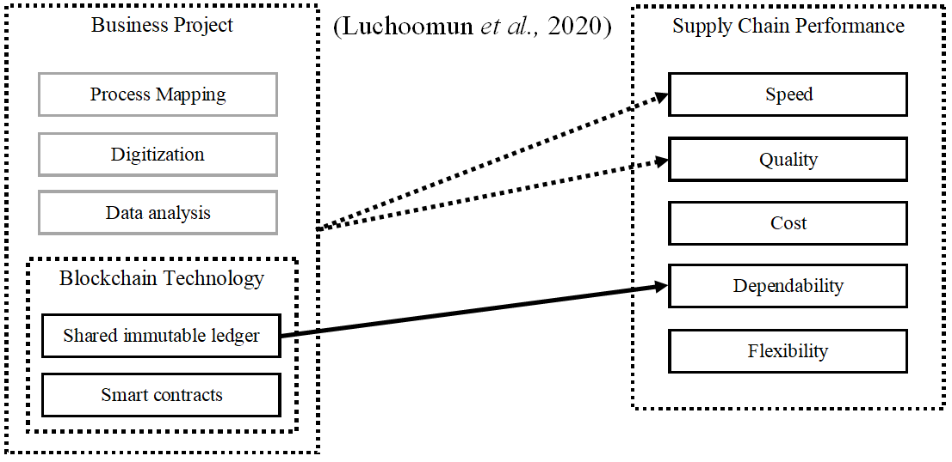
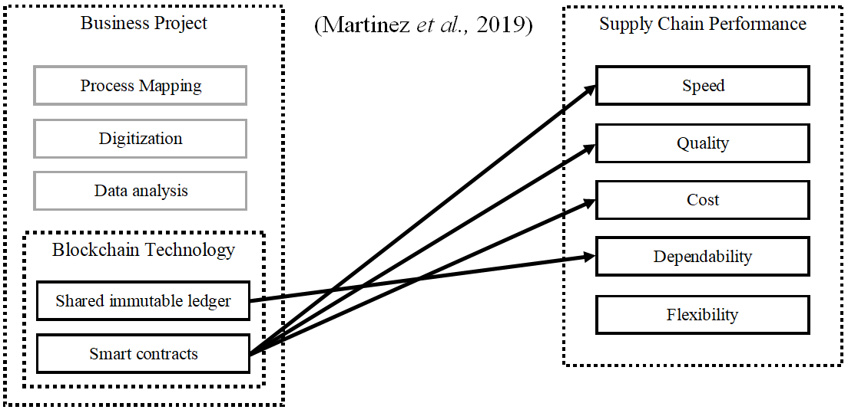

Section E: Updated frameworks based on primary cases (per case)
