Supplement file
Overview of cluster: co-citation analysis
Cluster | Core top cited Documents | Topic Focus

Cluster 1 (Green): Consumer Behavior and Brand Equity in Green Marketing | - Martin and Schouten (2012)  - Aaker (1991)  - Ailawadi and Keller (2004) | This cluster emphasizes consumer attitudes and behaviors in relation to green marketing, with a particular focus on how brand equity influences consumer loyalty and decision-making. It highlights the importance of integrating sustainability into brand management as a key differentiator in the market.

Cluster 2 (Blue): Sustainable Innovation and Green Marketing | - Dangelico and Vocalelli (2017)  - Zhang et al. (2018) | This cluster focuses on the role of innovation in driving green marketing practices. It examines how companies develop and implement sustainable innovations as part of their marketing strategies, reflecting a shift toward more environmentally conscious business models.

Cluster 3 (Red): Consumer Behavior and Sustainability Practices | - Laroche et al. (2001)  - Do Paco et al. (2020)  - Schuhwerk et al. (1995) | This cluster delves into consumers' specific behaviors and practices regarding sustainability. It explores how environmental concerns influence consumer choices and how these choices drive the adoption of green marketing practices.

Cluster 4 (Yellow): Measurement and Evaluation in Sustainable Marketing | - Fornell and Larcker (1981)  - Nunnally (1978)  - Fuller (1999)  - Peattie K. and Crane A. (2005) | This cluster is dedicated to the methodologies and tools used to assess the effectiveness of sustainable marketing strategies. It focuses on measurement models, psychometric assessments, and the evaluation of marketing performance from a sustainability perspective.

Cluster 5 (Purple): Green Marketing and Corporate Social Responsibility | - Peattie K. and Crane A. (2005)  - Jain et al. (2004)  - Manaktola and Jauhari (2007) | This cluster examines the intersection of green marketing and corporate social responsibility (CSR). It discusses how companies integrate CSR into their marketing strategies to enhance brand reputation and engage with consumers who value sustainability.

Note on references

Cluster 1
- Aaker, D.A. (1991), Managing Brand Equity: Capitalizing on the Value of a Brand Name, Free Press.
- Martin, D. and Schouten, J. (2012), Sustainable Marketing, Pearson.
- Ailawadi, K.L. and Keller, K.L. (2004), “Understanding retail branding: Conceptual insights and research priorities”, Journal of Retailing, Vol. 80 No. 4, pp. 331-342. https://doi.org/10.1016/j.jretai.2004.10.008
Cluster 2
- Dangelico, R.M. and Pujari, D. (2010), “Mainstreaming green product innovation: Why and how companies integrate environmental sustainability”, Journal of Business Ethics, Vol. 95 No. 3, pp. 471-486. https://doi.org/10.1007/s10551-010-0434-0
- Dangelico, R.M. and Vocalelli, D. (2017), “Green marketing: An analysis of definitions, strategy steps, and tools through a systematic review of the literature”, Journal of Cleaner Production, Vol. 165, pp. 1263-1279. https://doi.org/10.1016/j.jclepro.2017.07.184
- Zhang, L., Li, D. and Cao, C. (2018), “The influence of greenwashing perception on green purchasing intentions: The mediating role of green word-of-mouth and the moderating role of green concern”, Journal of Cleaner Production, Vol. 187, pp. 740-750. https://doi.org/10.1016/j.jclepro.2018.03.201
Cluster 3
- Laroche, M., Bergeron, J. and Barbaro-Forleo, G. (2001), “Targeting consumers who are willing to pay more for environmentally friendly products”, Journal of Consumer Marketing, Vol. 18 No. 6, pp. 503-520. https://doi.org/10.1108/EUM0000000006155
- do Paço, A., Shiel, C. and Alves, H. (2020), “Generativity, sustainable development and green consumer behaviour”, Journal of Cleaner Production, Vol. 245, 118865. https://doi.org/10.1016/j.jclepro.2019.118865
- Schuhwerk, M.E. and Lefkoff-Hagius, R. (1995), “Green or non-green? Does type of appeal matter when advertising a green product?”, Journal of Advertising, Vol. 24 No. 2, pp. 45-54. https://doi.org/10.1080/00913367.1995.10673475
Cluster 4
- Fornell, C. and Larcker, D.F. (1981), “Evaluating structural equation models with unobservable variables and measurement error”, Journal of Marketing Research, Vol. 18 No. 1, pp. 39-50. https://doi.org/10.1177/002224378101800104
- Nunnally, J.C. (1978), Psychometric Theory (2nd ed.), McGraw-Hill.
- Fuller, D.A. (1999), Sustainable Marketing: Managerial-Ecological Issues, SAGE Publications.
- Peattie, K. and Crane, A. (2005), “Green Marketing: Legend, Myth, Farce or Prophesy?”, Qualitative Market Research: An International Journal, Vol. 8 No. 4, pp. 357-370. https://doi.org/10.1108/13522750510619733
Cluster 5
- Peattie, K. and Crane, A. (2005), “Green Marketing: Legend, Myth, Farce or Prophesy?”, Qualitative Market Research: An International Journal, Vol. 8 No. 4, pp. 357-370. https://doi.org/10.1108/13522750510619733
- Jain, S.K. and Kaur, G. (2004), “Green Marketing: An Attitudinal and Behavioural Analysis of Indian Consumers”, Global Business Review, Vol. 5 No. 2, pp. 187-205. https://doi.org/10.1177/0972150904005002031
- Manaktola, K. and Jauhari, V. (2007), “Exploring consumer attitude and behaviour towards green practices in the lodging industry in India”, International Journal of Contemporary Hospitality Management, Vol. 19 No. 5, pp. 364-377. https://doi.org/10.1108/09596110710757534

Top Keywords in Green Marketing
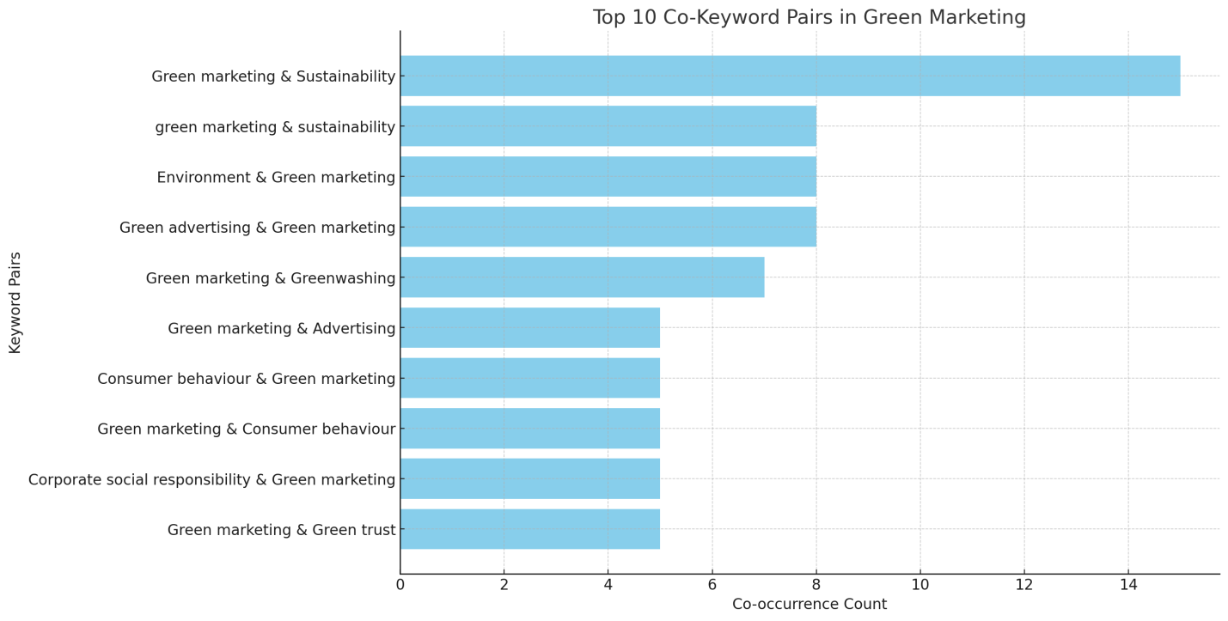

Centrality Metrics for Green Marketing Keywords
Rank | Keyword | Degree Centrality | Betweenness Centrality | Closeness Centrality
1 | Green Marketing | 1 | 0.981818 | 1
2 | Environment | 0.181818 | 0 | 0.55
3 | Sustainability | 0.181818 | 0 | 0.55
4 | Consumer Behavior | 0.090909 | 0 | 0.52381
5 | Consumer Behavior | 0.090909 | 0 | 0.52381
6 | Green Brand Equity | 0.090909 | 0 | 0.52381
7 | Green Brand Image | 0.090909 | 0 | 0.52381
8 | Advertising | 0.090909 | 0 | 0.52381
9 | Greenwashing | 0.090909 | 0 | 0.52381
10 | Corporate Social Responsibility | 0.090909 | 0 | 0.52381

