Supplementary Materials
Supersonic Sustainability Transitions: An Integrated Life Cycle and Triple Bottom Line Assessment with Socio-Technical Transition Lenses for Next-Generation Passenger Aircraft
Supplementary-file clarification. This file contains all appendices cited in the main article (Appendices A-L), including Tables A1-A7 and Figures A1-A5. References cited in the supplementary material are listed in the main article reference list. Cross-references have been harmonized with the revised article file.
Supplementary contents
Appendix | Item | Content
Appendix A | Table A1 | Literature gaps and study contribution
Appendix B | Table A2 | Full data inventory and assumptions matrix
Appendix C | Table A3 | LCA inventory modules and uncertainty treatment
Appendix D | Table A4 | Life-cycle contribution analysis
Appendix E | Table A5 | Resource use and recovery potential
Appendix F | Table A6 | Social and equity indicators and scenario values
Appendix G | Table A7 | Stakeholder-specific implementation actions
Appendix H | Figure A1 | Data provenance and integration pipeline
Appendix I | Figure A2 | PRISMA flow for the literature corpus
Appendix J | Figure A3 | Total CASK by scenario
Appendix K | Figure A4 | RASK, CASK, and operating margin by scenario
Appendix L | Figure A5 | Environmental-justice overlay
Appendix A. Literature gap synthesis
Table A1. Economic feasibility, Key Literature Insights
Thematic Area | Key Literature Insights | Remaining Gap | Contribution of This Study
Supersonic aircraft development | New SST concepts focus on low-boom design, advanced materials, propulsion improvement, and SAF compatibility (Harding, 2021; NASA, 2023). | Historical barriers remain: fuel intensity, cost, sonic boom, and public acceptance. | Evaluates SST as a sustainability-transition problem rather than only an aircraft-design issue.
Environmental impact | SST may produce higher fuel burn, CO₂, NOₓ-related ozone effects, stratospheric H₂O forcing, and noise exposure than subsonic aircraft (Davis & Kharina, 2018; Matthes et al., 2022; Rötger et al., 2024). | Few assessments integrate high-altitude non-CO₂ effects, boom exposure, and lifecycle burdens. | Applies cradle-to-grave LCA with aviation-relevant climate and noise considerations.
SAF and propulsion pathways | SAF offers near-term emission reduction potential, while hydrogen and hybrid-electric concepts remain promising but less mature (IATA, 2020; Cabrera & Melo de Sousa, 2022; Su-ungkavatin et al., 2023). | Prior work often evaluates fuel and propulsion options separately from cost, infrastructure, and equity. | Compares Jet-A, SAF, and LH₂-related pathways within an integrated sustainability model.
Economic feasibility | SST viability depends on fuel cost, energy intensity, premium demand, aircraft utilization, and passenger-normalized unit operating cost–unit revenue balance | Economic analysis is often disconnected from environmental and social exposure assessment. | Integrates passenger-normalized unit operating cost, unit revenue, operating margin, fuel cost, carbon cost, and uncertainty into TBL-based pathway evaluation
Noise, equity, and public acceptance | Sonic boom, airport noise, and environmental-justice exposure influence regulatory feasibility and community acceptance (Coen et al., 2022; Ghosh & Bressman, 2024). | Social and equity indicators are rarely incorporated into SST transition assessment. | Includes noise exposure, affordability, accessibility, equity exposure, public sentiment, and safety perception indicators.
STS/MLP transition analysis | STS and MLP explain how innovations interact with regimes, infrastructure, policy, markets, and users (Geels, 2020; El Bilali, 2019). | Aviation-specific STS/MLP categories are often discussed conceptually but not operationalized. | Uses certification regime, fuel infrastructure, airline economics, airport noise governance, SAF/LH₂ supply chain, overland boom regulation, and community acceptance as interpretive categories.
Framework integration | LCA, TBL, and transition frameworks are often applied separately (Elkington, 1998; Cucurachi et al., 2019; Sitarska, 2025). | Limited research converts these frameworks into explicit decision rules for SST transition readiness. | Develops SSTAM to classify pathways as no-regrets when robust across uncertainty and conditional when dependent on policy, infrastructure, energy, or community safeguards.
Note. Citations correspond to sources listed in the main article reference list.

Appendix B. Data inventory and assumptions
Table A2. Full data inventory and assumptions matrix for the integrated LCA-TBL assessment
Input Domain | Key Parameters | Main Source Basis | Assumption / Uncertainty Treatment | Role in the Model
Aircraft mission and performance | Stage length, seating capacity, load factor, Mach number, cruise altitude, specific fuel consumption, lift-to-drag ratio, block fuel | OEM/NASA concepts; peer-reviewed SST studies; A350/787-type benchmarks | Supersonic missions were matched with comparable long-haul subsonic operations; uncertainty range: ±10–30%. | Defines mission profile, RPK denominator, fuel burn, energy intensity, and g CO₂-eq/mission.
Materials, manufacturing, and end-of-life | Aluminum, titanium, composites, engine materials, process energy, machining waste, recycling and disposal | LCI databases; aircraft materials literature; OEM/technical reports | Advanced SST airframes require lightweight and high-temperature materials; recovery credits applied where supported; uncertainty range: ±20–40%. | Estimates embodied emissions, resource demand, manufacturing impacts, and circularity benefits.
Fuel and hydrogen pathways | Jet-A, HEFA-SAF, FT-SAF, ATJ-SAF, LH₂ carbon intensity, electrolysis intensity, grid carbon intensity, liquefaction energy, boil-off | GREET, ecoinvent, SAF/LH₂ studies, ASTM-related literature, energy-system reports | Fuel pathways modeled on a well-to-wake basis; co-products treated using source-specific energy, mass, or economic allocation; uncertainty range: ±15–50%. | Determines fuel-cycle emissions, fuel cost, pathway comparison, and conditional viability of LH₂ scenarios.
Operations and maintenance | Mission fuel burn, lubricants, spare parts, MRO energy, maintenance intensity | Airline/MRO reports; technical studies; subsonic benchmark data | Operations dominate lifecycle impacts because of high SST fuel intensity; uncertainty range: ±10–25%. | Main contributor to GWP100, energy demand, operating cost, and sensitivity outcomes.
High-altitude emissions | NOₓ-induced ozone, stratospheric H₂O, non-CO₂ forcing | Atmospheric modeling studies; ICAO/CAEP literature | Non-CO₂ effects were characterized separately from direct CO₂ because SST cruise altitude affects radiative forcing; uncertainty range: ±30–50%. | Expands climate assessment beyond CO₂-only accounting.
Noise, social, and equity indicators | L_den, SEL, PLdB, exposed population, affordability index, accessibility coverage, equity exposure ratio, safety perception, public favorability | FAA/EASA/ICAO noise standards; NASA X-59 data; policy documents; environmental-justice and community-exposure literature | Social outcomes were represented through exposure, affordability, access, and perception proxies; uncertainty range: ±10–30%. | Supports TBL social pillar, community-acceptance assessment, and equity-safeguard evaluation.
Economic and policy variables | Passenger-normalized unit operating cost, unit revenue, operating margin, CAPEX, OPEX, fuel cost, carbon cost | Airline reports; aviation cost literature; ICAO/IATA policy documents; carbon-pricing and SAF-mandate studies | Economic and policy variables were modeled as scenario and sensitivity factors; uncertainty range: ±10–40% or binary policy switch. | Supports economic feasibility, MCDA integration, and no-regrets/conditional pathway classification.
Quality and validation | Unit checks, source hierarchy, benchmark comparison, pedigree scoring, sensitivity testing | Regulatory, OEM/NASA, database, and peer-reviewed sources | Higher-quality sources were prioritized when values conflicted; assumptions were checked through benchmark comparison and uncertainty testing. | Supports transparency, reproducibility, and reviewer auditability.
Note. Uncertainty ranges reflect the bounds reported in the revised methodology and are applied according to parameter type and source quality.

Appendix C. Life-cycle inventory structure
Table A3. LCA inventory modules, assumptions, uncertainty ranges, and model roles
LCI Module | Key Parameters | Unit | Main Source Type | Main Assumption | Allocation / Treatment | Uncertainty Range | Role in LCA Model
Aircraft mission profile | Stage length, seating capacity, load factor, mission frequency | km; passengers; %; flights/year | OEM/NASA concepts; peer-reviewed studies | Representative supersonic missions are matched with comparable subsonic long-haul operations. | Used to calculate RPK and mission-level outputs. | ±10–30% | Defines denominator for g CO₂-eq/RPK and total g CO₂-eq/mission.
Aircraft performance | Cruise Mach, altitude, SFC, lift-to-drag ratio, block fuel | Mach; ft; kg fuel/hr; L/D; kg | NASA/OEM data; technical literature | Supersonic performance is estimated from published concept ranges and benchmarked against A350/787-type subsonic data. | Direct input to operational fuel-burn model. | ±10–25% | Drives operational emissions, fuel use, and energy intensity.
Materials and components | Aluminum, titanium, composites, engine materials, fasteners | kg; kg CO₂-eq/kg | LCI databases; aircraft materials literature | Advanced supersonic airframes require higher shares of lightweight and high-temperature materials. | Material burdens assigned by mass-based inventory factors. | ±20–30% | Estimates embodied emissions and resource demand.
Manufacturing and assembly | Process energy, machining waste, assembly energy | MJ; kg waste | LCI databases; OEM/technical reports | Manufacturing energy reflects advanced airframe and propulsion complexity. | Process energy allocated to aircraft production stage. | ±20–30% | Estimates production-phase impacts.
Fuel pathways | Jet-A, HEFA-SAF, FT-SAF, ATJ-SAF, LH₂ carbon intensity | g CO₂-eq/MJ; MJ/kg | GREET; ecoinvent; SAF/LH₂ studies; ASTM-related literature | Fuel pathways are assessed on a well-to-wake basis. | Co-products allocated using source-specific energy, mass, or economic rules. | ±15–40% | Determines fuel-cycle emissions and pathway comparison.
Hydrogen pathway | Electrolysis electricity intensity, grid carbon intensity, liquefaction energy, boil-off | kWh/kg H₂; g CO₂-eq/kWh; % | Hydrogen LCI studies; energy-system reports | LH₂ benefits depend on low-carbon electricity and airport supply-chain readiness. | Liquefaction and boil-off included in well-to-wake boundary. | ±20–50% | Tests conditional viability of LH₂ scenarios.
Operations and maintenance | Mission fuel burn, lubricants, spare parts, MRO energy | kg fuel; MJ; kg parts | Airline/MRO reports; technical studies | Operations dominate life-cycle impacts because of high supersonic fuel intensity. | Directly assigned to use phase. | ±10–25% | Main contributor to GWP100 and energy demand.
High-altitude emissions | NOₓ-induced ozone, stratospheric H₂O, non-CO₂ forcing | g CO₂-eq/RPK; g CO₂-eq/mission | Atmospheric modeling studies; ICAO/CAEP literature | Non-CO₂ effects are included because supersonic cruise altitude affects radiative forcing. | Characterization factors applied separately from direct CO₂. | ±30–50% | Expands climate assessment beyond CO₂-only accounting.
End-of-life | Metal recovery, composite recycling, disposal, waste treatment | % recovery; kg CO₂-eq | LCI databases; recycling literature | Metals have higher recovery potential than composites. | Recovery credits applied where supported by source data. | ±20–40% | Estimates circularity benefits and residual disposal burden.
Quality and validation | Unit checks, source hierarchy, benchmark comparison, sensitivity testing | n/a | Regulatory, OEM, database, and peer-reviewed sources | Higher-quality sources are prioritized when values conflict. | Pedigree and consistency checks applied before scenario modeling. | Parameter-specific | Supports transparency, reproducibility, and reviewer auditability.
Note. LCA = life cycle assessment; LCI = life cycle inventory; RPK = revenue passenger-kilometre; SFC = specific fuel consumption; LH2 = liquid hydrogen.

Appendix D. Life-cycle contribution analysis
Table A4. Contribution analysis by life-cycle stage
Life-Cycle Stage | CO₂ Emissions (%) | Energy Demand (%) | Resource Use (%) | Noise Impact (%)
Manufacturing | 25% | 20% | 35% | 5%
Operations | 65% | 70% | 50% | 90%
End-of-Life | 10% | 10% | 15% | 5%
Note. Percentages are scenario-model contribution shares used to support the comparative life-cycle interpretation in the main article.

Appendix E. Resource use and recovery potential
Table A5. Resource use and recovery potential across the life cycle
Stage | Key Materials | Energy Demand (MJ) | Recovery Potential (%)
Raw Materials & Components | Aluminum, titanium, carbon composites, fasteners | 5,200 | 40% (scrap recovery)
Manufacturing & Assembly | Machining waste, process energy (electricity, heat) | 3,800 | 25% (process recycling)
Fuel Pathways (Well-to-Wake) | Jet-A, SAF, LH₂ (production, liquefaction, distribution) | 12,500 | 5% (limited recovery)
Operations & Maintenance | Aviation fuel, lubricants, spare parts, MRO energy | 18,400 | 10% (parts reuse)
End-of-Life | Airframe/engine disassembly, composites recovery | 2,100 | 60% (metal & component recovery)

Appendix F. Social and equity indicators
Table A6. Social and equity indicators, scales, and scenario values
Indicator | Unit / Scale | Direction | Reference | Best-case | Worst-case | Notes / Source Mapping
Population within L_den ≥ 65 dB (airport contours) | thousand persons | ↓ better | 85 | 70 | 120 | See main article, Figure 4 (airport-noise contours and community vulnerability).
Population within L_den ≥ 55 dB | thousand persons | ↓ better | 320 | 290 | 400 | See main article, Figure 4 (airport-noise contours and community vulnerability).
Population within PLdB ≥ 75 (boom corridor) | thousand persons | ↓ better | 60 | 45 | 95 | See Appendix L, Figure A5 (boom-corridor/community-vulnerability overlay).
Complaint rate | complaints per 10,000 flights | ↓ better | 22 | 15 | 38 | Proxy from noise exposure & literature elasticities
Public favorability/sentiment | −1 to +1 index | ↑ better | 0.05 | 0.2 | −0.15 | Document/survey synthesis
Affordability index (round-trip fare ÷ median monthly income) | % | ↓ better | 140 | 120 | 170 | Linked to the passenger-normalized unit revenue–unit operating cost analysis in Section 4.2 of the main article
Accessibility coverage (viable city-pairs with ≥2 h time saving) | count | ↑ better | 18 | 26 | 10 | Network viability under scenarios
Equity exposure ratio (share of vulnerable pop. among exposed ÷ regional share) | ratio | ↓ better | 1.25 | 1.1 | 1.4 | See Appendix L, Figure A5 (environmental-justice overlay).
Workforce impact | FTE per aircraft (direct+indirect) | ↑ better | 450 | 520 | 380 | Industry/job creation proxy
Safety perception | Likert 1–5 | ↑ better | 3.6 | 3.9 | 3.2 | Expert/document coding
Note. Arrows indicate the preferred direction of performance. Public-favorability and safety-perception values are document/survey-synthesis proxies rather than primary survey observations. Figure references identify the visualization supporting the spatial interpretation.

Appendix G. Implementation actions
Table A7. Stakeholder-specific implementation actions for sustainable supersonic aviation transition
Stakeholder | Priority Actions | Transition Value
OEMs | Improve energy intensity, low-boom design, propulsion efficiency, lightweighting, and design-for-recycling. | Reduces fuel burn, emissions, noise burden, and lifecycle impacts.
Airlines | Screen high-yield routes, maintain positive passenger-normalized revenue–cost margins, optimize flight profiles, and secure verified SAF offtake | Supports commercial viability while reducing fuel and carbon-risk exposure.
Airports | Expand noise monitoring, SAF logistics, exposure mapping, and phased LH₂ readiness gates. | Enables infrastructure readiness and protects communities from unmanaged exposure.
Fuel suppliers | Provide low-carbon fuel supply, lifecycle carbon-intensity data, feedstock traceability, and certification evidence. | Strengthens fuel credibility, MRV, and decarbonization claims.
Regulators | Apply lifecycle MRV, PLdB governance, SAF mandates/incentives, carbon pricing, and EJ safeguards. | Aligns SST deployment with climate policy, noise control, and social acceptance.
Communities and stakeholders | Support public disclosure, complaint-response systems, consultation, and environmental-justice screening. | Improves legitimacy and reduces disproportionate exposure risks.

Appendix H. Data provenance and integration pipeline
Figure A1. Data provenance and integration pipeline supporting the SSTAM analysis.
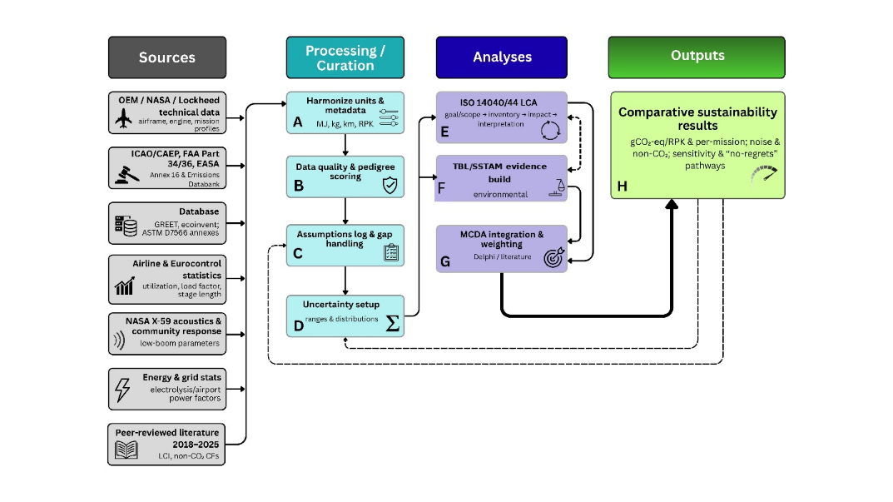
Note. Secondary evidence is harmonized, quality-scored, logged for assumptions and uncertainty, and integrated through LCA, TBL/SSTAM evidence building, and MCDA to produce comparative sustainability outputs.

Appendix I. Literature-screening flow
Figure A2. PRISMA flow for the literature corpus (2018-2025).

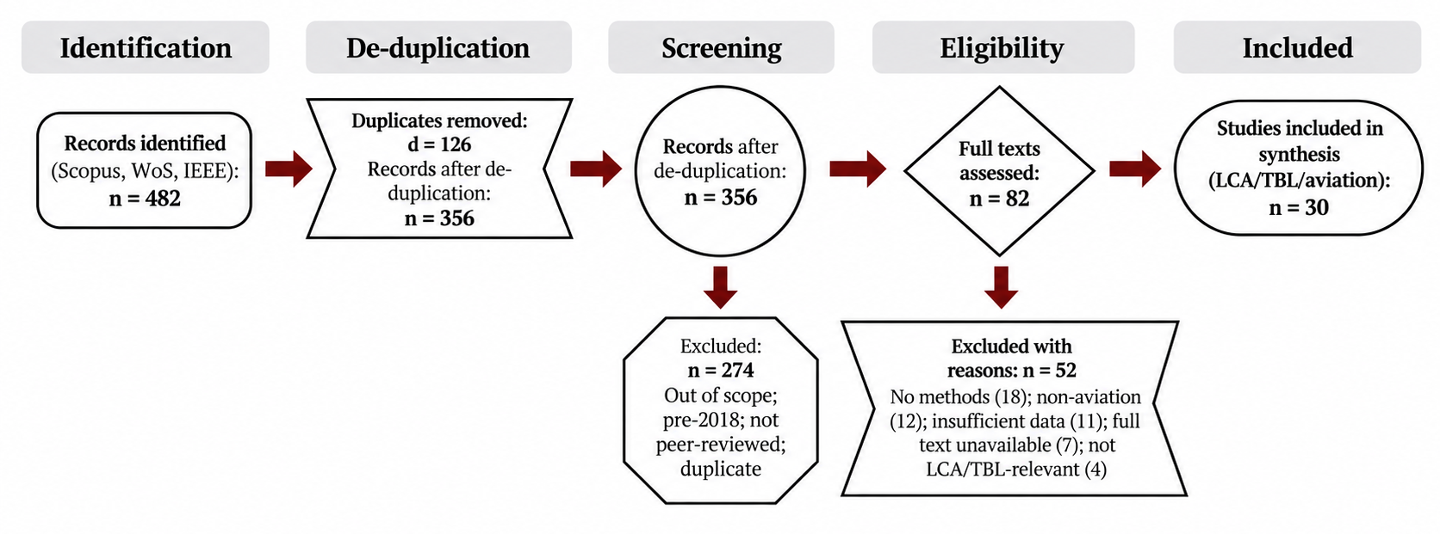
Note. The flow summarizes identification, de-duplication, screening, eligibility assessment, and inclusion of records used in the synthesis.

Appendix J. Economic scenario comparison
Figure A3. Passenger-normalized unit operating cost by scenario (USD/RPK).

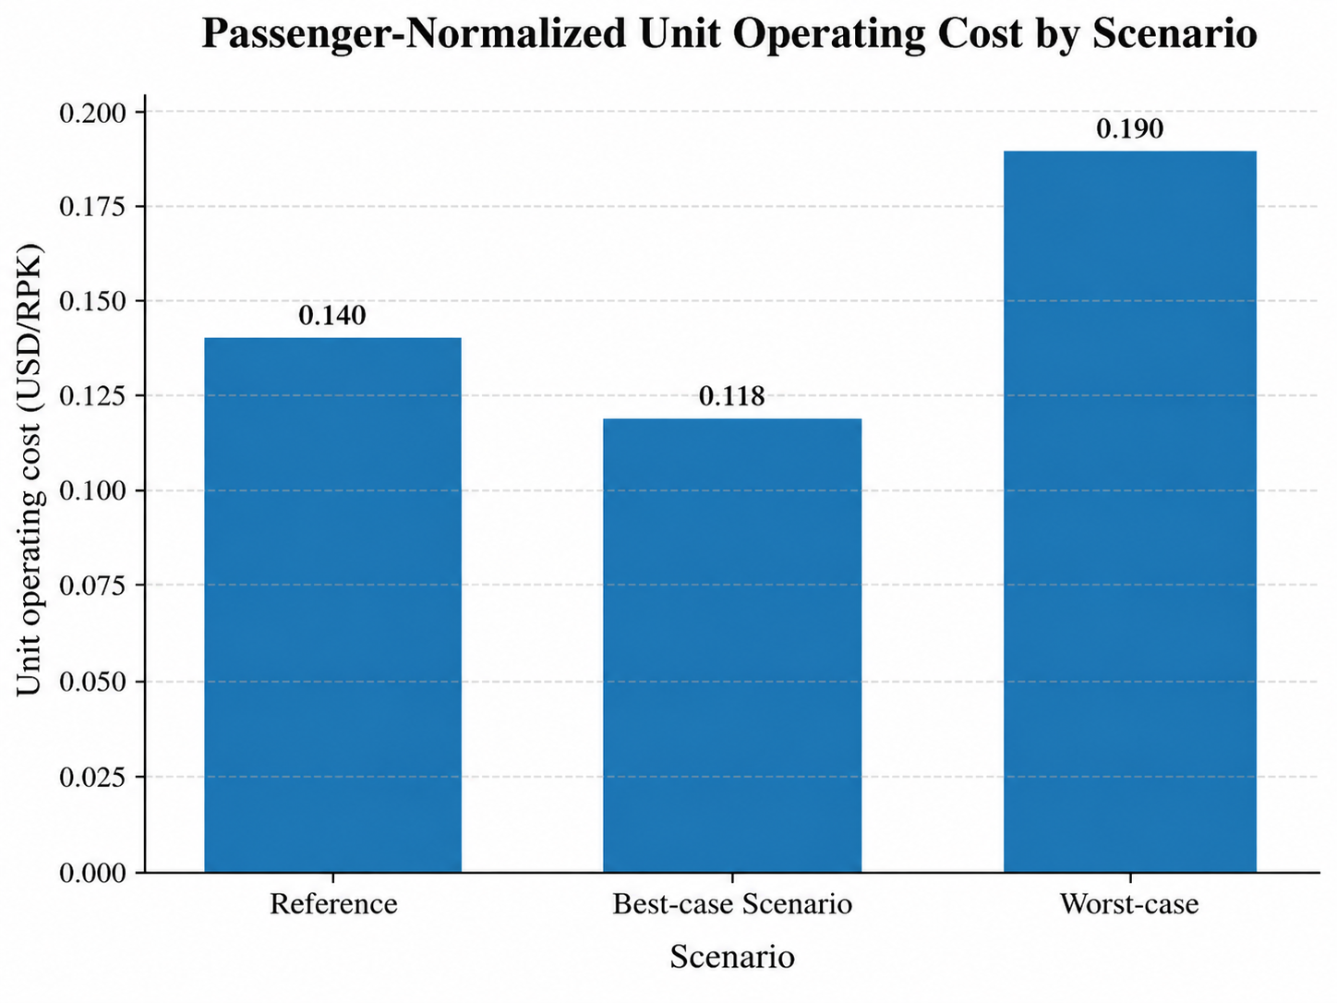
Note. Unit operating-cost values correspond to the scenario totals reported in Section 4.2 of the main article: reference = 0.140, best-case = 0.118, and worst-case = 0.190 USD/RPK.
Appendix K. Revenue-cost-margin comparison
Figure A4. Passenger-normalized unit revenue, unit operating cost, and operating margin by scenario

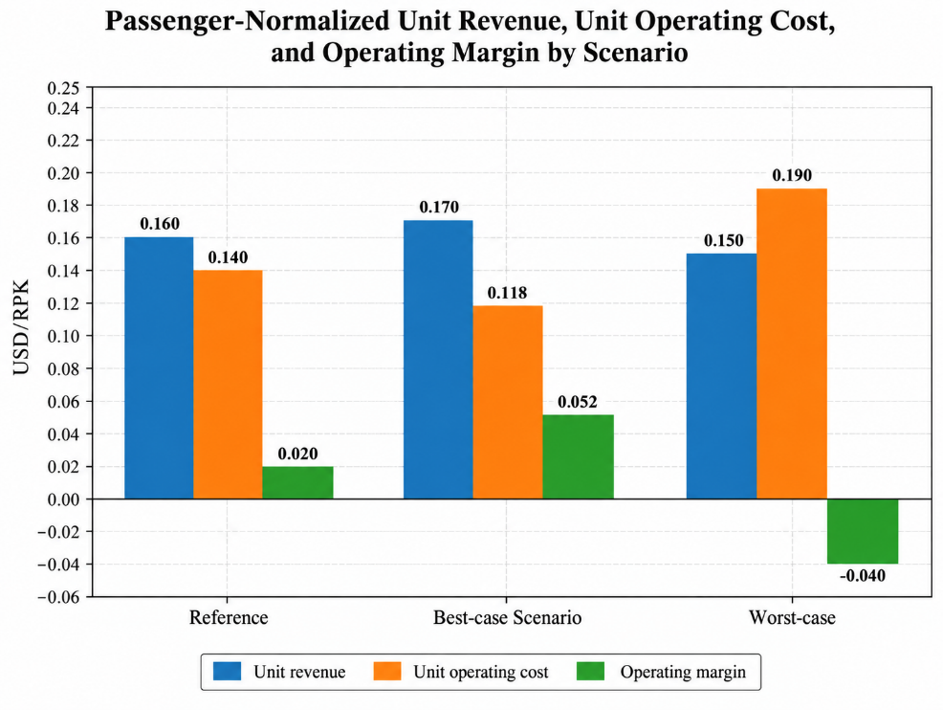

Note. Positive operating margins occur in the reference and best-case scenarios, whereas the worst-case scenario produces a negative margin.

Appendix L. Environmental-justice overlay
Figure A5. Environmental-justice overlay: airport noise contours and supersonic boom corridor versus community vulnerability index.
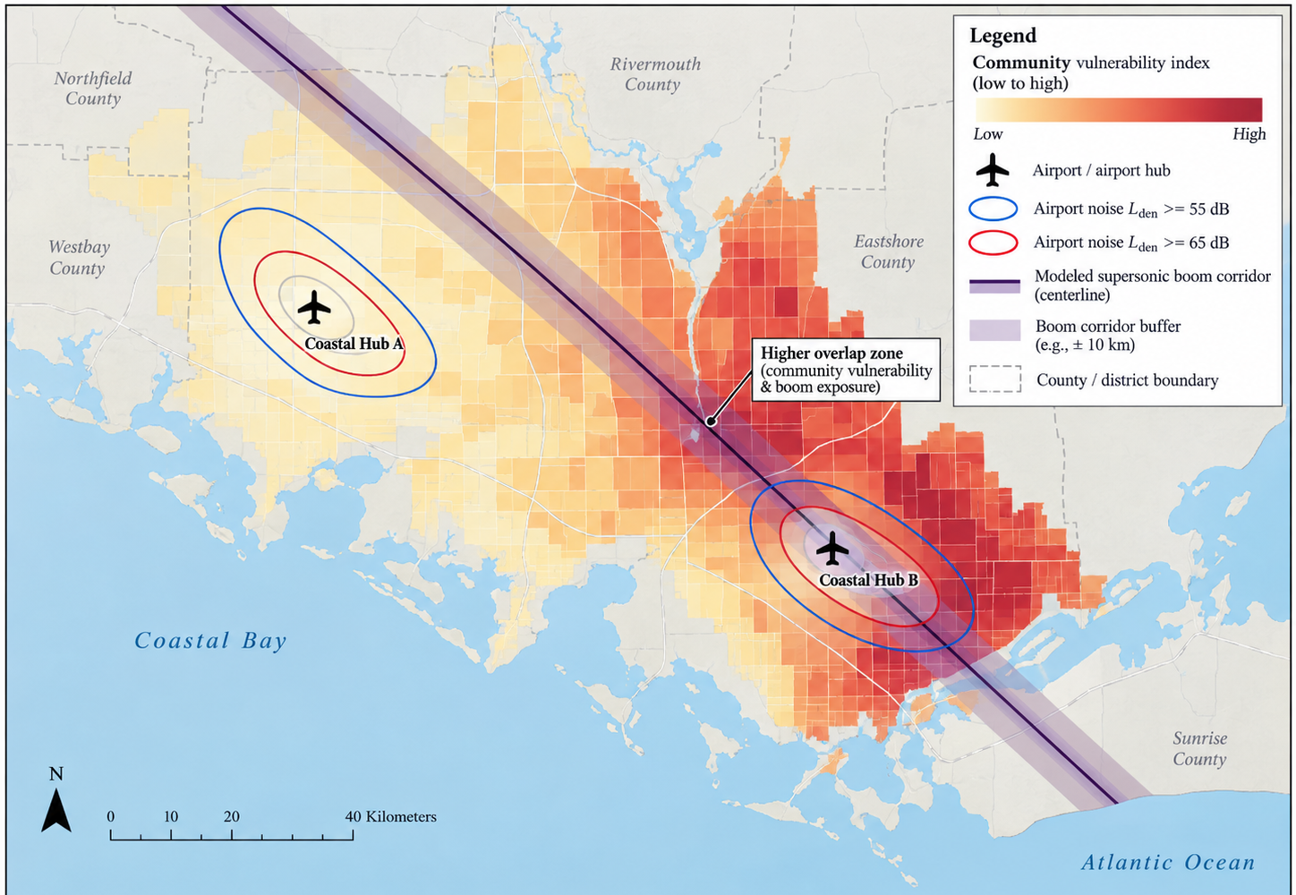
Note. Conceptual spatial overlay used to visualize how airport-noise contours and a modeled supersonic boom corridor may intersect with areas of differing community vulnerability. The figure supports spatial interpretation and does not by itself constitute a site-specific exposure inventory.

