Appendix A
Stimuli for the First Experimental Factor: Pro-Environmental Messages
With concrete green action claims
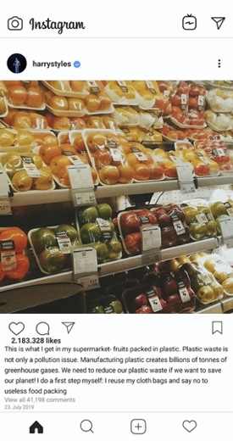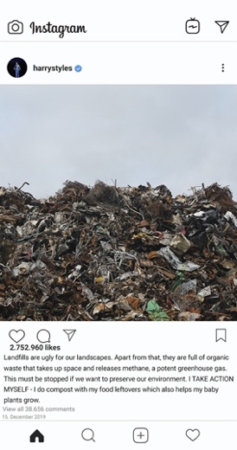
Without concrete green action claims
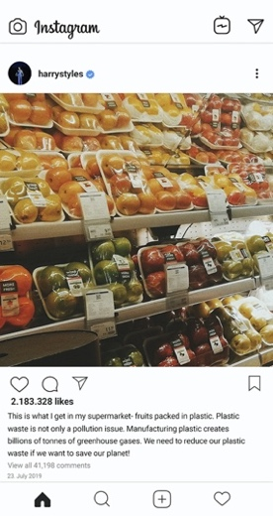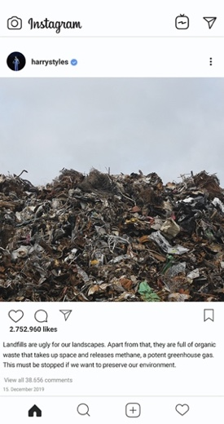

Control group
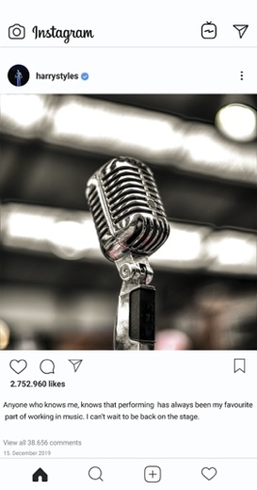
Stimuli for the Second Experimental Factor: Message-Lifestyle Congruence
Congruent messages depicting an environmentally friendly lifestyle
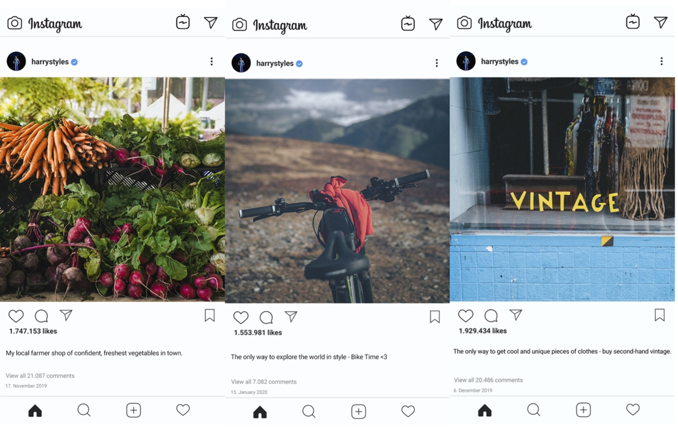
Incongruent messages depicting an environmentally unfriendly lifestyle
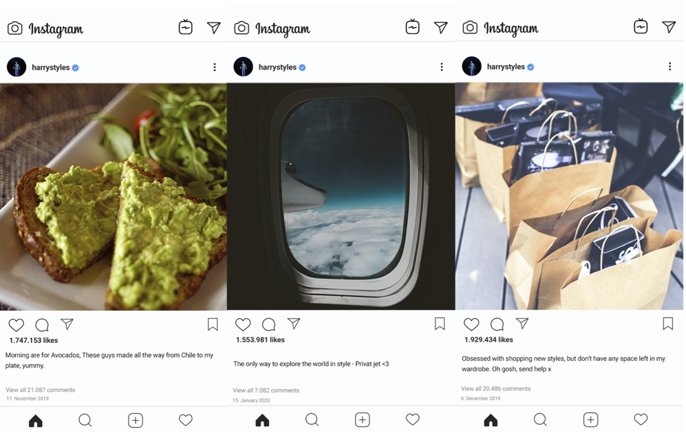

Figure A1
Histograms of Mediators and Dependent Variables
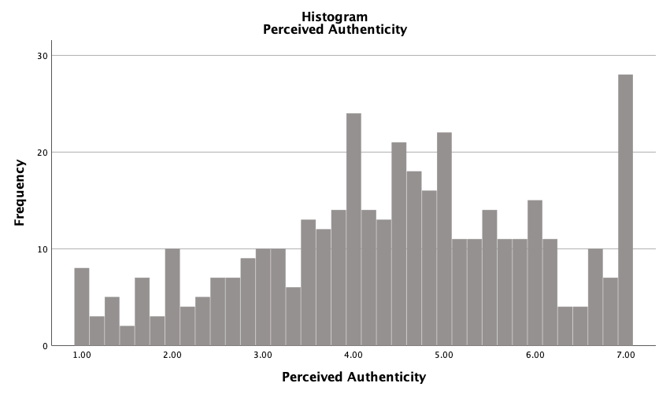
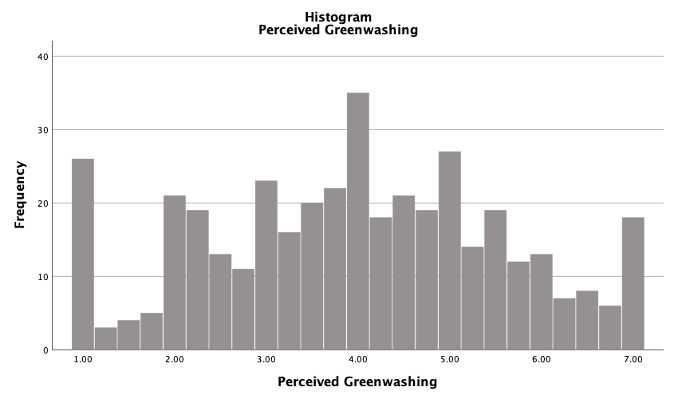

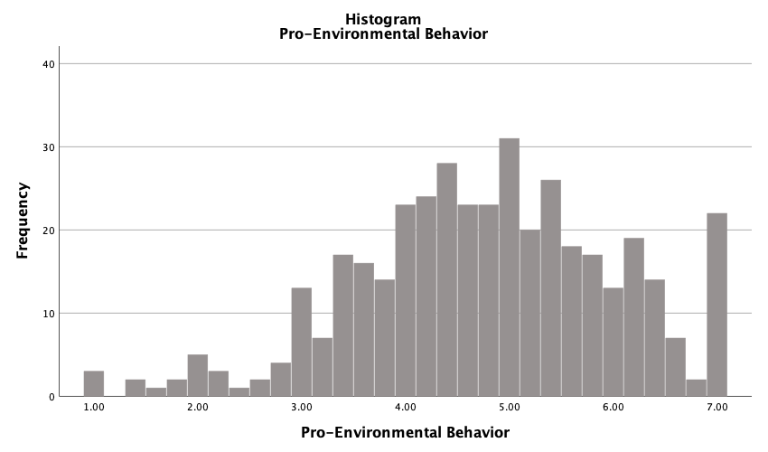
Table A1
Means (M) and Standard Deviations (SD) of Mediators and Dependent Variables per Experimental Condition
 |  | Perceived authenticity |  | Perceived greenwashing |  | Pro-environmental behavior
Pro-environmental messages | n | M | SD | M | SD |  | M | SD
With concrete green action claims | 130 | 4.62 | 1.61 | 3.90 | 1.68 |  | 4.76 | 1.18
Without concrete green action claims | 139 | 4.30 | 1.61 | 4.13 | 1.58 |  | 4.66 | 1.29
Control condition | 131 | 4.44 | 1.43 | 3.88 | 1.54 |  | 4.88 | 1.25
Message-lifestyle congruence | n | M | SD | M | SD |  | M | SD
Congruent | 201 | 5.10 | 1.27 | 3.51 | 1.55 |  | 4.98 | 1.21
Incongruent | 199 | 3.80 | 1.55 | 4.44 | 1.52 |  | 4.55 | 1.24
TOTAL | 400 | 4.45 | 1.56 | 3.97 | 1.60 |  | 4.77 | 1.24
Note. N = 400.
Table A2
Balance Check
Variables
 | Green Messages | Congruity
Age | F(2, 397) = 0.19, p = .831 | F(1, 398) = 0.93, p = .334
Gender (female vs. male) | χ²(2) = 1.21, p = .547 | χ²(1) = 1.21, p = .547
Education (high vs. low) | χ²(2) = 2.13, p = .346 | χ²(1) = 0.06, p = .814
Celebrity Liking | F(2, 394) = 0.23, p = .793 | F(1, 398) = 0.86, p = .354
Celebrity Recognition | F(2, 394) = 0.03, p = .974 | F(1, 398) = 0.90, p = .342
Note. Balance checks indicated that there were no systematic differences in age, gender, education, celebrity liking, and celebrity recognition between green message conditions and congruity conditions.
Table A3
Measures
Perceived Authenticity (ω = .95) | M = 4.45 | SD = 1.56
1. Harry Styles remains true to himself with these social media posts.
2. The social media posts are consistent with the values and beliefs of Harry Styles.
3. Harry Styles’ social media posts are authentic.
4. Harry Styles tries to act in a manner that is consistent with his held values, even if others criticize or reject him for doing so.
5. People can count on Harry Styles being who he is regardless of the situation.
6. With these social media posts, Harry Styles stands up for what he preaches.
Perceived Greenwashing (ω = .91) | M = 3.97 | SD = 1.60
1. When it comes to environmental protection, I believe that Harry Styles does not practice what he preaches.
2. I have the feeling that Harry Styles only pretends to care about the environment, but in reality, he does not.
3. Harry Styles presents himself as more pro-environmental than he actually is.
4. Harry Styles creates a misleading image when presenting himself as environmentally friendly.
Pro-environmental Behavior (ω = .73) | M = 4.77 | SD = 1.24
1. In the future, I intend to not buy things I do not really need.
2. In the future, I intend to buy more local or organic food.
3. In the future, I intend to only buy second-hand clothes if I need new clothes.
4. In the future, I intend to take my own bag with me when I go shopping.
5. In the future, I intend to eat vegetarian meals.
Celebrity Liking (ω = .92) | M = 4.36 | SD = 1.76
1. I like Harry Styles.
2. I think Harry Styles is attractive.
3. I believe Harry Styles is classy.
Table A1
(Continued)
Celebrity Recognition | M = 5.37 | SD = 1.78
1. How well do you recognize Harry Styles?
Manipulation Check I (ω = .90) | M = 4.34 | SD = 1.76
1. The social media posts are characterized by themes such as climate change mitigation and sustainability.
2. Sustainable behavior and environmental protection are central in the social media posts.
3. Harry Styles names specific behaviors such as compost food leftovers which he does himself to protect the environment.
4. In the social media posts, Harry Styles describes concrete actions which he does himself in order to mitigate climate change impacts.
Manipulation Check II (ω = .92) | M = 4.10 | SD = 1.81
1. I think that the two social media posts at the beginning of this questionnaire and Harry Styles’ free time activities are loyal between each other.
2. I think that the two social media posts at the beginning of this questionnaire and Harry Styles’ free time activities fit together.
3. I think that the two social media posts at the beginning of this questionnaire and Harry Styles’ free time activities complement each other thematically.
4. I think that the two social media posts at the beginning of this questionnaire and Harry Styles’ free time activities are congruent.

Table A4
Overview of the Regression Model Results
Variables | Perceived authenticity |  | Perceived greenwashing |  | Pro-environmental behavior
 | b | SE | b | SE | b | SE
Pro-environmental messages without concrete green action claims | 0.11 | 0.21 | -0.001 | 0.26 | 0.03 | 0.20
Control condition | 0.43 | 0.22 | -0.38 | 0.27 | 0.26 | 0.20
Message-lifestyle congruence | 1.75*** | 0.23 | -1.23*** | 0.26 | 0.48* | 0.22
Age | -0.00 | 0.02 | 0.07** | 0.03 | 0.00 | 0.02
Gender | 0.03 | 0.13 | -0.34* | 0.16 | 0.45*** | 0.12
Education | 0.06 | 0.04 | 0.04 | 0.5 | 0.09* | 0.04
Celebrity liking | 0.42*** | 0.04 | -0.16** | 0.05 | 0.11* | 0.04
Celebrity recognition | -0.06 | 0.04 | 0.08 | 0.05 | 0.05 | 0.04
Pro-environmental messages without concrete green action claims* Message-lifestyle congruence | -0.57 | 0.30 | 0.27 | 0.37 | -0.07 | 0.28
Control condition* Message-lifestyle congruence | -1.06*** | 0.30 | 0.67 | 0.37 | 0.16 | 0.28
Perceived authenticity |  |  |  |  | 0.13** | 0.05
Perceived greenwashing |  |  |  |  | 0.15*** | 0.04
 | R² = 0.41 |  | R² = 0.15 |  | R² = 0.21
Note. SPSS PROCESS 4 macro model no. 8 using 5000 bootstraps; N = 400; “Pro-environmental messages with concrete action claims” used as a reference group; *** p < .001; ** p < .01; * p < .05.

Appendix B
After showing participants the first set of social media posts, we used four items (McDonalds’s ω = .90, M = 4.34, SD = 1.76) that measured to what extent participants assessed the messages of the celebrity as pro-environmental and whether they perceived any concrete green action claims. We asked participants to rate the following statements on a 7-point Likert scale ranging from 1 – strongly disagree to 7 – strongly agree: “The social media posts are characterized by themes such as climate change mitigation and sustainability”; “Sustainable behavior and environmental protection are central in the social media posts”; “Harry Styles names specific behaviors such as compost food leftovers which he does himself to protect the environment”; “In the social media posts, Harry Styles describes concrete actions which he does himself in order to mitigate climate change impacts”. A one-way ANOVA using Welch’s F test (F(2, 256.20) = 93.34, p < 0.001) – variances were not equal across groups – revealed statistically significant differences between celebrity’s pro-environmental messages with concrete green action claims (M = 5.42, SD = 1.31) and without concrete green action claims (M = 4.71, SD = 1.16) and control group (M = 2.87, SD = 1.70). In addition, post hoc comparisons with Dunnet-T3 correction showed that all conditions differed at p < .001. Thus, the manipulation of our first experimental factor was successful.
After showing participants the second set of social media posts, we measured to what extent participants believed that the celebrity’s pro-environmental messages and the additional messages depicting an environmentally friendly (vs. environmentally unfriendly) lifestyle on the social media profile were perceived as congruent. We used four items (McDonalds’s ω = .92, M = 4.10, SD = 1.81; see Manipulation Check II in Appendix A, Table A3, under the anonymous OSF framework) measured on a 7-point Likert scale ranging from 1 – strongly disagree to 7 – strongly agree. Items were inspired by e.g., Kamins and Gupta (1994; e.g., “I think that the two social media posts at the beginning of this questionnaire and Harry Styles’ free time activities are loyal between each other”). A t-test showed a statistically significant difference between the celebrity’s social media posts depicting an environmentally unfriendly lifestyle (M = 3.11, SD = 1.63) and an environmentally friendly lifestyle (M = 5.07, SD = 1.42; t(389.51) = -12.80, p < .001). Therefore, the manipulation of our second experimental factor was also successful.

